**Service of Word and Table**

at

**Epworth Free Methodist Church**

6110 W. Northview Street, Boise, Idaho 83704

208-336-3951

[www.epworthfmc.org](http://www.epworthfmc.org)

The Rev. John Crow, Rector and Pastor

208-501-4037

**February 23, 2025, 10:00 a.m.**

*Seventh Sunday after Epiphany*



*_____*__________________________

**“Through the deep current of the historical Wesleyan church we will collaboratively serve and reach the lost in order to make disciples who love Jesus.”**

*____*___________________________

This service will be live streamed, and in the course of that any or all persons who attend may be filmed. Remaining in the service will constitute your consent to appear in the live-streamed, recorded, and published service.

*____*___________________________

**Rector and Pastor:** The Rev. John Crow

**Cantors:** Bryan Vanshur, Shannon Nichols

**Readers:**

**Old Testament:** Bryan Vanshur

**Psalm:** Bryan Vanshur

**Epistle:** Stan Crow

**Acolytes:** Stephen Crow, Josiah Crow, Corbin Crosswhite, and Jessica Crosswhite

**Jr. Acolytes:** Asher Crow & Lizzie Crosswhite

**Usher:** Asher Crow

___________________________________________________

**ACTS OF ENTRANCE**

**Prélude**

**(The people enter and remain in prayer and meditation.)**

**Entrance canticle (cantor only):**

“Brightest and best of the stars of the morning, Dawn on our darkness and lend us Thine aid; Star of the east, the horizon adorning, Guide where our infant Redeemer is laid.

Cold on His cradle the dewdrops are shining; Low lies His head with the beats of the stall; Angels adore Him in slumber reclining, Maker and Monarch and Savior of all.” (Brightest and Best of the Stars, vv. 1-2, Reginald Heber)

**Processional Hymn (all standing):**

*All My Hope on God is Founded*  (No. 356)

**The Salutation:**

**Minister:** Blessed be God: Father, Son, and Holy Spirit.

**People:** *And blessed be his kingdom, now and forever.*

**Lord’s Prayer:**

**Minister:** Let us pray.

**(All standing):** *Our Father, who art in heaven, hallowed be thy Name. Thy kingdom come. Thy will be done, on earth as it is in heaven. Give us this day our daily bread. And forgive us our trespasses, as we forgive those who trespass against us. And lead us not into temptation, but deliver us from evil, for thine is the kingdom, and the power, and the glory, for ever and ever.* *Amen.*

**The Collect for Purity:**

**Minister:** Almighty God, unto whom all hearts are open, all desires known, and from whom no secrets are hid; cleanse the thoughts of our hearts by the inspiration of your Holy Spirit, that we may perfectly love You, and worthily magnify your holy Name, through Christ our Lord.

**All:** *Amen.*

**The *Gloria*: (all standing, singing):**

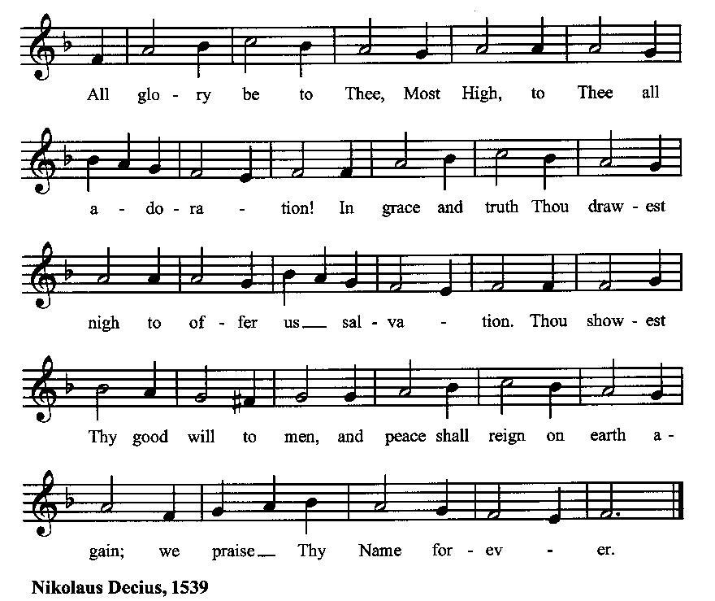

**The *Trisagion:***

**Minister:** Holy God, Holy and Mighty, Holy Immortal One,

**People:** *Have mercy upon us.*

**SERVICE OF THE WORD**

**Mutual Invocation of the Grace of God for the Service of the Word:**

**Minister:** The Lord be with you.

**People:** *And also with you.* **(The people then be seated.)**

**Old Testament Lesson (the people sitting):**

**Reader:** The Old Testament lesson is written in the forty-fifth chapter of the book of Genesis, beginning at verse 1:

1. Then Joseph could not control himself before all those who stood by him. He cried, “Make everyone go out from me.” So no one stayed with him when Joseph made himself known to his brothers.
2. And he wept aloud, so that the Egyptians heard it, and the household of Pharaoh heard it.
3. And Joseph said to his brothers, “I am Joseph! Is my father still alive?” But his brothers could not answer him, for they were dismayed at his presence.
4. So Joseph said to his brothers, “Come near to me, please.” And they came near. And he said, “I am your brother, Joseph, whom you sold into Egypt.
5. And now do not be distressed or angry with yourselves because you sold me here, for God sent me before you to preserve life.
6. For the famine has been in the land these two years, and there are yet five years in which there will be neither plowing nor harvest.
7. And God sent me before you to preserve for you a remnant on earth, and to keep alive for you many survivors.
8. So it was not you who sent me here, but God. He has made me a father to Pharaoh, and lord of all his house and ruler over all the land of Egypt.
9. Hurry and go up to my father and say to him, ‘Thus says your son Joseph, God has made me lord of all Egypt. Come down to me; do not tarry.
10. You shall dwell in the land of Goshen, and you shall be near me, you and your children and your children's children, and your flocks, your herds, and all that you have.
11. There I will provide for you, for there are yet five years of famine to come, so that you and your household, and all that you have, do not come to poverty.’
12. And he kissed all his brothers and wept upon them. After that his brothers talked with him. (ESV)

**Reader:** The Word of the Lord.

**People:** *Thanks be to God.*

**The Psalm: (The people sit for the responsive reading, by half-verse, of a portion of Psalm 37, a praise of God’s justice for the righteous.)**

**Reader:** The Psalm is chapter 37, beginning at verse 1.

**Reader:** 1 Do not fret yourself because of evildoers;

**People:** *do not be jealous of those who do wrong.*

**Reader:** 2 For they shall soon wither like the grass

**People:** *and like the green grass fade away.*

**Reader:** 3 Put your trust in the Lord and do good;

**People:** *dwell in the land and feed on its riches.*

**Reader:** 4 Take delight in the Lord,

**People:** *and he shall give you your heart’s desire.*

**Reader:** 5 Commit your way to the Lord and put your trust in him,

**People:** *and he will bring it to pass.*

**Reader:** 6 He will make your righteousness as clear as the light

**People:** *and your just dealing as the noonday.*

**Reader:** 7 Be still before the LORD

**People:** *and wait patiently for him.*

**Reader:** 8 Do not fret yourself over the one who prospers,

**People:** *the one who succeeds in evil schemes.*

**Reader:** 9 Refrain from anger, leave rage alone;

**People:** *do not fret yourself; it leads only to evil.*

**Reader:** 10 For evildoers shall be cut off,

**People:** *but those who wait upon the Lord shall possess the land.*

**Reader:** 11 In a little while the wicked shall be no more;

**People:** *you shall search out their place, but they will not be there.*

**Reader:** 12 But the lowly shall possess the land;

**People:** *they will delight in abundance of peace.*

**Reader:** 41 But the deliverance of the righteous comes from the Lord;

**People:** *he is their stronghold in time of trouble.*

**Reader:** 42 The Lord will help them and rescue them;

**People:** *he will rescue them from the wicked and deliver them, because they seek refuge in him.*  (BCP)

***Gloria Patri*:**

**Reader:** Glory be to the Father, and to the Son, and to the Holy Spirit.

**People:** *As it was in the beginning, is now and ever shall be, world without end. Amen.*

**Collect for the Seventh Sunday after Epiphany (the people sitting):**

**Minister:** O Lord, who has taught us that all our doings without love are worth nothing: Send thy Holy Spirit and pour into our hearts that most excellent gift of love, the very bond of peace and of all virtues, without which whosoever lives is counted dead before you. Grant this for thine only Son Jesus Christ’s sake, who lives and reigns with You, and the same Holy Spirit, one God, now and for ever.

**All:** *Amen.*

**The Epistle (the people sitting):**

**Reader:** The Epistle lesson is written in the fifteenth chapter of the first letter to the church in Corinth, beginning at verse 35:

1. But someone will ask, “How are the dead raised? With what kind of body do they come?”
2. You foolish person! What you sow does not come to life unless it dies.
3. And what you sow is not the body that is to be, but a bare kernel, perhaps of wheat or of some other grain.
4. But God gives it a body as he has chosen, and to each kind of seed its own body.
5. So is it with the resurrection of the dead. What is sown is perishable; what is raised is imperishable.
6. It is sown in dishonor; it is raised in glory. It is sown in weakness; it is raised in power.
7. It is sown a natural body; it is raised a spiritual body. If there is a natural body, there is also a spiritual body.
8. Thus it is written, “The first man Adam became a living being”; the last Adam became a life-giving spirit.
9. But it is not the spiritual that is first but the natural, and then the spiritual.
10. The first man was from the earth, a man of dust; the second man is from heaven.
11. As was the man of dust, so also are those who are of the dust, and as is the man of heaven, so also are those who are of heaven.
12. Just as we have borne the image of the man of dust, we shall also bear the image of the man of heaven.
13. I tell you this, brothers: flesh and blood cannot inherit the kingdom of God, nor does the perishable inherit the imperishable. (ESV)

**Reader:** Here ends the Epistle.

**People:** *Thanks be to God.*

**Sequence Hymn (all standing):**

*Just As I Am*, vv. 1-3 (No. 260)

**The Gospel (all standing, and turning toward the Gospel reading):**

**Minister:** The holy Gospel is written in the sixth chapter of the Gospel according to Luke, beginning at verse 27:

**Minister:**

1. “But I say to you who hear, Love your enemies, do good to those who hate you,
2. bless those who curse you, pray for those who abuse you.
3. To one who strikes you on the cheek, offer the other also, and from one who takes away your cloak do not withhold your tunic either.
4. Give to everyone who begs from you, and from one who takes away your goods do not demand them back.
5. And as you wish that others would do to you, do so to them.
6. “If you love those who love you, what benefit is that to you? For even sinners love those who love them.
7. And if you do good to those who do good to you, what benefit is that to you? For even sinners do the same.
8. And if you lend to those from whom you expect to receive, what credit is that to you? Even sinners lend to sinners, to get back the same amount.
9. But love your enemies, and do good, and lend, expecting nothing in return, and your reward will be great, and you will be sons of the Most High, for he is kind to the ungrateful and the evil.
10. Be merciful, even as your Father is merciful.
11. “Judge not, and you will not be judged; condemn not, and you will not be condemned; forgive, and you will be forgiven;
12. give, and it will be given to you. Good measure, pressed down, shaken together, running over, will be put into your lap. For with the measure you use it will be measured back to you.” (ESV)

**Minister:** The Gospel of the Lord.

**People:** *Praise to You, Lord Christ*.

**Sequence Hymn (all standing):**

*Just As I Am*, vv. 4-6 (No. 260)

[Elementary age children may exit for Children's Worship in the Parish Hall.

They will return to the service at the Passing of the Peace.]

**Minister:** Grace be unto you, and peace, from our Lord Jesus Christ.

**All:** *Amen.* **(The people then be seated.)**

**The Sermon**

**Minister:** In the name of the Father, and of the Son, and the Holy Spirit.

**Silence, for review of the sermon, and for meditative prayer**

**SERVICE OF DEDICATION: OUR NEW LECTERN**

**Minister: (The people sitting)** The Lord be with you.

**People:** *And also with you.*

**Minister:** Thy word is a lantern unto my feet;

**People:** *And a light unto my paths*

**Minister:** When Thy word goes forth:

**People:** *It gives light and understanding to the simple.*

**Minister:** All Scripture is breathed out by God and profitable for teaching, for

reproof, for correction, and for training in righteousness, that the

man of God may be complete, equipped for every good work.

**People:** *Thanks be to God.*

**Minister:** Grant, O Lord, that they who shall read the holy Scriptures in this

place may be filled with the faith of Thy Gospel, and may so read

that all shall understand. Grant also that they who shall hear Thy

holy Word may receive it into honest and good hearts, and bring

forth fruits with patience; through Jesus Christ our Lord.

**People:** *Amen.*

**Minister:** In the faith of Jesus Christ and to the glory of God, we bless and

dedicate this lectern. In the Name of the Father, and of the Son,

and of the Holy Spirit.

**People:** *Amen.*

**SERVICE OF THE TABLE: THE GREAT THANKSGIVING**

**The Nicene Creed (all standing):**

**Minister:** Let us confess our faith, saying:

**All:** *We believe in one God,*

*the Father, the Almighty,*

*maker of heaven and earth,*

*of all that is, seen and unseen.*

*We believe in one Lord, Jesus Christ,*

*the only Son of God,*

*eternally begotten of the Father,*

*God from God, Light from Light,*

*true God from true God,*

*begotten, not made,*

*of one Being with the Father.*

*Through him all things were made.*

*For us and for our salvation*

*he came down from heaven:*

*by the power of the Holy Spirit*

*he became incarnate from the Virgin Mary,*

*and was made man.*

*For our sake he was crucified under Pontius Pilate;*

*he suffered death and was buried.*

*On the third day he rose again*

*in accordance with the Scriptures;*

*he ascended into heaven*

*and is seated at the right hand of the Father.*

*He will come again in glory to judge the living and the dead,*

*and his kingdom will have no end.*

*We believe in the Holy Spirit, the Lord, the giver of life,*

*who proceeds from the Father and the Son.*

*With the Father and the Son he is worshiped and glorified.*

*He has spoken through the Prophets.*

*We believe in one holy catholic and apostolic Church.*

*We acknowledge one baptism for the forgiveness of sins.*

*We look for the resurrection of the dead,*

*and the life of the world to come.* *Amen.*

**Minister: (The people sitting)** Let us with gladness present the offerings and oblations of our life and labor to the Lord.

**Offertory:**

**Offering Hymn (all standing):**

*From All That Dwell Below the Skies* (No. 484)

**Minister:** All things come from You, O Lord.

**People:** *And of your own have we given You.*

**(The people then be seated.)**

**The Prayers of the People (the people sitting):**

**Minister:** Let us pray for the Church and the world. For the unity of the Church throughout the world, that we might faithfully preach the Gospel to the ends of the earth, let us pray to the Lord:

**People:** *Lord, hear our prayer.*

**Minister:** For the persecuted church, and for its persecutors, that You would turn their hearts, let us pray to the Lord:

**People:** *Lord, hear our prayer.*

**Minister:** For our President and all who govern and hold authority in our nation and in the world, let us pray to the Lord:

**People:** *Lord, hear our prayer.*

**Minister:** For the good earth which You have given us, and for the wisdom and will to conserve it, let us pray to the Lord:

**People:** *Lord, hear our prayer.*

**Minister:** For all ministers of your Gospel, that they might faithfully preach your Word, administer your sacraments, and care for your people, let us pray to the Lord:

**People:** *Lord, hear our prayer.*

**Minister:** For the peace of the world, that a spirit of respect and forbearance may grow among all nations and peoples, let us pray to the Lord:

**People:** *Lord, hear our prayer.*

**Minister:** For all those who do not yet believe, and for those who have lost their faith, that in due time we may all stand reconciled before You, let us pray to the Lord:

**People:** *Lord, hear our prayer.*

**Minister:** For the poor and the oppressed, prisoners and captives, the unemployed, and all who are in need or trouble, let us pray to the Lord:

**People:** *Lord, hear our prayer.*

**Minister:** For our enemies and all who wish us harm, and for all whom we have injured or offended, let us pray to the Lord:

**People:** *Lord, hear our prayer.*

**Minister:** For this congregation, that we might show forth your glory in all that we do; and for those who have commended themselves to our prayers, including these: _____________:

[Nation: Bosnia & Herzegovina

Denomination: Open Bible Study Churches

Congregation: Grace Bible Church, Nampa, ID, and the Rev. Keith Waggoner

Ministry: Military Chaplains

Parishioners: Those living on Liberty Road],

Grant that all of these may be delivered from anxiety, and live in joy, peace, and health.

*(Please add your own intentions, either silently or aloud.)*

**Minister:** Let us pray to the Lord:

**People:** *Lord, hear our prayer.*

**Minister:** We bless your holy Name for the thanksgivings of your people, including these: _________; for those in every generation in whom Christ has been honored;Give us grace to follow their good examples, that with them we may be partakers of your heavenly kingdom.

*(Please add your intentions, either silently or aloud.)*

**Minister:** Let us pray to the Lord:

**People:** *Lord, hear our prayer.*

**Collect (the people kneeling or sitting):**

**Minister:** Ever living God, whose will it is that all should come to You through your Son Jesus Christ: Inspire our witness to him, that all may know the power of his forgiveness and the hope of his resurrection; who lives and reigns with You and the Holy Spirit, one God, now and for ever.

**All:** *Amen*.

**Preparation for Holy Communion (the people sitting):**

**Minister:** The Lord’s Supper was ordained by God to be a means of conveying grace according to the need of each person. Those for whom it was ordained are all those who know and feel that they want the grace of God, to restrain them from sin, or to forgive their sins, or to assure them of pardon, or to renew their souls in the image of God, or to enter into the holy presence of God in communion with him. No preparation is indispensably necessary, other than a desire to receive the grace God pleases to give. No fitness or church membership is required at the time of communicating, other than a sense of our state, of our utter sinfulness and helplessness apart from Christ. Therefore, if you want such grace as God pleases to give to you, draw near with faith, and as you prepare to receive this holy sacrament to your comfort and strength, make your sincere confession to Almighty God, kneeling if you wish and are able, or otherwise sitting.

**The Prayer of Confession, Petition and Thanksgiving:**

**(The minister kneels, and the people kneel or sit.)**

**Minister:** Let us pray together:

**All:** *Almighty God, Father of our Lord Jesus Christ, Maker of all things, Judge of all persons: We have erred and strayed from your ways like lost sheep. We have followed too much the devices and desires of our own hearts. You have shown us the way of life through your Son, Jesus Christ. Where there is sin or falling short of your will in our lives, or any spiritual pride, carelessness or presumption on our part, or any failure to see or know your good and righteous will, we earnestly repent and are heartily sorry for our misdoings. Forgive us all that is past, grant that we may ever serve and please You in newness of life, and accept our thanksgiving for the wondrous grace and forgiveness You extend to us, to the honor and glory of your Name, through Jesus Christ our Lord. Amen.*

***Agnus Dei* (the people kneeling or sitting):**

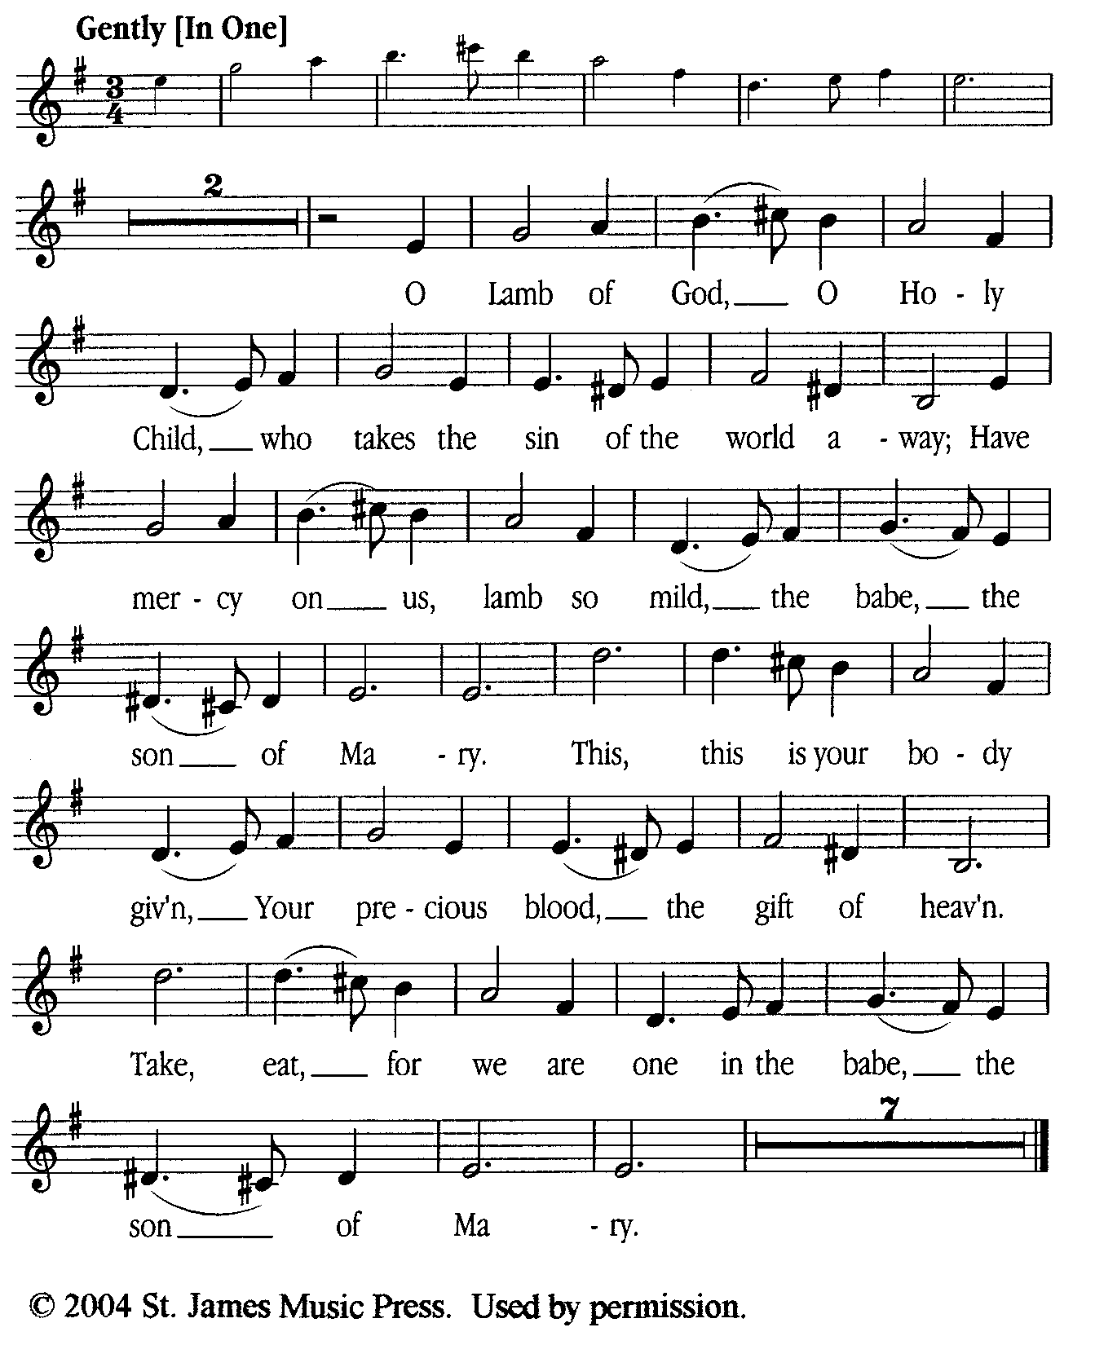

**Prayer for Absolution (the people kneeling or sitting):**

**Minister:** Almighty God, our heavenly Father, who of your great mercy has promised forgiveness of sins to all those who with hearty repentance and true faith turn unto You; Have mercy upon us; pardon and deliver us from all our sins, confirm and strengthen us in all goodness, and bring us to everlasting life, through Jesus Christ our Lord.

**All:** *Amen.*

**The Comforting Words of Forgiveness (the people sitting):**

**Minister:** Hear what comforting words our Savior Christ says to all who truly turn to him: Come to me, all you who are weary and carry heavy burdens, and I will give you rest. God so loved the world that he gave his only Son, so that everyone who believes in him will not perish but have eternal life. Hear also what St. Paul says: Christ Jesus came into the world to save sinners. Hear also what St. John says: If anyone sins, we have an Advocate with the Father, Jesus Christ the righteous: and he is the atonement for our sins.

**The Passing of the Peace:**

**Minister:** The peace of the Lord be always with you.

**People:** *And also with you.*

**Minister:** As the peace of Christ has been extended to you, extend the peace of the Lord to one another, and greet one another in the name of the Lord. **(The people rise and remain standing.)**

*(The people greet those near to them, saying, “The peace of the Lord be with you,” or, “Peace be with you,” or simply, “Peace.” They respond to one another, “And also with you,” or simply, “Peace”.)*

**Hymn of Entry Into the Heavenly Worship (all standing, singing):**

*Forgive Our Sins As We Forgive*  (No. 282)

**Preparation for the Table:**

**(Minister:** I wash my hands in innocence, and go about your altar, O LORD, proclaiming aloud your praise and telling of all your wonderful deeds.) [Psalm 26:6-7, NIV]

**The *Sursum Corda* (all standing):**

**Minister:** The Lord be with you.

**People:**  *And also with you.*

**Minister:** Lift up your hearts.

**People:** *We lift them up unto the Lord.*

**Minister:** Let us give thanks unto the Lord our God.

**People:** *It is meet and right so to do.*

**The Salutation:**

**Minister:** It is very meet, right, and our gladsome duty, that we should at all times, and in all places, give thanks unto You, O Lord, Holy Father, Almighty, Everlasting God,

**The Proper Preface:**

**Minister:** Because in the mystery of the Word made flesh, You have caused a new light to shine in our hearts, to give the knowledge of your glory in the face of your Son Jesus Christ our Lord.

**Minister:** Therefore, with Angels and Archangels and with all the company of heaven, we laud and magnify your glorious Name, evermore praising You and saying,

**The *Sanctus* (all standing, singing):**

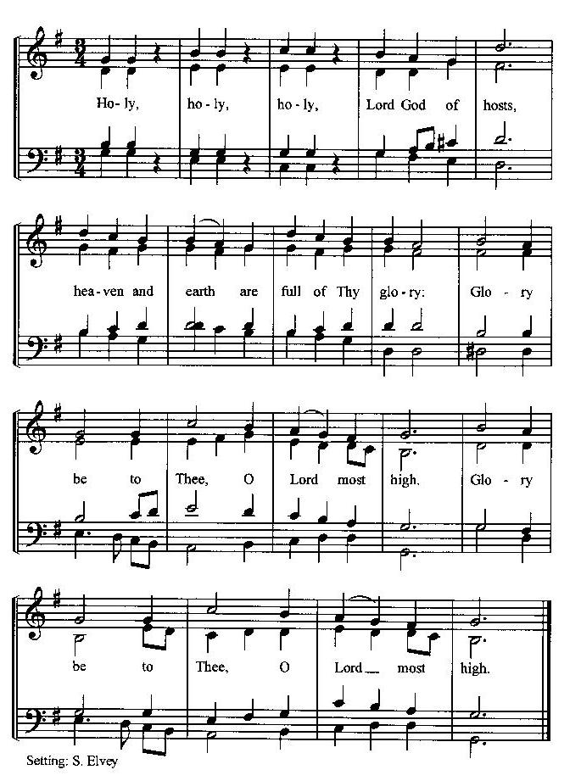

**The Prayer of Humble Access and for Cleansing**

**(the people kneeling or sitting):**

**Minister:** Let us pray together:

**All:** *We do not presume to come to this your table, O merciful Lord, trusting in our own righteousness, but in your many and great mercies. We are not worthy so much as to gather up the crumbs under your table. But You are the same Lord, whose nature is always to have mercy: Grant us, therefore, gracious Lord, so to experience the spiritual presence of your dear Son Jesus Christ at this your table, that we may be made clean by his body and blood, and that we may evermore dwell in him, and he in us. Deliver us, gracious Lord, from the presumption of coming to this table for solace for ourselves only, and not for strength to serve You and others. Deliver us, gracious Lord, from the presumption of coming to this table for pardon of our sins only, and not for transformation of our lives in your holiness. Amen.*

***Epiclesis* Prayer (Invocation of the Holy Spirit upon the Bread and Wine)**

**(the people kneeling or sitting):**

**Minister:** Holy and gracious Father, in your infinite love You made us for yourself; and, when we had fallen into sin and become subject to evil and death, You sent Jesus Christ, your only and eternal Son, to share our human nature, to live and die as one of us, to reconcile us to You, the God and Father of all. He stretched out his arms upon the cross and offered himself, in obedience to your will, a perfect sacrifice for the sins of the whole world. Recalling now his death, resurrection, and ascension, we offer You these gifts. Sanctify them by your Holy Spirit to be for us the Body and Blood of your Son, the holy food and drink of new and unending life in him. Sanctify us also, that we may faithfully receive this holy Sacrament, and serve You in unity, constancy, and peace; and at the last day bring us with all your saints into the joy of your eternal kingdom. We ask this through Jesus Christ, your Son, our Lord; through him, and with him, and in him, in the unity of the Holy Spirit, all honor and glory are yours, O Father Almighty, now and for ever.

**All:** *Amen.*

**The Words of Institution (the people kneeling or sitting):**

**Minister:** Our Lord Jesus Christ, on the night that he was betrayed took bread; and when he had given thanks, he broke it, and gave it to his disciples, saying, Take, eat; this is my Body which is given for you: Do this in remembrance of me.

Likewise, after supper, he took the cup; and when he had given thanks, he gave it to them, saying, Drink this, all of you; for this is my blood of the New Testament, which is shed for you, and for many, for the remission of sins: Do this, as often as you shall drink it, in remembrance of me.

**All:** *Amen.*

**The Acclamation:**

**Minister:** Therefore, we proclaim the mystery of faith:

**People:** *Christ has died, Christ is risen, Christ will come again.*

**The Fraction:**

**Minister:** Christ our passover is sacrificed for us.

**People:** *Therefore let us keep the feast.*

**Fraction Anthem (the people kneeling or sitting, singing):**

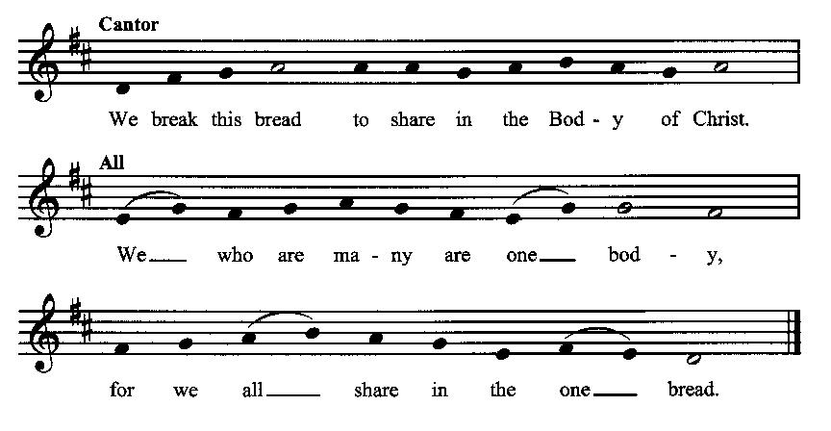

**Minister:** The gifts of God for the people of God. Take them in remembrance that Christ died for you and rose again, and feed on him in your hearts by faith with thanksgiving.

**Communion Hymn (cantors only, the people kneeling or sitting):**

“What shall we give Him, in costly devotion? Shall we bring incense and off’rings divine, Gems of the mountains and pearls of the ocean, Myrrh from the forest or gold from the mine?

Vainly we offer each lavish oblation, Vainly with gifts would His favor secure; Richer by far is the heart’s adoration, Dearer to God are the prayers of the poor.” (Brightest and Best of the Stars, vv. 3-4, Reginald Heber)

*After the minister(s) and acolyte(s) are served, the people come forward to receive, as space is available. The people kneel if they are able, or stand.* **Communion by intincture: The people receive the Bread in their open hands, continue to hold it, then dip the Bread in the cup, and then consume.** *They return to their seats via the side aisles.*)

**Renewal of the Mutual Invocation of God’s Grace for the Eucharist:**

**Minister:** The Lord be with you.

**People:** *And also with you.*

**The Prayer of Thanksgiving and Living Sacrifice:**

**(The minister kneeling, the people kneeling or sitting):**

**Minister:** Let us pray together:

**All:** *O Lord and Heavenly Father, we heartily thank You because You feed us, in these holy mysteries, with the spiritual food of the most precious Body and Blood of your Son our Savior Jesus Christ; because by this You assure us of your favor and goodness toward us; because we are living members of the body of your Son and heirs of your eternal kingdom. We ask You to accept this our sacrifice of praise and thanksgiving, and to grant that by the merits and death of your Son Jesus Christ and through faith in him, we and all your whole Church may obtain all of the benefits of his passion. And here we offer and present unto You, O Lord, ourselves, our souls and bodies, to be a reasonable, holy, and living sacrifice unto You; humbly asking You that we may be filled with your grace and heavenly benediction; through Jesus Christ our Lord; by whom, and with whom, in the Unity of the Holy Spirit, all honor and glory be unto You, O Father Almighty, world without end. Amen.* **(The people stand.)**

**ACTS OF DISMISSAL**

**The *Gloria* Prayer of Praise and Thanksgiving (all standing):**

**Minister:** Let us pray together:

**All:** *Glory be to God on high, and on earth peace, good-will toward all people. We praise You, we bless You, we worship You, we glorify You, we give thanks to You for your great glory, O Lord God, heavenly King, God the Father Almighty.**For You only are the Holy One, You only are the Lord, You only, O Christ, with the Holy Spirit, are most high in the glory of God the Father. Amen.*

**Recessional Hymn (all standing):**

*Praise to the Lord, the Almighty* (No. 477)

**The Prayer of Benediction:**

**Minister:** May the Daystar from on High shine upon you, guiding your feet into the way of peace; and may the blessing of God Almighty, the Father, the Son, and the Holy Spirit, be among you, and remain with you always.

**All:** *Amen.*

**Minister:** Let us go forth in peace, walking as children of the Light.

**People:** *Thanks be to God.*

**(The people then be seated.)**

**Greetings and Announcements**

**Postlude:**

**(The people sit and remain quiet until the candles are extinguished and the organ raises its voice.)**

*____*___________________________________________

Based on, and freely adapted from,

John Wesley’s *Order for the Administration of the Lord’s Supper*,

the 1662 and 1979 editions of *The Book of Common Prayer,* and

*Common Worship: Services and Prayers for the Church of England*

*_________________________*___________________________

**Scripture Lessons for March 2 (Transfiguration Sunday):**

Exodus 34:29-35; Psalm 99:5-9; 2 Peter 1:13-21; Luke 9:28-36

**Parish Prayer for This Week and Next Sunday**

Those living on Lubkin Street

_______________________________

**Parish Notices**

**This coming weekend: Wesley House Grand Opening!**

The grand opening of the Wesley House will be held 28 February – 2 March. The schedule of events is as follows:

Friday, 28 FEB: Community Dinner catered by Luciano’s at 6 pm

Friday, 28 FEB: Movie & Popcorn (*The Chosen*) at 7 pm

Saturday, 1 MAR: Service of Dedication at 3 pm (Guest speaker: Superintendent Michael Traylor)

Immediately following: Open house with refreshments (library open for business)

Sunday, 2 MAR: Service of Word & Table at 10 am

Sunday, 2 MAR: Renewing Worship Service at 4 pm

**Library Open to the Public**

The Epworth Library will be open to the public starting Tuesday, March 4th, 8 am – noon. For now, that will be the hours of operation, Tuesday – Saturday. Come by and get coffee, tea, and a treat from Great Harvest Bread Co.

**Shrove Tuesday Pancake Dinner!**

The day before Ash Wednesday is our traditional Shrove Tuesday pancake dinner. This is one of the few times of the year we gather to simply have fun! The dinner will be at 6 pm on March 4th, and it will be in the new Parish Hall! Bring a friend and your appetite! There will be silly pancake-related games for the kids (and those who want to feel like a kid again).

**Worship with Imposition of Ashes**

Lent begins with Ash Wednesday on March 5th. The beginning date for Lent is determined by counting back 6 ½ weeks from Easter, which will be April 20th. Ashes are a biblical symbol of repentance and grief (Job sat in ashes, as did the king of Nineveh after hearing Jonah’s message). The sign of the cross is a reminder to Christians to follow the example of Jesus. On Ash Wednesday, the symbol of the cross and ashes come together to mark the beginning of Lent as a time of intense spiritual reflection and renewal.

**Lenten Soup Suppers (Revised)**

We are trying something new this Lent. Rather than having a single soup supper at one location for everyone, we are inviting Epworthies to gather in their homes every Tuesday for a meal and prayer with another person or family in the congregation. This will start on Tuesday, March 11, and end on Tuesday, April 8. That gives everyone five opportunities to gather with others for a meal (it doesn’t have to be soup…). Don’t be shy, invite someone over! And to assist with the prayer, everyone will receive a short prayer by email each week as a recommended prompt.

**Coming Events at Epworth**

Today, 10:00 am Word & Table Service

Today, 11:40 Afterword (moderated

discussion)

Thursday Evening & Healing Prayers

(7 pm)

Friday, 28 FEB Community Dinner (6 pm)

Saturday, 1 MAR Dedication Service for new

Parish Hall (followed by

open house)

Sunday, 2 MAR Kick-off for Renewing

Worship service (4 pm)

Tuesday, 4 MAR Shrove Tuesday Pancake

Dinner (6 pm)

Wednesday, 5 MAR Ash Wednesday service (7

pm)

**February Birthdays & Anniversaries**

04 – Bryan Vanshur

04 – Carol Crosswhite

10 – Sheila Ross

24 – Elijah Graham

26 – Mindy Crow

**Epworth Church Office Email**

[epworthchapel.office@gmail.com](mailto:epworthchapel.office@gmail.com)

All correspondence for the office should be sent to this email address.

**Pastor Crow Contact Information**

***Healing prayer is provided every week upon request***

Rev. John Crow, Rector and Pastor

208-501-4037

[rector@epworthchapelonthegreen.org](mailto:rector@epworthchapelonthegreen.org)