**Service of Word and Table**

at

**Epworth Free Methodist Church**

6110 W. Northview Street, Boise, Idaho 83704

208-336-3951

[www.epworthfmc.org](http://www.epworthfmc.org)

The Rev. John Crow, Rector and Pastor

208-501-4037

**February 16, 2025, 10:00 a.m.**

*Sixth Sunday after Epiphany*



*_____*__________________________

**“Through the deep current of the historical Wesleyan church we will collaboratively serve and reach the lost in order to make disciples who love Jesus.”**

*____*___________________________

This service will be live streamed, and in the course of that any or all persons who attend may be filmed. Remaining in the service will constitute your consent to appear in the live-streamed, recorded, and published service.

*____*___________________________

**Rector and Pastor:** The Rev. John Crow

**Cantors:** Bryan Vanshur, Shannon Nichols

**Readers:**

**Old Testament:** Donna Crow

**Psalm:** Donna Crow

**Epistle:** Adam Graham

**Acolytes:** Stephen Crow, Josiah Crow, Corbin Crosswhite, and Jessica Crosswhite

**Jr. Acolytes:** Asher Crow & Lizzie Crosswhite

**Usher:** Asher Crow

___________________________________________________

**ACTS OF ENTRANCE**

**Prélude**

**(The people enter and remain in prayer and meditation.)**

**Entrance canticle (cantor only):**

“O Christ, you are both light and day, you drive away the shadowed night; as Daystar you precede the dawn, the Herald of the light to come.

We pray you, O most holy Lord, to be our guardian while we sleep; bestow on us who rest in you the blessing of a quiet night.” (O Christ, You Are Both Light and Day, vv. 1-2, Latin, 6th Century)

**Processional Hymn (all standing):**

*Come, Christians, Join to Sing*  (No. 202)

**The Salutation:**

**Minister:** Blessed be God: Father, Son, and Holy Spirit.

**People:** *And blessed be his kingdom, now and forever.*

**Lord’s Prayer:**

**Minister:** Let us pray.

**(All standing):** *Our Father, who art in heaven, hallowed be thy Name. Thy kingdom come. Thy will be done, on earth as it is in heaven. Give us this day our daily bread. And forgive us our trespasses, as we forgive those who trespass against us. And lead us not into temptation, but deliver us from evil, for thine is the kingdom, and the power, and the glory, for ever and ever.* *Amen.*

**The Collect for Purity:**

**Minister:** Almighty God, unto whom all hearts are open, all desires known, and from whom no secrets are hid; cleanse the thoughts of our hearts by the inspiration of your Holy Spirit, that we may perfectly love You, and worthily magnify your holy Name, through Christ our Lord.

**All:** *Amen.*

**The *Gloria*: (all standing, singing):**

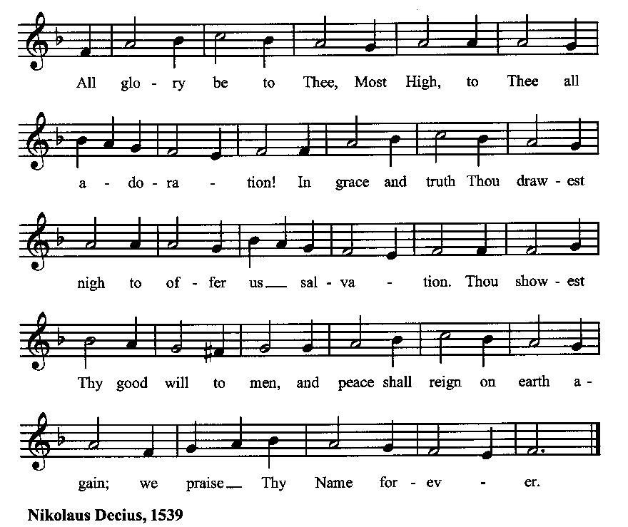

**The *Trisagion:***

**Minister:** Holy God, Holy and Mighty, Holy Immortal One,

**People:** *Have mercy upon us.*

**SERVICE OF THE WORD**

**Mutual Invocation of the Grace of God for the Service of the Word:**

**Minister:** The Lord be with you.

**People:** *And also with you.* **(The people then be seated.)**

**Old Testament Lesson (the people sitting):**

**Reader:** The Old Testament lesson is written in the seventeenth chapter of the book of the prophet Jeremiah, beginning at verse 5:

1. Thus says the Lord: “Cursed is the man who trusts in man and makes flesh his strength, whose heart turns away from the Lord.
2. He is like a shrub in the desert, and shall not see any good come. He shall dwell in the parched places of the wilderness, in an uninhabited salt land.
3. “Blessed is the man who trusts in the Lord, whose trust is the Lord.
4. He is like a tree planted by water, that sends out its roots by the stream, and does not fear when heat comes, for its leaves remain green, and is not anxious in the year of drought, for it does not cease to bear fruit.”
5. The heart is deceitful above all things, and desperately sick; who can understand it?
6. “I the Lord search the heart and test the mind, to give every man according to his ways, according to the fruit of his deeds.” (ESV)

**Reader:** The Word of the Lord.

**People:** *Thanks be to God.*

**The Psalm: (The people sit for the responsive reading, by half-verse, of Psalm 1, a song praising God’s care for the righteous.)**

**Reader:** The Psalm is chapter 1, beginning at verse 1.

**Reader:** 1 Happy are they who have not walked in the counsel of the wicked,

**People:** nor lingered in the way of sinners, nor sat in the seats of the scornful!

**Reader:** 2 Their delight is in the law of the Lord,

**People:** *and they meditate on his law day and night.*

**Reader:** 3 They are like trees planted by streams of water, bearing fruit in due season, with leaves that do not wither;

**People:** *everything they do shall prosper.*

**Reader:** 4 It is not so with the wicked;

**People:** *they are like chaff which the wind blows away.*

**Reader:** 5 Therefore the wicked shall not stand upright when judgment comes,

**People:** *nor the sinner in the council of the righteous.*

**Reader:** 6 For the Lord knows the way of the righteous,

**People:** *but the way of the wicked is doomed.* (BCP)

***Gloria Patri*:**

**Reader:** Glory be to the Father, and to the Son, and to the Holy Spirit.

**People:** *As it was in the beginning, is now and ever shall be, world without end. Amen.*

**Collect for the Sixth Sunday after Epiphany (the people sitting):**

**Minister:** O God, the strength of all those who put their trust in thee: Mercifully accept our prayers; and because, through the weakness of our moral nature, we can do no good thing without thee, grant us the help of thy grace, that in keeping thy commandments we ma please thee both in will and deed; through Jesus Christ our Lord, who lives and reigns with You, and the Holy Spirit, one God, now and for ever and ever.

**All:** *Amen.*

**The Epistle (the people sitting):**

**Reader:** The Epistle lesson is written in the fifteenth chapter of the first letter to the church in Corinth, beginning at verse 12:

1. Now if Christ is proclaimed as raised from the dead, how can some of you say that there is no resurrection of the dead?
2. But if there is no resurrection of the dead, then not even Christ has been raised.
3. And if Christ has not been raised, then our preaching is in vain and your faith is in vain.
4. We are even found to be misrepresenting God, because we testified about God that he raised Christ, whom he did not raise if it is true that the dead are not raised.
5. For if the dead are not raised, not even Christ has been raised.
6. And if Christ has not been raised, your faith is futile and you are still in your sins.
7. Then those also who have fallen asleep in Christ have perished.
8. If in Christ we have hope in this life only, we are of all people most to be pitied.
9. But in fact Christ has been raised from the dead, the firstfruits of those who have fallen asleep. (ESV)

**Reader:** Here ends the Epistle.

**People:** *Thanks be to God.*

**Sequence Hymn (all standing):**

*Joy is a Fruit That Will Not Grow*, vv. 1-2 (No. 347)

**The Gospel (all standing, and turning toward the Gospel reading):**

**Minister:** The holy Gospel is written in the sixth chapter of the Gospel according to Luke, beginning at verse 17:

**Minister:**

1. And he came down with them and stood on a level place, with a great crowd of his disciples and a great multitude of people from all Judea and Jerusalem and the seacoast of Tyre and Sidon,
2. who came to hear him and to be healed of their diseases. And those who were troubled with unclean spirits were cured.
3. And all the crowd sought to touch him, for power came out from him and healed them all.
4. And he lifted up his eyes on his disciples, and said: “Blessed are you who are poor, for yours is the kingdom of God.
5. “Blessed are you who are hungry now, for you shall be satisfied. “Blessed are you who weep now, for you shall laugh.
6. “Blessed are you when people hate you and when they exclude you and revile you and spurn your name as evil, on account of the Son of Man!
7. Rejoice in that day, and leap for joy, for behold, your reward is great in heaven; for so their fathers did to the prophets.
8. “But woe to you who are rich, for you have received your consolation.
9. “Woe to you who are full now, for you shall be hungry. “Woe to you who laugh now, for you shall mourn and weep.
10. “Woe to you, when all people speak well of you, for so their fathers did to the false prophets. (ESV)

**Minister:** The Gospel of the Lord.

**People:** *Praise to You, Lord Christ*.

**Sequence Hymn (all standing):**

*Joy is a Fruit That Will Not Grow*, v. 3 (No. 347)

[Elementary age children may exit for Children's Worship in the Parish Hall.

They will return to the service at the Passing of the Peace.]

**Minister:** Grace be unto you, and peace, from our Lord Jesus Christ.

**All:** *Amen.* **(The people then be seated.)**

**The Sermon**

**Minister:** In the name of the Father, and of the Son, and the Holy Spirit.

**Silence, for review of the sermon, and for meditative prayer**

**SERVICE OF THE TABLE: THE GREAT THANKSGIVING**

**The Nicene Creed (all standing):**

**Minister:** Let us confess our faith, saying:

**All:** *We believe in one God,*

*the Father, the Almighty,*

*maker of heaven and earth,*

*of all that is, seen and unseen.*

*We believe in one Lord, Jesus Christ,*

*the only Son of God,*

*eternally begotten of the Father,*

*God from God, Light from Light,*

*true God from true God,*

*begotten, not made,*

*of one Being with the Father.*

*Through him all things were made.*

*For us and for our salvation*

*he came down from heaven:*

*by the power of the Holy Spirit*

*he became incarnate from the Virgin Mary,*

*and was made man.*

*For our sake he was crucified under Pontius Pilate;*

*he suffered death and was buried.*

*On the third day he rose again*

*in accordance with the Scriptures;*

*he ascended into heaven*

*and is seated at the right hand of the Father.*

*He will come again in glory to judge the living and the dead,*

*and his kingdom will have no end.*

*We believe in the Holy Spirit, the Lord, the giver of life,*

*who proceeds from the Father and the Son.*

*With the Father and the Son he is worshiped and glorified.*

*He has spoken through the Prophets.*

*We believe in one holy catholic and apostolic Church.*

*We acknowledge one baptism for the forgiveness of sins.*

*We look for the resurrection of the dead,*

*and the life of the world to come.* *Amen.*

**Minister: (The people sitting)** Let us with gladness present the offerings and oblations of our life and labor to the Lord.

**Offertory:**

**Offering Hymn (all standing):**

*Praise God, from Whom All Blessings Flow* (No. 83)

**Minister:** All things come from You, O Lord.

**People:** *And of your own have we given You.*

**(The people then be seated.)**

**The Prayers of the People (the people sitting):**

**Minister:** Let us pray for the Church and the world. For the unity of the Church throughout the world, that we might faithfully preach the Gospel to the ends of the earth, let us pray to the Lord:

**People:** *Lord, hear our prayer.*

**Minister:** For the persecuted church, and for its persecutors, that You would turn their hearts, let us pray to the Lord:

**People:** *Lord, hear our prayer.*

**Minister:** For our President and all who govern and hold authority in our nation and in the world, let us pray to the Lord:

**People:** *Lord, hear our prayer.*

**Minister:** For the good earth which You have given us, and for the wisdom and will to conserve it, let us pray to the Lord:

**People:** *Lord, hear our prayer.*

**Minister:** For all ministers of your Gospel, that they might faithfully preach your Word, administer your sacraments, and care for your people, let us pray to the Lord:

**People:** *Lord, hear our prayer.*

**Minister:** For the peace of the world, that a spirit of respect and forbearance may grow among all nations and peoples, let us pray to the Lord:

**People:** *Lord, hear our prayer.*

**Minister:** For all those who do not yet believe, and for those who have lost their faith, that in due time we may all stand reconciled before You, let us pray to the Lord:

**People:** *Lord, hear our prayer.*

**Minister:** For the poor and the oppressed, prisoners and captives, the unemployed, and all who are in need or trouble, let us pray to the Lord:

**People:** *Lord, hear our prayer.*

**Minister:** For our enemies and all who wish us harm, and for all whom we have injured or offended, let us pray to the Lord:

**People:** *Lord, hear our prayer.*

**Minister:** For this congregation, that we might show forth your glory in all that we do; and for those who have commended themselves to our prayers, including these: _____________:

[Nation: Bolivia

Denomination: North American Baptist Churches

Congregation: Lancaster Evangelical Presbyterian Church, Lancaster, NY, and the Rev. Dr. Kelly Negus

Ministry: Youth With a Mission

Parishioners: Those living on Leisure Drive],

Grant that all of these may be delivered from anxiety, and live in joy, peace, and health.

*(Please add your own intentions, either silently or aloud.)*

**Minister:** Let us pray to the Lord:

**People:** *Lord, hear our prayer.*

**Minister:** We bless your holy Name for the thanksgivings of your people, including these: _________; for those in every generation in whom Christ has been honored;Give us grace to follow their good examples, that with them we may be partakers of your heavenly kingdom.

*(Please add your intentions, either silently or aloud.)*

**Minister:** Let us pray to the Lord:

**People:** *Lord, hear our prayer.*

**Collect (the people kneeling or sitting):**

**Minister:** Ever living God, whose will it is that all should come to You through your Son Jesus Christ: Inspire our witness to him, that all may know the power of his forgiveness and the hope of his resurrection; who lives and reigns with You and the Holy Spirit, one God, now and for ever.

**All:** *Amen*.

**Preparation for Holy Communion (the people sitting):**

**Minister:** The Lord’s Supper was ordained by God to be a means of conveying grace according to the need of each person. Those for whom it was ordained are all those who know and feel that they want the grace of God, to restrain them from sin, or to forgive their sins, or to assure them of pardon, or to renew their souls in the image of God, or to enter into the holy presence of God in communion with him. No preparation is indispensably necessary, other than a desire to receive the grace God pleases to give. No fitness or church membership is required at the time of communicating, other than a sense of our state, of our utter sinfulness and helplessness apart from Christ. Therefore, if you want such grace as God pleases to give to you, draw near with faith, and as you prepare to receive this holy sacrament to your comfort and strength, make your sincere confession to Almighty God, kneeling if you wish and are able, or otherwise sitting.

**The Prayer of Confession, Petition and Thanksgiving:**

**(The minister kneels, and the people kneel or sit.)**

**Minister:** Let us pray together:

**All:** *Almighty God, Father of our Lord Jesus Christ, Maker of all things, Judge of all persons: We have erred and strayed from your ways like lost sheep. We have followed too much the devices and desires of our own hearts. You have shown us the way of life through your Son, Jesus Christ. Where there is sin or falling short of your will in our lives, or any spiritual pride, carelessness or presumption on our part, or any failure to see or know your good and righteous will, we earnestly repent and are heartily sorry for our misdoings. Forgive us all that is past, grant that we may ever serve and please You in newness of life, and accept our thanksgiving for the wondrous grace and forgiveness You extend to us, to the honor and glory of your Name, through Jesus Christ our Lord. Amen.*

***Agnus Dei* (the people kneeling or sitting):**

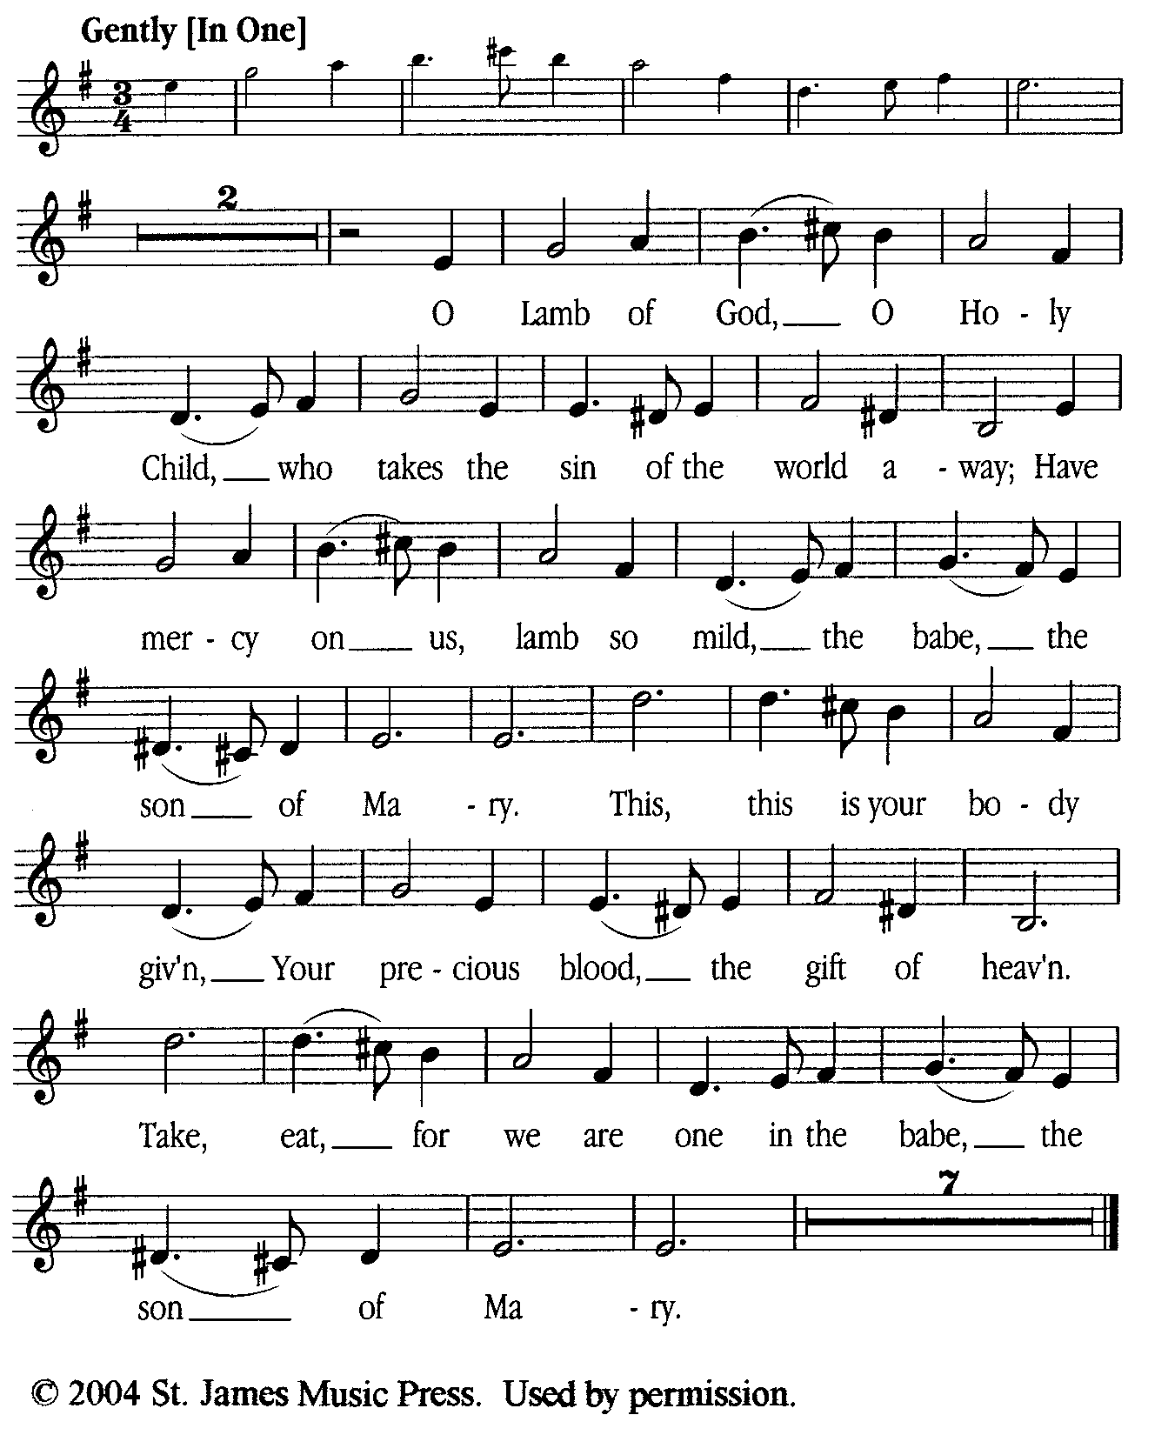

**Prayer for Absolution (the people kneeling or sitting):**

**Minister:** Almighty God, our heavenly Father, who of your great mercy has promised forgiveness of sins to all those who with hearty repentance and true faith turn unto You; Have mercy upon us; pardon and deliver us from all our sins, confirm and strengthen us in all goodness, and bring us to everlasting life, through Jesus Christ our Lord.

**All:** *Amen.*

**The Comforting Words of Forgiveness (the people sitting):**

**Minister:** Hear what comforting words our Savior Christ says to all who truly turn to him: Come to me, all you who are weary and carry heavy burdens, and I will give you rest. God so loved the world that he gave his only Son, so that everyone who believes in him will not perish but have eternal life. Hear also what St. Paul says: Christ Jesus came into the world to save sinners. Hear also what St. John says: If anyone sins, we have an Advocate with the Father, Jesus Christ the righteous: and he is the atonement for our sins.

**The Passing of the Peace:**

**Minister:** The peace of the Lord be always with you.

**People:** *And also with you.*

**Minister:** As the peace of Christ has been extended to you, extend the peace of the Lord to one another, and greet one another in the name of the Lord. **(The people rise and remain standing.)**

*(The people greet those near to them, saying, “The peace of the Lord be with you,” or, “Peace be with you,” or simply, “Peace.” They respond to one another, “And also with you,” or simply, “Peace”.)*

**Hymn of Entry Into the Heavenly Worship (all standing, singing):**

*Lift Up Your Hearts*  (No. 297)

**Preparation for the Table:**

**(Minister:** I wash my hands in innocence, and go about your altar, O LORD, proclaiming aloud your praise and telling of all your wonderful deeds.) [Psalm 26:6-7, NIV]

**The *Sursum Corda* (all standing):**

**Minister:** The Lord be with you.

**People:**  *And also with you.*

**Minister:** Lift up your hearts.

**People:** *We lift them up unto the Lord.*

**Minister:** Let us give thanks unto the Lord our God.

**People:** *It is meet and right so to do.*

**The Salutation:**

**Minister:** It is very meet, right, and our gladsome duty, that we should at all times, and in all places, give thanks unto You, O Lord, Holy Father, Almighty, Everlasting God,

**The Proper Preface:**

**Minister:** Because in the mystery of the Word made flesh, You have caused a new light to shine in our hearts, to give the knowledge of your glory in the face of your Son Jesus Christ our Lord.

**Minister:** Therefore, with Angels and Archangels and with all the company of heaven, we laud and magnify your glorious Name, evermore praising You and saying,

**The *Sanctus* (all standing, singing):**

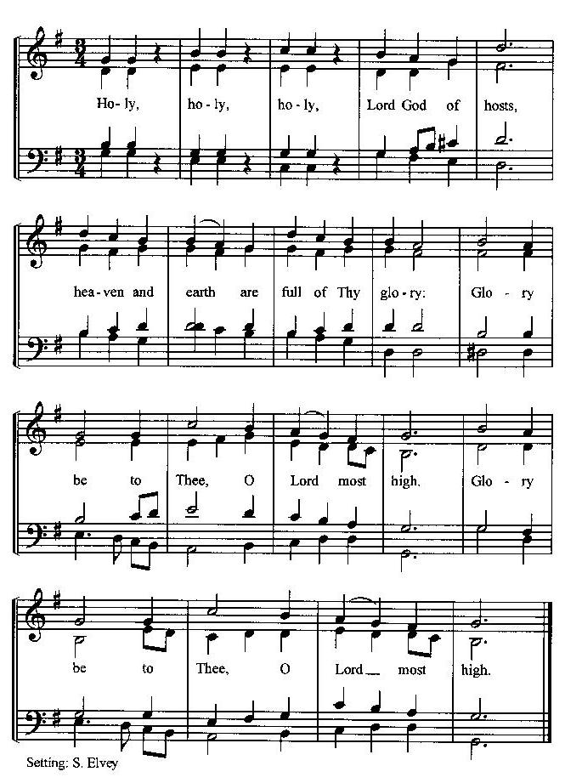

**The Prayer of Humble Access and for Cleansing**

**(the people kneeling or sitting):**

**Minister:** Let us pray together:

**All:** *We do not presume to come to this your table, O merciful Lord, trusting in our own righteousness, but in your many and great mercies. We are not worthy so much as to gather up the crumbs under your table. But You are the same Lord, whose nature is always to have mercy: Grant us, therefore, gracious Lord, so to experience the spiritual presence of your dear Son Jesus Christ at this your table, that we may be made clean by his body and blood, and that we may evermore dwell in him, and he in us. Deliver us, gracious Lord, from the presumption of coming to this table for solace for ourselves only, and not for strength to serve You and others. Deliver us, gracious Lord, from the presumption of coming to this table for pardon of our sins only, and not for transformation of our lives in your holiness. Amen.*

***Epiclesis* Prayer (Invocation of the Holy Spirit upon the Bread and Wine)**

**(the people kneeling or sitting):**

**Minister:** Holy and gracious Father, in your infinite love You made us for yourself; and, when we had fallen into sin and become subject to evil and death, You sent Jesus Christ, your only and eternal Son, to share our human nature, to live and die as one of us, to reconcile us to You, the God and Father of all. He stretched out his arms upon the cross and offered himself, in obedience to your will, a perfect sacrifice for the sins of the whole world. Recalling now his death, resurrection, and ascension, we offer You these gifts. Sanctify them by your Holy Spirit to be for us the Body and Blood of your Son, the holy food and drink of new and unending life in him. Sanctify us also, that we may faithfully receive this holy Sacrament, and serve You in unity, constancy, and peace; and at the last day bring us with all your saints into the joy of your eternal kingdom. We ask this through Jesus Christ, your Son, our Lord; through him, and with him, and in him, in the unity of the Holy Spirit, all honor and glory are yours, O Father Almighty, now and for ever.

**All:** *Amen.*

**The Words of Institution (the people kneeling or sitting):**

**Minister:** Our Lord Jesus Christ, on the night that he was betrayed took bread; and when he had given thanks, he broke it, and gave it to his disciples, saying, Take, eat; this is my Body which is given for you: Do this in remembrance of me.

Likewise, after supper, he took the cup; and when he had given thanks, he gave it to them, saying, Drink this, all of you; for this is my blood of the New Testament, which is shed for you, and for many, for the remission of sins: Do this, as often as you shall drink it, in remembrance of me.

**All:** *Amen.*

**The Acclamation:**

**Minister:** Therefore, we proclaim the mystery of faith:

**People:** *Christ has died, Christ is risen, Christ will come again.*

**The Fraction:**

**Minister:** Christ our passover is sacrificed for us.

**People:** *Therefore let us keep the feast.*

**Fraction Anthem (the people kneeling or sitting, singing):**

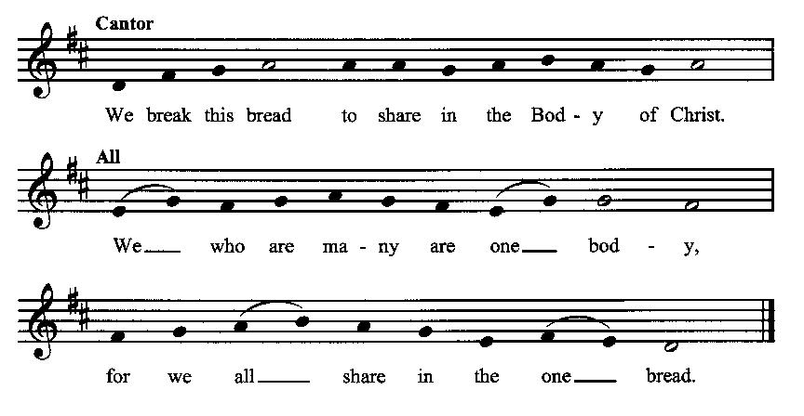

**Minister:** The gifts of God for the people of God. Take them in remembrance that Christ died for you and rose again, and feed on him in your hearts by faith with thanksgiving.

**Communion Hymn (cantors only, the people kneeling or sitting):**

“Although our eyes in sleep be closed, let hearts in constant vigil watch; with your right hand you will protect those who believe and trust in you.

Defender of us all, look down; repel our dread, malicious foe; direct your faithful household, Lord, whom you have purchased with your blood.” (O Christ, You Are Both Light and Day, vv. 3-4, Latin, 6th Century)

*After the minister(s) and acolyte(s) are served, the people come forward to receive, as space is available. The people kneel if they are able, or stand.* **Communion by intincture: The people receive the Bread in their open hands, continue to hold it, then dip the Bread in the cup, and then consume.** *They return to their seats via the side aisles.*)

**Renewal of the Mutual Invocation of God’s Grace for the Eucharist:**

**Minister:** The Lord be with you.

**People:** *And also with you.*

**The Prayer of Thanksgiving and Living Sacrifice:**

**(The minister kneeling, the people kneeling or sitting):**

**Minister:** Let us pray together:

**All:** *O Lord and Heavenly Father, we heartily thank You because You feed us, in these holy mysteries, with the spiritual food of the most precious Body and Blood of your Son our Savior Jesus Christ; because by this You assure us of your favor and goodness toward us; because we are living members of the body of your Son and heirs of your eternal kingdom. We ask You to accept this our sacrifice of praise and thanksgiving, and to grant that by the merits and death of your Son Jesus Christ and through faith in him, we and all your whole Church may obtain all of the benefits of his passion. And here we offer and present unto You, O Lord, ourselves, our souls and bodies, to be a reasonable, holy, and living sacrifice unto You; humbly asking You that we may be filled with your grace and heavenly benediction; through Jesus Christ our Lord; by whom, and with whom, in the Unity of the Holy Spirit, all honor and glory be unto You, O Father Almighty, world without end. Amen.* **(The people stand.)**

**ACTS OF DISMISSAL**

**The *Gloria* Prayer of Praise and Thanksgiving (all standing):**

**Minister:** Let us pray together:

**All:** *Glory be to God on high, and on earth peace, good-will toward all people. We praise You, we bless You, we worship You, we glorify You, we give thanks to You for your great glory, O Lord God, heavenly King, God the Father Almighty.**For You only are the Holy One, You only are the Lord, You only, O Christ, with the Holy Spirit, are most high in the glory of God the Father. Amen.*

**Recessional Hymn (all standing):**

*How Firm a Foundation* (No. 307)

**The Prayer of Benediction:**

**Minister:** May the Daystar from on High shine upon you, guiding your feet into the way of peace; and may the blessing of God Almighty, the Father, the Son, and the Holy Spirit, be among you, and remain with you always.

**All:** *Amen.*

**Minister:** Let us go forth in peace, walking as children of the Light.

**People:** *Thanks be to God.*

**(The people then be seated.)**

**Greetings and Announcements**

**Postlude:**

**(The people sit and remain quiet until the candles are extinguished and the organ raises its voice.)**

*____*___________________________________________

Based on, and freely adapted from,

John Wesley’s *Order for the Administration of the Lord’s Supper*,

the 1662 and 1979 editions of *The Book of Common Prayer,* and

*Common Worship: Services and Prayers for the Church of England*

*_________________________*___________________________

**Scripture Lessons for February 23 (Seventh Sunday after the Epiphany):**

Genesis 45:1-11, 15; Psalm 37:1-12, 41-42; 1 Corinthians 15:35-38, 42-50; Luke 6:27-38

**Parish Prayer for This Week and Next Sunday**

Those living on Liberty Road

_______________________________

**Parish Notices**

**Do you know someone who would make a good library intern?**

We are offering a free place to stay (a bedroom and bathroom upstairs in the Wesley House) to someone who will serve as our library intern/caretaker. If you know someone who could run the library during open hours (8-noon), and do so as an ambassador of Epworth, please make a connection.

**Wesley House Grand Opening!**

The grand opening of the Wesley House will be held 28 February – 2 March. The schedule of events is as follows:

Friday, 28 FEB: Community Dinner catered by Luciano’s at 6 pm

Friday, 28 FEB: Movie & Popcorn (*The Chosen*) at 7 pm

Saturday, 1 MAR: Service of Dedication at 3 pm (Guest speaker:

Superintendent Michael Traylor)

Immediately following: Open house with refreshments (library open

for business)

Sunday, 2 MAR: Service of Word & Table at 10 am

Sunday, 2 MAR: Renewing Worship Service at 4 pm

**Library Open to the Public**

The Epworth Library will be open to the public starting Tuesday, March 4th, 8 am – noon. For now, that will be the hours of operation, Tuesday – Saturday. This schedule may change after we get a better picture of public interest.

**Shrove Tuesday Pancake Dinner!**

The day before Ash Wednesday is our traditional Shrove Tuesday pancake dinner. This is one of the few times of the year we gather to simply have fun! The dinner will be at 6 pm on March 4th. Bring a friend and your appetite! There will be silly pancake-related games for the kids (and those who want to feel like a kid again).

**Worship with Imposition of Ashes**

Lent begins with Ash Wednesday on March 5th. The beginning date for Lent is determined by counting back 6 ½ weeks from Easter, which will be April 20th. Ashes are a biblical symbol of repentance and grief (Job sat in ashes, as did the king of Nineveh after hearing Jonah’s message). The sign of the cross is a reminder to Christians to follow the example of Jesus. On Ash Wednesday, the symbol of the cross and ashes come together to mark the beginning of Lent as a time of intense spiritual reflection and renewal.

**Coming Events at Epworth**

Today, 10:00 am Word & Table Service

Today, 11:40 Afterword (moderated

discussion)

Tuesday Board Meeting (6:30)

Thursday Evening & Healing Prayers

(7 pm)

Friday, 28 FEB Community Dinner (6 pm)

Saturday, 1 MAR Dedication Service for new

Parish Hall (followed by

open house)

Sunday, 2 MAR Kick-off for Renewing

Worship service (4 pm)

Tuesday, 4 MAR Shrove Tuesday Pancake

Dinner (6 pm)

Wednesday, 5 MAR Ash Wednesday service (7

pm)

**February Birthdays & Anniversaries**

04 – Bryan Vanshur

04 – Carol Crosswhite

10 – Sheila Ross

24 – Elijah Graham

26 – Mindy Crow

**Sermon Notes**

**Epworth Church Office Email**

[epworthchapel.office@gmail.com](mailto:epworthchapel.office@gmail.com)

All correspondence for the office should be sent to this email address.

**Pastor Crow Contact Information**

***Healing prayer is provided every week upon request***

Rev. John Crow, Rector and Pastor

208-501-4037

[rector@epworthchapelonthegreen.org](mailto:rector@epworthchapelonthegreen.org)