**Service of Word and Table**

at

**Epworth Free Methodist Church**

6110 W. Northview Street, Boise, Idaho 83704

208-336-3951

[www.epworthfmc.org](http://www.epworthfmc.org)

The Rev. John Crow, Rector and Pastor

208-501-4037

**January 19, 2025, 10:00 a.m.**

*Second Sunday after Epiphany*



*_____*__________________________

**“Through the deep current of the historical Wesleyan church we will collaboratively serve and reach the lost in order to make disciples who love Jesus.”**

*____*___________________________

This service will be live streamed, and in the course of that any or all persons who attend may be filmed. Remaining in the service will constitute your consent to appear in the live-streamed, recorded, and published service.

*____*___________________________

**Rector and Pastor:** The Rev. John Crow

**Cantors:** Bryan Vanshur, Shannon Nichols

**Readers:**

**Old Testament:** Donna Crow

**Psalm:** Donna Crow

**Epistle:** Stephen Crow

**Acolytes:** Stephen Crow, Josiah Crow, Corbin Crosswhite, and Jessica Crosswhite

**Jr. Acolytes:** Asher Crow & Lizzie Crosswhite

**Usher:** Asher Crow

___________________________________________________

**ACTS OF ENTRANCE**

**Prélude**

**(The people enter and remain in prayer and meditation.)**

**Entrance canticle (cantor only):**

“How bright appears the Morning Star, with mercy beaming from afar; the host of heaven rejoices; O righteous Branch, O Jesse’s Rod! Thou Son of Man and Son of God! We, too, will lift our voices: Jesus, Jesus! Holy, Holy, yet most lowly, draw thou near us; great Emmanuel, come and hear us.” (*How Bright Appears the Morning Star*, v. 1, Philipp Nicolai)

**Processional Hymn (all standing):**

*Joyful, Joyful, We Adore Thee*  (No. 181)

**The Salutation:**

**Minister:** Blessed be God: Father, Son, and Holy Spirit.

**People:** *And blessed be his kingdom, now and forever.*

**Lord’s Prayer:**

**Minister:** Let us pray.

**(All standing):** *Our Father, who art in heaven, hallowed be thy Name. Thy kingdom come. Thy will be done, on earth as it is in heaven. Give us this day our daily bread. And forgive us our trespasses, as we forgive those who trespass against us. And lead us not into temptation, but deliver us from evil, for thine is the kingdom, and the power, and the glory, for ever and ever.* *Amen.*

**The Collect for Purity:**

**Minister:** Almighty God, unto whom all hearts are open, all desires known, and from whom no secrets are hid; cleanse the thoughts of our hearts by the inspiration of your Holy Spirit, that we may perfectly love You, and worthily magnify your holy Name, through Christ our Lord.

**All:** *Amen.*

**The *Gloria*: (all standing, singing):**

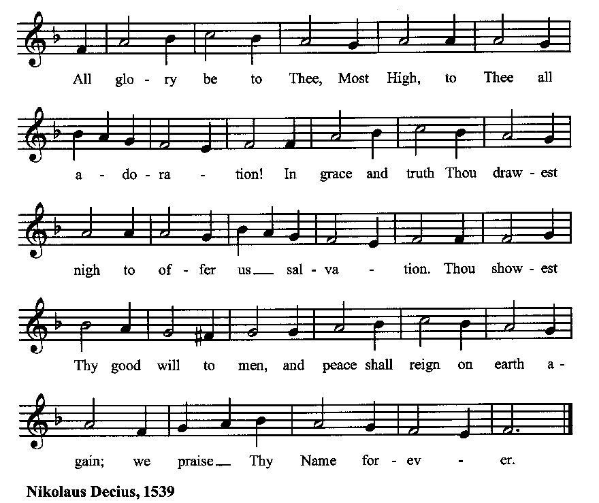

**The *Trisagion:***

**Minister:** Holy God, Holy and Mighty, Holy Immortal One,

**People:** *Have mercy upon us.*

**SERVICE OF THE WORD**

**Mutual Invocation of the Grace of God for the Service of the Word:**

**Minister:** The Lord be with you.

**People:** *And also with you.* **(The people then be seated.)**

**Old Testament Lesson (the people sitting):**

**Reader:** The Old Testament lesson is written in the sixty-second chapter of the book of the prophet Isaiah, beginning at verse 1:

1. For Zion's sake I will not keep silent, and for Jerusalem's sake I will not be quiet, until her righteousness goes forth as brightness, and her salvation as a burning torch.
2. The nations shall see your righteousness, and all the kings your glory, and you shall be called by a new name that the mouth of the Lord will give.
3. You shall be a crown of beauty in the hand of the Lord, and a royal diadem in the hand of your God.
4. You shall no more be termed Forsaken, and your land shall no more be termed Desolate, but you shall be called My Delight Is in Her, and your land Married; for the Lord delights in you, and your land shall be married.
5. For as a young man marries a young woman, so shall your sons marry you, and as the bridegroom rejoices over the bride, so shall your God rejoice over you. (ESV)

**Reader:** The Word of the Lord.

**People:** *Thanks be to God.*

**The Psalm: (The people sit for the responsive reading, by half-verse, a portion of Psalm 36, a song recounting God’s love and faithfulness.)**

**Reader:** The Psalm is chapter 36, beginning at verse 5.

**Reader:** 5 Your love, O Lord, reaches to the heavens,

**People:** *and your faithfulness to the clouds.*

**Reader:** 6 Your righteousness is like the strong mountains, your justice like the great deep;

**People:** *you save both man and beast, O Lord.*

**Reader:** 7 How priceless is your love, O God!

**People:** *your people take refuge under the shadow of your wings.*

**Reader:** 8 They feast upon the abundance of your house;

**People:** *you give them drink from the river of your delights.*

**Reader:** 9 For with you is the well of life,

**People:** *and in your light we see light.*

**Reader:** 10 Continue your loving-kindness to those who know you,

**People:** *and your favor to those who are true of heart*.(BCP)

***Gloria Patri*:**

**Reader:** Glory be to the Father, and to the Son, and to the Holy Spirit.

**People:** *As it was in the beginning, is now and ever shall be, world without end. Amen.*

**Collect for the Second Sunday after Epiphany (the people sitting):**

**Minister:** Almighty God, whose Son our Savior Jesus Christ is the Light of the world: Grant that your people, illumined by your Word and Sacraments, may shine with the radiance of Christ’s glory, that he may be known, worshiped, and obeyed to the ends of the earth; through Jesus Christ our Lord, who with You and the Holy Spirit lives and reigns, one God, now and for ever.

**All:** *Amen.*

**The Epistle (the people sitting):**

**Reader:** The Epistle lesson is written in the twelfth chapter of the first letter to the church in Corinth, beginning at verse 1:

1. Now concerning spiritual gifts, brothers, I do not want you to be uninformed.
2. You know that when you were pagans you were led astray to mute idols, however you were led.
3. Therefore I want you to understand that no one speaking in the Spirit of God ever says “Jesus is accursed!” and no one can say “Jesus is Lord” except in the Holy Spirit.
4. Now there are varieties of gifts, but the same Spirit;
5. and there are varieties of service, but the same Lord;
6. and there are varieties of activities, but it is the same God who empowers them all in everyone.
7. To each is given the manifestation of the Spirit for the common good.
8. For to one is given through the Spirit the utterance of wisdom, and to another the utterance of knowledge according to the same Spirit,
9. to another faith by the same Spirit, to another gifts of healing by the one Spirit,
10. to another the working of miracles, to another prophecy, to another the ability to distinguish between spirits, to another various kinds of tongues, to another the interpretation of tongues.
11. All these are empowered by one and the same Spirit, who apportions to each one individually as he wills. (ESV)

**Reader:** Here ends the Epistle.

**People:** *Thanks be to God.*

**Sequence Hymn (all standing):**

*The Fish in Wave, the Bird on Wing*, vv. 1-2 (No. 95)

**The Gospel (all standing, and turning toward the Gospel reading):**

**Minister:** The holy Gospel is written in the second chapter of the Gospel according to John, beginning at verse 1:

**Minister:**

1. 1 On the third day there was a wedding at Cana in Galilee, and the mother of Jesus was there.
2. Jesus also was invited to the wedding with his disciples.
3. When the wine ran out, the mother of Jesus said to him, “They have no wine.”
4. And Jesus said to her, “Woman, what does this have to do with me? My hour has not yet come.”
5. His mother said to the servants, “Do whatever he tells you.”
6. Now there were six stone water jars there for the Jewish rites of purification, each holding twenty or thirty gallons.
7. Jesus said to the servants, “Fill the jars with water.” And they filled them up to the brim.
8. And he said to them, “Now draw some out and take it to the master of the feast.” So they took it.
9. When the master of the feast tasted the water now become wine, and did not know where it came from (though the servants who had drawn the water knew), the master of the feast called the bridegroom
10. and said to him, “Everyone serves the good wine first, and when people have drunk freely, then the poor wine. But you have kept the good wine until now.”
11. This, the first of his signs, Jesus did at Cana in Galilee, and manifested his glory. And his disciples believed in him. (ESV)

**Minister:** The Gospel of the Lord.

**People:** *Praise to You, Lord Christ*.

**Sequence Hymn (all standing):**

*The Fish in Wave, the Bird on Wing*, vv. 3-4 (No. 95)

[Elementary age children may exit for Children's Worship in the Parish Hall.

They will return to the service at the Passing of the Peace.]

**Minister:** Grace be unto you, and peace, from our Lord Jesus Christ.

**All:** *Amen.* **(The people then be seated.)**

**The Sermon**

**Minister:** In the name of the Father, and of the Son, and the Holy Spirit.

**Silence, for review of the sermon, and for meditative prayer**

**SERVICE OF THE TABLE: THE GREAT THANKSGIVING**

**The Nicene Creed (all standing):**

**Minister:** Let us confess our faith, saying:

**All:** *We believe in one God,*

*the Father, the Almighty,*

*maker of heaven and earth,*

*of all that is, seen and unseen.*

*We believe in one Lord, Jesus Christ,*

*the only Son of God,*

*eternally begotten of the Father,*

*God from God, Light from Light,*

*true God from true God,*

*begotten, not made,*

*of one Being with the Father.*

*Through him all things were made.*

*For us and for our salvation*

*he came down from heaven:*

*by the power of the Holy Spirit*

*he became incarnate from the Virgin Mary,*

*and was made man.*

*For our sake he was crucified under Pontius Pilate;*

*he suffered death and was buried.*

*On the third day he rose again*

*in accordance with the Scriptures;*

*he ascended into heaven*

*and is seated at the right hand of the Father.*

*He will come again in glory to judge the living and the dead,*

*and his kingdom will have no end.*

*We believe in the Holy Spirit, the Lord, the giver of life,*

*who proceeds from the Father and the Son.*

*With the Father and the Son he is worshiped and glorified.*

*He has spoken through the Prophets.*

*We believe in one holy catholic and apostolic Church.*

*We acknowledge one baptism for the forgiveness of sins.*

*We look for the resurrection of the dead,*

*and the life of the world to come.* *Amen.*

**Minister: (The people sitting)** Let us with gladness present the offerings and oblations of our life and labor to the Lord.

**Offertory:**

**Offering Hymn (all standing):**

*Praise God, from Whom All Blessings Flow* (No. 83)

**Minister:** All things come from You, O Lord.

**People:** *And of your own have we given You.*

**(The people then be seated.)**

**The Prayers of the People (the people sitting):**

**Minister:** Let us pray for the Church and the world. For the unity of the Church throughout the world, that we might faithfully preach the Gospel to the ends of the earth, let us pray to the Lord:

**People:** *Lord, hear our prayer.*

**Minister:** For the persecuted church, and for its persecutors, that You would turn their hearts, let us pray to the Lord:

**People:** *Lord, hear our prayer.*

**Minister:** For our President and all who govern and hold authority in our nation and in the world, let us pray to the Lord:

**People:** *Lord, hear our prayer.*

**Minister:** For the good earth which You have given us, and for the wisdom and will to conserve it, let us pray to the Lord:

**People:** *Lord, hear our prayer.*

**Minister:** For all ministers of your Gospel, that they might faithfully preach your Word, administer your sacraments, and care for your people, let us pray to the Lord:

**People:** *Lord, hear our prayer.*

**Minister:** For the peace of the world, that a spirit of respect and forbearance may grow among all nations and peoples, let us pray to the Lord:

**People:** *Lord, hear our prayer.*

**Minister:** For all those who do not yet believe, and for those who have lost their faith, that in due time we may all stand reconciled before You, let us pray to the Lord:

**People:** *Lord, hear our prayer.*

**Minister:** For the poor and the oppressed, prisoners and captives, the unemployed, and all who are in need or trouble, let us pray to the Lord:

**People:** *Lord, hear our prayer.*

**Minister:** For our enemies and all who wish us harm, and for all whom we have injured or offended, let us pray to the Lord:

**People:** *Lord, hear our prayer.*

**Minister:** For this congregation, that we might show forth your glory in all that we do; and for those who have commended themselves to our prayers, including these: _____________:

[Nation: Belgium

Denomination: Military Chapels

Congregation: Riverside Baptist Church, Elizabeth City, NC, and the Rev. Jason Davis

Ministry: Jews for Jesus

Parishioners: Those living on Fisk Lane],

Grant that all of these may be delivered from anxiety, and live in joy, peace, and health.

*(Please add your own intentions, either silently or aloud.)*

**Minister:** Let us pray to the Lord:

**People:** *Lord, hear our prayer.*

**Minister:** We bless your holy Name for the thanksgivings of your people, including these: _________; for those in every generation in whom Christ has been honored;Give us grace to follow their good examples, that with them we may be partakers of your heavenly kingdom.

*(Please add your intentions, either silently or aloud.)*

**Minister:** Let us pray to the Lord:

**People:** *Lord, hear our prayer.*

**Collect (the people kneeling or sitting):**

**Minister:** Almighty God, grant that the words which we have heard this day with our outward ears, may, through your grace, be so grafted inwardly in our hearts, that they may bring forth in us the fruit of good living, to the honor and praise of your Name; through Jesus Christ our Lord. Almighty God, who hast given us this good land for our heritage: We humbly beseech thee that we may always prove ourselves a people mindful of thy favor and glad to do thy will. Bless our land, save us from violence, discord, and confusion; from pride and arrogance, and from every evil way. Defend our liberties, and fashion into one united people the multitudes brought hither out of many kindreds and tongues. Endue with the spirit of wisdom those to whom in thy Name we entrust the authority of government, that there may be justice and peace at home, and that, through obedience to thy law, we may show forth thy praise among the nations of the earth; all which we ask through Jesus Christ our Lord.

**All:** *Amen*.

**Preparation for Holy Communion (the people sitting):**

**Minister:** The Lord’s Supper was ordained by God to be a means of conveying grace according to the need of each person. Those for whom it was ordained are all those who know and feel that they want the grace of God, to restrain them from sin, or to forgive their sins, or to assure them of pardon, or to renew their souls in the image of God, or to enter into the holy presence of God in communion with him. No preparation is indispensably necessary, other than a desire to receive the grace God pleases to give. No fitness or church membership is required at the time of communicating, other than a sense of our state, of our utter sinfulness and helplessness apart from Christ. Therefore, if you want such grace as God pleases to give to you, draw near with faith, and as you prepare to receive this holy sacrament to your comfort and strength, make your sincere confession to Almighty God, kneeling if you wish and are able, or otherwise sitting.

**The Prayer of Confession, Petition and Thanksgiving:**

**(The minister kneels, and the people kneel or sit.)**

**Minister:** Let us pray together:

**All:** *Almighty God, Father of our Lord Jesus Christ, Maker of all things, Judge of all persons: We have erred and strayed from your ways like lost sheep. We have followed too much the devices and desires of our own hearts. You have shown us the way of life through your Son, Jesus Christ. Where there is sin or falling short of your will in our lives, or any spiritual pride, carelessness or presumption on our part, or any failure to see or know your good and righteous will, we earnestly repent and are heartily sorry for our misdoings. Forgive us all that is past, grant that we may ever serve and please You in newness of life, and accept our thanksgiving for the wondrous grace and forgiveness You extend to us, to the honor and glory of your Name, through Jesus Christ our Lord. Amen.*

***Agnus Dei* (the people kneeling or sitting):**

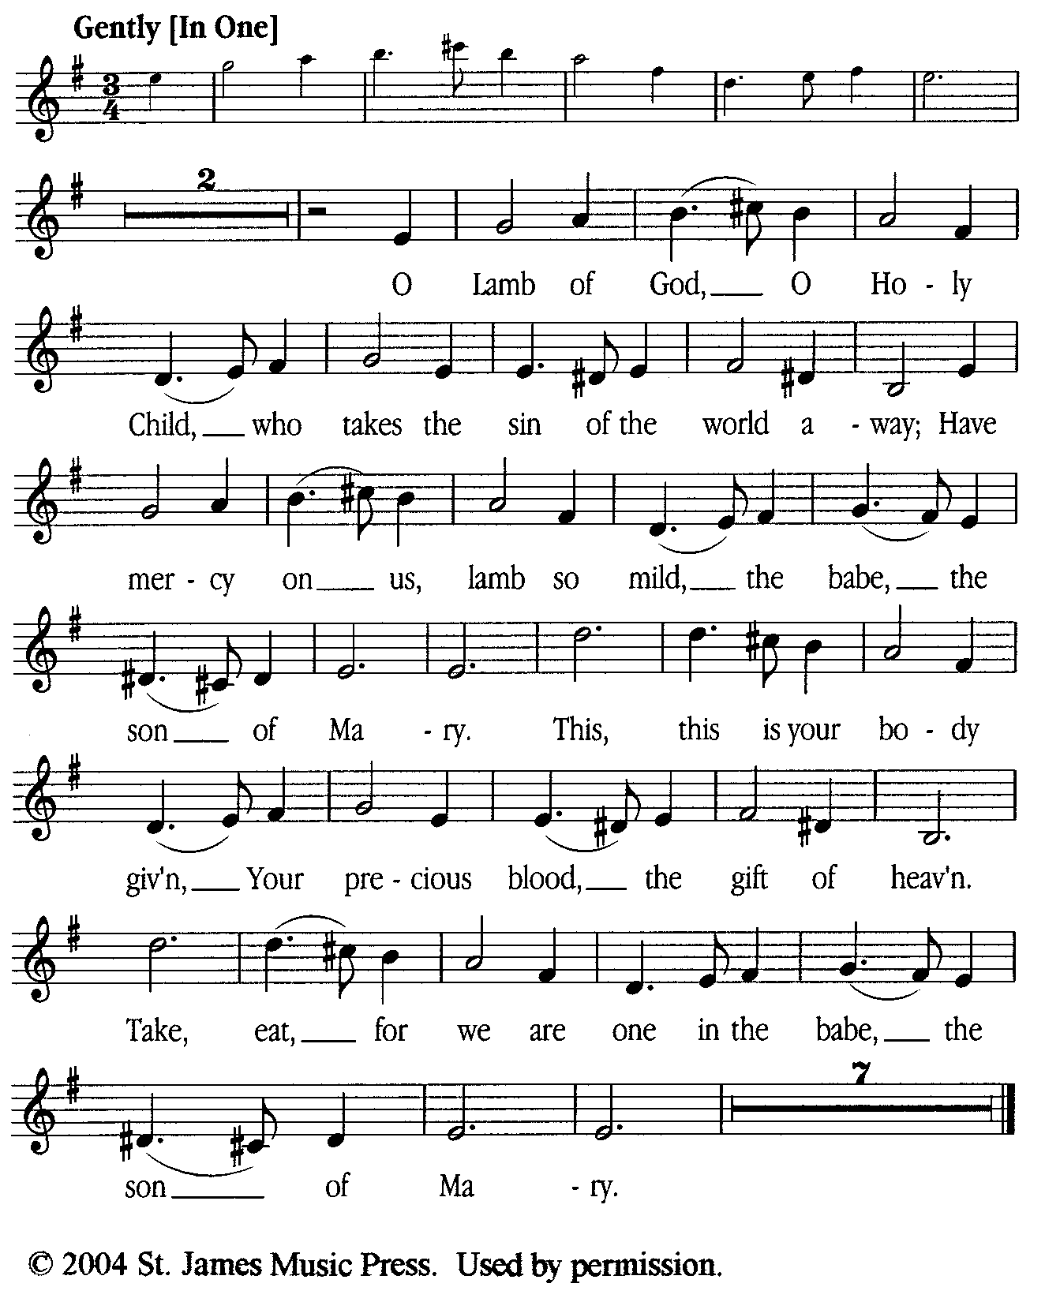

**Prayer for Absolution (the people kneeling or sitting):**

**Minister:** Almighty God, our heavenly Father, who of your great mercy has promised forgiveness of sins to all those who with hearty repentance and true faith turn unto You; Have mercy upon us; pardon and deliver us from all our sins, confirm and strengthen us in all goodness, and bring us to everlasting life, through Jesus Christ our Lord.

**All:** *Amen.*

**The Comforting Words of Forgiveness (the people sitting):**

**Minister:** Hear what comforting words our Savior Christ says to all who truly turn to him: Come to me, all you who are weary and carry heavy burdens, and I will give you rest. God so loved the world that he gave his only Son, so that everyone who believes in him will not perish but have eternal life. Hear also what St. Paul says: Christ Jesus came into the world to save sinners. Hear also what St. John says: If anyone sins, we have an Advocate with the Father, Jesus Christ the righteous: and he is the atonement for our sins.

**The Passing of the Peace:**

**Minister:** The peace of the Lord be always with you.

**People:** *And also with you.*

**Minister:** As the peace of Christ has been extended to you, extend the peace of the Lord to one another, and greet one another in the name of the Lord. **(The people rise and remain standing.)**

*(The people greet those near to them, saying, “The peace of the Lord be with you,” or, “Peace be with you,” or simply, “Peace.” They respond to one another, “And also with you,” or simply, “Peace”.)*

**Hymn of Entry Into the Heavenly Worship (all standing, singing):**

*We Come as Guests Invited*  (No. 91)

**Preparation for the Table:**

**(Minister:** I wash my hands in innocence, and go about your altar, O LORD, proclaiming aloud your praise and telling of all your wonderful deeds.) [Psalm 26:6-7, NIV]

**The *Sursum Corda* (all standing):**

**Minister:** The Lord be with you.

**People:**  *And also with you.*

**Minister:** Lift up your hearts.

**People:** *We lift them up unto the Lord.*

**Minister:** Let us give thanks unto the Lord our God.

**People:** *It is meet and right so to do.*

**The Salutation:**

**Minister:** It is very meet, right, and our gladsome duty, that we should at all times, and in all places, give thanks unto You, O Lord, Holy Father, Almighty, Everlasting God,

**The Proper Preface:**

**Minister:** Because in the mystery of the Word made flesh, You have caused a new light to shine in our hearts, to give the knowledge of your glory in the face of your Son Jesus Christ our Lord.

**Minister:** Therefore, with Angels and Archangels and with all the company of heaven, we laud and magnify your glorious Name, evermore praising You and saying,

**The *Sanctus* (all standing, singing):**

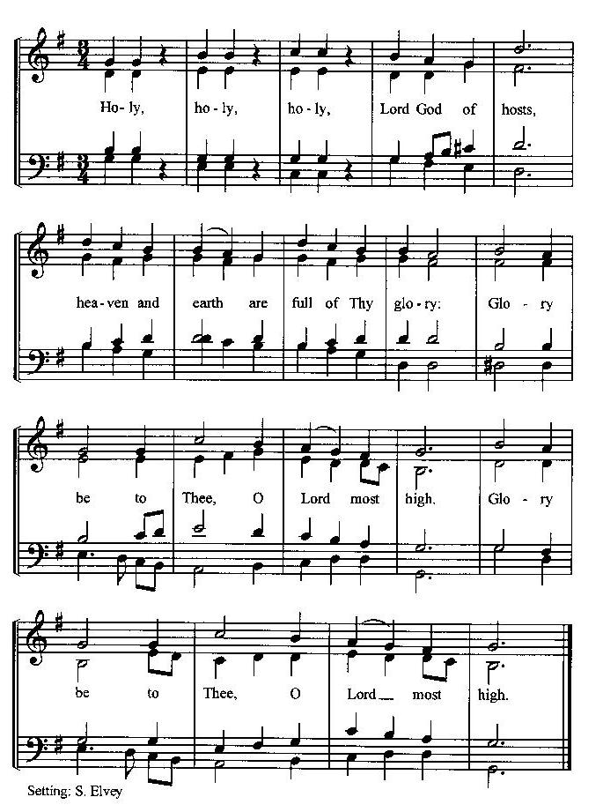

**The Prayer of Humble Access and for Cleansing**

**(the people kneeling or sitting):**

**Minister:** Let us pray together:

**All:** *We do not presume to come to this your table, O merciful Lord, trusting in our own righteousness, but in your many and great mercies. We are not worthy so much as to gather up the crumbs under your table. But You are the same Lord, whose nature is always to have mercy: Grant us, therefore, gracious Lord, so to experience the spiritual presence of your dear Son Jesus Christ at this your table, that we may be made clean by his body and blood, and that we may evermore dwell in him, and he in us. Deliver us, gracious Lord, from the presumption of coming to this table for solace for ourselves only, and not for strength to serve You and others. Deliver us, gracious Lord, from the presumption of coming to this table for pardon of our sins only, and not for transformation of our lives in your holiness. Amen.*

***Epiclesis* Prayer (Invocation of the Holy Spirit upon the Bread and Wine)**

**(the people kneeling or sitting):**

**Minister:** Holy and gracious Father, in your infinite love You made us for yourself; and, when we had fallen into sin and become subject to evil and death, You sent Jesus Christ, your only and eternal Son, to share our human nature, to live and die as one of us, to reconcile us to You, the God and Father of all. He stretched out his arms upon the cross and offered himself, in obedience to your will, a perfect sacrifice for the sins of the whole world. Recalling now his death, resurrection, and ascension, we offer You these gifts. Sanctify them by your Holy Spirit to be for us the Body and Blood of your Son, the holy food and drink of new and unending life in him. Sanctify us also, that we may faithfully receive this holy Sacrament, and serve You in unity, constancy, and peace; and at the last day bring us with all your saints into the joy of your eternal kingdom. We ask this through Jesus Christ, your Son, our Lord; through him, and with him, and in him, in the unity of the Holy Spirit, all honor and glory are yours, O Father Almighty, now and for ever.

**All:** *Amen.*

**The Words of Institution (the people kneeling or sitting):**

**Minister:** Our Lord Jesus Christ, on the night that he was betrayed took bread; and when he had given thanks, he broke it, and gave it to his disciples, saying, Take, eat; this is my Body which is given for you: Do this in remembrance of me.

Likewise, after supper, he took the cup; and when he had given thanks, he gave it to them, saying, Drink this, all of you; for this is my blood of the New Testament, which is shed for you, and for many, for the remission of sins: Do this, as often as you shall drink it, in remembrance of me.

**All:** *Amen.*

**The Acclamation:**

**Minister:** Therefore, we proclaim the mystery of faith:

**People:** *Christ has died, Christ is risen, Christ will come again.*

**The Fraction:**

**Minister:** Christ our passover is sacrificed for us.

**People:** *Therefore let us keep the feast.*

**Fraction Anthem (the people kneeling or sitting, singing):**

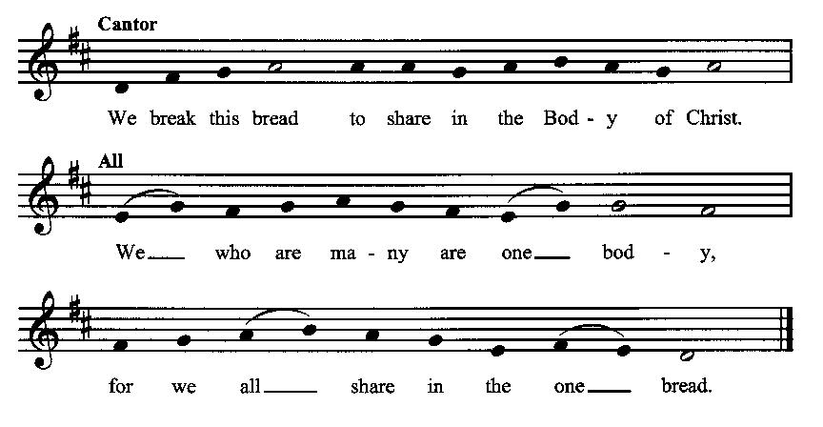

**Minister:** The gifts of God for the people of God. Take them in remembrance that Christ died for you and rose again, and feed on him in your hearts by faith with thanksgiving.

**Communion Hymn (cantors only, the people kneeling or sitting):**

“Though circled by the hosts on high, he deigned to cast a pitying eye upon his helpless creature; the whole creation’s Head and Lord, by highest seraphim adored, assumed our very nature; Jesus, grant us, through thy merit, to inherit thy salvation; hear, O hear our supplication.

“Rejoice, ye heaven; thou earth, reply; with praise, ye sinners, fill the sky, for this his Incarnation. Incarnate God, put forth thy power, ride on, ride on, great Conqueror, till all know thy salvation. Amen, amen! Alleluia, alleluia! Praise be given ever more, by earth and heaven.” (*How Bright Appears the Morning Star*, vv. 2-3, Philipp Nicolai)

*After the minister(s) and acolyte(s) are served, the people come forward to receive, as space is available. The people kneel if they are able, or stand.* **Communion by intincture: The people receive the Bread in their open hands, continue to hold it, then dip the Bread in the cup, and then consume.** *They return to their seats via the side aisles.*)

**Renewal of the Mutual Invocation of God’s Grace for the Eucharist:**

**Minister:** The Lord be with you.

**People:** *And also with you.*

**The Prayer of Thanksgiving and Living Sacrifice:**

**(The minister kneeling, the people kneeling or sitting):**

**Minister:** Let us pray together:

**All:** *O Lord and Heavenly Father, we heartily thank You because You feed us, in these holy mysteries, with the spiritual food of the most precious Body and Blood of your Son our Savior Jesus Christ; because by this You assure us of your favor and goodness toward us; because we are living members of the body of your Son and heirs of your eternal kingdom. We ask You to accept this our sacrifice of praise and thanksgiving, and to grant that by the merits and death of your Son Jesus Christ and through faith in him, we and all your whole Church may obtain all of the benefits of his passion. And here we offer and present unto You, O Lord, ourselves, our souls and bodies, to be a reasonable, holy, and living sacrifice unto You; humbly asking You that we may be filled with your grace and heavenly benediction; through Jesus Christ our Lord; by whom, and with whom, in the Unity of the Holy Spirit, all honor and glory be unto You, O Father Almighty, world without end. Amen.* **(The people stand.)**

**ACTS OF DISMISSAL**

**The *Gloria* Prayer of Praise and Thanksgiving (all standing):**

**Minister:** Let us pray together:

**All:** *Glory be to God on high, and on earth peace, good-will toward all people. We praise You, we bless You, we worship You, we glorify You, we give thanks to You for your great glory, O Lord God, heavenly King, God the Father Almighty.**For You only are the Holy One, You only are the Lord, You only, O Christ, with the Holy Spirit, are most high in the glory of God the Father. Amen.*

**Recessional Hymn (all standing):**

*Come, Holy Ghost, Our Hearts Inspire* (No. 229)

**The Prayer of Benediction:**

**Minister:** May the Daystar from on High shine upon you, guiding your feet into the way of peace; and may the blessing of God Almighty, the Father, the Son, and the Holy Spirit, be among you, and remain with you always.

**All:** *Amen.*

**Minister:** Let us go forth in peace, walking as children of the Light.

**People:** *Thanks be to God.*

**(The people then be seated.)**

**Greetings and Announcements**

**Postlude:**

**(The people sit and remain quiet until the candles are extinguished and the organ raises its voice.)**

*____*___________________________________________

Based on, and freely adapted from,

John Wesley’s *Order for the Administration of the Lord’s Supper*,

the 1662 and 1979 editions of *The Book of Common Prayer,* and

*Common Worship: Services and Prayers for the Church of England*

*_________________________*___________________________

**Scripture Lessons for January 26 (Third Sunday after the Epiphany):**

Malachai 3:1-4; Psalm 84; Hebrews 2:14-18; Luke 2:22-40

**Parish Prayer for This Week and Next Sunday**

Those living on Hartman Street

_______________________________

**Parish Notices**

**Today: Special Collection**

Immediately following the service today and next week we will have a special offering for the purchase of children’s books in our new library. We believe children’s books will be our highest-demand items, and what is most likely to bring people in. If you are able to donate any amount, please do so.

**Wanted: Library Helpers!**

If you are willing to put in some time helping get the library set up for our grand opening, please talk to Pastor John. No special library training is required; just willing hands. In fact, you can work from home! We need helpers to put plastic covers on books, look up the Dewey Decimal call number, add books to our circulation, and shelve books once they are ready.

**Do you have a congregation that we should pray for?**

In the parish hall we have a new sign-up sheet where you can write down information about any congregation that you would like added to our weekly prayer emphases.

**Coming Events at Epworth**

Today, 10:00 am Word & Table Service

Today, 11:40 Afterword (moderated

discussion)

Thursday, 9 JAN Evening & Healing Prayers (7

pm)

Monday, 20 JAN Board Meeting (6:30)

**January Birthdays & Anniversaries**

10 – Michael Roberts

14 – John & Mindy Crow

**Sermon Notes**

**Epworth Church Office Email**

[epworthchapel.office@gmail.com](mailto:epworthchapel.office@gmail.com)

All correspondence for the office should be sent to this email address.

**Pastor Crow Contact Information**

***Healing prayer is provided every week upon request***

Rev. John Crow, Rector and Pastor

208-501-4037

[jdowningcrow@hotmail.com](mailto:jdowningcrow@hotmail.com)