**Service of Word and Table**

at

**Epworth Free Methodist Church**

6110 W. Northview Street, Boise, Idaho 83704

208-336-3951

www.epworthfmc.org

The Rev. John Crow, Rector and Pastor

208-501-4037

**December 29, 2024, 10:00 a.m.**

*First Sunday after Christmas*

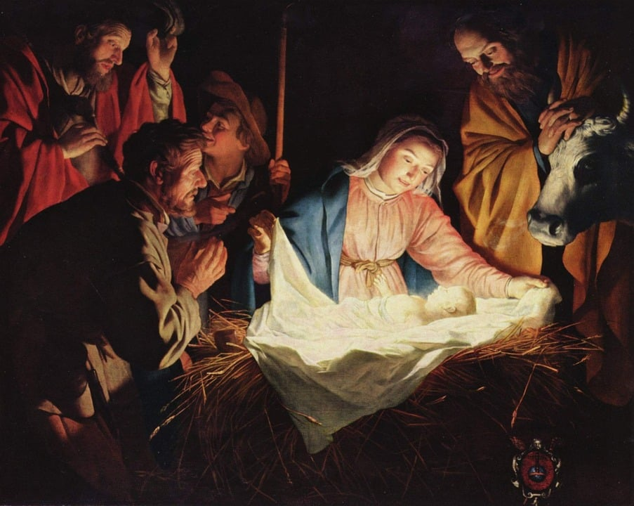

**And the angel said to them, “Be not afraid; for behold, I bring**

**you good news of a great joy which will come to all the people;**

**for to you is born this day in the city of David a Savior, who**

**is Christ the Lord.” Luke 2:10-11, RSV**

*_____*__________________________

**“Through the deep current of the historical Wesleyan church we will collaboratively serve and reach the lost in order to make disciples who love Jesus.”**

*____*___________________________

This service will be live streamed, and in the course of that any or all persons who attend may be filmed. Remaining in the service will constitute your consent to appear in the live-streamed, recorded, and published service.

**Rector and Pastor:** The Rev. John Crow

**Cantors:** Bryan Vanshur, Shannon Nichols

**Readers:**

**Old Testament:** Carol Crosswhite

**Psalm:** Carol Crosswhite

**Epistle:** Stan Crow

**Acolytes:** Stephen Crow, Josiah Crow, Corbin Crosswhite, and Jessica Crosswhite

**Jr. Acolytes:** Asher Crow & Lizzie Crosswhite

**Usher:** Asher Crow

_______________________________

**ACTS OF ENTRANCE**

**(The people enter and remain in prayer and meditation.)**

**Prelude:**

**Entrance canticle (cantors only):**

“Once in royal David’s city stood a lowly cattle shed where a mother laid her baby in a manger for his bed. Mary was that mother mild; Jesus Christ, her little child.

“He came down to earth from heaven who is God and Lord of all; and his shelter was a stable, and his cradle was a stall. With the poor and mean and lowly lived on earth our Savior holy.” (*Once in Royal David’s City,* vv. 1-2; Cecil Francis Alexander)

**Processional Hymn (all standing, singing):**

*Angels We Have Heard on High* (No. 50)

**Minister:** Blessed be God: Father, Son, and Holy Spirit.

**People:** *And blessed be his kingdom, now and forever.*

**Lord’s Prayer:**

**Minister:** Let us pray.

**(All standing):** *Our Father, who art in heaven, hallowed be thy Name. Thy kingdom come. Thy will be done, on earth as it is in heaven. Give us this day our daily bread. And forgive us our trespasses, as we forgive those who trespass against us. And lead us not into temptation, but deliver us from evil, for thine is the kingdom, and the power, and the glory, for ever and ever.* *Amen.*

**Collect for Covenant:**

**Minister:** God of grace, through the mediation of your Son, you call us into a new covenant. Help us therefore to draw near with faith and join ourselves in a perpetual covenant with You, through Jesus Christ our Lord.

**All:** *Amen.*

**The *Gloria* Hymn (all standing, singing):**

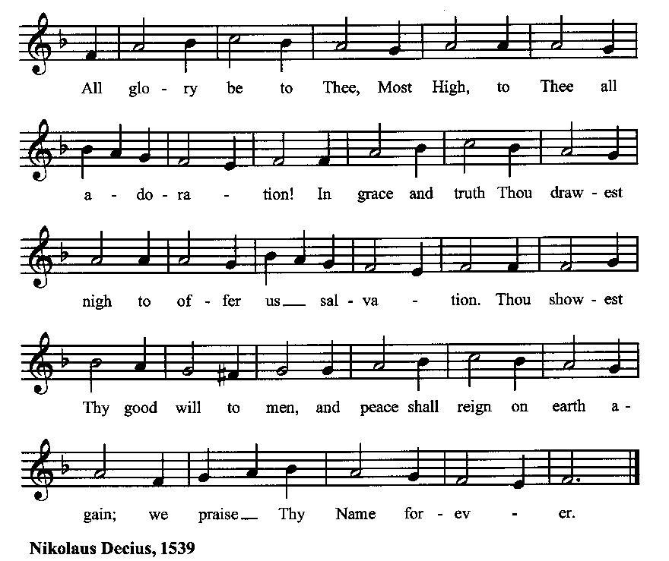

**Minister:** Holy God, Holy and Mighty, Holy Immortal One,

**People:** *Have mercy upon us.*

**SERVICE OF THE WORD**

**Mutual Invocation of the Grace of God for the Service of the Word:**

**Minister:** The Lord be with you.

**People:** *And also with you.*

**(The people then be seated.)**

**The Ten Commandments (the people sitting):**

**Minister:** God spoke these words, and said, I am the Lord your God:

You shall have no other gods but me.

You shall not make to yourself any graven image, to bow down to them, or worship them.

You shall not take the name of the Lord your God in vain.

Remember that you keep holy the Sabbath day.

Honor your father and your mother.

You shall not murder.

You shall not commit adultery.

You shall not steal.

You shall not bear false witness against your neighbor.

You shall not covet.

**The Great Commandments (the people sitting):**

**Minister:** Hear what our Lord Jesus Christ says. You shall love the Lord your God with all your heart, and with all your soul, and with all your mind. This is the first and great commandment. And the second is like unto it: You shall love your neighbor as yourself. On these two commandments hang all the Law and the Prophets.

**The *Kyrie* (the people sitting, singing):**

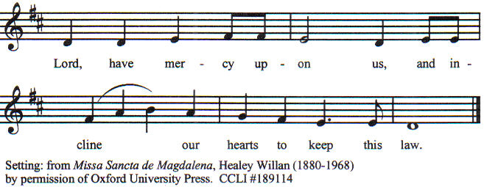

**Old Testament Lesson (the people sitting):**

**Reader:** The Old Testament lesson is written in the sixty-first and sixty-second chapters of the book of the prophet Isaiah, beginning at verse 10 of chapter sixty-one:

1. I will greatly rejoice in the Lord; my soul shall exult in my God, for he has clothed me with the garments of salvation; he has covered me with the robe of righteousness, as a bridegroom decks himself like a priest with a beautiful headdress, and as a bride adorns herself with her jewels.
2. For as the earth brings forth its sprouts, and as a garden causes what is sown in it to sprout up, so the Lord God will cause righteousness and praise to sprout up before all the nations.
3. For Zion's sake I will not keep silent, and for Jerusalem's sake I will not be quiet, until her righteousness goes forth as brightness, and her salvation as a burning torch.
4. The nations shall see your righteousness, and all the kings your glory, and you shall be called by a new name that the mouth of the LORD will give.
5. You shall be a crown of beauty in the hand of the Lord, and a royal diadem in the hand of your God. (ESV)

**Reader:** The Word of the Lord*.*

**People:** *Thanks be to God.*

**The Psalm: (The people sit for the responsive reading, by half-verse, of a portion of Psalm 147, a song of praise for the LORD’s blessing of Israel.)**

**Reader:** The Psalm is chapter 147, beginning at verse 13.

**Reader:** 13 Worship the LORD, O Jerusalem

**People:** *praise your God, O Zion;*

**Reader:** 14 For he has strengthened the bars of your gates;

**People:** *he has blessed your children within you.*

**Reader:** 15 He has established peace on your borders;

**People:** *he satisfies you with the finest wheat.*

**Reader:** 16 He sends out his command to the earth,

**People:** *and his word runs very swiftly.*

**Reader:** 17 He gives snow like wool;

**People:** *he scatters hoarfrost like ashes.*

**Reader:** 18 He scatters his hail like bread crumbs;

**People:** *who can stand against his cold?*

**Reader:** 19 He sends forth his word and melts them;

**People:** *he blows with his wind, and the waters flow.*

**Reader:** 20 He declares his word to Jacob,

**People:** *his statutes and his judgments to Israel.*

**Reader:** 21 He has not done so to any other nation;

**People:** *to them he has not revealed his judgments. Hallelujah!* (BCP)

***Gloria Patri*** **(the people sitting)**

**Reader:** Glory be to the Father, and to the Son, and to the Holy Spirit;

**People:** *As it was in the beginning, is now and ever shall be, world without end. Amen.*

**Collect for the First Sunday after Christmas (the people sitting):**

**Minister:** Almighty God, who hast poured upon us the new light of thine incarnate Word: Grant that this same light, enkindled in our hearts, may shine forth in our lives; through Jesus Christ our Lord, who lives and reigns with You, in the unity of the Holy Spirit, one God, now and for ever.

**All:** *Amen.*

**The Epistle (the people sitting):**

**Reader:** The epistle lesson is written in the third and fourth chapters of the epistle to the Galatians, beginning at verse 23 of chapter 3:

1. Now before faith came, we were held captive under the law, imprisoned until the coming faith would be revealed.
2. So then, the law was our guardian until Christ came, in order that we might be justified by faith.
3. But now that faith has come, we are no longer under a guardian,
4. But when the fullness of time had come, God sent forth his Son, born of woman, born under the law,
5. to redeem those who were under the law, so that we might receive adoption as sons.
6. And because you are sons, God has sent the Spirit of his Son into our hearts, crying, “Abba! Father!”
7. So you are no longer a slave, but a son, and if a son, then an heir through God. (ESV)

**Reader:** Here ends the Epistle.

**People:** *Thanks be to God.*

**Sequence Hymn (all standing):**

*O Little Town of Bethlehem,* vv. 1-2 (No. 61)

**The Gospel (all standing, and turning toward the Gospel reading):**

**Minister:** The holy Gospel is written in the first chapter of the Gospel according to John, beginning at verse 1:

**Minister:**

1. In the beginning was the Word, and the Word was with God, and the Word was God.
2. He was in the beginning with God.
3. All things were made through him, and without him was not any thing made that was made.
4. In him was life, and the life was the light of men.
5. The light shines in the darkness, and the darkness has not overcome it.
6. There was a man sent from God, whose name was John.
7. He came as a witness, to bear witness about the light, that all might believe through him.
8. He was not the light, but came to bear witness about the light.
9. The true light, which gives light to everyone, was coming into the world.
10. He was in the world, and the world was made through him, yet the world did not know him.
11. He came to his own, and his own people did not receive him.
12. But to all who did receive him, who believed in his name, he gave the right to become children of God,
13. who were born, not of blood nor of the will of the flesh nor of the will of man, but of God.
14. And the Word became flesh and dwelt among us, and we have seen his glory, glory as of the only Son from the Father, full of grace and truth.
15. (John bore witness about him, and cried out, “This was he of whom I said, ‘He who comes after me ranks before me, because he was before me.’”)
16. For from his fullness we have all received, grace upon grace.
17. For the law was given through Moses; grace and truth came through Jesus Christ.
18. No one has ever seen God; the only God, who is at the Father's side, he has made him known. (ESV)

**Minister:** The Gospel of the Lord.

**People:** *Praise to You, Lord Christ*.

**Sequence Hymn (all standing):**

*O Little Town of Bethlehem,* vv. 3-4 (No. 61)

[Elementary age children may exit for Children’s Worship in the Parish Hall.

They may return to the service at the Passing of the Peace.]

**Minister:** Grace be unto you, and peace, from our Lord Jesus Christ.

**All:** *Amen.* **(The people then be seated.)**

**The Sermon**

**Minister:** In the name of the Father, and of the Son, and the Holy Spirit.

**Silence, for review of the sermon, and for meditative prayer**

**SERVICE OF THE TABLE: THE GREAT THANKSGIVING**

**The Nicene Creed (all standing):**

**Minister:** Let us confess our faith, saying:

**All:** *We believe in one God,*

*the Father, the Almighty,*

*maker of heaven and earth,*

*of all that is, seen and unseen.*

*We believe in one Lord, Jesus Christ,*

*the only Son of God,*

*eternally begotten of the Father,*

*God from God, Light from Light,*

*true God from true God,*

*begotten, not made,*

*of one Being with the Father.*

*Through him all things were made.*

*For us and for our salvation*

*he came down from heaven:*

*by the power of the Holy Spirit*

*he became incarnate from the Virgin Mary,*

*and was made man.*

*For our sake he was crucified under Pontius Pilate;*

*he suffered death and was buried.*

*On the third day he rose again*

*in accordance with the Scriptures;*

*he ascended into heaven*

*and is seated at the right hand of the Father.*

*He will come again in glory to judge the living and the dead,*

*and his kingdom will have no end.*

*We believe in the Holy Spirit, the Lord, the giver of life,*

*who proceeds from the Father and the Son.*

*With the Father and the Son he is worshiped and glorified.*

*He has spoken through the Prophets.*

*We believe in one holy catholic and apostolic Church.*

*We acknowledge one baptism for the forgiveness of sins.*

*We look for the resurrection of the dead,*

*and the life of the world to come.* *Amen.*

**Minister: (The people sitting)** Let us with gladness present the offerings and oblations of our life and labor to the Lord.

**Offertory:**

**Offering Hymn (all standing):**

*Good Christian Friends, Rejoice*  (No. 55)

**Minister:** All things come from You, O Lord,

**People:** *And of your own have we given You.*

**The Prayer of Commitment:**

**(The minister kneels, and the people kneel or sit.)**

**Minister:** Let us pray together:

**All:** *Lord God, holy Father, since you have called us through Christ to share in this gracious covenant, we take upon ourselves with joy the yoke of obedience and, for love of You, engage ourselves to seek and do your perfect will. We are no longer our own, but yours.*

*I am no longer my own, but yours. Put me to what you will, rank me with whom you will; put me to doing, put me to suffering; let me be employed for you, or laid aside for you; exalted for you, or brought low for you; let me be full, or let me be empty; let me have all things, or let me have nothing. I freely and wholeheartedly yield all things to your pleasure and disposal.*

*Place me where You want me to be, and make me what You want me to be, whether of silver or gold, or wood or stone; whether of honor or not.*

*I reverence you. I dedicate myself to your service.*

*Lord God, holy Father, I firmly covenant with You not to allow myself to participate in any known sin, but conscientiously to use all the means that I know You have prescribed, for the death and utter destruction of all my sinful corruption. I humbly affirm before your glorious Majesty that it is the firm resolution of my heart to forsake all that is dear unto me in this world, rather than to turn from You to the ways of sin. I will watch against all its temptations, whether of prosperity or adversity, lest they should withdraw my heart from You.*

*And since You have, of your boundless mercy, offered graciously to me to be my God through Christ, I call heaven and earth to record this day, that I do here solemnly acknowledge You as the Lord my God. I do here take You, the Lord Jehovah, Father, Son, and Holy Ghost, for my portion and do give up myself, body and soul, to be your servant, promising and vowing to serve You in holiness and righteousness all the days of my life.*

*O blessed Jesus, I come to You hungry, wretched, miserable, blind, and naked, unworthy to wash the feet of the servants of my Lord, much less to be solemnly married to the King of Glory. But since this is your unparalleled love, I do here with all my power accept You and take You for my Head and Husband, to love, honor, and obey You before all others, and this to the death. I renounce my own worthiness and do here avow You for the Lord my righteousness. I renounce my own wisdom and do here take You for my only Guide. I renounce my own will and take your Will for my law.*

*And I do here covenant with You to take my lot, as it falls, with You and by your grace to take my risk with You, purposing that neither life nor death shall part between You and me.*

*Now, Almighty God, Searcher of Hearts, You know that I make this covenant with You this day, without any known guile or reservation, and I ask You that if You see any flaw or falsehood within me or in what I hereby covenant, You would reveal it to me and help me to put it right.*

*And now, glorious and blessed God, Father, Son and Holy Spirit, You are mine and I am yours. So be it. And the covenant now made on earth, let it be ratified in heaven.*

**All:** *Amen*.

**Preparation for Holy Communion (the people sitting):**

**Minister:** The Lord’s Supper was ordained by God to be a means of conveying grace according to the need of each person. Those for whom it was ordained are all those who know and feel that they want the grace of God, to restrain them from sin, or to forgive their sins, or to assure them of pardon, or to renew their souls in the image of God, or to enter into the holy presence of God in communion with him. No preparation is indispensably necessary, other than a desire to receive the grace God pleases to give. No fitness or church membership is required at the time of communicating, other than a sense of our state, of our utter sinfulness and helplessness apart from Christ. Therefore, if you want such grace as God pleases to give to you, draw near with faith, and as you prepare to receive this holy sacrament to your comfort and strength, make your sincere confession to Almighty God, kneeling if you wish and are able, or otherwise sitting.

**The Prayer of Confession, Petition and Thanksgiving:**

**(The minister kneels, and the people kneel or sit.)**

**Minister:** Let us pray together:

**All:** *Most merciful God, we confess that we have sinned against thee in thought, word, and deed, by what we have done, and by what we have left undone. We have not loved thee with our whole heart; we have not loved our neighbors as ourselves. We are truly sorry and we humbly repent. For the sake of thy Son Jesus Christ, have mercy on us and forgive us; that we may delight in thy will, and walk in thy ways, to the glory of thy Name. Amen.*

**Prayer for Absolution (the people kneeling or sitting):**

**Minister:** Almighty God, our heavenly Father, who of your great mercy has promised forgiveness of sins to all those who with hearty repentance and true faith turn unto You; Have mercy upon us; pardon and deliver us from all our sins, confirm and strengthen us in all goodness, and bring us to everlasting life, through Jesus Christ our Lord.

**All:** *Amen.*

**The Comforting Words of Forgiveness (the people sitting):**

**Minister:** Hear what comforting words our Savior Christ says to all who truly turn to him: Come to me, all you who are weary and carry heavy burdens, and I will give you rest. God so loved the world that he gave his only Son, so that everyone who believes in him will not perish but have eternal life. Hear also what St. Paul says: Christ Jesus came into the world to save sinners. Hear also what St. John says: If anyone sins, we have an Advocate with the Father, Jesus Christ the righteous: and he is the atonement for our sins.

**The Passing of the Peace:**

**Minister:** The peace of the Lord be always with you.

**People:** *And also with you.*

**Minister:** As the peace of Christ has been extended to you, extend the peace of the Lord to one another, and greet those who are near to you in the name of the Lord. **(The people rise and remain standing.)**

*(The people greet those near to them, saying, “The peace of the Lord be with you,” or, “Peace be with you,” or simply, “Peace.” They respond to one another, “And also with you,” or simply, “Peace”.)*

**Hymn of Entry Into the Heavenly Worship (all standing):**

*Angels, from the Realms of Glory* (No. 60)

**Preparation for the Table:**

**(Minister:** I wash my hands in innocence, and go about your altar, O LORD, proclaiming aloud your praise and telling of all your wonderful deeds). [Psalm 26:6-7, NIV]

**The *Sursum Corda* (all standing):**

**Minister:** The Lord be with you.

**People:** *And also with you.*

**Minister:** Lift up your hearts.

**People:** *We lift them up unto the Lord*.

**Minister:** Let us give thanks unto our Lord God.

**People:** *It is meet and right so to do.*

**The Salutation:**

**Minister:** It is very meet, right, and our gladsome duty, that we should at all times, and in all places, give thanks unto You, O Lord, Holy Father, Almighty, Everlasting God,

**The Preface:**

**Minister:** Through Jesus Christ our Lord. In fulfillment of his true promise, the Holy Spirit came down from heaven, lighting upon the disciples, to teach them and to lead them into all truth; uniting peoples of many tongues in the confession of one faith, and giving to your Church the power to serve You as a royal priesthood, and to preach the Gospel to all nations.

**Minister:** Therefore, with Angels and Archangels and with all the company of heaven, we laud and magnify your glorious Name, evermore praising You, and saying,

**The *Sanctus* (the people standing, singing):**

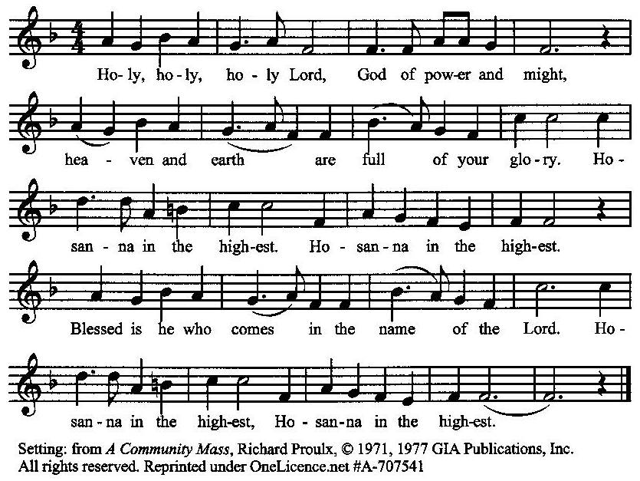

**The Prayer of Humble Access and for Cleansing**

**(the people kneeling or sitting):**

**Minister:** Let us pray together:

**All:** *We do not presume to come to this your table, O merciful Lord, trusting in our own righteousness, but in your many and great mercies. We are not worthy so much as to gather up the crumbs under your table. But You are the same Lord, whose nature is always to have mercy: Grant us, therefore, gracious Lord, so to experience the spiritual presence of your dear Son Jesus Christ at this your table, that we may be made clean by his body and blood, and that we may evermore dwell in him, and he in us. Deliver us, gracious Lord, from the presumption of coming to this table for solace for ourselves only, and not for strength to serve You and others. Deliver us, gracious Lord, from the presumption of coming to this table for pardon of our sins only, and not for transformation of our lives in your holiness. Amen.*

***Epiclesis* Prayer (the people kneeling or sitting):**

**Minister:** Holy and gracious Father, in your infinite love You made us for yourself; and, when we had fallen into sin and become subject to evil and death, You sent Jesus Christ, your only and eternal Son, to share our human nature, to live and die as one of us, to reconcile us to You, the God and Father of all. He stretched out his arms upon the cross and offered himself, in obedience to your will, a perfect sacrifice for the sins of the whole world. Recalling now his death, resurrection, and ascension, we offer You these gifts. Sanctify them by your Holy Spirit to be for us the Body and Blood of your Son, the holy food and drink of new and unending life in him. Sanctify us also, that we may faithfully receive this holy Sacrament, and serve You in unity, constancy, and peace; and at the last day bring us with all your saints into the joy of your eternal kingdom. We ask this through Jesus Christ, your Son, our Lord; through him, and with him, and in him, in the unity of the Holy Spirit, all honor and glory are yours, O Father Almighty, now and forever.

**All:** *Amen.*

**The Words of Institution (the people kneeling or sitting):**

**Minister:** Our Lord Jesus Christ, on the night that he was betrayed took bread; and when he had given thanks, he broke it, and gave it to his disciples, saying, Take, eat; this is my Body which is given for you: Do this in remembrance of me.

Likewise, after supper, he took the cup; and when he had given thanks, he gave it to them, saying, Drink this, all of you; for this is my blood of the New Testament, which is shed for you, and for many, for the remission of sins: Do this, as often as you shall drink it, in remembrance of me.

**All:** *Amen.*

**Minister:** Therefore, we proclaim the mystery of faith:

**People:** *Christ has died. Christ is risen. Christ will come again*.

**The Fraction:**

**Minister:** Christ our passover is sacrificed for us.

**People:** *Therefore let us keep the feast.*

**Fraction Anthem (the people kneeling or sitting, singing):**

(The cantor sings the first line, and then all sing the other lines.)

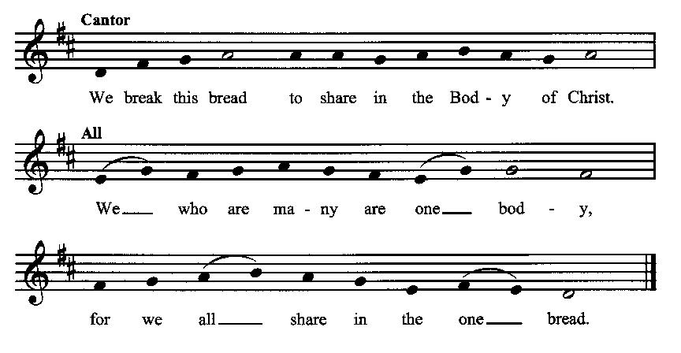

**Minister:** The gifts of God for the people of God. Take them in remembrance that Christ died for you and rose again, and feed on him in your hearts by faith with thanksgiving.

**Communion Hymn (cantors only, the people kneeling or sitting):**

“Jesus is our childhood pattern; day by day like us he grew. He was little, weak, and helpless; tears and smiles like us he knew. And he feeleth for our sadness, and he shareth in our gladness.

“And our eyes at last shall see him through his own redeeming love; for that child so dear and gentle is our Lord in heav’n above. And he leads his children on to the place where he is gone.” (*Once in Royal David’s City,* vv. 3-4; Cecil Francis Alexander)

**The Communion:** *(After the minister(s) and acolyte(s) are served, the people come forward to receive, as space is available. The people kneel if they are able, or stand.* **Communion by intincture: The people receive the Bread in their open hands, continue to hold it, then dip the Bread in the cup, and then consume.**) *They return to their seats via the side aisles.*

**Renewal of the Mutual Invocation of God’s Grace for the Eucharist:**

**Minister:** The Lord be with you.

**People:** *And also with you.*

**The Prayer of Thanksgiving and Living Sacrifice:**

**(The minister kneeling, the people kneeling or sitting):**

**Minister:** Let us pray together:

**All:** *O Lord and Heavenly Father, we heartily thank You because You feed us, in these holy mysteries, with the spiritual food of the most precious Body and Blood of your Son our Savior Jesus Christ; because by this You assure us of your favor and goodness toward us; because we are living members of the body of your Son and heirs of your eternal kingdom. We ask You to accept this our sacrifice of praise and thanksgiving, and to grant that by the merits and death of your Son Jesus Christ and through faith in him, we and all your whole Church may obtain all of the benefits of his passion. And here we offer and present unto You, O Lord, ourselves, our souls and bodies, to be a reasonable, holy, and living sacrifice unto You; humbly asking You that we may be filled with your grace and heavenly benediction; through Jesus Christ our Lord; by whom, and with whom, in the Unity of the Holy Spirit, all honor and glory be unto You, O Father Almighty, world without end. AMEN.*

**The *Gloria* Prayer of Praise and Thanksgiving (all standing):**

**Minister:** Let us pray together:

**All:**  *Glory be to God on high, and on earth peace, good-will toward all people. We praise You, we bless You, we worship You, we glorify You, we give thanks to You for your great glory, O Lord God, heavenly King, God the Father Almighty. For You only are the Holy One, You only are the Lord, You only, O Christ, with the Holy Spirit, are most high in the glory of God the Father.* *Amen.*

**ACTS OF DISMISSAL**

**Recessional Hymn (all standing, singing):**

*Joy to the World* (No. 39)

**The Prayer of Benediction:**

**Minister:** Now to him who by the power at work within us is able to do far more abundantly than all that we ask or think, to him be glory in the church and in Christ Jesus to all generations, for ever and ever.

**All:** *Amen.*

**Minister:** Let us go forth in the Name of Christ.

**People:** *Thanks be to God.*

**(The people then be seated.)**

**Greetings and Announcements**

**Postlude:**

**(The people sit and remain quiet until the candles are extinguished and the organ raises its voice.)**

*____*___________________________________________

Based on, and freely adapted from,

John Wesley’s *Order for the Administration of the Lord’s Supper*,

the 1662 and 1979 editions of *The Book of Common Prayer,* and

*Common Worship: Services and Prayers for the Church of England*

*_________________________*___________________________

**Scripture Lessons for January 5 (Epiphany Sunday):**

Isaiah 60:1-6; Psalm 72:1-7, 10-14; Ephesians 3:1-13; Matthew 2:1-12

**Parish Prayer for This Week and Next Sunday**

Those living on Esquire Circle

_______________________________

**Parish Notices**

**Next Sunday: Epiphany!**



Immediately following the 12 days of Christmas is Epiphany, or manifestation. This season celebrates the revealing of the Messiah to the world, which is generally associated with the arrival of the 3 wise men and Jesus’ baptism. Epworth’s annual end-of-Christmas revelry will be held on Sunday, January 5th, immediately following the service. We will have a short pageant, followed by food and a white elephant gift exchange. Please bring something to give that you have around the house but no longer want—one item per member of your family. There will also be Three Kings’ cakes, and sandwiches provided by Parish Life. We also ask that each family bring an appetizer to share.

Following the Epiphany party, we will be taking down all the Christmas decorations and storing them until next year. If you are able to stay for a little while, your help would be greatly appreciated!

**Coming Events at Epworth**

Today, 10:00 am Word & Table Service

Today, 11:40 Afterword (moderated discussion)

Thursday, 2 JAN NO EVENING PRAYERS

Sunday, 5 JAN Epiphany Sunday (pageant & party)

**January Birthdays & Anniversaries**

10 – Michael Roberts

14 – John & Mindy Crow

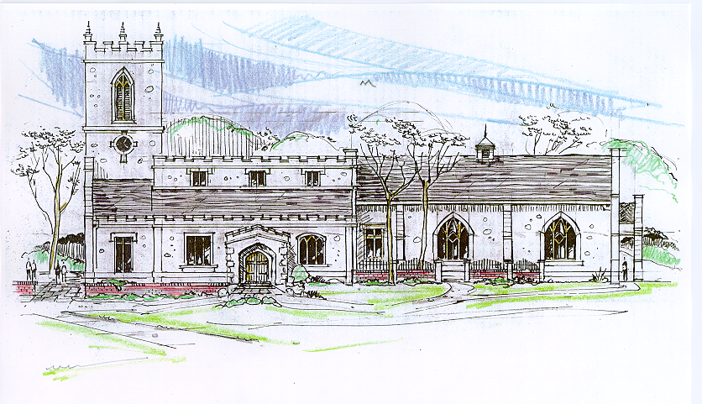

This is an architect’s rendering of St. Andrew’s Church in Epworth, England, the Anglican parish for which Samuel Wesley- poet, Oxford scholar, and the father of John and Charles Wesley and their eight siblings- served as a priest and where the children were raised. In 2005, during a Wesleyan-Anglican Heritage Tour/Spiritual Pilgrimage in England, Epworthies from the Epworth Chapel on the Green in Boise received Communion at St. Andrew’s from the same chalice which John Wesley used to serve Communion as a deacon for his father Samuel. From that heritage, this drawing continues to represent an aspiration for the future appearance of Epworth Free Methodist Church.

**Sermon Notes**

**.**

**Epworth Church Office Email**

[epworthchapel.office@gmail.com](mailto:epworthchapel.office@gmail.com)

All correspondence for the office should be sent to this email address.

**Pastor Crow Contact Information**

***Healing prayer is provided every week upon request***

Rev. John Crow, Rector and Pastor

208-501-4037

[jdowningcrow@hotmail.com](mailto:jdowningcrow@hotmail.com)