**Service of Word and Table**

at

**Epworth Free Methodist Church**

6110 W. Northview Street, Boise, Idaho 83704

208-336-3951

www.epworthfmc.org

The Rev. John Crow, Rector and Pastor

208-501-4037

**December 22, 2024, 10:00 a.m.**

*Fourth Sunday of Advent*

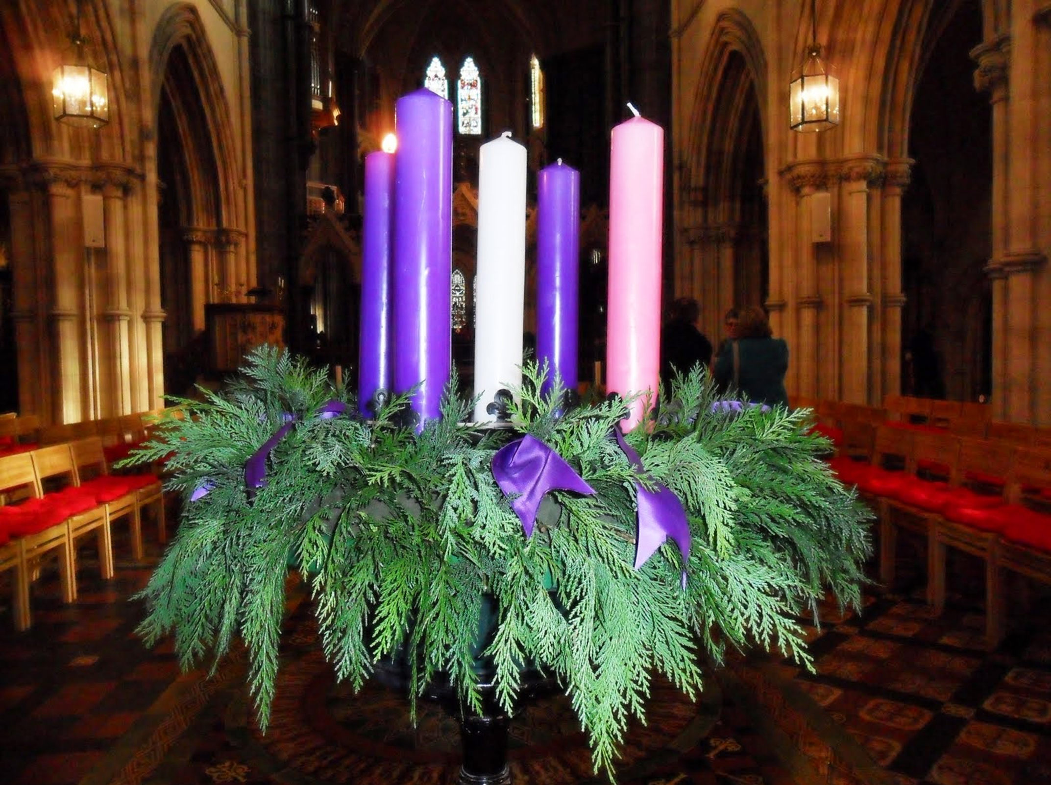

The picture above is licensed under Creative Commons: BY-NC-ND

*_____*__________________________

**“Through the deep current of the historical Wesleyan church we will collaboratively serve and reach the lost in order to make disciples who love Jesus.”**

*____*___________________________

This service will be live streamed, and in the course of that any or all persons who attend may be filmed. Remaining in the service will constitute your consent to appear in the live-streamed, recorded, and published service.

**Rector and Pastor:** The Rev. John Crow

**Cantors:** Bryan Vanshur, Shannon Nichols

**Readers:**

**Old Testament:** Bryan Vanshur

**Psalm:** Bryan Vanshur

**Epistle:** Adam Graham

**Acolytes:** Stephen Crow, Josiah Crow, Corbin Crosswhite, and Jessica Crosswhite

**Jr. Acolytes:** Asher Crow & Lizzie Crosswhite

**Usher:** Asher Crow

______________________________________________

**ACTS OF ENTRANCE**

**Prélude:**

**(The people enter and remain in prayer and meditation, and the candles are lit in silence.)**

**Minister:** In the wilderness prepare the way of the Lord; make straight in the desert a highway for our God.

**People:** *The glory of the Lord shall be revealed, and all flesh shall see it together.*

**Collect for the Fourth Sunday of Advent (the people sitting):**

**Minister:** We beseech thee, Almighty God, to purify our consciences by thy daily visitation, that when thy Son our Lord cometh he may find in us a mansion prepared for himself; through the same Jesus Christ our Lord, who liveth and reigneth with thee, in the unity of the Holy Spirit, one God, now and for ever.

**All:** *Amen.*

**The “O” Antiphons (the people sitting):**

**Minister:** O Wisdom, who came forth from the mouth of the Most High, reaching from eternity to eternity and ordering all things mightily and sweetly:

**People:** *Come, and teach us the way of prudence.*

**Minister:** O Adonai and Leader of the house of Israel, who appeared to Moses in the flames of the burning bush and gave him the law on Sinai:

**People:** *Come, and with your outstretched arm redeem us.*

**Minister:** O Root of Jesse, who stands for a sign of the people, before whom kings shall keep silence and to whom all nations shall make their supplication:

**People:** *Come, deliver us, and tarry not.*

**Minister:** O Key of David and Scepter of the house of Israel, who opens and no one shuts, who shuts and no one opens:

**People:** *Come and bring forth from prison the captives who sit in darkness and in the shadow of death.*

**Minister:** O Dayspring, Brightness of the Light eternal and Son of Justice:

**People:** *Come, and enlighten them that sit in darkness and in the shadow of death.*

**Minister:** O King of the nations and their Desired One, Cornerstone that makes all people one:

**People:** *Come, and deliver us whom you formed out of the dust of the earth.*

**Minister:** O Emmanuel, our Ruler and Lawgiver, the Expected of the nations and their Savior:

**People:** *Come to save us, O Lord our God.*

**Advent canticle (cantor only):**

“My heart sings out with joyful praise to God who raises me, who came to me when I was low and changed my destiny. The Holy One, the Living God, is always full of grace to those who seek their Maker’s will in ev’ry time and place.” (My Heart Sings Out with Joyful Praise, v. 1; Ruth Duck)

**Processional Hymn (all standing):**

*Light of Those Whose Dreary Dwelling*  (No. 16)

**Minister:** Blessed be God: Father, Son, and Holy Spirit.

**People:** *And blessed be his kingdom, now and forever.*

**Lord’s Prayer:**

**Minister:** Let us pray.

**(All standing):** *Our Father, who art in heaven, hallowed be thy Name. Thy kingdom come. Thy will be done, on earth as it is in heaven. Give us this day our daily bread. And forgive us our trespasses, as we forgive those who trespass against us. And lead us not into temptation, but deliver us from evil, for thine is the kingdom, and the power, and the glory, for ever and ever.* *Amen.*

**The Collect for Purity:**

**Minister:** Almighty God, unto whom all hearts are open, all desires known, and from whom no secrets are hid; cleanse the thoughts of our hearts by the inspiration of your Holy Spirit, that we may perfectly love You, and worthily magnify your holy Name, through Christ our Lord.

**All:** *Amen.*

**Minister:** Holy God, Holy and Mighty, Holy Immortal One,

**People:** *Have mercy upon us.*

**SERVICE OF THE WORD**

**Mutual Invocation of the Grace of God for the Service of the Word:**

**Minister:** The Lord be with you.

**People:** *And also with you.* **(The people then be seated.)**

**The Ten Commandments (the people sitting):**

**Minister:** God spoke these words, and said, I am the Lord your God:

You shall have no other gods but me.

You shall not make to yourself any graven image, to bow down

to them, or worship them.

You shall not take the name of the Lord your God in vain.

Remember that you keep holy the Sabbath day.

Honor your father and your mother.

You shall not murder.

You shall not commit adultery.

You shall not steal.

You shall not bear false witness against your neighbor.

You shall not covet.

**The Great Commandments:**

**Minister:** Hear what our Lord Jesus Christ says. You shall love the Lord your God with all your heart, and with all your soul, and with all your mind. This is the first and great commandment. And the second is like unto it: You shall love your neighbor as yourself. On these two commandments hang all the Law and the Prophets.

**The Prayer of Confession:**

**(The minister kneels, and the people kneel or sit.)**

**Minister:** Let us confess our sins to God:

**All:** *Almighty and merciful Father, we have erred and strayed from your ways like lost sheep. We have followed too much the devices and desires of our own hearts. We have offended against your holy laws by what we have done, and by what we have left undone. We have not loved You with our whole heart, nor our neighbors as ourselves. Have mercy upon us, O Lord; spare those who are penitent according to your promises in Christ Jesus our Lord; that we may delight in your will, and walk in your ways, to the glory of your holy Name. Amen.*

**The *Agnus Dei* (the people kneeling or sitting):**

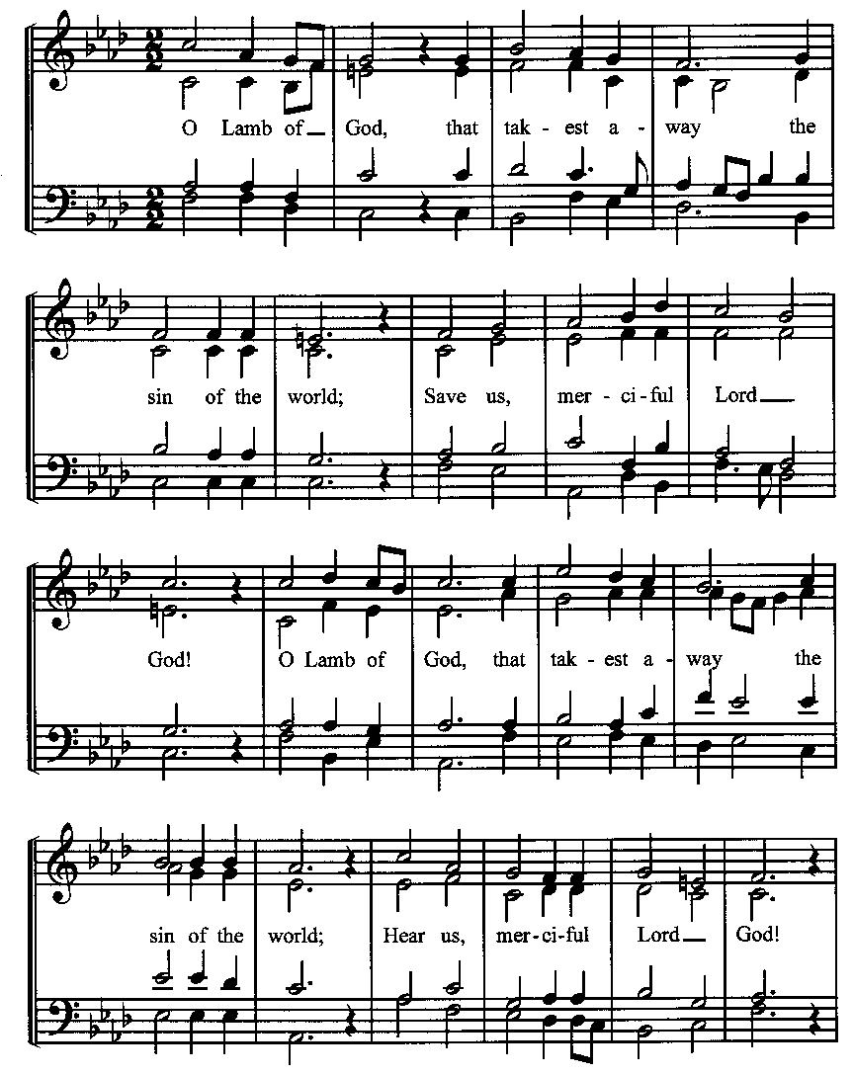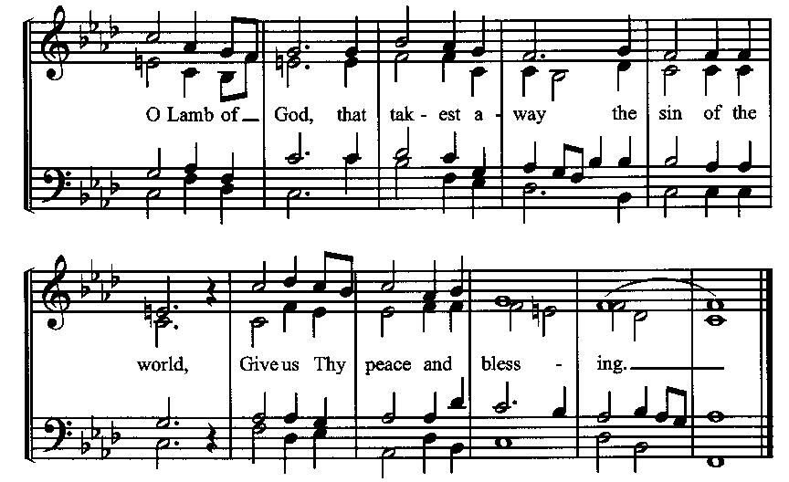

**Prayer for Absolution**

**Minister:** Almighty God have mercy on us, forgive us all our sins through our Lord Jesus Christ, strengthen us in all goodness, and by the power of the Holy Spirit keep us in eternal life.

**All:** *Amen.* **(The people then be seated.)**

**Old Testament Lesson (the people sitting):**

**Reader:** The Old Testament reading is written in the fifth chapter of the book of the prophet Micah, beginning at verse 2:

1. But you, O Bethlehem Ephrathah, who are too little to be among the clans of Judah, from you shall come forth for me one who is to be ruler in Israel, whose coming forth is from of old, from ancient days.
2. Therefore he shall give them up until the time when she who is in labor has given birth; then the rest of his brothers shall return to the people of Israel.
3. And he shall stand and shepherd his flock in the strength of the Lord, in the majesty of the name of the Lord his God. And they shall dwell secure, for now he shall be great to the ends of the earth.
4. And he shall be their peace. When the Assyrian comes into our land and treads in our palaces, then we will raise against him seven shepherds and eight princes of men; (ESV)

**Reader:** The Word of the Lord.

**People:** *Thanks be to God.*

**The Psalm: (The people sit for the responsive reading, by half-verse, of Psalm 80, a prayer for God’s restoration.)**

**Reader:** The Psalm is chapter 80, beginning at verse 1.

**Reader:** 1 Hear, O Shepherd of Israel, leading Joseph like a flock;

**People:** *Shine forth, you that are enthroned upon the cherubim.*

**Reader:** 2 In the presence of Ephraim, Benjamin, and Manasseh,

**People:** *stir up your strength and come help us.*

**Reader:** 3 Restore us, O God of hosts;

**People:** *show the light of your countenance, and we shall be saved.*

**Reader:** 4 O Lord God of hosts,

**People:** *how long will you be angered despite the prayers of your people?*

**Reader:** 5 You have fed them with the bread of tears;

**People:** *you have given them bowls of tears to drink.*

**Reader:** 6 You have made us the derision of our neighbors,

**People:** *and our enemies laugh us to scorn.*

**Reader:** 7 Restore us, O God of hosts;

**People:** *show the light of your countenance, and we shall be saved.* (BCP)

***Gloria Patri*:**

**Reader:** Glory be to the Father, and to the Son, and to the Holy Spirit.

**All:** *As it was in the beginning, is now and ever shall be, world without end. Amen.*

**The Epistle (the people sitting):**

**Reader:** The Epistle lesson is written in the tenth chapter of the letter to the Hebrews, beginning at verse 5:

1. Consequently, when Christ came into the world, he said, “Sacrifices and offerings you have not desired, but a body have you prepared for me;
2. in burnt offerings and sin offerings you have taken no pleasure.
3. Then I said, ‘Behold, I have come to do your will, O God, as it is written of me in the scroll of the book.’”
4. When he said above, “You have neither desired nor taken pleasure in sacrifices and offerings and burnt offerings and sin offerings” (these are offered according to the law),
5. then he added, “Behold, I have come to do your will.” He does away with the first in order to establish the second.
6. And by that will we have been sanctified through the offering of the body of Jesus Christ once for all. (ESV)

**Reader:** Here ends the Epistle.

**People:** *Thanks be to God.*

**Sequence Hymn (all standing):**

*O Very God of Very God*, vv. 1-3 (No. 4)

**The Gospel (all standing, and turning toward the Gospel reading):**

**Minister:** The holy Gospel is written in the first chapter of the Gospel according to Luke, beginning at verse 39:

**Minister:**

1. In those days Mary arose and went with haste into the hill country, to a town in Judah,
2. and she entered the house of Zechariah and greeted Elizabeth.
3. And when Elizabeth heard the greeting of Mary, the baby leaped in her womb. And Elizabeth was filled with the Holy Spirit,
4. and she exclaimed with a loud cry, “Blessed are you among women, and blessed is the fruit of your womb!
5. And why is this granted to me that the mother of my Lord should come to me?
6. For behold, when the sound of your greeting came to my ears, the baby in my womb leaped for joy.
7. And blessed is she who believed that there would be a fulfillment of what was spoken to her from the Lord.” (ESV)

**Minister:** The Gospel of the Lord.

**People:** *Praise to You, Lord Christ*.

**Sequence Hymn (all standing):**

*O Very God of Very God*, vv. 4-5 (No. 4)

[Elementary age children may exit for Children’s Worship in the Parish Hall.

They may return to the service at the Passing of the Peace.]

**Minister:** Grace be unto you, and peace, from our Lord Jesus Christ.

**All:** *Amen.* **(The people then be seated.)**

**The Sermon**

**Minister:** In the name of the Father, and of the Son, and the Holy Spirit.

**Silence, for review of the sermon, and for meditative prayer**

**SERVICE OF THE TABLE: THE GREAT THANKSGIVING**

**The Nicene Creed (all standing):**

**Minister:** Let us confess our faith, saying:

**All:** *We believe in one God,*

*the Father, the Almighty,*

*maker of heaven and earth,*

*of all that is, seen and unseen.*

*We believe in one Lord, Jesus Christ,*

*the only Son of God,*

*eternally begotten of the Father,*

*God from God, Light from Light,*

*true God from true God,*

*begotten, not made,*

*of one Being with the Father.*

*Through him all things were made.*

*For us and for our salvation*

*he came down from heaven:*

*by the power of the Holy Spirit*

*he became incarnate from the Virgin Mary,*

*and was made man.*

*For our sake he was crucified under Pontius Pilate;*

*he suffered death and was buried.*

*On the third day he rose again*

*in accordance with the Scriptures;*

*he ascended into heaven*

*and is seated at the right hand of the Father.*

*He will come again in glory to judge the living and the dead,*

*and his kingdom will have no end.*

*We believe in the Holy Spirit, the Lord, the giver of life,*

*who proceeds from the Father and the Son.*

*With the Father and the Son he is worshiped and glorified.*

*He has spoken through the Prophets.*

*We believe in one holy catholic and apostolic Church.*

*We acknowledge one baptism for the forgiveness of sins.*

*We look for the resurrection of the dead,*

*and the life of the world to come.* *Amen.*

**The Prayers of the People (the people kneeling or sitting):**

**Minister:** Let us pray for the Church and the world. For the unity of the Church throughout the world, that we might faithfully preach the Gospel to the ends of the earth, let us pray to the Lord:

**People:** *Lord, hear our prayer.*

**Minister:** For the persecuted church, and for its persecutors, that You would turn their hearts, let us pray to the Lord:

**People:** *Lord, hear our prayer.*

**Minister:** For our President and all who govern and hold authority in our nation and in the world, let us pray to the Lord:

**People:** *Lord, hear our prayer.*

**Minister:** For the good earth which You have given us, and for the wisdom and will to conserve it, let us pray to the Lord:

**People:** *Lord, hear our prayer.*

**Minister:** For all ministers of your Gospel, that they might faithfully preach your Word, administer your sacraments, and care for your people, let us pray to the Lord:

**People:** *Lord, hear our prayer.*

**Minister:** For the peace of the world, that a spirit of respect and forbearance may grow among all nations and peoples, let us pray to the Lord:

**People:** *Lord, hear our prayer.*

**Minister:** For all those who do not yet believe, and for those who have lost their faith, that in due time we may all stand reconciled before You, let us pray to the Lord:

**People:** *Lord, hear our prayer.*

**Minister:** For the poor and the oppressed, prisoners and captives, the unemployed, and all who are in need or trouble, let us pray to the Lord:

**People:** *Lord, hear our prayer.*

**Minister:** For our enemies and all who wish us harm, and for all whom we have injured or offended, let us pray to the Lord:

**People:** *Lord, hear our prayer.*

**Minister:** For this congregation, that we might show forth your glory in all that we do; and for those who have commended themselves to our prayers, including these: _____________:

[Nation: Bahrain

Denomination: Lutheran Church – Missouri Synod

Congregation: Christ the King Anglican Church, Meridian, ID and the Rev. Logan Shield

Ministry: Seattle Pacific University

Parishioners: Those living on El Rancho Drive].

Grant that all of these may be delivered from anxiety, and live in joy, peace, and health.

*(Please add your own intentions, either silently or aloud.)*

**Minister:** Let us pray to the Lord:

**People:** *Lord, hear our prayer.*

**Minister:** We bless your holy Name for the thanksgivings of your people, including these: ____________; for those in every generation in whom Christ has been honored;give us grace to follow their good examples, that with them we may be partakers of your heavenly kingdom.

*(Please add your intentions, either silently or aloud.)*

**Minister:** Let us pray to the Lord:

**People:** *Lord, hear our prayer.*

**Collect:**

**Minister:** Grant us, Lord, not to be anxious about earthly things, but to love things heavenly; and even now, while we are placed among things that are passing away, to hold fast to those that shall endure; through Jesus Christ our Lord, who lives and reigns with You and the Holy Spirit, one God, for ever and ever.

**All:** *Amen*. **(The people then be seated.)**

**The Passing of the Peace:**

**Minister:** The peace of the Lord be always with you.

**People:** *And also with you.*

**Minister:** As the peace of Christ has been extended to you, extend the peace of the Lord to one another, and greet one another in the name of the Lord. **(The people rise and remain standing.)**

*(The people greet one another, saying, “The peace of the Lord be with you,” or, “Peace be with you,” or simply, “Peace.” They respond to one another, “And also with you,” or simply, “Peace”.)*

**Minister: (The people sitting)** Let us with gladness present the offerings and oblations of our life and labor to the Lord.

**Offertory:**

**Offering Hymn (all standing):**

*For the Life That You Have Given* (No. 485)

**Minister:** All things come from You, O Lord.

**People:** *And of your own have we given You.*

**Preparation for Holy Communion (the people sitting):**

**Minister:** The Lord’s Supper was ordained by God to be a means of conveying grace according to the need of each person. Those for whom it was ordained are all those who know and feel that they want the grace of God, to restrain them from sin, or to forgive their sins, or to assure them of pardon, or to renew their souls in the image of God, or to enter into the holy presence of God in communion with him. No preparation is indispensably necessary, other than a desire to receive the grace God pleases to give. No fitness or church membership is required at the time of communicating, other than a sense of our state, of our utter sinfulness and helplessness apart from Christ. Therefore, if you want such grace as God pleases to give to you, draw near with faith.

**Hymn of Entry Into the Heavenly Worship (all standing):**

*O Come, All Ye Faithful* (No. 38)

*vv. 1 – Children’s Choir*

*vv. 2 – Children & Cantors*

*vv. 3 – Entire Congregation*

**Preparation for the Table:**

**(Minister:** I wash my hands in innocence, and go about your altar, O LORD, proclaiming aloud your praise and telling of all your wonderful deeds.) [Psalm 26:6-7, NIV]

**Entry into the Heavenly Worship *(Sursum Corda)* (all standing):**

**Minister:** The Lord be with you.

**People:**  *And also with you.*

**Minister:** Lift up your hearts.

**People:** *We lift them up unto the Lord.*

**Minister:** Let us give thanks unto the Lord our God.

**People:** *It is meet and right so to do.*

**The Salutation:**

**Minister:** It is very meet, right, and our gladsome duty, that we should at all times, and in all places, give thanks unto you, O Lord, Holy Father, Almighty, Everlasting God,

**The Preface:**

**Minister:** Because You sent your beloved Son to redeem us from sin and death, and to make us heirs in him of everlasting life; that when he shall come again in power and great triumph to judge the world, we may without shame or fear rejoice to behold his appearing.

**Minister:** Therefore, with Angels and Archangels and with all the company of heaven, we laud and magnify your glorious Name, evermore praising You and saying,

**The *Sanctus* (all standing, singing):**

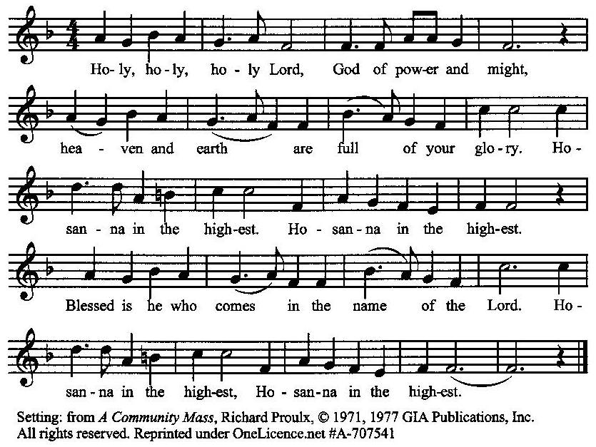

**The Prayer of Humble Access and for Cleansing**

**(the people kneeling or sitting):**

**Minister:** Let us pray together:

**All:** *We do not presume to come to this your table, O merciful Lord, trusting in our own righteousness, but in your many and great mercies. We are not worthy so much as to gather up the crumbs under your table. But You are the same Lord, whose nature is always to have mercy: Grant us, therefore, gracious Lord, so to experience the spiritual presence of your dear Son Jesus Christ at this your table, that we may be made clean by his body and blood, and that we may evermore dwell in him, and he in us. Deliver us, gracious Lord, from the presumption of coming to this table for solace for ourselves only, and not for strength to serve You and others. Deliver us, gracious Lord, from the presumption of coming to this table for pardon of our sins only, and not for transformation of our lives in your holiness. Amen.*

***Epiclesis* Prayer (Invocation of the Holy Spirit upon the Bread and Wine)**

**(the people kneeling or sitting):**

**Minister:** We give thanks to You, O God, for the goodness and love which You have made known to us in creation; in the calling of Israel to be your people; in your Word spoken through the prophets; and above all in the Word made flesh, Jesus, your Son. For in these last days You sent him to be incarnate from the Virgin Mary, to be the Savior and Redeemer of the world. Lord, we pray that in your goodness and mercy your Holy Spirit may descend upon us, and upon these gifts, sanctifying them and showing them to be holy gifts for your holy people, the bread of life and the cup of salvation, the Body and Blood of your Son Jesus Christ. Grant that all who share this bread and cup may become one body and one spirit, a living sacrifice in Christ, to the praise of your Name. Remember, Lord, your one holy catholic and apostolic Church, redeemed by the blood of your Christ. Reveal its unity, guard its faith, and preserve its peace; and grant that we may find our inheritance with the Blessed Virgin Mary, the patriarchs, prophets, apostles and martyrs, and with all the saints who have found favor with You in ages past. We praise You in union with them and give You glory through your Son Jesus Christ our Lord. Through him, and with him, and in him, all honor and glory are yours, Almighty God and Father, in the unity of the Holy Spirit, for ever and ever.

**All:** *Amen.*

**The Words of Institution (the people kneeling or sitting):**

**Minister:** Our Lord Jesus Christ, on the night that he was betrayed took bread; and when he had given thanks, he broke it, and gave it to his disciples, saying, Take, eat; this is my Body which is given for you: do this in remembrance of me.

Likewise, after supper, he took the cup; and when he had given thanks, he gave it to them, saying, Drink this, all of you; for this is my blood of the New Testament, which is shed for you, and for many, for the remission of sins: Do this, as often as you shall drink it, in remembrance of me.

**All:** *Amen.*

**Minister:** Therefore, we proclaim the mystery of faith:

**People:** *Christ has died, Christ is risen, Christ will come again.*

**The Fraction:**

**Minister:** Christ our passover is sacrificed for us.

**People:** *Therefore let us keep the feast.*

**Fraction Anthem (the people kneeling or sitting, singing):**

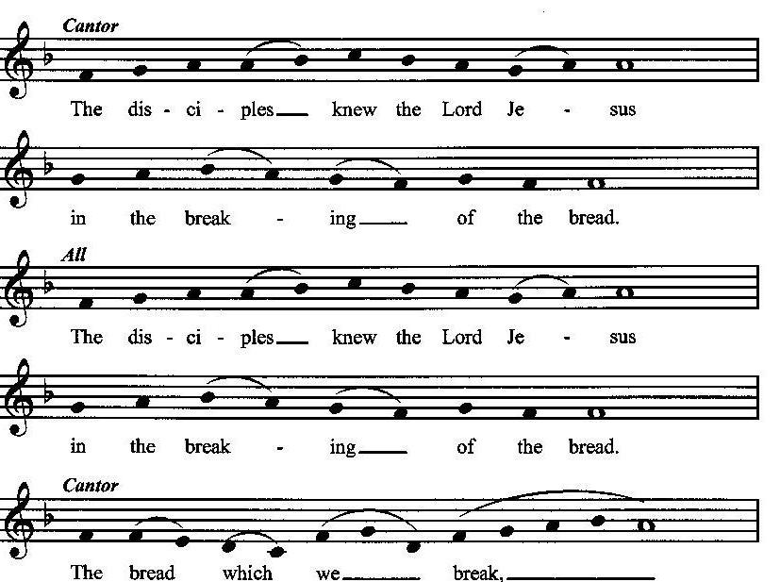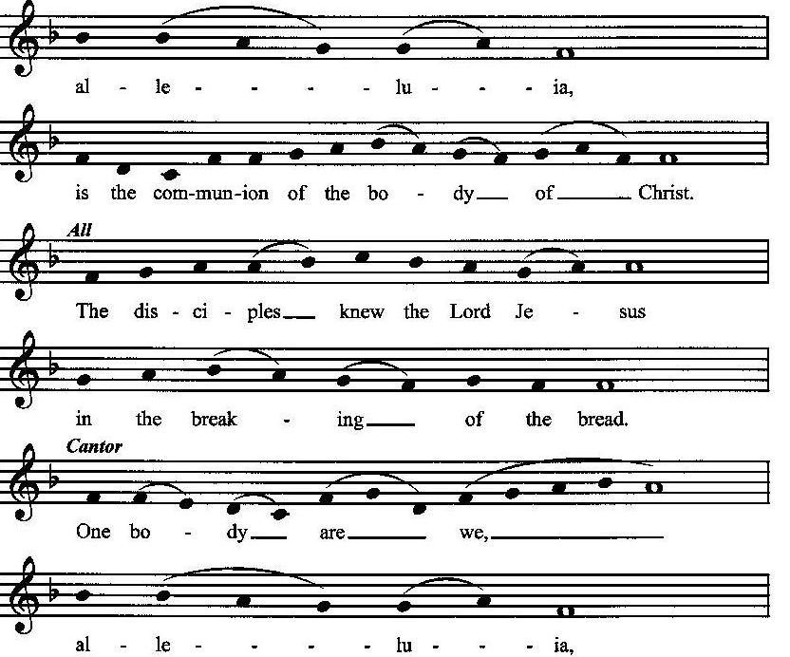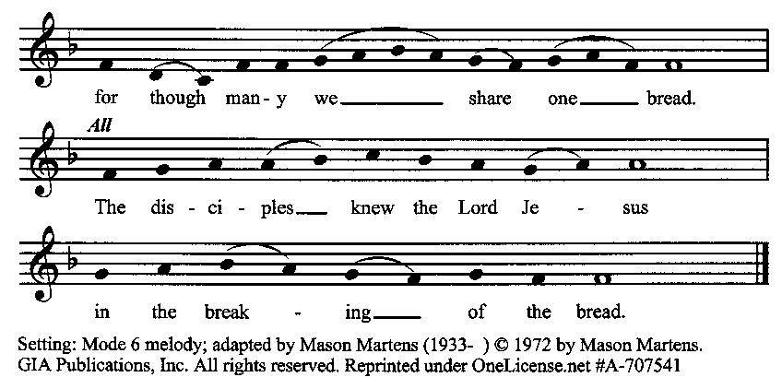

**Minister:** The gifts of God for the people of God. Take them in remembrance that Christ died for you, and feed on him in your hearts by faith with thanksgiving.

**Communion Hymn (cantors only, the people kneeling or sitting):**

“The arm of God is strong and just to scatter all the proud. The tyrants tumble from their thrones and vanish like a cloud. The hungry all are satisfied; the rich are sent away. The poor of earth who suffer long will welcome God’s new day.

The promise made in ages past at last has come to be, for God has come in pow’r to save, to set all people free. Rememb’ring those who wait to see salvation’s dawning day, our Savior comes to all who weep to wipe their tears away.” (My Heart Sings Out with Joyful Praise, vv. 2-3; Ruth Duck)

**The Communion, Open to all:** *(After the minister(s) and acolyte(s) are served, the people come forward to receive, as space is available. The people kneel if they are able, or stand.* **Communion by intincture: The people receive the Bread in their open hands, continue to hold it, then dip the Bread in the cup, and then consume.**) *They return to their seats via the side aisles.*

**Renewal of the Mutual Invocation of God’s Grace for the Eucharist:**

**Minister:** The Lord be with you.

**People:** *And also with you.*

**The Prayer of Thanksgiving and Living Sacrifice:**

**(The minister kneeling, the people kneeling or sitting):**

**Minister:** Let us pray together:

**All:** *O Lord and Heavenly Father, we heartily thank You because You feed us, in these holy mysteries, with the spiritual food of the most precious Body and Blood of your Son our Savior Jesus Christ; because by this You assure us of your favor and goodness toward us; because we are living members of the body of your Son and heirs of your eternal kingdom. We ask You to accept this our sacrifice of praise and thanksgiving, and to grant that by the merits and death of your Son Jesus Christ and through faith in him, we and all your whole Church may obtain all of the benefits of his passion. And here we offer and present unto You, O Lord, ourselves, our souls and bodies, to be a reasonable, holy, and living sacrifice unto You; humbly asking You that we may be filled with your grace and heavenly benediction; through Jesus Christ our Lord; by whom, and with whom, in the Unity of the Holy Spirit, all honor and glory be unto You, O Father Almighty, world without end. Amen.*

**The *Gloria* Prayer of Praise and Thanksgiving (all standing):**

**Minister:** Let us pray together:

**All:** *Glory be to God on high, and on earth peace, good-will toward all people. We praise You, we bless You, we worship You, we glorify You, we give thanks to You for your great glory, O Lord God, heavenly King, God the Father Almighty.**For You only are the Holy One, You only are the Lord, You only, O Christ, with the Holy Spirit, are most high in the glory of God the Father. Amen.*

**ACTS OF DISMISSAL**

**Recessional Hymn (all standing):**

*Hark! The Glad Sound!*  (No. 23)

**The Prayer of Benediction:**

**Minister:** May God our Heavenly Father give you grace, fill you with hope, and prepare you for His coming kingdom; and may the blessing of God Almighty, the Father, the Son, and the Holy Spirit, be among you, and remain with you always.

**All:** *Amen.*

**Minister:** Go in peace, joyfully awaiting His coming.

**People:** *Thanks be to God.* **(The people then be seated.)**

**Greetings and Announcements:**

**Postlude: (The people sit and remain quiet until the candles are extinguished and the organ raises its voice.)**

*_____*__________________________

Based on, and freely adapted from,

John Wesley’s *Order for the Administration of the Lord’s Supper*,

The 1662 and 1979 editions of *The Book of Common Prayer,* and

*Common Worship: Services and Prayers for the Church of England*

**___________________________________________**

**Scripture Lessons for December 29 (Christmas 1)**

Isaiah 61:10-62:3; Psalm 147; Galatians 3:23-25, 4:4-7; John 1:1-18

**Parish Prayer This Week and Next Sunday**

Those living on El Rancho Place

_______________________________________________

**Parish Notices**

**Christmas Eve Service:**

**The Principal Service of the Christmas Season**

**Tuesday, December 24th at 6:00 p.m.**

“From the very beginnings of the Christmas celebration in the early fourth century, the theme of the Christmas season has always been the arrival of the light, the light that has come to dispel darkness.” — Robert E. Webber, *The Services of the Christian Year*, Vol. 5, p. 158.

That early-Church worship began at midnight,and in many churches that remains the practice today. However, because Jewish practice counted the day as beginning with sundown the previous day, the first service after sundown on Christmas Eve counts as the principal service of Christmas Day—and also of the entire 12-day Christmas season. Come join as we celebrate the greatest gift of all: God became one of us!

**Coming Soon: Epiphany Sunday**



Immediately following the 12 days of Christmas is Epiphany, or manifestation. This season celebrates the revealing of the Messiah to the world, which is generally associated with the arrival of the 3 wise men and Jesus’ baptism. Epworth’s annual end-of-Christmas revelry will be held on Sunday, January 5th, immediately following the service. We will have a short pageant, followed by food and a white elephant gift exchange. Please bring something to give that you have around the house but no longer want—one item per member of your family. There will also be Three Kings’ cakes, and sandwiches provided by Parish Life. We also ask that each family bring an appetizer to share.

Following the Epiphany party, we will be taking down all the Christmas decorations and storing them until next year. If you are able to stay for a little while, your help would be greatly appreciated!

**Coming Events at Epworth**

Today, 10:00 am Word & Table Service

Today, 11:40 Afterword (moderated discussion)

Tuesday, 24 DEC Christmas Eve Service (6 pm)

Thursday, 26 DEC NO EVENING PRAYERS

Thursday, 2 JAN NO EVENING PRAYERS

Sunday, 5 JAN Epiphany Sunday (pageant & party)

**January Birthdays & Anniversaries**

10 – Michael Roberts

14 – John & Mindy Crow

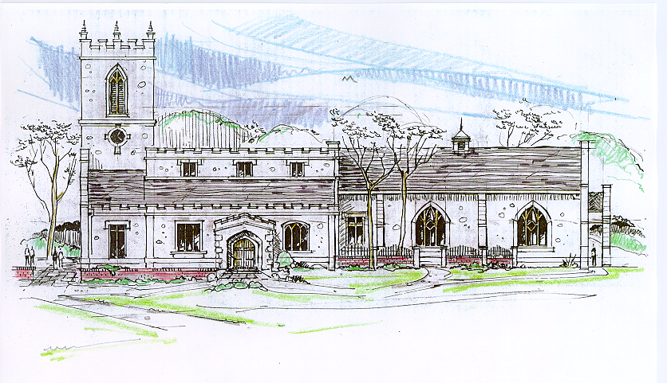

This is an architect’s rendering of St. Andrew’s Church in Epworth, England, the Anglican parish for which Samuel Wesley- poet, Oxford scholar, and the father of John and Charles Wesley and their eight siblings- served as a priest and where the children were raised. In 2005, during a Wesleyan-Anglican Heritage Tour/Spiritual Pilgrimage in England, Epworthies from the Epworth Chapel on the Green in Boise received Communion at St. Andrew’s from the same chalice which John Wesley used to serve Communion as a deacon for his father Samuel. From that heritage, this drawing continues to represent an aspiration for the future appearance of Epworth Free Methodist Church.

**Sermon Notes**

**Epworth Church Office Email**

[epworthchapel.office@gmail.com](mailto:epworthchapel.office@gmail.com)

All correspondence for the office should be sent to this email address.

**Pastor Crow Contact Information**

***Healing prayer is provided every week upon request***

Rev. John Crow, Rector and Pastor

208-501-4037

[rector@epworthchapelonthegreen.org](mailto:rector@epworthchapelonthegreen.org)