**Service of Word and Table**

at

**Epworth Free Methodist Church**

6110 W. Northview Street, Boise, Idaho 83704

208-336-3951

www.epworthfmc.org

The Rev. John Crow, Rector and Pastor

208-501-4037

**December 15, 2024, 10:00 a.m.**

*Third Sunday of Advent (Gaudete Sunday)*

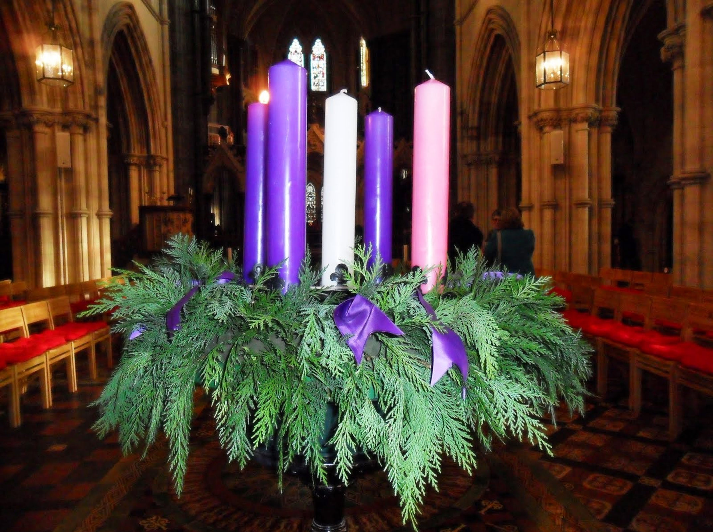

The picture above is licensed under Creative Commons: BY-NC-ND

*_____*__________________________

**“Through the deep current of the historical Wesleyan church we will collaboratively serve and reach the lost in order to make disciples who love Jesus.”**

*____*___________________________

This service will be live streamed, and in the course of that any or all persons who attend may be filmed. Remaining in the service will constitute your consent to appear in the live-streamed, recorded, and published service.

**Rector and Pastor:** The Rev. John Crow

**Cantors:** Bryan Vanshur, Shannon Nichols

**Readers:**

**Old Testament:** Stan Crow

**Psalm:** Stan Crow

**Epistle:** Carol Crosswhite

**Acolytes:** Stephen Crow, Josiah Crow, Corbin Crosswhite, and Jessica Crosswhite

**Jr. Acolytes:** Asher Crow & Lizzie Crosswhite

**Usher:** Asher Crow

______________________________________________

**ACTS OF ENTRANCE**

**Prélude:**

**(The people enter and remain in prayer and meditation, and the candles are lit in silence.)**

**Minister:** In the wilderness prepare the way of the Lord; make straight in the desert a highway for our God.

**People:** *The glory of the Lord shall be revealed, and all flesh shall see it together.*

**Collect for the Third Sunday of Advent (the people sitting):**

**Minister:** Stir up your power, O Lord, and with great might come among us; and, because we are sorely hindered by our sins, let your bountiful grace and mercy speedily help and deliver us; through Jesus Christ our Lord, to whom, with You and the Holy Spirit, be honor and glory, now and for ever.

**All:** *Amen.*

**The “O” Antiphons (the people sitting):**

**Minister:** O Wisdom, who came forth from the mouth of the Most High, reaching from eternity to eternity and ordering all things mightily and sweetly:

**People:** *Come, and teach us the way of prudence.*

**Minister:** O Adonai and Leader of the house of Israel, who appeared to Moses in the flames of the burning bush and gave him the law on Sinai:

**People:** *Come, and with your outstretched arm redeem us.*

**Minister:** O Root of Jesse, who stands for a sign of the people, before whom kings shall keep silence and to whom all nations shall make their supplication:

**People:** *Come, deliver us, and tarry not.*

**Minister:** O Key of David and Scepter of the house of Israel, who opens and no one shuts, who shuts and no one opens:

**People:** *Come and bring forth from prison the captives who sit in darkness and in the shadow of death.*

**Minister:** O Dayspring, Brightness of the Light eternal and Son of Justice:

**People:** *Come, and enlighten them that sit in darkness and in the shadow of death.*

**Minister:** O King of the nations and their Desired One, Cornerstone that makes all people one:

**People:** *Come, and deliver us whom you formed out of the dust of the earth.*

**Minister:** O Emmanuel, our Ruler and Lawgiver, the Expected of the nations and their Savior:

**People:** *Come to save us, O Lord our God.*

**Advent canticle (cantor only):**

“Wholly counter to my nature is the path ordained for me; yet I’ll tread it, yes, and calmly, while thy precious face I see; count the cross a crown, and bear it, cheerful live ‘mid all life’s woes; this the Way which, straight though tangled, to the heav’nly city goes.

Old it is, yet never aging, and its name is Wonderful; ne’er begun, new for ever, making dead men rise up whole; winning all who travel by it; Head and Husband ‘tis to me; sacred way, I’ll pass along it till in it my rest shall be.” (Wholly Counter to My Nature, vv. 1-2; Ann Griffiths)

**Processional Hymn (all standing):**

*There’s a Voice in the Wilderness Crying*  (No. 2)

**Minister:** Blessed be God: Father, Son, and Holy Spirit.

**People:** *And blessed be his kingdom, now and forever.*

**Lord’s Prayer:**

**Minister:** Let us pray.

**(All standing):** *Our Father, who art in heaven, hallowed be thy Name. Thy kingdom come. Thy will be done, on earth as it is in heaven. Give us this day our daily bread. And forgive us our trespasses, as we forgive those who trespass against us. And lead us not into temptation, but deliver us from evil, for thine is the kingdom, and the power, and the glory, for ever and ever.* *Amen.*

**The Collect for Purity:**

**Minister:** Almighty God, unto whom all hearts are open, all desires known, and from whom no secrets are hid; cleanse the thoughts of our hearts by the inspiration of your Holy Spirit, that we may perfectly love You, and worthily magnify your holy Name, through Christ our Lord.

**All:** *Amen.*

**Minister:** Holy God, Holy and Mighty, Holy Immortal One,

**People:** *Have mercy upon us.*

**SERVICE OF THE WORD**

**Mutual Invocation of the Grace of God for the Service of the Word:**

**Minister:** The Lord be with you.

**People:** *And also with you.* **(The people then be seated.)**

**The Ten Commandments (the people sitting):**

**Minister:** God spoke these words, and said, I am the Lord your God:

You shall have no other gods but me.

You shall not make to yourself any graven image, to bow down

to them, or worship them.

You shall not take the name of the Lord your God in vain.

Remember that you keep holy the Sabbath day.

Honor your father and your mother.

You shall not murder.

You shall not commit adultery.

You shall not steal.

You shall not bear false witness against your neighbor.

You shall not covet.

**The Great Commandments:**

**Minister:** Hear what our Lord Jesus Christ says. You shall love the Lord your God with all your heart, and with all your soul, and with all your mind. This is the first and great commandment. And the second is like unto it: You shall love your neighbor as yourself. On these two commandments hang all the Law and the Prophets.

**The Prayer of Confession:**

**(The minister kneels, and the people kneel or sit.)**

**Minister:** Let us confess our sins to God:

**All:** *Almighty and merciful Father, we have erred and strayed from your ways like lost sheep. We have followed too much the devices and desires of our own hearts. We have offended against your holy laws by what we have done, and by what we have left undone. We have not loved You with our whole heart, nor our neighbors as ourselves. Have mercy upon us, O Lord; spare those who are penitent according to your promises in Christ Jesus our Lord; that we may delight in your will, and walk in your ways, to the glory of your holy Name. Amen.*

**The *Agnus Dei* (the people kneeling or sitting):**

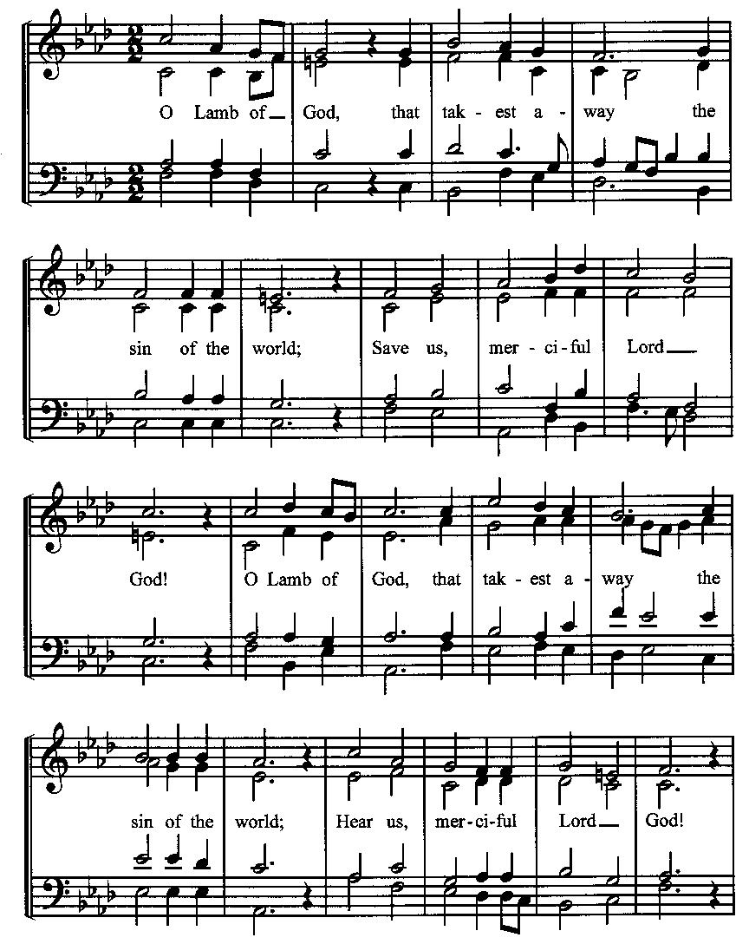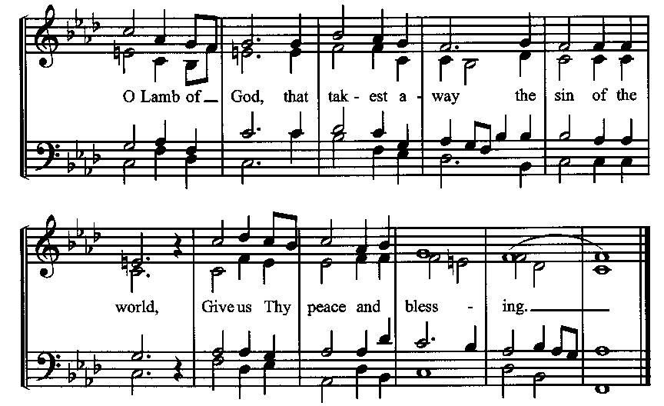

**Prayer for Absolution**

**Minister:** Almighty God have mercy on us, forgive us all our sins through our Lord Jesus Christ, strengthen us in all goodness, and by the power of the Holy Spirit keep us in eternal life.

**All:** *Amen.* **(The people then be seated.)**

**Old Testament Lesson (the people sitting):**

**Reader:** The Old Testament reading is written in the third chapter of the book of the prophet Zephaniah, beginning at verse 14:

1. Sing aloud, O daughter of Zion; shout, O Israel! Rejoice and exult with all your heart, O daughter of Jerusalem!
2. The Lord has taken away the judgments against you; he has cleared away your enemies. The King of Israel, the Lord, is in your midst; you shall never again fear evil.
3. On that day it shall be said to Jerusalem: “Fear not, O Zion; let not your hands grow weak.
4. The Lord your God is in your midst, a mighty one who will save; he will rejoice over you with gladness; he will quiet you by his love; he will exult over you with loud singing.
5. I will gather those of you who mourn for the festival, so that you will no longer suffer reproach.
6. Behold, at that time I will deal with all your oppressors. And I will save the lame and gather the outcast, and I will change their shame into praise and renown in all the earth.
7. At that time I will bring you in, at the time when I gather you together; for I will make you renowned and praised among all the peoples of the earth, when I restore your fortunes before your eyes,” says the Lord. (ESV)

**Reader:** The Word of the Lord.

**People:** *Thanks be to God.*

**The Psalm: (The people sit for the responsive reading, by half-verse, of Psalm 85, a prayer for God’s restoration of Israel.)**

**Reader:** The Psalm is chapter 85, beginning at verse 1.

**Reader:** 1 You have been gracious to your land, O Lord,

**People:** *you have restored the good fortune of Jacob.*

**Reader:** 2 You have forgiven the iniquity of your people

**People:** *and blotted out all our sins.*

**Reader:** 8 I will listen to what the Lord God is saying,

**People:** *for he is speaking peace to his faithful people and to those who turn their hearts to him.*

**Reader:** 9 Truly, his salvation is very near to those who fear him,

**People:** *that his glory may dwell in our land.*

**Reader:** 10 Mercy and truth have met together;

**People:** *righteousness and peace have kissed each other.*

**Reader:** 11 Truth shall spring up from the earth,

**People:** *and righteousness shall look down from heaven.*

**Reader:** 12 The Lord will indeed grant prosperity,

**People:** *and our land will yield its increase.*

**Reader:** 13 Righteousness shall go before him,

**People:** *and peace shall be a pathway for his feet.* (BCP)

***Gloria Patri*:**

**Reader:** Glory be to the Father, and to the Son, and to the Holy Spirit.

**All:** *As it was in the beginning, is now and ever shall be, world without end. Amen.*

**The Epistle (the people sitting):**

**Reader:** The Epistle lesson is written in the fourth chapter of the letter to the Philippians, beginning at verse 4:

1. Rejoice in the Lord always; again I will say, rejoice.
2. Let your reasonableness be known to everyone. The Lord is at hand;
3. do not be anxious about anything, but in everything by prayer and supplication with thanksgiving let your requests be made known to God.
4. And the peace of God, which surpasses all understanding, will guard your hearts and your minds in Christ Jesus. (ESV)

**Reader:** Here ends the Epistle.

**People:** *Thanks be to God.*

**Sequence Hymn (all standing):**

*Hark! A Thrilling Voice is Sounding*, vv. 1-3 (No. 20)

**The Gospel (all standing, and turning toward the Gospel reading):**

**Minister:** The holy Gospel is written in the third chapter of the Gospel according to Luke, beginning at verse 7:

**Minister:**

1. He said therefore to the crowds that came out to be baptized by him, “You brood of vipers! Who warned you to flee from the wrath to come?
2. Bear fruits in keeping with repentance. And do not begin to say to yourselves, ‘We have Abraham as our father.’ For I tell you, God is able from these stones to raise up children for Abraham.
3. Even now the axe is laid to the root of the trees. Every tree therefore that does not bear good fruit is cut down and thrown into the fire.”
4. And the crowds asked him, “What then shall we do?”
5. And he answered them, “Whoever has two tunics is to share with him who has none, and whoever has food is to do likewise.”
6. Tax collectors also came to be baptized and said to him, “Teacher, what shall we do?”
7. And he said to them, “Collect no more than you are authorized to do.”
8. Soldiers also asked him, “And we, what shall we do?” And he said to them, “Do not extort money from anyone by threats or by false accusation, and be content with your wages.”
9. As the people were in expectation, and all were questioning in their hearts concerning John, whether he might be the Christ,
10. John answered them all, saying, “I baptize you with water, but he who is mightier than I is coming, the strap of whose sandals I am not worthy to untie. He will baptize you with the Holy Spirit and fire.
11. His winnowing fork is in his hand, to clear his threshing floor and to gather the wheat into his barn, but the chaff he will burn with unquenchable fire.”
12. So with many other exhortations he preached good news to the people.  (ESV)

**Minister:** The Gospel of the Lord.

**People:** *Praise to You, Lord Christ*.

**Sequence Hymn (all standing):**

*Hark! A Thrilling Voice is Sounding*, vv. 4-5 (No. 20)

[Elementary age children may exit for Children’s Worship in the Parish Hall.

They may return to the service at the Passing of the Peace.]

**Minister:** Grace be unto you, and peace, from our Lord Jesus Christ.

**All:** *Amen.* **(The people then be seated.)**

**The Sermon**

**Minister:** In the name of the Father, and of the Son, and the Holy Spirit.

**Silence, for review of the sermon, and for meditative prayer**

**SERVICE OF THE TABLE: THE GREAT THANKSGIVING**

**The Nicene Creed (all standing):**

**Minister:** Let us confess our faith, saying:

**All:** *We believe in one God,*

*the Father, the Almighty,*

*maker of heaven and earth,*

*of all that is, seen and unseen.*

*We believe in one Lord, Jesus Christ,*

*the only Son of God,*

*eternally begotten of the Father,*

*God from God, Light from Light,*

*true God from true God,*

*begotten, not made,*

*of one Being with the Father.*

*Through him all things were made.*

*For us and for our salvation*

*he came down from heaven:*

*by the power of the Holy Spirit*

*he became incarnate from the Virgin Mary,*

*and was made man.*

*For our sake he was crucified under Pontius Pilate;*

*he suffered death and was buried.*

*On the third day he rose again*

*in accordance with the Scriptures;*

*he ascended into heaven*

*and is seated at the right hand of the Father.*

*He will come again in glory to judge the living and the dead,*

*and his kingdom will have no end.*

*We believe in the Holy Spirit, the Lord, the giver of life,*

*who proceeds from the Father and the Son.*

*With the Father and the Son he is worshiped and glorified.*

*He has spoken through the Prophets.*

*We believe in one holy catholic and apostolic Church.*

*We acknowledge one baptism for the forgiveness of sins.*

*We look for the resurrection of the dead,*

*and the life of the world to come.* *Amen.*

**The Prayers of the People (the people kneeling or sitting):**

**Minister:** Let us pray for the Church and the world. For the unity of the Church throughout the world, that we might faithfully preach the Gospel to the ends of the earth, let us pray to the Lord:

**People:** *Lord, hear our prayer.*

**Minister:** For the persecuted church, and for its persecutors, that You would turn their hearts, let us pray to the Lord:

**People:** *Lord, hear our prayer.*

**Minister:** For our President and all who govern and hold authority in our nation and in the world, let us pray to the Lord:

**People:** *Lord, hear our prayer.*

**Minister:** For the good earth which You have given us, and for the wisdom and will to conserve it, let us pray to the Lord:

**People:** *Lord, hear our prayer.*

**Minister:** For all ministers of your Gospel, that they might faithfully preach your Word, administer your sacraments, and care for your people, let us pray to the Lord:

**People:** *Lord, hear our prayer.*

**Minister:** For the peace of the world, that a spirit of respect and forbearance may grow among all nations and peoples, let us pray to the Lord:

**People:** *Lord, hear our prayer.*

**Minister:** For all those who do not yet believe, and for those who have lost their faith, that in due time we may all stand reconciled before You, let us pray to the Lord:

**People:** *Lord, hear our prayer.*

**Minister:** For the poor and the oppressed, prisoners and captives, the unemployed, and all who are in need or trouble, let us pray to the Lord:

**People:** *Lord, hear our prayer.*

**Minister:** For our enemies and all who wish us harm, and for all whom we have injured or offended, let us pray to the Lord:

**People:** *Lord, hear our prayer.*

**Minister:** For this congregation, that we might show forth your glory in all that we do; and for those who have commended themselves to our prayers, including these: _____________:

[Nation: Bahamas

Denomination: International Pentecostal Holiness Church

Congregation: First Christian Church, Ferrelview, MO and the Rev. Michael McMullen

Ministry: LifeWay

Parishioners: Those living on Curtis Road].

Grant that all of these may be delivered from anxiety, and live in joy, peace, and health.

*(Please add your own intentions, either silently or aloud.)*

**Minister:** Let us pray to the Lord:

**People:** *Lord, hear our prayer.*

**Minister:** We bless your holy Name for the thanksgivings of your people, including these: ____________; for those in every generation in whom Christ has been honored;give us grace to follow their good examples, that with them we may be partakers of your heavenly kingdom.

*(Please add your intentions, either silently or aloud.)*

**Minister:** Let us pray to the Lord:

**People:** *Lord, hear our prayer.*

**Collect:**

**Minister:** Grant us, Lord, not to be anxious about earthly things, but to love things heavenly; and even now, while we are placed among things that are passing away, to hold fast to those that shall endure; through Jesus Christ our Lord, who lives and reigns with You and the Holy Spirit, one God, for ever and ever.

**All:** *Amen*. **(The people then be seated.)**

**The Passing of the Peace:**

**Minister:** The peace of the Lord be always with you.

**People:** *And also with you.*

**Minister:** As the peace of Christ has been extended to you, extend the peace of the Lord to one another, and greet one another in the name of the Lord. **(The people rise and remain standing.)**

*(The people greet one another, saying, “The peace of the Lord be with you,” or, “Peace be with you,” or simply, “Peace.” They respond to one another, “And also with you,” or simply, “Peace”.)*

**Minister: (The people sitting)** Let us with gladness present the offerings and oblations of our life and labor to the Lord.

**Offertory:**

**Offering Hymn (all standing):**

*Praise God, from Whom All Blessings Flow* (No. 83)

**Minister:** All things come from You, O Lord.

**People:** *And of your own have we given You.*

**Preparation for Holy Communion (the people sitting):**

**Minister:** The Lord’s Supper was ordained by God to be a means of conveying grace according to the need of each person. Those for whom it was ordained are all those who know and feel that they want the grace of God, to restrain them from sin, or to forgive their sins, or to assure them of pardon, or to renew their souls in the image of God, or to enter into the holy presence of God in communion with him. No preparation is indispensably necessary, other than a desire to receive the grace God pleases to give. No fitness or church membership is required at the time of communicating, other than a sense of our state, of our utter sinfulness and helplessness apart from Christ. Therefore, if you want such grace as God pleases to give to you, draw near with faith.

**Hymn of Entry Into the Heavenly Worship (all standing):**

*Open Now Thy Gates of Beauty* (No. 438)

**Preparation for the Table:**

**(Minister:** I wash my hands in innocence, and go about your altar, O LORD, proclaiming aloud your praise and telling of all your wonderful deeds.) [Psalm 26:6-7, NIV]

**Entry into the Heavenly Worship *(Sursum Corda)* (all standing):**

**Minister:** The Lord be with you.

**People:**  *And also with you.*

**Minister:** Lift up your hearts.

**People:** *We lift them up unto the Lord.*

**Minister:** Let us give thanks unto the Lord our God.

**People:** *It is meet and right so to do.*

**The Salutation:**

**Minister:** It is very meet, right, and our gladsome duty, that we should at all times, and in all places, give thanks unto you, O Lord, Holy Father, Almighty, Everlasting God,

**The Preface:**

**Minister:** Because You sent your beloved Son to redeem us from sin and death, and to make us heirs in him of everlasting life; that when he shall come again in power and great triumph to judge the world, we may without shame or fear rejoice to behold his appearing.

**Minister:** Therefore, with Angels and Archangels and with all the company of heaven, we laud and magnify your glorious Name, evermore praising You and saying,

**The *Sanctus* (all standing, singing):**

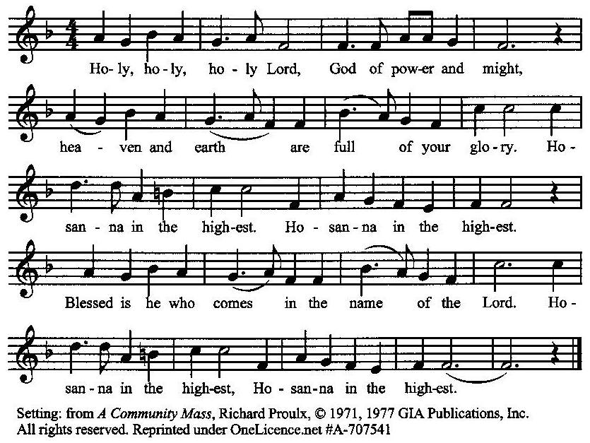

**The Prayer of Humble Access and for Cleansing**

**(the people kneeling or sitting):**

**Minister:** Let us pray together:

**All:** *We do not presume to come to this your table, O merciful Lord, trusting in our own righteousness, but in your many and great mercies. We are not worthy so much as to gather up the crumbs under your table. But You are the same Lord, whose nature is always to have mercy: Grant us, therefore, gracious Lord, so to experience the spiritual presence of your dear Son Jesus Christ at this your table, that we may be made clean by his body and blood, and that we may evermore dwell in him, and he in us. Deliver us, gracious Lord, from the presumption of coming to this table for solace for ourselves only, and not for strength to serve You and others. Deliver us, gracious Lord, from the presumption of coming to this table for pardon of our sins only, and not for transformation of our lives in your holiness. Amen.*

***Epiclesis* Prayer (Invocation of the Holy Spirit upon the Bread and Wine)**

**(the people kneeling or sitting):**

**Minister:** We give thanks to You, O God, for the goodness and love which You have made known to us in creation; in the calling of Israel to be your people; in your Word spoken through the prophets; and above all in the Word made flesh, Jesus, your Son. For in these last days You sent him to be incarnate from the Virgin Mary, to be the Savior and Redeemer of the world. Lord, we pray that in your goodness and mercy your Holy Spirit may descend upon us, and upon these gifts, sanctifying them and showing them to be holy gifts for your holy people, the bread of life and the cup of salvation, the Body and Blood of your Son Jesus Christ. Grant that all who share this bread and cup may become one body and one spirit, a living sacrifice in Christ, to the praise of your Name. Remember, Lord, your one holy catholic and apostolic Church, redeemed by the blood of your Christ. Reveal its unity, guard its faith, and preserve its peace; and grant that we may find our inheritance with the Blessed Virgin Mary, the patriarchs, prophets, apostles and martyrs, and with all the saints who have found favor with You in ages past. We praise You in union with them and give You glory through your Son Jesus Christ our Lord. Through him, and with him, and in him, all honor and glory are yours, Almighty God and Father, in the unity of the Holy Spirit, for ever and ever.

**All:** *Amen.*

**The Words of Institution (the people kneeling or sitting):**

**Minister:** Our Lord Jesus Christ, on the night that he was betrayed took bread; and when he had given thanks, he broke it, and gave it to his disciples, saying, Take, eat; this is my Body which is given for you: do this in remembrance of me.

Likewise, after supper, he took the cup; and when he had given thanks, he gave it to them, saying, Drink this, all of you; for this is my blood of the New Testament, which is shed for you, and for many, for the remission of sins: Do this, as often as you shall drink it, in remembrance of me.

**All:** *Amen.*

**Minister:** Therefore, we proclaim the mystery of faith:

**People:** *Christ has died, Christ is risen, Christ will come again.*

**The Fraction:**

**Minister:** Christ our passover is sacrificed for us.

**People:** *Therefore let us keep the feast.*

**Fraction Anthem (the people kneeling or sitting, singing):**

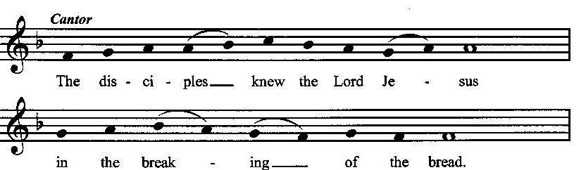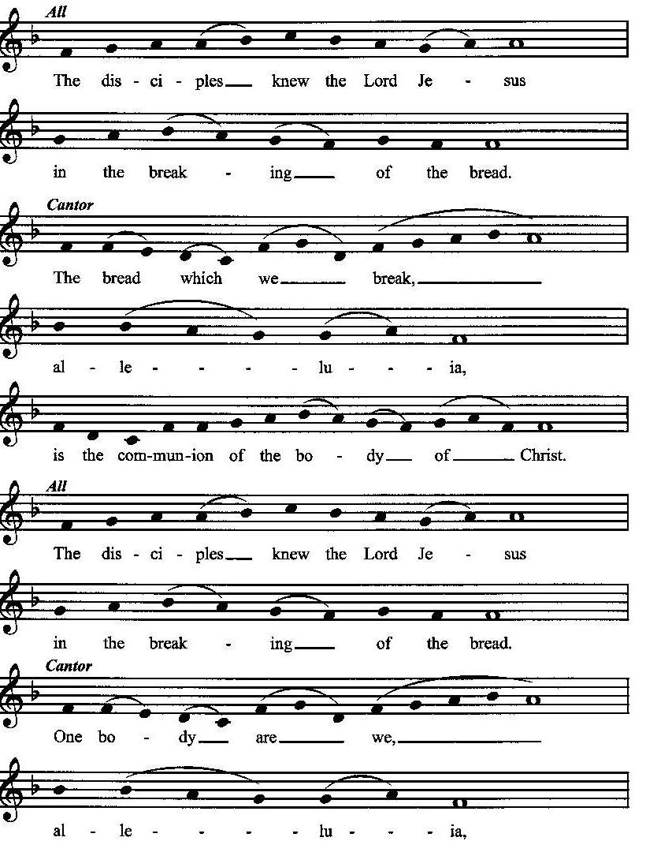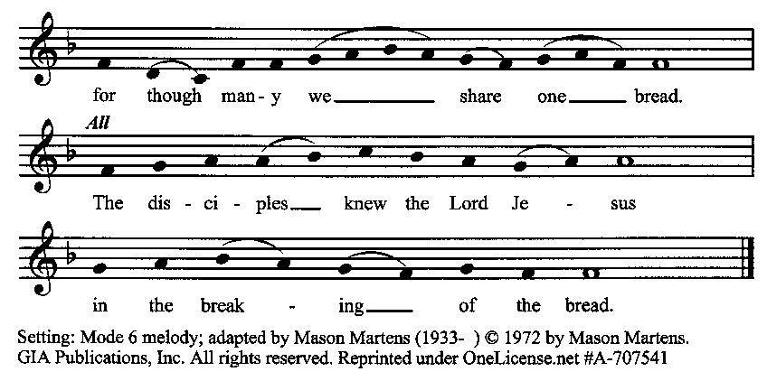

**Minister:** The gifts of God for the people of God. Take them in remembrance that Christ died for you, and feed on him in your hearts by faith with thanksgiving.

**Communion Hymn (cantors only, the people kneeling or sitting):**

“Eye of kite could ne’er discern it, though it shines with noontide blaze; none can tread it, none can see it, save where faith its light displays; breaking ne’er the law of justice, Godless souls it justifies, leads them to God’s peace and favor, bids the dead to life arise.

Way made straight before creation, kept to be revealed at need, when in days of old, in Eden, God proclaimed the woman’s Seed; His new covenant’s foundation, once decreed ere time began, ‘tis the wine whose ample virtue glads the heart of God and man.” (Wholly Counter to My Nature, vv. 3-4; Ann Griffiths)

**The Communion, Open to all:** *(After the minister(s) and acolyte(s) are served, the people come forward to receive, as space is available. The people kneel if they are able, or stand.* **Communion by intincture: The people receive the Bread in their open hands, continue to hold it, then dip the Bread in the cup, and then consume.**) *They return to their seats via the side aisles.*

**Renewal of the Mutual Invocation of God’s Grace for the Eucharist:**

**Minister:** The Lord be with you.

**People:** *And also with you.*

**The Prayer of Thanksgiving and Living Sacrifice:**

**(The minister kneeling, the people kneeling or sitting):**

**Minister:** Let us pray together:

**All:** *O Lord and Heavenly Father, we heartily thank You because You feed us, in these holy mysteries, with the spiritual food of the most precious Body and Blood of your Son our Savior Jesus Christ; because by this You assure us of your favor and goodness toward us; because we are living members of the body of your Son and heirs of your eternal kingdom. We ask You to accept this our sacrifice of praise and thanksgiving, and to grant that by the merits and death of your Son Jesus Christ and through faith in him, we and all your whole Church may obtain all of the benefits of his passion. And here we offer and present unto You, O Lord, ourselves, our souls and bodies, to be a reasonable, holy, and living sacrifice unto You; humbly asking You that we may be filled with your grace and heavenly benediction; through Jesus Christ our Lord; by whom, and with whom, in the Unity of the Holy Spirit, all honor and glory be unto You, O Father Almighty, world without end. Amen.*

**The *Gloria* Prayer of Praise and Thanksgiving (all standing):**

**Minister:** Let us pray together:

**All:** *Glory be to God on high, and on earth peace, good-will toward all people. We praise You, we bless You, we worship You, we glorify You, we give thanks to You for your great glory, O Lord God, heavenly King, God the Father Almighty.**For You only are the Holy One, You only are the Lord, You only, O Christ, with the Holy Spirit, are most high in the glory of God the Father. Amen.*

**ACTS OF DISMISSAL**

**Recessional Hymn (all standing):**

*On Jordan’s Bank the Baptist’s Cry*  (No. 35)

**The Prayer of Benediction:**

**Minister:** May God our Heavenly Father give you grace, fill you with hope, and prepare you for His coming kingdom; and may the blessing of God Almighty, the Father, the Son, and the Holy Spirit, be among you, and remain with you always.

**All:** *Amen.*

**Minister:** Go in peace, joyfully awaiting His coming.

**People:** *Thanks be to God.* **(The people then be seated.)**

**Greetings and Announcements:**

**Postlude: (The people sit and remain quiet until the candles are extinguished and the organ raises its voice.)**

*_____*__________________________

Based on, and freely adapted from,

John Wesley’s *Order for the Administration of the Lord’s Supper*,

The 1662 and 1979 editions of *The Book of Common Prayer,* and

*Common Worship: Services and Prayers for the Church of England*

**___________________________________________**

**Scripture Lessons for December 22 (Advent 4)**

Micah 5:2-5; Psalm 80:1-7; Hebrews 10:5-10; Luke 1:39-45

**Parish Prayer This Week and Next Sunday**

Those living on El Rancho Drive

_______________________________________________

**Parish Notices**

**Last Day for Poinsettias**

Would you like to honor or memorialize someone with a Poinsettia? They are $10 per plant. Please write the name or names of those you are honoring on the prepared sign-up sheet. You can mark your check Poinsettia and put in the offering plate. The list of those honored or memorialized will be listed in the folders for Christmas Eve. The deadline to sign the sheet is today, December 15.

**Todasy: Koelsch Christmas Market gifts due**

We are assisting Koelsch Elementary in their Christmas market. Gently used (or new) items are requested as items the students can pick as gifts for loved ones. There is a small table in the Parish Hall where these gifts can be dropped off. Thank you to everyone who participated. Today is the last day to drop off gifts.

**Last Week of Advent Evening Prayers**

Advent Evening Prayers are this Tuesday and Thursday. Join us as we prepare our hearts for the coming of our Lord.

**Christmas Eve Service:**

**The Principal Service of the Christmas Season**

**Tuesday, December 24th at 6:00 p.m.**

“From the very beginnings of the Christmas celebration in the early fourth century, the theme of the Christmas season has always been the arrival of the light, the light that has come to dispel darkness.” — Robert E. Webber, *The Services of the Christian Year*, Vol. 5, p. 158.

That early-Church worship began at midnight,and in many churches that remains the practice today. However, because Jewish practice counted the day as beginning with sundown the previous day, the first service after sundown on Christmas Eve counts as the principal service of Christmas Day—and also of the entire 12-day Christmas season. Come join as we celebrate the greatest gift of all: God became one of us!

**Capital Campaign for Furnishing Wesley House**

**and the New Parish Hall**



We have a new property, and now we need to furnish it for use and ministry!

To help us to do that, the church board has authorized a campaign to raise money for the purchase of furniture, equipment, technology (including hardware, software, memberships and subscriptions), wall hangings and coverings, window coverings, floor coverings, signs, locks, decorations, dishware, utensils, kitchenware, lamps, tools, and whatever else.

Already, money has been contributed for the purchase of chairs for the new parish hall, which makes a good start.

You may contribute money simply by indicating “capital campaign” on your check in the offering plate. If you wish to contribute furniture or other physical items, arrange for that with Pastor John. Appropriate contribution receipts will be provided. And please be sure that these donations are above your regular tithe instead of replacing your tithe.

**Coming Events at Epworth**

Today, 10:00 am Word & Table Service

Today, 11:40 Afterword (moderated discussion)

Tuesday, 17 DEC Advent Evening Prayers (7:00)

Thursday, 19 DEC Advent Evening Prayers (7:00)

Sunday, 22 DEC Advent 4

Tuesday, 24 DEC Christmas Eve Service (6 pm)

**December Birthdays & Anniversaries**

14 – Stan & Donna Crow

**Sermon Notes**

**Epworth Church Office Email**

[epworthchapel.office@gmail.com](mailto:epworthchapel.office@gmail.com)

All correspondence for the office should be sent to this email address.

**Pastor Crow Contact Information**

***Healing prayer is provided every week upon request***

Rev. John Crow, Rector and Pastor

208-501-4037

[rector@epworthchapelonthegreen.org](mailto:rector@epworthchapelonthegreen.org)