**Service of Word & Table**

at

**Epworth Chapel on the Green**

6110 W. Northview Street, Boise, Idaho 83704

208-336-3951

www.epworthchapelonthegreen.org

The Rev. John Crow, Rector and Pastor

208-501-4037

**October 20, 2024, 10:00 a.m.**

*Harvest Festival*

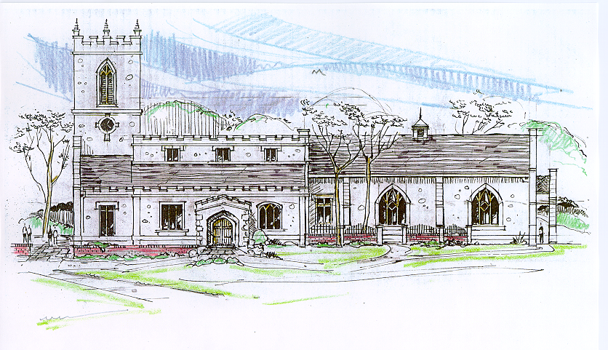

*____*___________________________________________

**“Through the deep current of the historical wesleyan church we will collaboratively serve and reach the lost in order to make disciples who love Jesus.”**

*_________________________*___________________________

This service will be live streamed, and in the course of that any or all persons who attend may be filmed. Remaining in the service will constitute your consent to appear in the live-streamed, recorded, and published service

**Rector and Pastor:** The Rev. John Crow

**Cantors:** Bryan Vanshur, Shannon Nichols

**Readers:**

**Old Testament:** Stan Crow

**Psalm:** Stan Crow

**Epistle:** Donna Crow

**Acolytes:** Stephen Crow, Josiah Crow, Corbin Crosswhite, Jessica Crosswhite

**Jr. Acolytes:** Asher Crow, & Lizzie Crosswhite

**Usher:** Asher Crow

_______________________________

**ACTS OF ENTRANCE**

**(The people enter and remain in prayer and meditation.)**

**Prelude:**

**Entrance canticle (cantors only):**

“Let all things now living a song of thanksgiving to God the Creator triumphantly raise; Who fashioned and made us, protected and stayed us, who still guides us on to the end of our days. God’s banners are o’er us; His light goes before us; a pillar of fire shining forth in the night Till shadows have vanished and darkness is banished, as forward we travel from light into light.” (Let All Things Now Living*,* v. 1; Katherine Davis)

**Processional Hymn (all standing, singing):**

*Praise, My Soul, the King of Heaven* (No. 455)

**Minister:** Blessed be God: Father, Son, and Holy Spirit.

**People:** *And blessed be his kingdom, now and forever.*

**Lord’s Prayer:**

**Minister:** Let us pray.

**(All standing):** *Our Father, who art in heaven, hallowed be thy Name. Thy kingdom come. Thy will be done, on earth as it is in heaven. Give us this day our daily bread. And forgive us our trespasses, as we forgive those who trespass against us. And lead us not into temptation, but deliver us from evil, for thine is the kingdom, and the power, and the glory, for ever and ever.* *Amen.*

**The Collect for Purity:**

**Minister:** Almighty God, unto whom all hearts are open, all desires known, and from whom no secrets are hid; cleanse the thoughts of our hearts by the inspiration of your Holy Spirit, that we may perfectly love You, and worthily magnify your holy Name, through Christ our Lord.

**All:** *Amen.*

**The *Gloria* Hymn (all standing):**

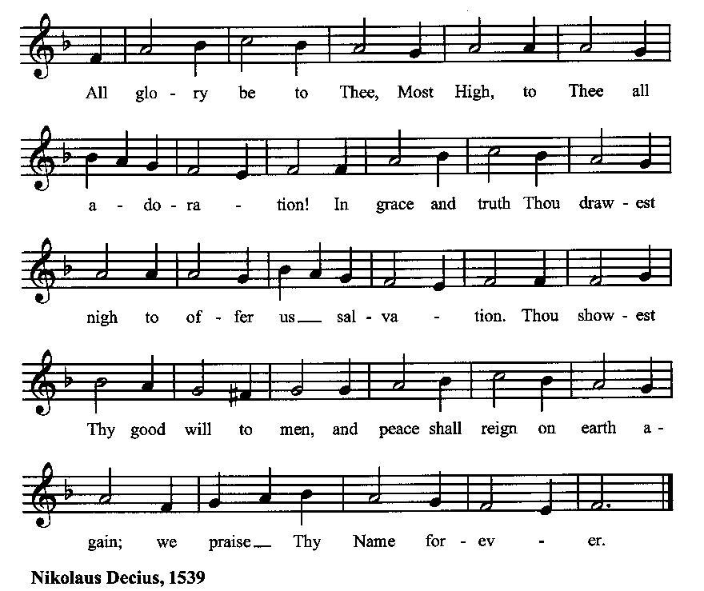

**Minister:** Holy God, Holy and Mighty, Holy Immortal One,

**People:** *Have mercy upon us.*

**SERVICE OF THE WORD**

**Mutual Invocation of the Grace of God for the Service of the Word:**

**Minister:** The Lord be with you.

**People:** *And also with you.*

**(The people then be seated.)**

**The Ten Commandments (the people sitting):**

**Minister:** God spoke these words, and said, I am the Lord your God:

You shall have no other gods but me.

You shall not make to yourself any graven image, to bow down to them, or worship them.

You shall not take the name of the Lord your God in vain.

Remember that you keep holy the Sabbath day.

Honor your father and your mother.

You shall not murder.

You shall not commit adultery.

You shall not steal.

You shall not bear false witness against your neighbor.

You shall not covet.

**The Great Commandments (the people sitting):**

**Minister:** Hear what our Lord Jesus Christ says. You shall love the Lord your God with all your heart, and with all your soul, and with all your mind. This is the first and great commandment. And the second is like unto it: You shall love your neighbor as yourself. On these two commandments hang all the Law and the Prophets.

**The *Kyrie* (the people sitting, singing):**

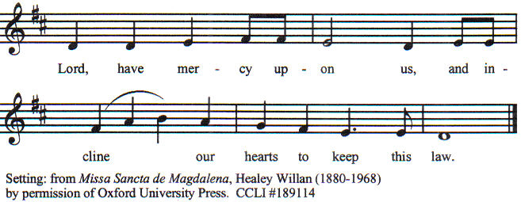

**Old Testament Lesson (the people sitting):**

**Reader:** The Old Testament lesson is written in the eighth chapter of the book of Deuteronomy, beginning at verse 6:

1. So you shall keep the commandments of the Lord your God by walking in his ways and by fearing him.
2. For the Lord your God is bringing you into a good land, a land of brooks of water, of fountains and springs, flowing out in the valleys and hills,
3. a land of wheat and barley, of vines and fig trees and pomegranates, a land of olive trees and honey,
4. a land in which you will eat bread without scarcity, in which you will lack nothing, a land whose stones are iron, and out of whose hills you can dig copper.
5. And you shall eat and be full, and you shall bless the Lord your God for the good land he has given you.
6. “Take care lest you forget the Lord your God by not keeping his commandments and his rules and his statutes, which I command you today,
7. lest, when you have eaten and are full and have built good houses and live in them,
8. and when your herds and flocks multiply and your silver and gold is multiplied and all that you have is multiplied,
9. then your heart be lifted up, and you forget the Lord your God, who brought you out of the land of Egypt, out of the house of slavery,
10. who led you through the great and terrifying wilderness, with its fiery serpents and scorpions and thirsty ground where there was no water, who brought you water out of the flinty rock,
11. who fed you in the wilderness with manna that your fathers did not know, that he might humble you and test you, to do you good in the end.
12. Beware lest you say in your heart, ‘My power and the might of my hand have gotten me this wealth.’
13. You shall remember the Lord your God, for it is he who gives you power to get wealth, that he may confirm his covenant that he swore to your fathers, as it is this day. (ESV)

**Reader:** The Word of the Lord*.*

**People:** *Thanks be to God.*

**The Psalm: (The people sit for the responsive reading, by half-verse, of Psalm 113, a song of praise to God who helps the weak and the poor.)**

**Reader:** The Psalm is chapter 113, beginning at verse 1.

**Reader:** 1 Hallelujah! Give praise, you servants of the LORD;

**People:** *praise the Name of the LORD.*

**Reader:** 2 Let the Name of the LORD be blessed,

**People:** *from this time forth for evermore.*

**Reader:** 3 From the rising of the sun to its going down

**People:** *let the Name of the LORD be praised.*

**Reader:** 4 The LORD is high above all the nations,

**People:** *and his glory above the heavens.*

**Reader:** 5 Who is like the LORD our God, who sits enthroned on high,

**People:** *but stoops to behold the heavens and the earth?*

**Reader:** 6 He takes up the weak out of the dust

**People:** *and lifts up the poor from the ashes.*

**Reader:** 7 He sets them with the princes,

**People:** *with the princes of his people.*

**Reader:** 8 He makes the woman of a childless house

**People:** *to be a joyful mother of children.* (BCP)

***Gloria Patri*** **(the people sitting)**

**Reader:** Glory be to the Father, and to the Son, and to the Holy Spirit;

**People:** *As it was in the beginning, is now and ever shall be, world without end. Amen.*

**Collect for the Twenty-first Sunday after Pentecost (the people sitting):**

**Minister:** O merciful Creator, your hand is open wide to satisfy the needs of every living creature: Make us always thankful for your loving providence; and grant that we, remembering the account that we must one day give, may be faithful stewards of your good gifts; through Jesus Christ our Lord, who with you and the Holy Spirit lives and reigns, one God, for ever and ever.

**All:** *Amen.*

**The Epistle (the people sitting):**

**Reader:** The epistle lesson is written in the ninth chapter of the second letter to the church in Corinth, beginning at verse 6:

1. The point is this: whoever sows sparingly will also reap sparingly, and whoever sows bountifully will also reap bountifully.
2. Each one must give as he has decided in his heart, not reluctantly or under compulsion, for God loves a cheerful giver.
3. And God is able to make all grace abound to you, so that having all sufficiency in all things at all times, you may abound in every good work.
4. As it is written, “He has distributed freely, he has given to the poor;  
   his righteousness endures forever.”
5. He who supplies seed to the sower and bread for food will supply and multiply your seed for sowing and increase the harvest of your righteousness.
6. You will be enriched in every way to be generous in every way, which through us will produce thanksgiving to God.
7. For the ministry of this service is not only supplying the needs of the saints but is also overflowing in many thanksgivings to God.
8. By their approval of this service, they will glorify God because of your submission that comes from your confession of the gospel of Christ, and the generosity of your contribution for them and for all others,
9. while they long for you and pray for you, because of the surpassing grace of God upon you.
10. Thanks be to God for his inexpressible gift! (ESV)

**Reader:** Here ends the Epistle.

**People:** *Thanks be to God.*

**Sequence Hymn (all standing):**

*Come, Ye Thankful People, Come,* vv. 1-2 (No. 456)

**The Gospel (all standing, and turning toward the Gospel reading):**

**Minister:** The holy Gospel is written in the seventeenth chapter of the Gospel according to Luke, beginning at verse 11:

**Minister:**

1. On the way to Jerusalem he was passing along between Samaria and Galilee.
2. And as he entered a village, he was met by ten lepers, who stood at a distance
3. and lifted up their voices, saying, “Jesus, Master, have mercy on us.”
4. When he saw them he said to them, “Go and show yourselves to the priests.” And as they went they were cleansed.
5. Then one of them, when he saw that he was healed, turned back, praising God with a loud voice;
6. and he fell on his face at Jesus' feet, giving him thanks. Now he was a Samaritan.
7. Then Jesus answered, “Were not ten cleansed? Where are the nine?
8. Was no one found to return and give praise to God except this foreigner?”
9. And he said to him, “Rise and go your way; your faith has made you well.” (ESV)

**Minister:** The Gospel of the Lord.

**People:** *Praise to You, Lord Christ*.

**Sequence Hymn (all standing):**

*Come, Ye Thankful People, Come,* vv. 3-4 (No. 456)

[Elementary age children may exit for Children's Worship in the Parish Hall.

They will return to the service at the Passing of the Peace.]

**Minister:** Grace be unto you, and peace, from our Lord Jesus Christ.

**All:** *Amen.* **(The people then be seated.)**

**The Sermon**

**Minister:** In the name of the Father, the Son and the Holy Spirit.

**All:** *Amen.*

**Silence, for review of the sermon, and for meditative prayer**

**SERVICE OF THE TABLE: THE GREAT THANKSGIVING**

**The Nicene Creed (all standing):**

**Minister:** Let us confess our faith, saying:

**All:** *We believe in one God,*

*the Father, the Almighty,*

*maker of heaven and earth,*

*of all that is, seen and unseen.*

*We believe in one Lord, Jesus Christ,*

*the only Son of God,*

*eternally begotten of the Father,*

*God from God, Light from Light,*

*true God from true God,*

*begotten, not made,*

*of one Being with the Father.*

*Through him all things were made.*

*For us and for our salvation*

*he came down from heaven:*

*by the power of the Holy Spirit*

*he became incarnate from the Virgin Mary,*

*and was made man.*

*For our sake he was crucified under Pontius Pilate;*

*he suffered death and was buried.*

*On the third day he rose again*

*in accordance with the Scriptures;*

*he ascended into heaven*

*and is seated at the right hand of the Father.*

*He will come again in glory to judge the living and the dead,*

*and his kingdom will have no end.*

*We believe in the Holy Spirit, the Lord, the giver of life,*

*who proceeds from the Father and the Son.*

*With the Father and the Son he is worshiped and glorified.*

*He has spoken through the Prophets.*

*We believe in one holy catholic and apostolic Church.*

*We acknowledge one baptism for the forgiveness of sins.*

*We look for the resurrection of the dead,*

*and the life of the world to come.* *Amen.*

**Minister: (The people sitting)** Let us with gladness present the offerings and oblations of our life and labor to the Lord.

**Offertory:**

**Offering Hymn (all standing):**

*As Saints of Old Their First Fruits Brought*  (No. 454)

**Minister:** All things come from You, O Lord,

**People:** *And of your own have we given You.*

**Special Harvest Festival Food Collection for the Poor**

**The Prayers of the People (the people kneeling or sitting):**

**Minister:** Let us pray for the Church and the world. Almighty God, we pray for your Church throughout the world; grant that our divisions may cease, that we may be one, and that we may be found without fault at the day of your coming, let us pray to the Lord:

**People:** *Lord, hear our prayer.*

**Minister:** For our President and for wisdom for the citizens of our country as we enter the season of selecting our leaders, let us pray to the Lord:

**People:** *Lord, hear our prayer.*

**Minister:** For all ministers of your Gospel, that they might faithfully preach your Word, administer your sacraments, and care for your people, let us pray to the Lord:

**People:** *Lord, hear our prayer.*

**Minister:** For the peace of the world, that a spirit of respect and forbearance may grow among all nations and peoples, let us pray to the Lord:

**People:** *Lord, hear our prayer.*

**Minister:** For our enemies and all who wish us harm, and for all whom we have injured or offended, let us pray to the Lord:

**People:** *Lord, hear our prayer.*

**Minister:** For this congregation, that we might show forth your glory in all that we do; and for those who have commended themselves to our prayers, including these: _____________:

[Nation: Andorra

Denomination: General Association of Separate Baptists

Congregation: Radcliff First Assembly of God in Radcliff, KY, and the Rev. Herman Gilley

Ministry: National Right to Life Committee

Parishioners: Those living on Bay Street],

Grant that all of these may be delivered from anxiety, and live in joy, peace, and health.

*(Please add your own intentions, either silently or aloud.)*

**Minister:** Let us pray to the Lord:

**People:** *Lord, hear our prayer.*

**Minister:** We bless your holy Name for the thanksgivings of your people, including these: _________; for those in every generation in whom Christ has been honored;Give us grace to follow their good examples, that with them we may be partakers of your heavenly kingdom.

*(Please add your intentions, either silently or aloud.)*

**Minister:** Let us pray to the Lord:

**People:** *Lord, hear our prayer*

**Collect (the people kneeling or sitting):**

**Minister:** Almighty God, grant that the words which we have heard this day with our outward ears, may, through your grace, be so grafted inwardly in our hearts, that they may bring forth in us the fruit of good living, to the honor and praise of your Name; through Jesus Christ our Lord. Almighty God, who hast given us this good land for our heritage: We humbly beseech thee that we may always prove ourselves a people mindful of thy favor and glad to do thy will. Bless our land, save us from violence, discord, and confusion; from pride and arrogance, and from every evil way. Defend our liberties, and fashion into one united people the multitudes brought hither out of many kindreds and tongues. Endue with the spirit of wisdom those to whom in thy Name we entrust the authority of government, that there may be justice and peace at home, and that, through obedience to thy law, we may show forth thy praise among the nations of the earth; all which we ask through Jesus Christ our Lord.

**All:** *Amen*.

**Preparation for Holy Communion (the people sitting):**

**Minister:** The Lord’s Supper was ordained by God to be a means of conveying grace according to the need of each person. Those for whom it was ordained are all those who know and feel that they want the grace of God, to restrain them from sin, or to forgive their sins, or to assure them of pardon, or to renew their souls in the image of God, or to enter into the holy presence of God in communion with him. No preparation is indispensably necessary, other than a desire to receive the grace God pleases to give. No fitness or church membership is required at the time of communicating, other than a sense of our state, of our utter sinfulness and helplessness apart from Christ. Therefore, if you want such grace as God pleases to give to you, draw near with faith, and as you prepare to receive this holy sacrament to your comfort and strength, make your sincere confession to Almighty God, kneeling if you wish and are able, or otherwise sitting.

**The Prayer of Confession, Petition and Thanksgiving:**

**(The minister kneels, and the people kneel or sit.)**

**Minister:** Let us pray together:

**All:** *Most merciful God, we confess that we have sinned against thee in thought, word, and deed, by what we have done, and by what we have left undone. We have not loved thee with our whole heart; we have not loved our neighbors as ourselves. We are truly sorry and we humbly repent. For the sake of thy Son Jesus Christ, have mercy on us and forgive us; that we may delight in thy will, and walk in thy ways, to the glory of thy Name. Amen.*

**The *Agnus Dei* (the people kneeling or sitting, singing):**

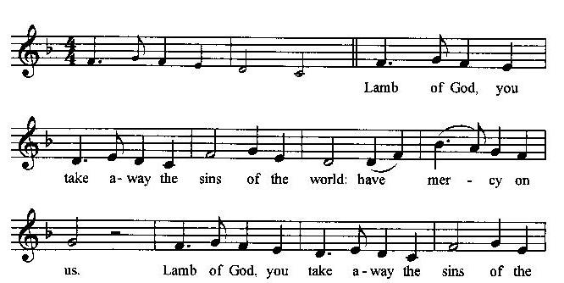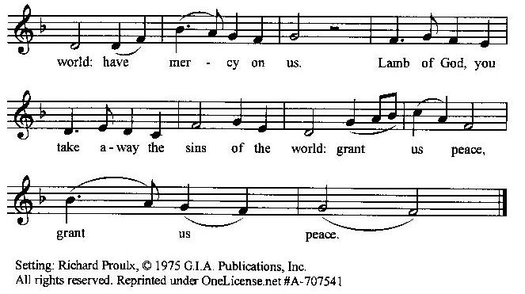

**Prayer for Absolution (the people kneeling or sitting):**

**Minister:** Almighty God, our heavenly Father, who of your great mercy has promised forgiveness of sins to all those who with hearty repentance and true faith turn unto You; Have mercy upon us; pardon and deliver us from all our sins, confirm and strengthen us in all goodness, and bring us to everlasting life, through Jesus Christ our Lord.

**All:** *Amen.*

**The Comforting Words of Forgiveness (the people sitting):**

**Minister:** Hear what comforting words our Savior Christ says to all who truly turn to him: Come to me, all you who are weary and carry heavy burdens, and I will give you rest. God so loved the world that he gave his only Son, so that everyone who believes in him will not perish but have eternal life. Hear also what St. Paul says: Christ Jesus came into the world to save sinners. Hear also what St. John says: If anyone sins, we have an Advocate with the Father, Jesus Christ the righteous: and he is the atonement for our sins.

**The Passing of the Peace:**

**Minister:** The peace of the Lord be always with you.

**People:** *And also with you.*

**Minister:** As the peace of Christ has been extended to you, extend the peace of the Lord to one another, and greet those who are near to you in the name of the Lord. **(The people rise and remain standing.)**

*(The people greet those near to them, saying, “The peace of the Lord be with you,” or, “Peace be with you,” or simply, “Peace.” They respond to one another, “And also with you,” or simply, “Peace”.)*

**Hymn of Entry Into the Heavenly Worship (all standing):**

*Christ, from Whom All Blessings Flow* (No. 453)

**Preparation for the Table:**

**(Minister:** I wash my hands in innocence, and go about your altar, O LORD, proclaiming aloud your praise and telling of all your wonderful deeds). [Psalm 26:6-7, NIV]

**The *Sursum Corda* (all standing):**

**Minister:** The Lord be with you.

**People:** *And also with you.*

**Minister:** Lift up your hearts.

**People:** *We lift them up unto the Lord*.

**Minister:** Let us give thanks unto our Lord God.

**People:** *It is meet and right so to do.*

**The Salutation:**

**Minister:** It is very meet, right, and our gladsome duty, that we should at all times, and in all places, give thanks unto You, O Lord, Holy Father, Almighty, Everlasting God,

**The Preface:**

**Minister:** Through Jesus Christ our Lord. In fulfillment of his true promise, the Holy Spirit came down from heaven, lighting upon the disciples, to teach them and to lead them into all truth; uniting peoples of many tongues in the confession of one faith, and giving to your Church the power to serve You as a royal priesthood, and to preach the Gospel to all nations.

**Minister:** Therefore, with Angels and Archangels and with all the company of heaven, we laud and magnify your glorious Name, evermore praising You, and saying,

**The *Sanctus* (the people standing, singing):**

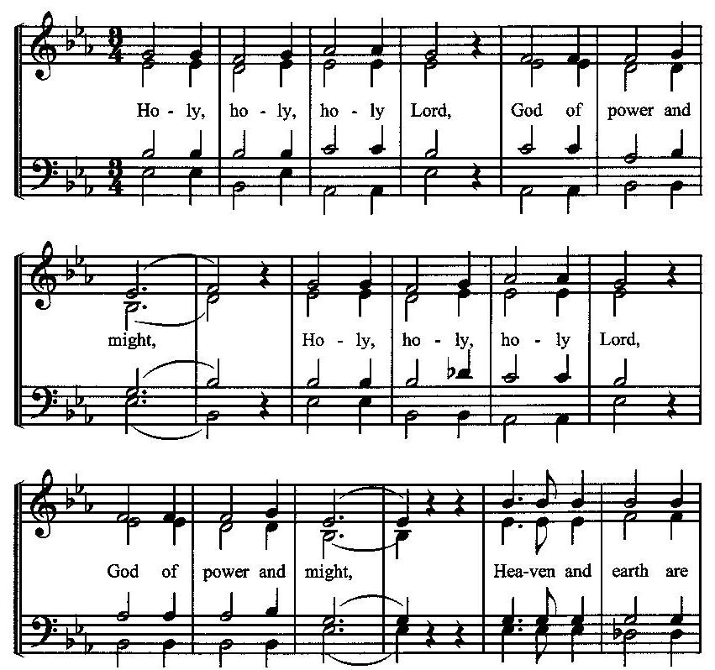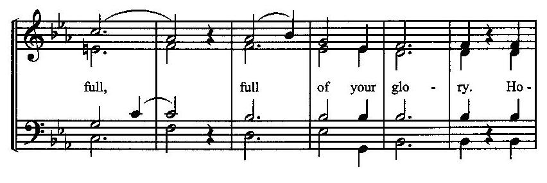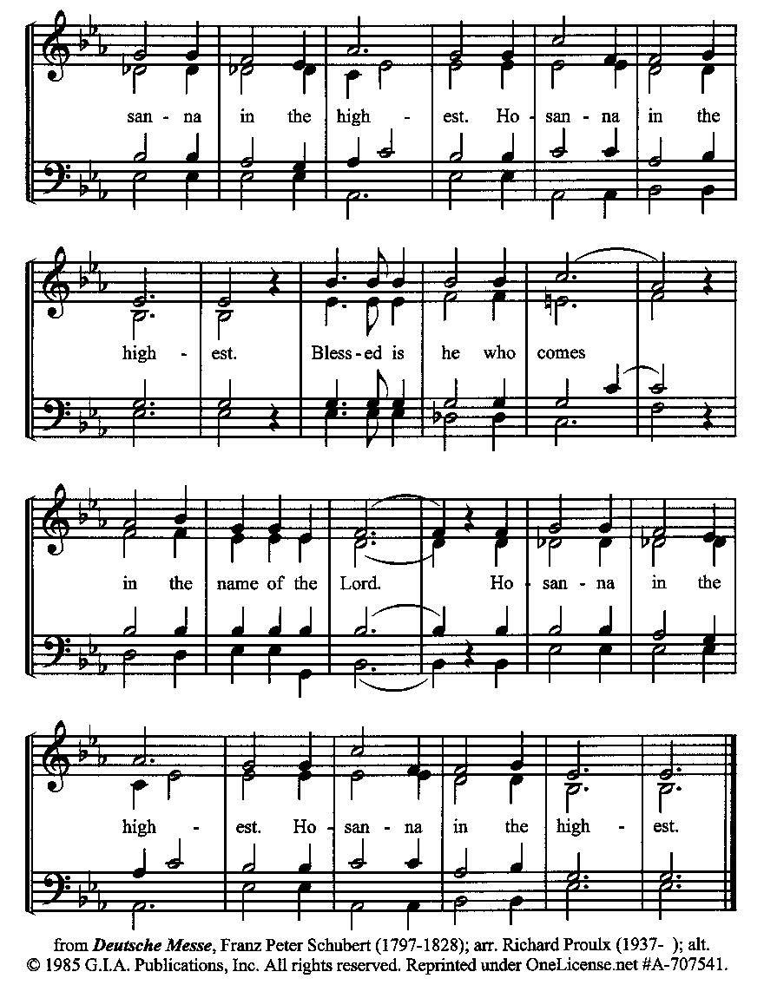

**The Prayer of Humble Access and for Cleansing**

**(the people kneeling or sitting):**

**Minister:** Let us pray together:

**All:** *We do not presume to come to this your table, O merciful Lord, trusting in our own righteousness, but in your many and great mercies. We are not worthy so much as to gather up the crumbs under your table. But You are the same Lord, whose nature is always to have mercy: Grant us, therefore, gracious Lord, so to experience the spiritual presence of your dear Son Jesus Christ at this your table, that we may be made clean by his body and blood, and that we may evermore dwell in him, and he in us. Deliver us, gracious Lord, from the presumption of coming to this table for solace for ourselves only, and not for strength to serve You and others. Deliver us, gracious Lord, from the presumption of coming to this table for pardon of our sins only, and not for transformation of our lives in your holiness. Amen.*

***Epiclesis* Prayer (the people kneeling or sitting):**

**Minister:** Holy and gracious Father, in your infinite love You made us for yourself; and, when we had fallen into sin and become subject to evil and death, You sent Jesus Christ, your only and eternal Son, to share our human nature, to live and die as one of us, to reconcile us to You, the God and Father of all. He stretched out his arms upon the cross and offered himself, in obedience to your will, a perfect sacrifice for the sins of the whole world. Recalling now his death, resurrection, and ascension, we offer You these gifts. Sanctify them by your Holy Spirit to be for us the Body and Blood of your Son, the holy food and drink of new and unending life in him. Sanctify us also, that we may faithfully receive this holy Sacrament, and serve You in unity, constancy, and peace; and at the last day bring us with all your saints into the joy of your eternal kingdom. We ask this through Jesus Christ, your Son, our Lord; through him, and with him, and in him, in the unity of the Holy Spirit, all honor and glory are yours, O Father Almighty, now and forever.

**All:** *Amen.*

**The Words of Institution (the people kneeling or sitting):**

**Minister:** Our Lord Jesus Christ, on the night that he was betrayed took bread; and when he had given thanks, he broke it, and gave it to his disciples, saying, Take, eat; this is my Body which is given for you: Do this in remembrance of me.

Likewise, after supper, he took the cup; and when he had given thanks, he gave it to them, saying, Drink this, all of you; for this is my blood of the New Testament, which is shed for you, and for many, for the remission of sins: Do this, as often as you shall drink it, in remembrance of me.

**All:** *Amen.*

**Minister:** Therefore, we proclaim the mystery of faith:

**People:** *Christ has died. Christ is risen. Christ will come again*.

**The Fraction:**

**Minister:** Christ our passover is sacrificed for us.

**People:** *Therefore let us keep the feast.*

**Fraction Anthem (the people kneeling or sitting, singing):**

(The cantor sings the first line, and then all sing the other lines.)

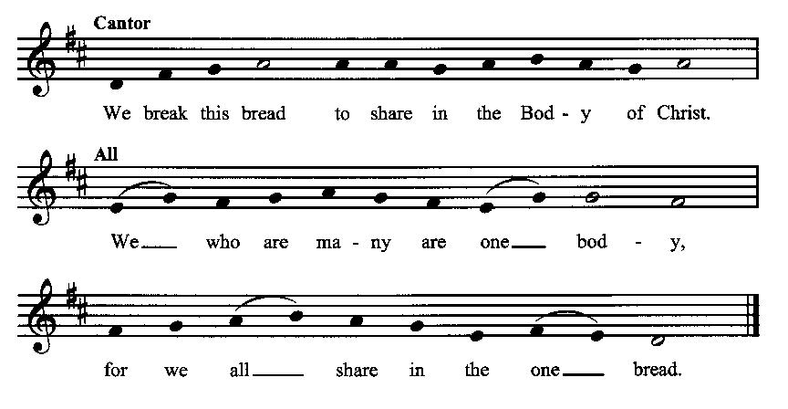

**Minister:** The gifts of God for the people of God. Take them in remembrance that Christ died for you and rose again, and feed on him in your hearts by faith with thanksgiving.

**Communion Hymn (cantors only, the people kneeling or sitting):**

“His law He enforces; the stars in their courses and sun in its orbit obediently shine. The hills and the mountains, the deeps of the ocean proclaim Him divine. We, too, should be voicing our love and rejoicing; with glad adoration a song let us raise Till all things now living unite in thanksgiving: ‘To God in the highest, hosanna and praise!’” (Let All Things Now Living*,* v. 2; Katherine Davis)

**The Communion:** *(After the minister(s) and acolyte(s) are served, the people come forward to receive, as space is available. The people kneel if they are able, or stand.* **Communion by intincture: The people receive the Bread in their open hands, continue to hold it, then dip the Bread in the cup, and then consume.**) *They return to their seats via the side aisles.*

**Renewal of the Mutual Invocation of God’s Grace for the Eucharist:**

**Minister:** The Lord be with you.

**People:** *And also with you.*

**The Prayer of Thanksgiving and Living Sacrifice:**

**(The minister kneeling, the people kneeling or sitting):**

**Minister:** Let us pray together:

**All:** *O Lord and Heavenly Father, we heartily thank You because You feed us, in these holy mysteries, with the spiritual food of the most precious Body and Blood of your Son our Savior Jesus Christ; because by this You assure us of your favor and goodness toward us; because we are living members of the body of your Son and heirs of your eternal kingdom. We ask You to accept this our sacrifice of praise and thanksgiving, and to grant that by the merits and death of your Son Jesus Christ and through faith in him, we and all your whole Church may obtain all of the benefits of his passion. And here we offer and present unto You, O Lord, ourselves, our souls and bodies, to be a reasonable, holy, and living sacrifice unto You; humbly asking You that we may be filled with your grace and heavenly benediction; through Jesus Christ our Lord; by whom, and with whom, in the Unity of the Holy Spirit, all honor and glory be unto You, O Father Almighty, world without end. AMEN.*

**ACTS OF DISMISSAL**

**Recessional Hymn (all standing, singing):**

*Sing to the Lord of Harvest* (No. 457)

**The Prayer of Benediction:**

**Minister:** Now may the God of hope fill you with all joy and peace in believing, that you may abound in hope by the power of the Holy Spirit; and may the blessing of God Almighty, the Father, the Son, and the Holy Spirit, be among you and remain with you always.

**All:** *Amen.*

**Minister:** Let us go forth in the Name of Christ.

**People:** *Thanks be to God.*

**(The people then be seated.)**

**Greetings and Announcements**

**Postlude:**

**(The people sit and remain quiet until the candles are extinguished and the organ raises its voice.)**

*____*_____________________________________________

Based on, and freely adapted from,

John Wesley’s *Order for the Administration of the Lord’s Supper*,

the 1662 and 1979 editions of *The Book of Common Prayer,* and

*Common Worship: Services and Prayers for the Church of England*

**______________________________________**

**Scripture Lessons for October 27 (Twenty-third Sunday after Pentecost):**

Job 42:1-6, 10-17; Psalm 34:1-8; Hebrews 7:23-28; Mark 10:46-52

**Parish Prayer for This Week and Next Sunday**

Those living on Beach Street

_______________________________________

**Parish Notices**

**Today: Harvest Festival!**

Immediately following the service, we will enjoy a time of food and fellowship.

During our offering time, we will bring our contributions of food to the front of the church. Feel free to bring produce from your garden, or store-bought items. Suggested items: Potatoes, apples, granola bars, chips, pudding packs, jerky, and nuts. All will be donated to the City Light/Boise Rescue Mission.

**Ladies Fellowship**

Epworth is having a Ladies Fellowship on Saturday, November 2, from 1:30-3:30 in our new Parish Hall! Bring an appetizer/snack to share. We will enjoy some food, fellowship, and working on a craft together. Feel free to invite a friend!

**All Saints Commemorations (NOV 3rd)**

The list of names that were commemorated at last year’s All Saints celebration is on a clipboard in the Parish Hall. Please highlight the names you want commemorated again this year and write in any names to add.

**Coming Events at Epworth**

Today, 10:00 am Word & Table Service

Today, 11:30 am Fellowship

Today, 11:40 Afterword (moderated discussion)

Thursday, 6:00 pm After Party Community Class

(session 5)

Thursday, 7:00 pm Evening Prayers & Healing Prayer

Sunday, 20 OCT Harvest Festival

Sunday, 3 NOV All Saints Commemoration

**October Birthdays & Anniversaries**

04 – Chris Blanchard & Carol Crosswhite

07 – Josiah Crow

12 – Adam Graham

**Sermon Notes**

**Epworth Church Office Email**

[epworthchapel.office@gmail.com](mailto:epworthchapel.office@gmail.com)

All correspondence for the office should be sent to this email address.

**Pastor Crow Contact Information**

***Healing prayer is provided every week upon request***

Rev. John Crow, Rector and Pastor

208-501-4037

[rector@epworthchapelonthegreen.org](mailto:rector@epworthchapelonthegreen.org)