**Service of Word & Table**

at

**Epworth Chapel on the Green**

6110 W. Northview Street, Boise, Idaho 83704

208-336-3951

www.epworthchapelonthegreen.org

The Rev. John Crow, Rector and Pastor

208-501-4037

**October 6, 2024, 10:00 a.m.**

*Twentieth Sunday after Pentecost*

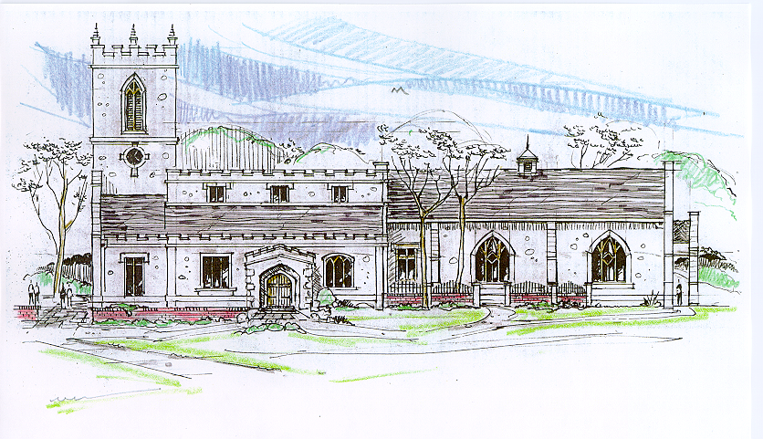

*____*___________________________________________

**“Through the deep current of the historical wesleyan church we will collaboratively serve and reach the lost in order to make disciples who love Jesus.”**

*_________________________*___________________________

This service will be live streamed, and in the course of that any or all persons who attend may be filmed. Remaining in the service will constitute your consent to appear in the live-streamed, recorded, and published service

**Rector and Pastor:** The Rev. John Crow

**Cantors:** Bryan Vanshur, Shannon Nichols

**Readers:**

**Old Testament:** Bryan Vanshur

**Psalm:** Bryan Vanshur

**Epistle:** Stephen Crow

**Acolytes:** Stephen Crow, Josiah Crow, Corbin Crosswhite, Jessica Crosswhite

**Jr. Acolytes:** Asher Crow, & Lizzie Crosswhite

**Usher:** Asher Crow

_______________________________

**ACTS OF ENTRANCE**

**(The people enter and remain in prayer and meditation.)**

**Prelude:**

**Entrance canticle (cantors only):**

“Our children, Lord, in faith and prayer, we now devote to thee; let them thy cov’nant mercies share, and thy salvation see.

Such helpless babes thou didst embrace, while dwelling here below; to us and ours, O God of grace, the same compassion show.” (Our Children, Lord, in Faith and Prayer*,* vv. 1-2; Thomas Haweis)

**Processional Hymn (all standing, singing):**

*Alas! And Did My Savior Bleed* (No. 121)

**Minister:** Blessed be God: Father, Son, and Holy Spirit.

**People:** *And blessed be his kingdom, now and forever.*

**Lord’s Prayer:**

**Minister:** Let us pray.

**(All standing):** *Our Father, who art in heaven, hallowed be thy Name. Thy kingdom come. Thy will be done, on earth as it is in heaven. Give us this day our daily bread. And forgive us our trespasses, as we forgive those who trespass against us. And lead us not into temptation, but deliver us from evil, for thine is the kingdom, and the power, and the glory, for ever and ever.* *Amen.*

**The Collect for Purity:**

**Minister:** Almighty God, unto whom all hearts are open, all desires known, and from whom no secrets are hid; cleanse the thoughts of our hearts by the inspiration of your Holy Spirit, that we may perfectly love You, and worthily magnify your holy Name, through Christ our Lord.

**All:** *Amen.*

**The *Gloria* Hymn (all standing):**

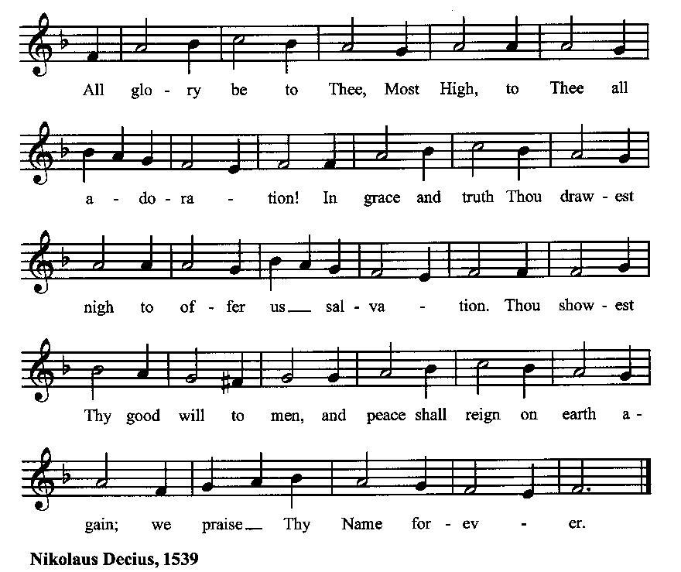

**Minister:** Holy God, Holy and Mighty, Holy Immortal One,

**People:** *Have mercy upon us.*

**SERVICE OF THE WORD**

**Mutual Invocation of the Grace of God for the Service of the Word:**

**Minister:** The Lord be with you.

**People:** *And also with you.*

**(The people then be seated.)**

**The Ten Commandments (the people sitting):**

**Minister:** God spoke these words, and said, I am the Lord your God:

You shall have no other gods but me.

You shall not make to yourself any graven image, to bow down to them, or worship them.

You shall not take the name of the Lord your God in vain.

Remember that you keep holy the Sabbath day.

Honor your father and your mother.

You shall not murder.

You shall not commit adultery.

You shall not steal.

You shall not bear false witness against your neighbor.

You shall not covet.

**The Great Commandments (the people sitting):**

**Minister:** Hear what our Lord Jesus Christ says. You shall love the Lord your God with all your heart, and with all your soul, and with all your mind. This is the first and great commandment. And the second is like unto it: You shall love your neighbor as yourself. On these two commandments hang all the Law and the Prophets.

**The *Kyrie* (the people sitting, singing):**

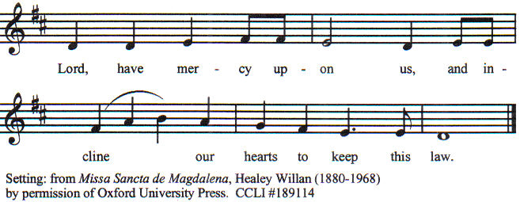

**Old Testament Lesson (the people sitting):**

**Reader:** The Old Testament lesson is written in the first and second chapters of the book of Job, beginning at verse 1 of chapter 1:

1. There was a man in the land of Uz whose name was Job, and that man was blameless and upright, one who feared God and turned away from evil.
2. Again there was a day when the sons of God came to present themselves before the Lord, and Satan also came among them to present himself before the Lord.
3. And the Lord said to Satan, “From where have you come?” Satan answered the Lord and said, “From going to and fro on the earth, and from walking up and down on it.”
4. And the Lord said to Satan, “Have you considered my servant Job, that there is none like him on the earth, a blameless and upright man, who fears God and turns away from evil? He still holds fast his integrity, although you incited me against him to destroy him without reason.”
5. Then Satan answered the Lord and said, “Skin for skin! All that a man has he will give for his life.
6. But stretch out your hand and touch his bone and his flesh, and he will curse you to your face.”
7. And the Lord said to Satan, “Behold, he is in your hand; only spare his life.”
8. So Satan went out from the presence of the Lord and struck Job with loathsome sores from the sole of his foot to the crown of his head.
9. And he took a piece of broken pottery with which to scrape himself while he sat in the ashes.
10. Then his wife said to him, “Do you still hold fast your integrity? Curse God and die.”
11. But he said to her, “You speak as one of the foolish women would speak. Shall we receive good from God, and shall we not receive evil?” In all this Job did not sin with his lips. (ESV)

**Reader:** The Word of the Lord*.*

**People:** *Thanks be to God.*

**The Psalm: (The people sit for the responsive reading, by half-verse, of Psalm 26, a prayer for God to bring vindication and redemption.)**

**Reader:** The Psalm is chapter 26, beginning at verse 1.

**Reader:** 1 Give judgment for me, O LORD, for I have lived with integrity;

**People:** *I have trusted in the LORD and not faltered*.

**Reader:** 2 Test me, O LORD, and try me;

**People:** *examine my heart and mind.*

**Reader:** 3 For your love is before my eyes;

**People:** *I have walked faithfully with you.*

**Reader:** 4 I have not sat with the worthless,

**People:** *nor do I consort with the deceitful.*

**Reader:** 5 I have hated the company of evildoers;

**People:** *I will not sit down with the wicked.*

**Reader:** 6 I will wash my hands in innocence, O LORD,

**People:** *that I may go in procession round your altar.*

**Reader:** 7 Singing aloud a song of thanksgiving

**People:** *and recounting all your wonderful deeds.*

**Reader:** 8 LORD, I love the house in which you dwell

**People:** *and the place where your glory abides.*

**Reader:** 9 Do not sweep me away with sinners,

**People:** *nor my life with those who thirst for blood.*

**Reader:** 10 Whose hands are full of evil plots,

**People:** *and their right hand full of bribes.*

**Reader:** 11 As for me, I will live with integrity;

**People:** *redeem me, O LORD, and have pity on me.*

**Reader:** 12 My foot stands on level ground;

**People:** *in the full assembly I will bless the LORD.* (BCP)

***Gloria Patri*** **(the people sitting)**

**Reader:** Glory be to the Father, and to the Son, and to the Holy Spirit;

**People:** *As it was in the beginning, is now and ever shall be, world without end. Amen.*

**Collect for the Twentieth Sunday after Pentecost (the people sitting):**

**Minister:** Almighty and everlasting God, you are always more ready to hear than we to pray, and to give more than we either desire or deserve: Pour upon us the abundance of your mercy, forgiving us those things of which our conscience is afraid, and giving us those good things for which we are not worthy to ask, except through the merits and mediation of Jesus Christ our Savior; who lives and reigns with you and the Holy Spirit, one God, for ever and ever.

**All:** *Amen.*

**The Epistle (the people sitting):**

**Reader:** The epistle lesson is written in the first and second chapters of the letter of Hebrews, beginning at verse 1 of chapter 1:

1. Long ago, at many times and in many ways, God spoke to our fathers by the prophets,
2. but in these last days he has spoken to us by his Son, whom he appointed the heir of all things, through whom also he created the world.
3. He is the radiance of the glory of God and the exact imprint of his nature, and he upholds the universe by the word of his power. After making purification for sins, he sat down at the right hand of the Majesty on high,
4. having become as much superior to angels as the name he has inherited is more excellent than theirs.
5. For it was not to angels that God subjected the world to come, of which we are speaking.
6. It has been testified somewhere, “What is man, that you are mindful of him, or the son of man, that you care for him?
7. You made him for a little while lower than the angels; you have crowned him with glory and honor,
8. putting everything in subjection under his feet.” Now in putting everything in subjection to him, he left nothing outside his control. At present, we do not yet see everything in subjection to him.
9. But we see him who for a little while was made lower than the angels, namely Jesus, crowned with glory and honor because of the suffering of death, so that by the grace of God he might taste death for everyone.
10. For it was fitting that he, for whom and by whom all things exist, in bringing many sons to glory, should make the founder of their salvation perfect through suffering.
11. For he who sanctifies and those who are sanctified all have one source. That is why he is not ashamed to call them brothers,
12. saying, “I will tell of your name to my brothers; in the midst of the congregation I will sing your praise.” (ESV)

**Reader:** Here ends the Epistle.

**People:** *Thanks be to God.*

**Sequence Hymn (all standing):**

*The Head That Once Was Crowned with Thorns,* vv. 1-4 (No. 203)

**The Gospel (all standing, and turning toward the Gospel reading):**

**Minister:** The holy Gospel is written in the tenth chapter of the Gospel according to Mark, beginning at verse 2:

**Minister:**

1. And Pharisees came up and in order to test him asked, “Is it lawful for a man to divorce his wife?”
2. He answered them, “What did Moses command you?”
3. They said, “Moses allowed a man to write a certificate of divorce and to send her away.”
4. And Jesus said to them, “Because of your hardness of heart he wrote you this commandment.
5. But from the beginning of creation, ‘God made them male and female.’
6. ‘Therefore a man shall leave his father and mother and hold fast to his wife,
7. and the two shall become one flesh.’ So they are no longer two but one flesh.
8. What therefore God has joined together, let not man separate.”
9. And in the house the disciples asked him again about this matter.
10. And he said to them, “Whoever divorces his wife and marries another commits adultery against her,
11. and if she divorces her husband and marries another, she commits adultery.”
12. And they were bringing children to him that he might touch them, and the disciples rebuked them.
13. But when Jesus saw it, he was indignant and said to them, “Let the children come to me; do not hinder them, for to such belongs the kingdom of God.
14. Truly, I say to you, whoever does not receive the kingdom of God like a child shall not enter it.”
15. And he took them in his arms and blessed them, laying his hands on them. (ESV)

**Minister:** The Gospel of the Lord.

**People:** *Praise to You, Lord Christ*.

**Sequence Hymn (all standing):**

*The Head That Once Was Crowned with Thorns,* vv. 5-6 (No. 203)

[Elementary age children may exit for Children's Worship in the Parish Hall.

They will return to the service at the Passing of the Peace.]

**Minister:** Grace be unto you, and peace, from our Lord Jesus Christ.

**All:** *Amen.* **(The people then be seated.)**

**The Sermon**

**Minister:** In the name of the Father, the Son and the Holy Spirit.

**All:** *Amen.*

**Silence, for review of the sermon, and for meditative prayer**

**SERVICE OF THE TABLE: THE GREAT THANKSGIVING**

**The Nicene Creed (all standing):**

**Minister:** Let us confess our faith, saying:

**All:** *We believe in one God,*

*the Father, the Almighty,*

*maker of heaven and earth,*

*of all that is, seen and unseen.*

*We believe in one Lord, Jesus Christ,*

*the only Son of God,*

*eternally begotten of the Father,*

*God from God, Light from Light,*

*true God from true God,*

*begotten, not made,*

*of one Being with the Father.*

*Through him all things were made.*

*For us and for our salvation*

*he came down from heaven:*

*by the power of the Holy Spirit*

*he became incarnate from the Virgin Mary,*

*and was made man.*

*For our sake he was crucified under Pontius Pilate;*

*he suffered death and was buried.*

*On the third day he rose again*

*in accordance with the Scriptures;*

*he ascended into heaven*

*and is seated at the right hand of the Father.*

*He will come again in glory to judge the living and the dead,*

*and his kingdom will have no end.*

*We believe in the Holy Spirit, the Lord, the giver of life,*

*who proceeds from the Father and the Son.*

*With the Father and the Son he is worshiped and glorified.*

*He has spoken through the Prophets.*

*We believe in one holy catholic and apostolic Church.*

*We acknowledge one baptism for the forgiveness of sins.*

*We look for the resurrection of the dead,*

*and the life of the world to come.* *Amen.*

**Minister: (The people sitting)** Let us with gladness present the offerings and oblations of our life and labor to the Lord.

**Offertory:**

**Offering Hymn (all standing):**

*For the Life That You Have Given*  (No. 485)

**Minister:** All things come from You, O Lord,

**People:** *And of your own have we given You.*

**The Prayers of the People (the people kneeling or sitting):**

**Minister:** Let us pray for the Church and the world. Almighty God, we pray for your Church throughout the world; grant that our divisions may cease, that we may be one, and that we may be found without fault at the day of your coming, let us pray to the Lord:

**People:** *Lord, hear our prayer.*

**Minister:** For our President and for wisdom for the citizens of our country as we enter the season of selecting our leaders, let us pray to the Lord:

**People:** *Lord, hear our prayer.*

**Minister:** For all those who do not yet believe, and for those who have lost their faith, that in due time we may all stand reconciled before You, let us pray to the Lord:

**People:** *Lord, hear our prayer.*

**Minister:** For the peace of the world, that a spirit of respect and forbearance may grow among all nations and peoples, let us pray to the Lord:

**People:** *Lord, hear our prayer.*

**Minister:** For the poor and the oppressed, prisoners and captives, the unemployed, and all who are in need or trouble, let us pray to the Lord:

**People:** *Lord, hear our prayer.*

**Minister:** For this congregation, that we might show forth your glory in all that we do; and for those who have commended themselves to our prayers, including these: _____________:

[Nation: Albania

Denomination: Free Full Gospel Churches

Congregation: Greenville Free Methodist Church in Greenville, IL, and the Rev. Steve Pichaske

Ministry: Anglican Relief and Development Fund

Parishioners: Those living on Alamo Road],

Grant that all of these may be delivered from anxiety, and live in joy, peace, and health.

*(Please add your own intentions, either silently or aloud.)*

**Minister:** Let us pray to the Lord:

**People:** *Lord, hear our prayer.*

**Minister:** We bless your holy Name for the thanksgivings of your people, including these: _________; for those in every generation in whom Christ has been honored;Give us grace to follow their good examples, that with them we may be partakers of your heavenly kingdom.

*(Please add your intentions, either silently or aloud.)*

**Minister:** Let us pray to the Lord:

**People:** *Lord, hear our prayer*

**Collect (the people kneeling or sitting):**

**Minister:** Almighty God, grant that the words which we have heard this day with our outward ears, may, through your grace, be so grafted inwardly in our hearts, that they may bring forth in us the fruit of good living, to the honor and praise of your Name; through Jesus Christ our Lord. Almighty God, who hast given us this good land for our heritage: We humbly beseech thee that we may always prove ourselves a people mindful of thy favor and glad to do thy will. Bless our land, save us from violence, discord, and confusion; from pride and arrogance, and from every evil way. Defend our liberties, and fashion into one united people the multitudes brought hither out of many kindreds and tongues. Endue with the spirit of wisdom those to whom in thy Name we entrust the authority of government, that there may be justice and peace at home, and that, through obedience to thy law, we may show forth thy praise among the nations of the earth; all which we ask through Jesus Christ our Lord.

**All:** *Amen*.

**Preparation for Holy Communion (the people sitting):**

**Minister:** The Lord’s Supper was ordained by God to be a means of conveying grace according to the need of each person. Those for whom it was ordained are all those who know and feel that they want the grace of God, to restrain them from sin, or to forgive their sins, or to assure them of pardon, or to renew their souls in the image of God, or to enter into the holy presence of God in communion with him. No preparation is indispensably necessary, other than a desire to receive the grace God pleases to give. No fitness or church membership is required at the time of communicating, other than a sense of our state, of our utter sinfulness and helplessness apart from Christ. Therefore, if you want such grace as God pleases to give to you, draw near with faith, and as you prepare to receive this holy sacrament to your comfort and strength, make your sincere confession to Almighty God, kneeling if you wish and are able, or otherwise sitting.

**The Prayer of Confession, Petition and Thanksgiving:**

**(The minister kneels, and the people kneel or sit.)**

**Minister:** Let us pray together:

**All:** *Most merciful God, we confess that we have sinned against thee in thought, word, and deed, by what we have done, and by what we have left undone. We have not loved thee with our whole heart; we have not loved our neighbors as ourselves. We are truly sorry and we humbly repent. For the sake of thy Son Jesus Christ, have mercy on us and forgive us; that we may delight in thy will, and walk in thy ways, to the glory of thy Name. Amen.*

**The *Agnus Dei* (the people kneeling or sitting, singing):**

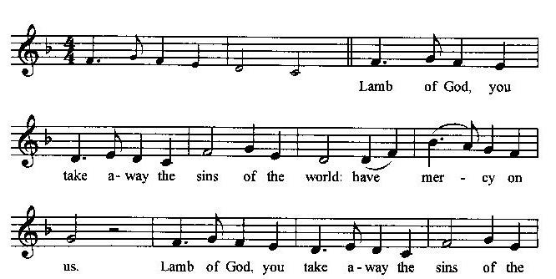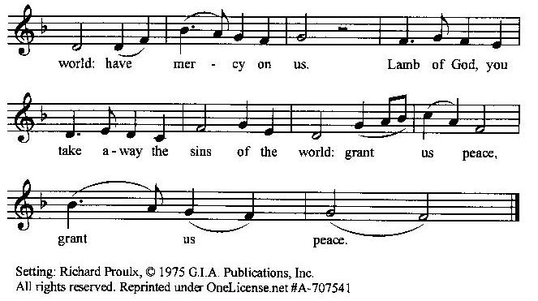

**Prayer for Absolution (the people kneeling or sitting):**

**Minister:** Almighty God, our heavenly Father, who of your great mercy has promised forgiveness of sins to all those who with hearty repentance and true faith turn unto You; Have mercy upon us; pardon and deliver us from all our sins, confirm and strengthen us in all goodness, and bring us to everlasting life, through Jesus Christ our Lord.

**All:** *Amen.*

**The Comforting Words of Forgiveness (the people sitting):**

**Minister:** Hear what comforting words our Savior Christ says to all who truly turn to him: Come to me, all you who are weary and carry heavy burdens, and I will give you rest. God so loved the world that he gave his only Son, so that everyone who believes in him will not perish but have eternal life. Hear also what St. Paul says: Christ Jesus came into the world to save sinners. Hear also what St. John says: If anyone sins, we have an Advocate with the Father, Jesus Christ the righteous: and he is the atonement for our sins.

**The Passing of the Peace:**

**Minister:** The peace of the Lord be always with you.

**People:** *And also with you.*

**Minister:** As the peace of Christ has been extended to you, extend the peace of the Lord to one another, and greet those who are near to you in the name of the Lord. **(The people rise and remain standing.)**

*(The people greet those near to them, saying, “The peace of the Lord be with you,” or, “Peace be with you,” or simply, “Peace.” They respond to one another, “And also with you,” or simply, “Peace”.)*

**Hymn of Entry Into the Heavenly Worship (all standing):**

*Even When the Soul Most Ardent* (No. 367)

**Preparation for the Table:**

**(Minister:** I wash my hands in innocence, and go about your altar, O LORD, proclaiming aloud your praise and telling of all your wonderful deeds). [Psalm 26:6-7, NIV]

**The *Sursum Corda* (all standing):**

**Minister:** The Lord be with you.

**People:** *And also with you.*

**Minister:** Lift up your hearts.

**People:** *We lift them up unto the Lord*.

**Minister:** Let us give thanks unto our Lord God.

**People:** *It is meet and right so to do.*

**The Salutation:**

**Minister:** It is very meet, right, and our gladsome duty, that we should at all times, and in all places, give thanks unto You, O Lord, Holy Father, Almighty, Everlasting God,

**The Preface:**

**Minister:** Through Jesus Christ our Lord. In fulfillment of his true promise, the Holy Spirit came down from heaven, lighting upon the disciples, to teach them and to lead them into all truth; uniting peoples of many tongues in the confession of one faith, and giving to your Church the power to serve You as a royal priesthood, and to preach the Gospel to all nations.

**Minister:** Therefore, with Angels and Archangels and with all the company of heaven, we laud and magnify your glorious Name, evermore praising You, and saying,

**The *Sanctus* (the people standing, singing):**

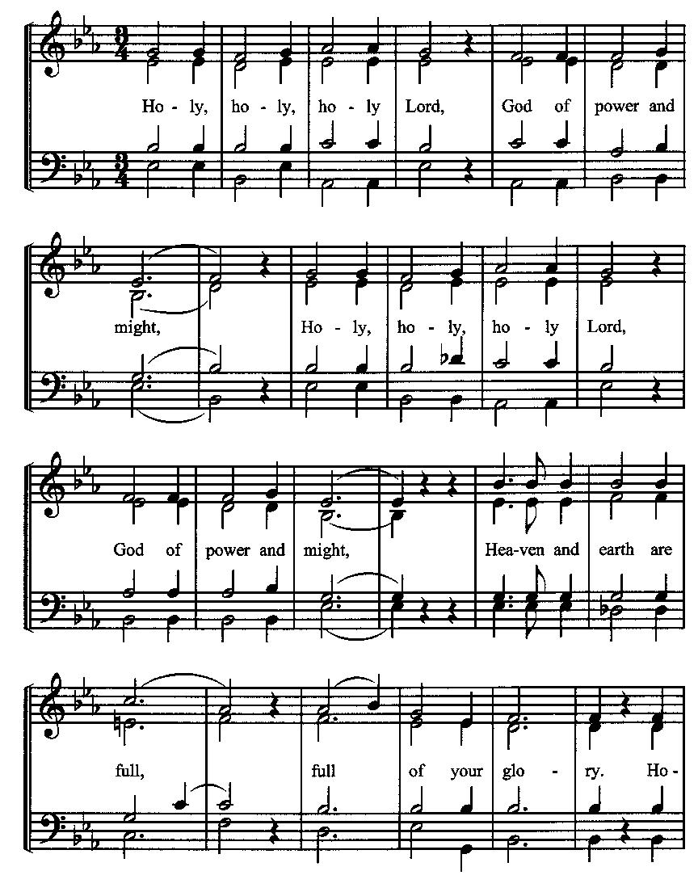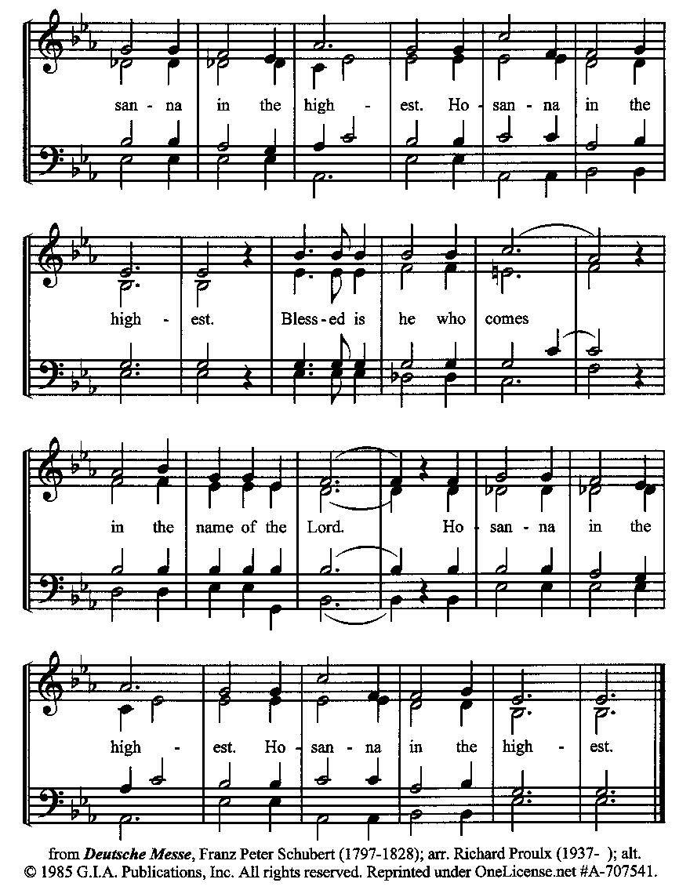

**The Prayer of Humble Access and for Cleansing**

**(the people kneeling or sitting):**

**Minister:** Let us pray together:

**All:** *We do not presume to come to this your table, O merciful Lord, trusting in our own righteousness, but in your many and great mercies. We are not worthy so much as to gather up the crumbs under your table. But You are the same Lord, whose nature is always to have mercy: Grant us, therefore, gracious Lord, so to experience the spiritual presence of your dear Son Jesus Christ at this your table, that we may be made clean by his body and blood, and that we may evermore dwell in him, and he in us. Deliver us, gracious Lord, from the presumption of coming to this table for solace for ourselves only, and not for strength to serve You and others. Deliver us, gracious Lord, from the presumption of coming to this table for pardon of our sins only, and not for transformation of our lives in your holiness. Amen.*

***Epiclesis* Prayer (the people kneeling or sitting):**

**Minister:** Holy and gracious Father, in your infinite love You made us for yourself; and, when we had fallen into sin and become subject to evil and death, You sent Jesus Christ, your only and eternal Son, to share our human nature, to live and die as one of us, to reconcile us to You, the God and Father of all. He stretched out his arms upon the cross and offered himself, in obedience to your will, a perfect sacrifice for the sins of the whole world. Recalling now his death, resurrection, and ascension, we offer You these gifts. Sanctify them by your Holy Spirit to be for us the Body and Blood of your Son, the holy food and drink of new and unending life in him. Sanctify us also, that we may faithfully receive this holy Sacrament, and serve You in unity, constancy, and peace; and at the last day bring us with all your saints into the joy of your eternal kingdom. We ask this through Jesus Christ, your Son, our Lord; through him, and with him, and in him, in the unity of the Holy Spirit, all honor and glory are yours, O Father Almighty, now and forever.

**All:** *Amen.*

**The Words of Institution (the people kneeling or sitting):**

**Minister:** Our Lord Jesus Christ, on the night that he was betrayed took bread; and when he had given thanks, he broke it, and gave it to his disciples, saying, Take, eat; this is my Body which is given for you: Do this in remembrance of me.

Likewise, after supper, he took the cup; and when he had given thanks, he gave it to them, saying, Drink this, all of you; for this is my blood of the New Testament, which is shed for you, and for many, for the remission of sins: Do this, as often as you shall drink it, in remembrance of me.

**All:** *Amen.*

**Minister:** Therefore, we proclaim the mystery of faith:

**People:** *Christ has died. Christ is risen. Christ will come again*.

**The Fraction:**

**Minister:** Christ our passover is sacrificed for us.

**People:** *Therefore let us keep the feast.*

**Fraction Anthem (the people kneeling or sitting, singing):**

(The cantor sings the first line, and then all sing the other lines.)

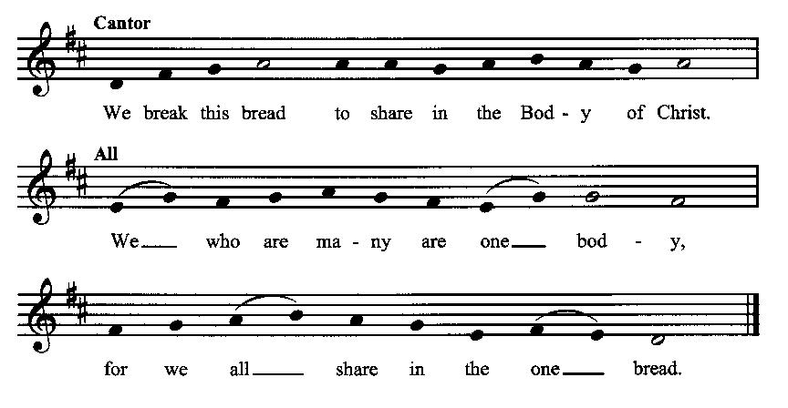

**Minister:** The gifts of God for the people of God. Take them in remembrance that Christ died for you and rose again, and feed on him in your hearts by faith with thanksgiving.

**Communion Hymn (cantors only, the people kneeling or sitting):**

“O thou whose infant feet were found, within thy Father’s shrine, whose years, with changeless virtue crowned, were all alike divine.

Dependent on thy bounteous breath, we seek thy grace alone, in childhood, manhood, age, and death, to keep us still thine own.” (Our Children, Lord, in Faith and Prayer*,* vv. 3-4; Reginald Heber)

**The Communion:** *(After the minister(s) and acolyte(s) are served, the people come forward to receive, as space is available. The people kneel if they are able, or stand.* **Communion by intincture: The people receive the Bread in their open hands, continue to hold it, then dip the Bread in the cup, and then consume.**) *They return to their seats via the side aisles.*

**Renewal of the Mutual Invocation of God’s Grace for the Eucharist:**

**Minister:** The Lord be with you.

**People:** *And also with you.*

**The Prayer of Thanksgiving and Living Sacrifice:**

**(The minister kneeling, the people kneeling or sitting):**

**Minister:** Let us pray together:

**All:** *O Lord and Heavenly Father, we heartily thank You because You feed us, in these holy mysteries, with the spiritual food of the most precious Body and Blood of your Son our Savior Jesus Christ; because by this You assure us of your favor and goodness toward us; because we are living members of the body of your Son and heirs of your eternal kingdom. We ask You to accept this our sacrifice of praise and thanksgiving, and to grant that by the merits and death of your Son Jesus Christ and through faith in him, we and all your whole Church may obtain all of the benefits of his passion. And here we offer and present unto You, O Lord, ourselves, our souls and bodies, to be a reasonable, holy, and living sacrifice unto You; humbly asking You that we may be filled with your grace and heavenly benediction; through Jesus Christ our Lord; by whom, and with whom, in the Unity of the Holy Spirit, all honor and glory be unto You, O Father Almighty, world without end. AMEN.*

**ACTS OF DISMISSAL**

**Recessional Hymn (all standing, singing):**

*Lord of All Hopefulness* (No. 390)

**The Prayer of Benediction:**

**Minister:** Now may the God of hope fill you with all joy and peace in believing, that you may abound in hope by the power of the Holy Spirit; and may the blessing of God Almighty, the Father, the Son, and the Holy Spirit, be among you and remain with you always.

**All:** *Amen.*

**Minister:** Let us go forth in the Name of Christ.

**People:** *Thanks be to God.*

**(The people then be seated.)**

**Greetings and Announcements**

**Postlude:**

**(The people sit and remain quiet until the candles are extinguished and the organ raises its voice.)**

*____*_____________________________________________

Based on, and freely adapted from,

John Wesley’s *Order for the Administration of the Lord’s Supper*,

the 1662 and 1979 editions of *The Book of Common Prayer,* and

*Common Worship: Services and Prayers for the Church of England*

**______________________________________**

**Scripture Lessons for October 13 (Twenty-first Sunday after Pentecost):**

Job 38:1-7; Psalm 104:1-9; Hebrews 5:1-10; Mark 10:35-45

**Parish Prayer for This Week and Next Sunday**

Those living on Amber Street

_______________________________________

**This week’s altar flowers were provided by The Blanchard’s in celebration of their anniversary.**

**Parish Notices**

**After Party Cancelled The Next Two Thursdays**

We will have evening prayers this Thursday, October 10th, but not the After Party. Same for next week.

**New Name for Epworth!**

All *members* of Epworth will be given a ballot for the online or in-person vote regarding renaming Epworth Chapel on the Green to *St. Gregory’s Free Methodist Church*. Information about why this name was chosen is available. The voting will begin on October 17th, and run through Sunday the 20th. This will be a simple yes or no on the name change; a no vote will reject the new name, leaving the Board members to decide if they want to keep the name Epworth or change to something else.

**Coming Soon: Harvest Festival!**

This year’s Harvest Festival has been moved to Sunday, October 20th. Immediately following the service, we will enjoy a time of food and fellowship. As usual, the church will provide meat and drinks, while everyone is asked to bring a side dish or dessert; the sign-up sheet is now available.

During our offering time, we will bring our contributions of food to the front of the church. Feel free to bring produce from your garden, or store-bought items. Suggested items: Potatoes, apples, granola bars, chips, pudding packs, jerky, and nuts. All will be donated to the City Light/Boise Rescue Mission.

**Coming Events at Epworth**

Today, 10:00 am Word & Table Service

Today, 11:30 am Fellowship

Today, 11:40 Afterword (moderated discussion)

Thursday, 6:00 pm NO After Party Community Class

Thursday, 7:00 pm Evening Prayers & Healing Prayer

Saturday, 12 OCT Membership Class (3 pm)

Sunday, 20 OCT Harvest Festival

**October Birthdays & Anniversaries**

04 – Chris Blanchard & Carol Crosswhite

07 – Josiah Crow

12 – Adam Graham

**Epworth Church Office Email**

[epworthchapel.office@gmail.com](mailto:epworthchapel.office@gmail.com)

All correspondence for the office should be sent to this email address.

**Pastor Crow Contact Information**

***Healing prayer is provided every week upon request***

Rev. John Crow, Rector and Pastor

208-501-4037

[rector@epworthchapelonthegreen.org](mailto:rector@epworthchapelonthegreen.org)