Service of Word & Table

at

Epworth Chapel on the Green
6110 W. Northview Street, Boise, Idaho 83704
208-336-3951
www.epworthchapelonthegreen.org

The Rev. John Crow, Rector and Pastor
208-501-4037
August 4, 2024, 10:00 a.m.
Eleventh Sunday after Pentecost

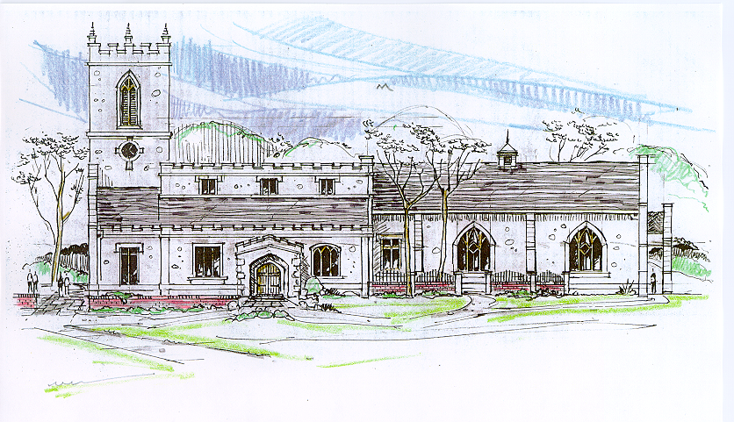

_______________________________________________
“Through the deep current of the historical wesleyan church we will collaboratively serve and reach the lost in order to make disciples who love Jesus.”
____________________________________________________
This service will be live streamed, and in the course of that any or all persons who attend may be filmed. Remaining in the service will constitute your consent to appear in the live-streamed, recorded, and published service

Rector and Pastor: The Rev. John Crow
Cantors: Bryan Vanshur, Shannon Nichols
Readers:
Old Testament: Stan Crow
Psalm: Stan Crow
Epistle: Stephen Crow
Acolytes: Stephen Crow, Josiah Crow, Corbin Crosswhite, Jessica Crosswhite
Jr. Acolytes: Asher Crow, & Lizzie Crosswhite
Usher: Asher Crow
_______________________________
ACTS OF ENTRANCE
(The people enter and remain in prayer and meditation.)
Prelude:
Entrance canticle (cantors only):
“Awake, my soul, and with the sun thy daily stage of duty run; shake off dull sloth, and joyful rise to pay thy morning sacrifice.
Lord, I my vows to thee renew; disperse my sins as morning dew; guard my first springs of thought and will, and with thyself my spirit fill.” (Awake, My Soul, and with the Sun, vv. 1-2; Thomas Ken)

Processional Hymn (all standing, singing):
Amazing Grace (No. 240)
Minister: Blessed be God: Father, Son, and Holy Spirit.
People: And blessed be his kingdom, now and forever.
Lord’s Prayer:
Minister: Let us pray.
(All standing): Our Father, who art in heaven, hallowed be thy Name. Thy kingdom come. Thy will be done, on earth as it is in heaven. Give us this day our daily bread. And forgive us our trespasses, as we forgive those who trespass against us. And lead us not into temptation, but deliver us from evil, for thine is the kingdom, and the power, and the glory, for ever and ever. Amen.
The Collect for Purity:
Minister: Almighty God, unto whom all hearts are open, all desires known, and from whom no secrets are hid; cleanse the thoughts of our hearts by the inspiration of your Holy Spirit, that we may perfectly love You, and worthily magnify your holy Name, through Christ our Lord.
All: Amen.

The Gloria Hymn (all standing):
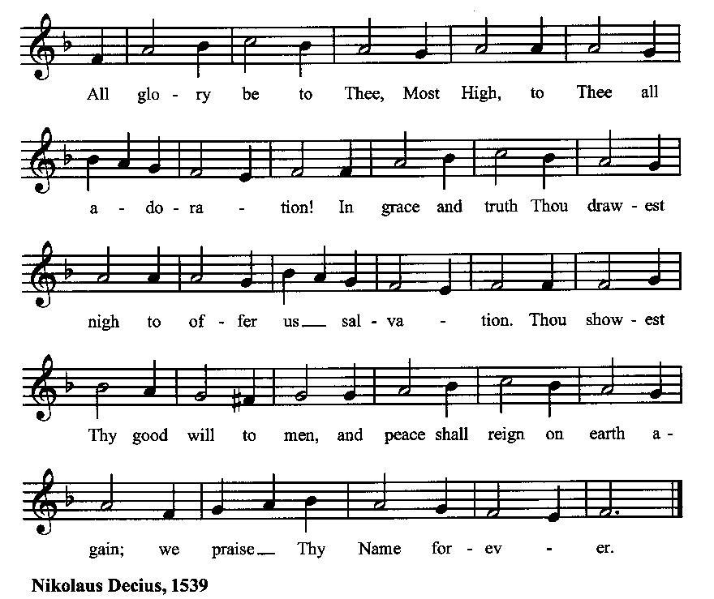

Minister: Holy God, Holy and Mighty, Holy Immortal One,
People: Have mercy upon us.
SERVICE OF THE WORD
Mutual Invocation of the Grace of God for the Service of the Word:
Minister: The Lord be with you.
People: And also with you.
(The people then be seated.)
The Ten Commandments (the people sitting):
Minister: God spoke these words, and said, I am the Lord your God:
You shall have no other gods but me.
You shall not make to yourself any graven image, to bow down to them, or worship them.
You shall not take the name of the Lord your God in vain.
Remember that you keep holy the Sabbath day.
Honor your father and your mother.
You shall not murder.
You shall not commit adultery.
You shall not steal.
You shall not bear false witness against your neighbor.
You shall not covet.

The Great Commandments (the people sitting):
Minister: Hear what our Lord Jesus Christ says. You shall love the Lord your God with all your heart, and with all your soul, and with all your mind. This is the first and great commandment. And the second is like unto it: You shall love your neighbor as yourself. On these two commandments hang all the Law and the Prophets.
The Kyrie (the people sitting, singing):
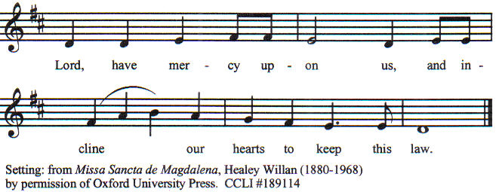

Old Testament Lesson (the people sitting):
Reader: The Old Testament lesson is written in the eleventh and twelfth chapters of the second book of the prophet Samuel, beginning at verse 26 of chapter eleven:
- When the wife of Uri′ah heard that Uri′ah her husband was dead, she made lamentation for her husband.
- And when the mourning was over, David sent and brought her to his house, and she became his wife, and bore him a son. But the thing that David had done displeased the Lord.
- And the Lord sent Nathan to David. He came to him, and said to him, “There were two men in a certain city, the one rich and the other poor.
- The rich man had very many flocks and herds;
- but the poor man had nothing but one little ewe lamb, which he had bought. And he brought it up, and it grew up with him and with his children; it used to eat of his morsel, and drink from his cup, and lie in his bosom, and it was like a daughter to him.
- Now there came a traveler to the rich man, and he was unwilling to take one of his own flock or herd to prepare for the wayfarer who had come to him, but he took the poor man’s lamb, and prepared it for the man who had come to him.”
- Then David’s anger was greatly kindled against the man; and he said to Nathan, “As the Lord lives, the man who has done this deserves to die;
- and he shall restore the lamb fourfold, because he did this thing, and because he had no pity.”
- Nathan said to David, “You are the man. Thus says the Lord, the God of Israel, ‘I anointed you king over Israel, and I delivered you out of the hand of Saul;
- and I gave you your master’s house, and your master’s wives into your bosom, and gave you the house of Israel and of Judah; and if this were too little, I would add to you as much more.
- Why have you despised the word of the Lord, to do what is evil in his sight? You have smitten Uri′ah the Hittite with the sword, and have taken his wife to be your wife, and have slain him with the sword of the Ammonites.
- Now therefore the sword shall never depart from your house, because you have despised me, and have taken the wife of Uri′ah the Hittite to be your wife.’
- Thus says the Lord, ‘Behold, I will raise up evil against you out of your own house; and I will take your wives before your eyes, and give them to your neighbor, and he shall lie with your wives in the sight of this sun.
- For you did it secretly; but I will do this thing before all Israel, and before the sun.’”
- David said to Nathan, “I have sinned against the Lord.” And Nathan said to David, “The Lord also has put away your sin; you shall not die. (RSV)
Reader: The Word of the Lord.
People: Thanks be to God.
The Psalm: (The people sit for the responsive reading, by half-verse, of a portion of Psalm 51, a request for God’s mercy and cleansing.)
Reader: The Psalm is chapter 51, beginning at verse 1.
Reader: 1 Have mercy on me, O God, according to your loving-kindness;
People: in your great compassion blot out my offenses
Reader: 2 Wash me through and through from my wickedness
People: and cleanse me from my sin.
Reader: 3 For I know my transgressions,
People: and my sin is ever before me.
Reader: 4 Against you only have I sinned
People: and done what is evil in your sight.
Reader: 5 And so you are justified when you speak
People: and upright in your judgment.
Reader: 6 Indeed, I have been wicked from my birth,
People: a sinner from my mother’s womb.
Reader: 7 For behold, you look for truth deep within me,
People: and will make me understand wisdom secretly.
Reader: 8 Purge me from my sin, and I shall be pure;
People: wash me, and I shall be clean indeed.
Reader: 9 Make me hear of joy and gladness,
People: that the body you have broken may rejoice.
Reader: 10 Hide your face from my sins
People: and blot out all my iniquities.
Reader: 11 Create in me a clean heart, O God,
People: and renew a right spirit within me.
Reader: 12 Cast me not away from your presence
People: and take not your holy Spirit from me.
Reader: 13 Give me the joy of your saving help again
People: and sustain me with your bountiful Spirit. (BCP)
Gloria Patri (the people sitting)
Reader: Glory be to the Father, and to the Son, and to the Holy Spirit;
People: As it was in the beginning, is now and ever shall be, world without end. Amen.

Collect for the Eleventh Sunday after Pentecost (the people sitting):
Minister: Let your continual mercy, O Lord, cleanse and defend your Church; and, because it cannot continue in safety without your help, protect and govern it always by your goodness; through Jesus Christ our Lord, who lives and reigns with you and the Holy Spirit, one God, for ever and ever.
All: Amen.

The Epistle (the people sitting):
Reader: The epistle lesson is written in the fourth chapter of Paul’s letter to the Ephesians, beginning at verse 1:
- I therefore, a prisoner for the Lord, beg you to lead a life worthy of the calling to which you have been called,
- with all lowliness and meekness, with patience, forbearing one another in love,
- eager to maintain the unity of the Spirit in the bond of peace.
- There is one body and one Spirit, just as you were called to the one hope that belongs to your call,
- one Lord, one faith, one baptism,
- one God and Father of us all, who is above all and through all and in all.
- But grace was given to each of us according to the measure of Christ’s gift.
- Therefore it is said, “When he ascended on high he led a host of captives, and he gave gifts to men.”
- (In saying, “He ascended,” what does it mean but that he had also descended into the lower parts of the earth?
- He who descended is he who also ascended far above all the heavens, that he might fill all things.)
- And his gifts were that some should be apostles, some prophets, some evangelists, some pastors and teachers,
- to equip the saints for the work of ministry, for building up the body of Christ,
- until we all attain to the unity of the faith and of the knowledge of the Son of God, to mature manhood, to the measure of the stature of the fulness of Christ;
- so that we may no longer be children, tossed to and fro and carried about with every wind of doctrine, by the cunning of men, by their craftiness in deceitful wiles.
- Rather, speaking the truth in love, we are to grow up in every way into him who is the head, into Christ,
- from whom the whole body, joined and knit together by every joint with which it is supplied, when each part is working properly, makes bodily growth and upbuilds itself in love. (RSV)
Reader: Here ends the Epistle.
People: Thanks be to God.
Sequence Hymn (all standing):
God of Grace and God of Glory, vv. 1-2 (No. 277)

The Gospel (all standing, and turning toward the Gospel reading):
Minister: The holy Gospel is written in the sixth chapter of the Gospel according to John, beginning at verse 24:
Minister:
- So when the people saw that Jesus was not there, nor his disciples, they themselves got into the boats and went to Caper′na-um, seeking Jesus.
- When they found him on the other side of the sea, they said to him, “Rabbi, when did you come here?”
- Jesus answered them, “Truly, truly, I say to you, you seek me, not because you saw signs, but because you ate your fill of the loaves.
- Do not labor for the food which perishes, but for the food which endures to eternal life, which the Son of man will give to you; for on him has God the Father set his seal.”
- Then they said to him, “What must we do, to be doing the works of God?”
- Jesus answered them, “This is the work of God, that you believe in him whom he has sent.”
- So they said to him, “Then what sign do you do, that we may see, and believe you? What work do you perform?
- Our fathers ate the manna in the wilderness; as it is written, ‘He gave them bread from heaven to eat.’”
- Jesus then said to them, “Truly, truly, I say to you, it was not Moses who gave you the bread from heaven; my Father gives you the true bread from heaven.
- For the bread of God is that which comes down from heaven, and gives life to the world.”
- They said to him, “Lord, give us this bread always.”
- Jesus said to them, “I am the bread of life; he who comes to me shall not hunger, and he who believes in me shall never thirst. (RSV)
Minister: The Gospel of the Lord.
People: Praise to You, Lord Christ.
Sequence Hymn (all standing):
God of Grace and God of Glory, vv. 3-4 (No. 277)
[Elementary age children may exit for Children's Worship in the Parish Hall.
They will return to the service at the Passing of the Peace.]

Minister: Grace be unto you, and peace, from our Lord Jesus Christ.
All: Amen. (The people then be seated.)
The Sermon
Minister: In the name of the Father, the Son and the Holy Spirit.
All: Amen.
Silence, for review of the sermon, and for meditative prayer
SERVICE OF THE TABLE: THE GREAT THANKSGIVING
The Nicene Creed (all standing):
Minister: Let us confess our faith, saying:
All: We believe in one God,
the Father, the Almighty,
maker of heaven and earth,
of all that is, seen and unseen.
We believe in one Lord, Jesus Christ,
the only Son of God,
eternally begotten of the Father,
God from God, Light from Light,
true God from true God,
begotten, not made,
of one Being with the Father.
Through him all things were made.
For us and for our salvation
he came down from heaven:
by the power of the Holy Spirit
he became incarnate from the Virgin Mary,
and was made man.
For our sake he was crucified under Pontius Pilate;
he suffered death and was buried.
On the third day he rose again
in accordance with the Scriptures;
he ascended into heaven
and is seated at the right hand of the Father.
He will come again in glory to judge the living and the dead,
and his kingdom will have no end.
We believe in the Holy Spirit, the Lord, the giver of life,
who proceeds from the Father and the Son.
With the Father and the Son he is worshiped and glorified.
He has spoken through the Prophets.
We believe in one holy catholic and apostolic Church.
We acknowledge one baptism for the forgiveness of sins.
We look for the resurrection of the dead,
and the life of the world to come. Amen.
Minister: (The people sitting) Let us with gladness present the offerings and oblations of our life and labor to the Lord.
Offertory:
Offering Hymn (all standing):
When the Church of Jesus (No. 337)
Minister: All things come from You, O Lord,
People: And of your own have we given You.
The Prayers of the People (the people kneeling or sitting):
Minister: Let us pray for the Church and the world. Almighty God, we pray for your Church throughout the world; grant that our divisions may cease, that we may be one, and that we may be found without fault at the day of your coming, let us pray to the Lord:
People: Lord, hear our prayer.
Minister: For our President and all who govern and hold authority in our nation and in the world, let us pray to the Lord:
People: Lord, hear our prayer.
Minister: For all those who do not yet believe, and for those who have lost their faith, that in due time we may all stand reconciled before You, let us pray to the Lord:
People: Lord, hear our prayer.
Minister: For the peace of the world, that a spirit of respect and forbearance may grow among all nations and peoples, let us pray to the Lord:
People: Lord, hear our prayer.
Minister: For the poor and the oppressed, prisoners and captives, the unemployed, and all who are in need or trouble, let us pray to the Lord:
People: Lord, hear our prayer.
Minister: For this congregation, that we might show forth your glory in all that we do; and for those who have commended themselves to our prayers, including these: _____________:
[Nation: Uruguay
Denomination: Evangelical Mennonite Church
Congregation: Transfiguration Lutheran Church in St. Louis, MO, and the Rev. Aaron Dickerson
Ministry: One Mission Society
Parishioners: Those living on Poplar Drive],
Grant that all of these may be delivered from anxiety, and live in joy, peace, and health.
(Please add your own intentions, either silently or aloud.)
Minister: Let us pray to the Lord:
People: Lord, hear our prayer.
Minister: We bless your holy Name for the thanksgivings of your people, including these: _________; for those in every generation in whom Christ has been honored; Give us grace to follow their good examples, that with them we may be partakers of your heavenly kingdom.
(Please add your intentions, either silently or aloud.)
Minister: Let us pray to the Lord:
People: Lord, hear our prayer

Collect (the people kneeling or sitting):
Minister: Ever living God, whose will it is that all should come to You through your Son Jesus Christ: Inspire our witness to him, that all may know the power of his forgiveness and the hope of his resurrection; who lives and reigns with You and the Holy Spirit, one God, now and for ever.
All: Amen.

Preparation for Holy Communion (the people sitting):
Minister: The Lord’s Supper was ordained by God to be a means of conveying grace according to the need of each person. Those for whom it was ordained are all those who know and feel that they want the grace of God, to restrain them from sin, or to forgive their sins, or to assure them of pardon, or to renew their souls in the image of God, or to enter into the holy presence of God in communion with him. No preparation is indispensably necessary, other than a desire to receive the grace God pleases to give. No fitness or church membership is required at the time of communicating, other than a sense of our state, of our utter sinfulness and helplessness apart from Christ. Therefore, if you want such grace as God pleases to give to you, draw near with faith, and as you prepare to receive this holy sacrament to your comfort and strength, make your sincere confession to Almighty God, kneeling if you wish and are able, or otherwise sitting.

The Prayer of Confession, Petition and Thanksgiving:
(The minister kneels, and the people kneel or sit.)
Minister: Let us pray together:
All: Most merciful God, we confess that we have sinned against thee in thought, word, and deed, by what we have done, and by what we have left undone. We have not loved thee with our whole heart; we have not loved our neighbors as ourselves. We are truly sorry and we humbly repent. For the sake of thy Son Jesus Christ, have mercy on us and forgive us; that we may delight in thy will, and walk in thy ways, to the glory of thy Name. Amen.

The Agnus Dei (the people kneeling or sitting, singing):
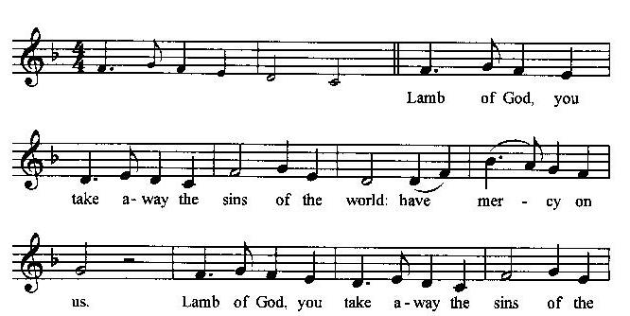
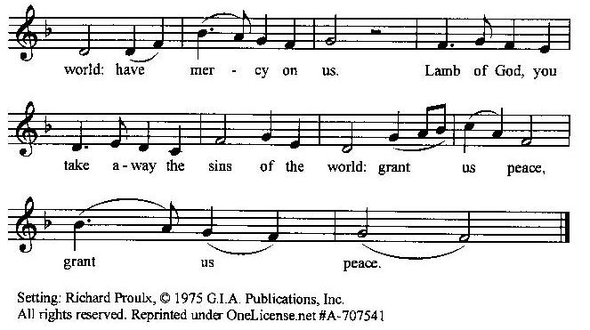

Prayer for Absolution (the people kneeling or sitting):
Minister: Almighty God, our heavenly Father, who of your great mercy has promised forgiveness of sins to all those who with hearty repentance and true faith turn unto You; Have mercy upon us; pardon and deliver us from all our sins, confirm and strengthen us in all goodness, and bring us to everlasting life, through Jesus Christ our Lord.
All: Amen.
The Comforting Words of Forgiveness (the people sitting):
Minister: Hear what comforting words our Savior Christ says to all who truly turn to him: Come to me, all you who are weary and carry heavy burdens, and I will give you rest. God so loved the world that he gave his only Son, so that everyone who believes in him will not perish but have eternal life. Hear also what St. Paul says: Christ Jesus came into the world to save sinners. Hear also what St. John says: If anyone sins, we have an Advocate with the Father, Jesus Christ the righteous: and he is the atonement for our sins.
The Passing of the Peace:
Minister: The peace of the Lord be always with you.
People: And also with you.
Minister: As the peace of Christ has been extended to you, extend the peace of the Lord to one another, and greet those who are near to you in the name of the Lord. (The people rise and remain standing.)
(The people greet those near to them, saying, “The peace of the Lord be with you,” or, “Peace be with you,” or simply, “Peace.” They respond to one another, “And also with you,” or simply, “Peace”.)

Hymn of Entry Into the Heavenly Worship (all standing):
Because Thou Hast Said (No. 319)
Preparation for the Table:
(Minister: I wash my hands in innocence, and go about your altar, O LORD, proclaiming aloud your praise and telling of all your wonderful deeds). [Psalm 26:6-7, NIV]
The Sursum Corda (all standing):
Minister: The Lord be with you.
People: And also with you.
Minister: Lift up your hearts.
People: We lift them up unto the Lord.
Minister: Let us give thanks unto our Lord God.
People: It is meet and right so to do.

The Salutation:
Minister: It is very meet, right, and our gladsome duty, that we should at all times, and in all places, give thanks unto You, O Lord, Holy Father, Almighty, Everlasting God,
The Preface:
Minister: Through Jesus Christ our Lord. In fulfillment of his true promise, the Holy Spirit came down from heaven, lighting upon the disciples, to teach them and to lead them into all truth; uniting peoples of many tongues in the confession of one faith, and giving to your Church the power to serve You as a royal priesthood, and to preach the Gospel to all nations.
Minister: Therefore, with Angels and Archangels and with all the company of heaven, we laud and magnify your glorious Name, evermore praising You, and saying,
The Sanctus (the people standing, singing):

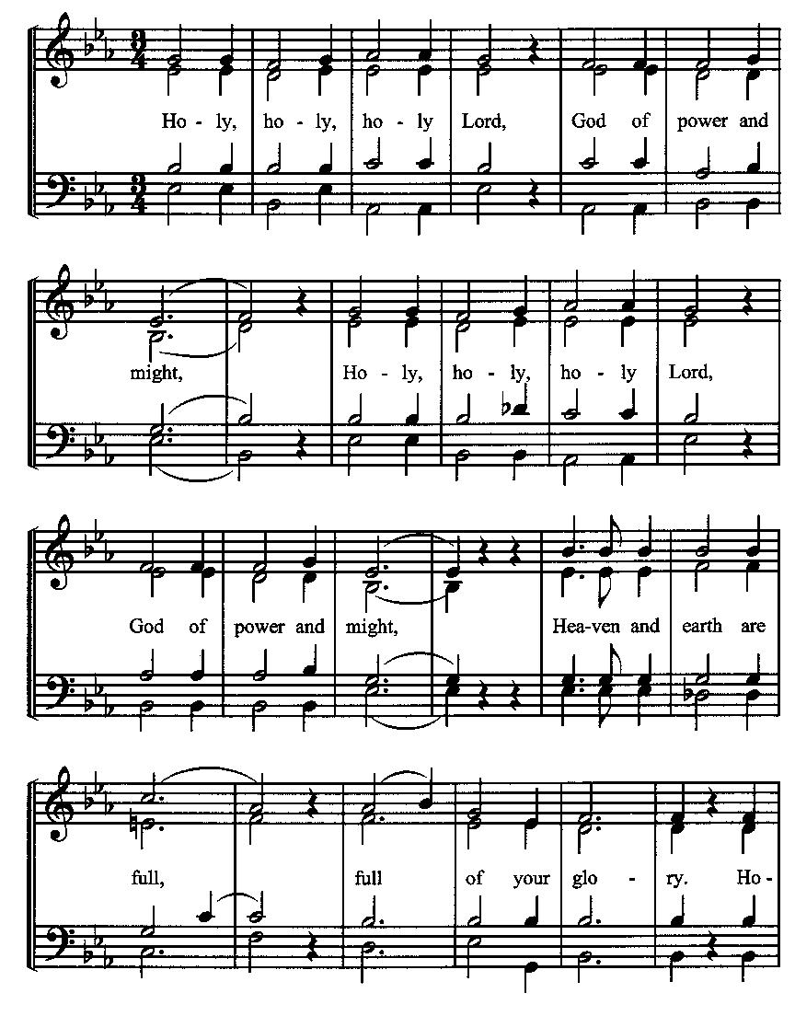
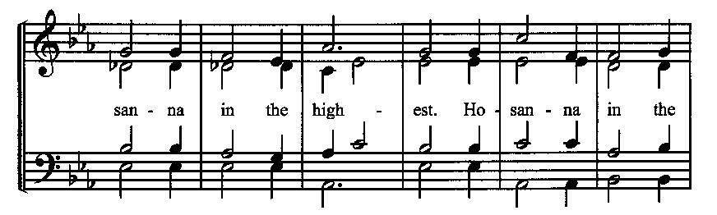
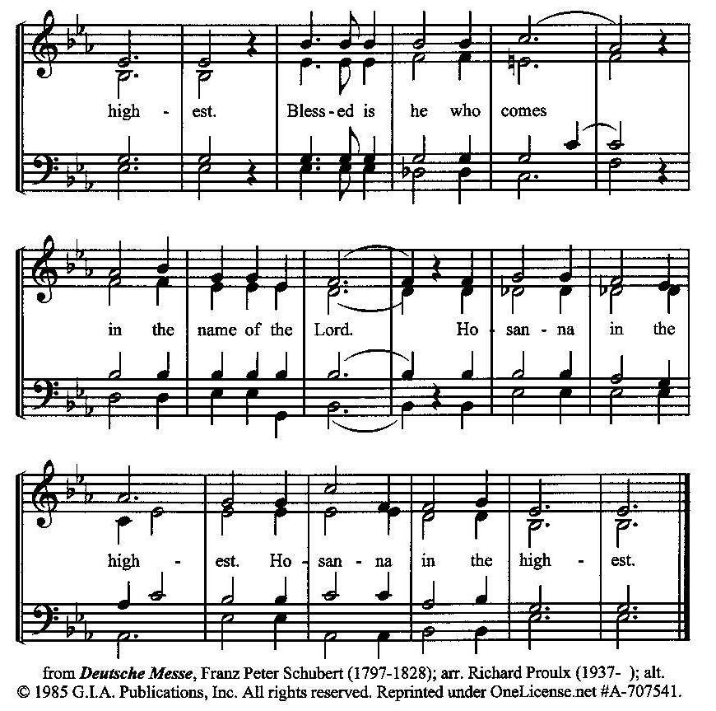
The Prayer of Humble Access and for Cleansing
(the people kneeling or sitting):
Minister: Let us pray together:
All: We do not presume to come to this your table, O merciful Lord, trusting in our own righteousness, but in your many and great mercies. We are not worthy so much as to gather up the crumbs under your table. But You are the same Lord, whose nature is always to have mercy: Grant us, therefore, gracious Lord, so to experience the spiritual presence of your dear Son Jesus Christ at this your table, that we may be made clean by his body and blood, and that we may evermore dwell in him, and he in us. Deliver us, gracious Lord, from the presumption of coming to this table for solace for ourselves only, and not for strength to serve You and others. Deliver us, gracious Lord, from the presumption of coming to this table for pardon of our sins only, and not for transformation of our lives in your holiness. Amen.
Epiclesis Prayer (the people kneeling or sitting):
Minister: Holy and gracious Father, in your infinite love You made us for yourself; and, when we had fallen into sin and become subject to evil and death, You sent Jesus Christ, your only and eternal Son, to share our human nature, to live and die as one of us, to reconcile us to You, the God and Father of all. He stretched out his arms upon the cross and offered himself, in obedience to your will, a perfect sacrifice for the sins of the whole world. Recalling now his death, resurrection, and ascension, we offer You these gifts. Sanctify them by your Holy Spirit to be for us the Body and Blood of your Son, the holy food and drink of new and unending life in him. Sanctify us also, that we may faithfully receive this holy Sacrament, and serve You in unity, constancy, and peace; and at the last day bring us with all your saints into the joy of your eternal kingdom. We ask this through Jesus Christ, your Son, our Lord; through him, and with him, and in him, in the unity of the Holy Spirit, all honor and glory are yours, O Father Almighty, now and forever.
All: Amen.
The Words of Institution (the people kneeling or sitting):
Minister: Our Lord Jesus Christ, on the night that he was betrayed took bread; and when he had given thanks, he broke it, and gave it to his disciples, saying, Take, eat; this is my Body which is given for you: Do this in remembrance of me.
Likewise, after supper, he took the cup; and when he had given thanks, he gave it to them, saying, Drink this, all of you; for this is my blood of the New Testament, which is shed for you, and for many, for the remission of sins: Do this, as often as you shall drink it, in remembrance of me.
All: Amen.
Minister: Therefore, we proclaim the mystery of faith:
People: Christ has died. Christ is risen. Christ will come again.
The Fraction:
Minister: Christ our passover is sacrificed for us.
People: Therefore let us keep the feast.

Fraction Anthem (the people kneeling or sitting, singing):
(The cantor sings the first line, and then all sing the other lines.)
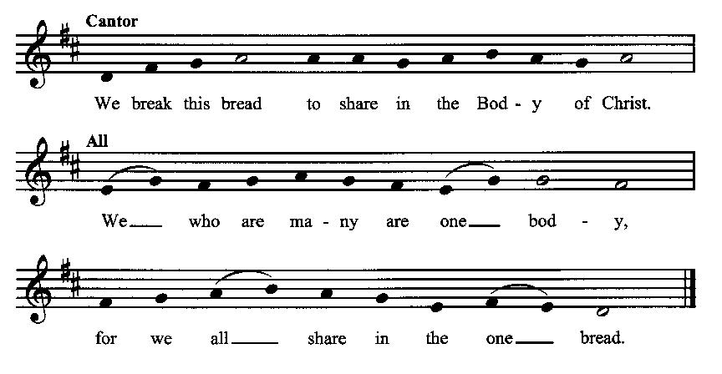

Minister: The gifts of God for the people of God. Take them in remembrance that Christ died for you and rose again, and feed on him in your hearts by faith with thanksgiving.
Communion Hymn (cantors only, the people kneeling or sitting):
“Direct, control, suggest, this day, all I design, or do, or say; that all my powers, with all their might, in thy sole glory may unite.
Praise God, from whom all blessings flow; praise him, all creatures here below; praise him above, ye heavenly host: praise Fater, Son, and Holy Ghost.” (Awake, My Soul, and with the Sun, vv. 3-4; Thomas Ken)
The Communion: (After the minister(s) and acolyte(s) are served, the people come forward to receive, as space is available. The people kneel if they are able, or stand. Communion by intincture: The people receive the Bread in their open hands, continue to hold it, then dip the Bread in the cup, and then consume.) They return to their seats via the side aisles.
Renewal of the Mutual Invocation of God’s Grace for the Eucharist:
Minister: The Lord be with you.
People: And also with you.

The Prayer of Thanksgiving and Living Sacrifice:
(The minister kneeling, the people kneeling or sitting):
Minister: Let us pray together:
All: O Lord and Heavenly Father, we heartily thank You because You feed us, in these holy mysteries, with the spiritual food of the most precious Body and Blood of your Son our Savior Jesus Christ; because by this You assure us of your favor and goodness toward us; because we are living members of the body of your Son and heirs of your eternal kingdom. We ask You to accept this our sacrifice of praise and thanksgiving, and to grant that by the merits and death of your Son Jesus Christ and through faith in him, we and all your whole Church may obtain all of the benefits of his passion. And here we offer and present unto You, O Lord, ourselves, our souls and bodies, to be a reasonable, holy, and living sacrifice unto You; humbly asking You that we may be filled with your grace and heavenly benediction; through Jesus Christ our Lord; by whom, and with whom, in the Unity of the Holy Spirit, all honor and glory be unto You, O Father Almighty, world without end. AMEN.

ACTS OF DISMISSAL
Recessional Hymn (all standing, singing):
Forgive Our Sins As We Forgive (No. 282)
The Prayer of Benediction:
Minister: The grace of the Lord Jesus Christ, and the love of God, and the fellowship of the Holy Spirit, be with you all.
All: Amen.
Minister: Let us go forth in the Name of Christ.
People: Thanks be to God.
(The people then be seated.)
Greetings and Announcements
Postlude:
(The people sit and remain quiet until the candles are extinguished and the organ raises its voice.)
_________________________________________________
Based on, and freely adapted from,
John Wesley’s Order for the Administration of the Lord’s Supper,
the 1662 and 1979 editions of The Book of Common Prayer, and
Common Worship: Services and Prayers for the Church of England
______________________________________
Scripture Lessons for August 11 (Twelfth Sunday after Pentecost):
1 Kings 19:4-8; Psalm 34:1-8; Ephesians 4:25-5:2; John 6:35, 41-51
Parish Prayer for This Week and Next Sunday
Those living on Poplar Street
_______________________________________

Parish Notices

Afterword Class Continues
Today we review week three of the Brian Kluth book, Generous Life. This book is a very practical guide to increasing our generosity, with daily devotionals and tips, which include basic money management skills. The class will run through 25 August. This would be a great class to invite people to if they have an interest in building the Kingdom with their financial resources.

National Night Out
The Winstead Park Neighborhood Association will be holding the National Night Out event at the Winstead Shelter on Tuesday, August 6th from 6-8 pm. We have been asked to grill hot dogs for this event. If you live in the Winstead area, please come out and meet your neighbors. And tell them how much you like Epworth 😊

Next Sunday: Ice Cream Social
Our annual ice cream social will take place on Sunday, August 11th, from 6 – 8 pm in the Winstead Park shelter. This is a great opportunity to meet our neighbors and invite friends. Please do 2 things: 1) Take some mailers (in the narthex) to hand out to your friends and family, and 2) Sign up on the sheet in the Parish Hall to bring ice cream or toppings. If you brought supplies, please leave them in the kitchen.

New Class: The Church Calendar
There has been a resurgence in interest lately in the church calendar. Many Christians have heard of it but have no real understanding. We will be offering a class to the public on Thursdays, August 29th and September 5th at 6 pm. The idea is that people can come and learn about the church calendar, and then stay and experience our Evening Prayers service if they choose. We are covering everything in just two 45-minute classes to make it as accessible to people as possible. Invite a friend!

Coming Events at Epworth
Today, 10:00 am Word & Table Service
Today, 11:30 am Fellowship
Today, 11:40 Afterword class: Generous Life,
session 3
Tuesday, 6:00 pm National Night Out in Winstead
Thursday, 7:00 pm Evening Prayers & Healing Prayer
Sunday, 11 August Ice Cream Social in Winstead Park

August Birthdays & Anniversaries

02 – Lizzie Crosswhite
04 – Ken Nichols
14 – Stephen Crow
22 – Rich Reid
31 – Cindy Roberts

Epworth Church Office Email
epworthchapel.office@gmail.com
All correspondence for the office should be sent to this email address.

Pastor Crow Contact Information
Healing prayer is provided every week upon request
Rev. John Crow, Rector and Pastor
208-501-4037
jdowningcrow@hotmail.com

