Service of Word & Table

at

Epworth Chapel on the Green
6110 W. Northview Street, Boise, Idaho 83704
208-336-3951
www.epworthchapelonthegreen.org

The Rev. John Crow, Rector and Pastor
208-501-4037
July 14, 2024, 10:00 a.m.
Eighth Sunday after Pentecost

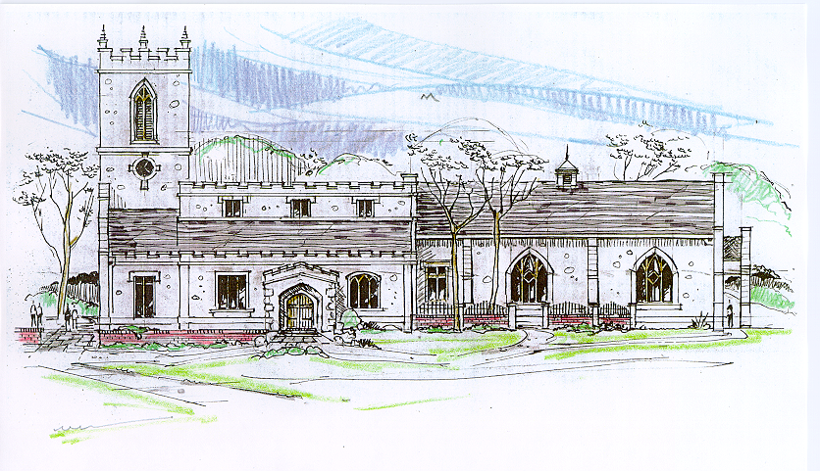

_______________________________________________
“Through the deep current of the historical church we will collaboratively serve and reach the lost in order to make disciples who love Jesus.”
____________________________________________________
This service will be live streamed, and in the course of that any or all persons who attend may be filmed. Remaining in the service will constitute your consent to appear in the live-streamed, recorded, and published service

Rector and Pastor: The Rev. Jim Porter
Cantors: Bryan Vanshur, Shannon Nichols
Readers:
Old Testament: Chris Blanchard
Psalm: Chris Blanchard
Epistle: Adam Graham
Acolytes: Stephen Crow, Josiah Crow, Corbin Crosswhite, Jessica Crosswhite
Jr. Acolytes: Asher Crow, & Lizzie Crosswhite
Usher: Kendra Millar
_______________________________
ACTS OF ENTRANCE
(The people enter and remain in prayer and meditation.)
Prelude:
Entrance canticle (cantors only):
“Christ for the world we sing! The world to Christ we bring with loving zeal: the poor and them that mourn, the faint and over-borne, sin-sick and sorrow-worn, whom Christ doth heal.
Christ for the world we sing! The world to Christ we bring with fervent prayer: the wayward and the lost, by restless passions tossed, redeemed at countless cost from dark despair.” (Christ for the World We Sing, vv. 1-2; Samuel Wolcott)
Processional Hymn (all standing, singing):
This Is My Father’s World (No. 478)
Minister: Blessed be God: Father, Son, and Holy Spirit.
People: And blessed be his kingdom, now and forever.
Lord’s Prayer:
Minister: Let us pray.
(All standing): Our Father, who art in heaven, hallowed be thy Name. Thy kingdom come. Thy will be done, on earth as it is in heaven. Give us this day our daily bread. And forgive us our trespasses, as we forgive those who trespass against us. And lead us not into temptation, but deliver us from evil, for thine is the kingdom, and the power, and the glory, for ever and ever. Amen.
The Collect for Purity:
Minister: Almighty God, unto whom all hearts are open, all desires known, and from whom no secrets are hid; cleanse the thoughts of our hearts by the inspiration of your Holy Spirit, that we may perfectly love You, and worthily magnify your holy Name, through Christ our Lord.
All: Amen.
The Gloria Hymn (all standing):
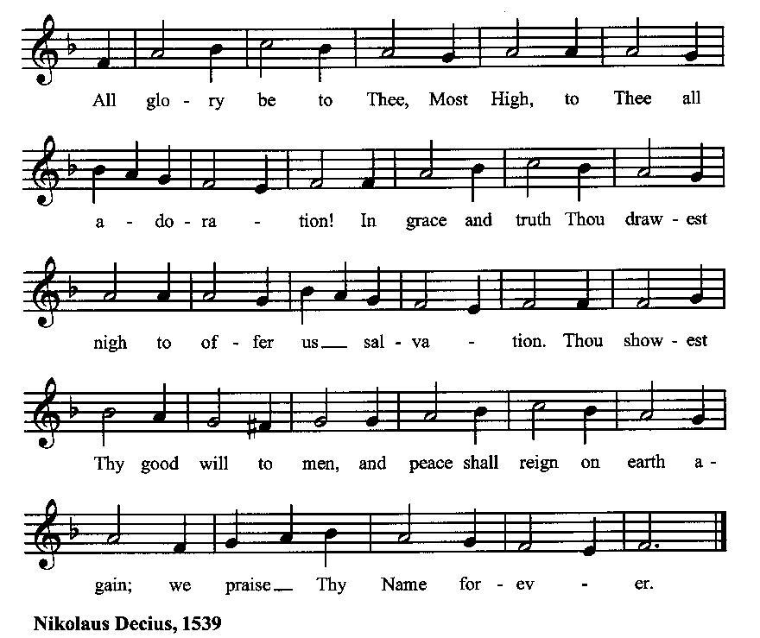

Minister: Holy God, Holy and Mighty, Holy Immortal One,
People: Have mercy upon us.
SERVICE OF THE WORD
Mutual Invocation of the Grace of God for the Service of the Word:
Minister: The Lord be with you.
People: And also with you.
(The people then be seated.)
The Ten Commandments (the people sitting):
Minister: God spoke these words, and said, I am the Lord your God:
You shall have no other gods but me.
You shall not make to yourself any graven image, to bow down to them, or worship them.
You shall not take the name of the Lord your God in vain.
Remember that you keep holy the Sabbath day.
Honor your father and your mother.
You shall not murder.
You shall not commit adultery.
You shall not steal.
You shall not bear false witness against your neighbor.
You shall not covet.

The Great Commandments (the people sitting):
Minister: Hear what our Lord Jesus Christ says. You shall love the Lord your God with all your heart, and with all your soul, and with all your mind. This is the first and great commandment. And the second is like unto it: You shall love your neighbor as yourself. On these two commandments hang all the Law and the Prophets.
The Kyrie (the people sitting, singing):
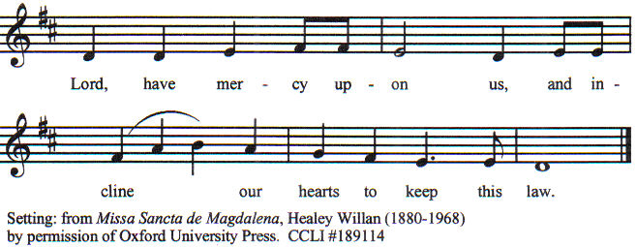

Old Testament Lesson (the people sitting):
Reader: The Old Testament lesson is written in the sixth chapter of the second book of the prophet Samuel, beginning at verse 1:
- David again gathered all the chosen men of Israel, thirty thousand.
- And David arose and went with all the people who were with him from Ba′ale-judah, to bring up from there the ark of God, which is called by the name of the Lord of hosts who sits enthroned on the cherubim.
- And they carried the ark of God upon a new cart, and brought it out of the house of Abin′adab which was on the hill; and Uzzah and Ahi′o, the sons of Abin′adab, were driving the new cart
- with the ark of God; and Ahi′o went before the ark.
- And David and all the house of Israel were making merry before the Lord with all their might, with songs and lyres and harps and tambourines and castanets and cymbals.
- And when they came to the threshing floor of Nacon, Uzzah put out his hand to the ark of God and took hold of it, for the oxen stumbled.
- And the anger of the Lord was kindled against Uzzah; and God smote him there because he put forth his hand to the ark; and he died there beside the ark of God.
- And David was angry because the Lord had broken forth upon Uzzah; and that place is called Pe′rez-uz′zah, to this day.
- And David was afraid of the Lord that day; and he said, “How can the ark of the Lord come to me?”
- So David was not willing to take the ark of the Lord into the city of David; but David took it aside to the house of O′bed-e′dom the Gittite.
- And the ark of the Lord remained in the house of O′bed-e′dom the Gittite three months; and the Lord blessed O′bed-e′dom and all his household.
- And it was told King David, “The Lord has blessed the household of O′bed-e′dom and all that belongs to him, because of the ark of God.” So David went and brought up the ark of God from the house of O′bed-e′dom to the city of David with rejoicing;
- and when those who bore the ark of the Lord had gone six paces, he sacrificed an ox and a fatling.
- And David danced before the Lord with all his might; and David was girded with a linen ephod.
- So David and all the house of Israel brought up the ark of the Lord with shouting, and with the sound of the horn.
- As the ark of the Lord came into the city of David, Michal the daughter of Saul looked out of the window, and saw King David leaping and dancing before the Lord; and she despised him in her heart.
- And they brought in the ark of the Lord, and set it in its place, inside the tent which David had pitched for it; and David offered burnt offerings and peace offerings before the Lord.
- And when David had finished offering the burnt offerings and the peace offerings, he blessed the people in the name of the Lord of hosts,
- and distributed among all the people, the whole multitude of Israel, both men and women, to each a cake of bread, a portion of meat, and a cake of raisins. Then all the people departed, each to his house. (RSV)
Reader: The Word of the Lord.
People: Thanks be to God.

The Psalm: (The people sit for the responsive reading, by half-verse, of Psalm 24, a song of praise for God’s mighty deeds.)
Reader: The Psalm is chapter 24, beginning at verse 1.
Reader: 1 The earth is the Lord’s and all that is in it,
People: the world and all who dwell therein.
Reader: 2 For it is he who founded it upon the seas
People: and made it firm upon the rivers of the deep.
Reader: 3 “Who can ascend the hill of the Lord?
People: and who can stand in his holy place?”
Reader: 4 “Those who have clean hands and a pure heart,
People: who have not pledged themselves to falsehood, nor sworn by
what is fraud.
Reader: 5 They shall receive a blessing from the Lord
People: and a just reward from the God of their salvation.”
Reader: 6 Such is the generation of those who seek him,
People: of those who seek your face, O God of Jacob.
Reader: 7 Lift up your heads, O gates; Lift them high, O everlasting doors;
People: and the King of glory shall come in.
Reader: 8 “Who is this King of glory?”
People: “The Lord, strong and mighty, the Lord, mighty in battle.”
Reader: 9 Lift up your heads, O gates; lift them high, O everlasting doors;
People: and the King of glory shall come in.
Reader: 10 “Who is he, this King of glory?”
People: the Lord of hosts, he is the King of glory.” (BCP)
Gloria Patri (the people sitting)
Reader: Glory be to the Father, and to the Son, and to the Holy Spirit;
People: As it was in the beginning, is now and ever shall be, world without end. Amen.
Collect for the Eighth Sunday after Pentecost (the people sitting):
Minister: O Lord, mercifully receive the prayers of your people who call upon you, and grant that they may know and understand what things they ought to do, and also may have grace and power faithfully to accomplish them; through Jesus Christ our Lord, who lives and reigns with you and the Holy Spirit, one God, now and for ever.
All: Amen.

The Epistle (the people sitting):
Reader: The epistle lesson is written in the first chapter of Paul’s letter to the Ephesians, beginning at verse 1:
- Blessed be the God and Father of our Lord Jesus Christ, who has blessed us in Christ with every spiritual blessing in the heavenly places,
- even as he chose us in him before the foundation of the world, that we should be holy and blameless before him.
- He destined us in love to be his sons through Jesus Christ, according to the purpose of his will,
- to the praise of his glorious grace which he freely bestowed on us in the Beloved.
- In him we have redemption through his blood, the forgiveness of our trespasses, according to the riches of his grace
- which he lavished upon us.
- For he has made known to us in all wisdom and insight the mystery of his will, according to his purpose which he set forth in Christ
- as a plan for the fulness of time, to unite all things in him, things in heaven and things on earth.
- In him, according to the purpose of him who accomplishes all things according to the counsel of his will,
- we who first hoped in Christ have been destined and appointed to live for the praise of his glory.
- In him you also, who have heard the word of truth, the gospel of your salvation, and have believed in him, were sealed with the promised Holy Spirit,
- which is the guarantee of our inheritance until we acquire possession of it, to the praise of his glory. (RSV)
Reader: Here ends the Epistle.
People: Thanks be to God.
Sequence Hymn (all standing):
How Firm a Foundation, vv. 1-4 (No. 307)

The Gospel (all standing, and turning toward the Gospel reading):
Minister: The holy Gospel is written in the sixth chapter of the Gospel according to Mark, beginning at verse 14:
Minister:
- King Herod heard of it; for Jesus’ name had become known. Some said, “John the baptizer has been raised from the dead; that is why these powers are at work in him.”
- But others said, “It is Eli′jah.” And others said, “It is a prophet, like one of the prophets of old.”
- But when Herod heard of it he said, “John, whom I beheaded, has been raised.”
- For Herod had sent and seized John, and bound him in prison for the sake of Hero′di-as, his brother Philip’s wife; because he had married her.
- For John said to Herod, “It is not lawful for you to have your brother’s wife.”
- And Hero′di-as had a grudge against him, and wanted to kill him. But she could not,
- for Herod feared John, knowing that he was a righteous and holy man, and kept him safe. When he heard him, he was much perplexed; and yet he heard him gladly.
- But an opportunity came when Herod on his birthday gave a banquet for his courtiers and officers and the leading men of Galilee.
- For when Hero′di-as’ daughter came in and danced, she pleased Herod and his guests; and the king said to the girl, “Ask me for whatever you wish, and I will grant it.”
- And he vowed to her, “Whatever you ask me, I will give you, even half of my kingdom.”
- And she went out, and said to her mother, “What shall I ask?” And she said, “The head of John the baptizer.”
- And she came in immediately with haste to the king, and asked, saying, “I want you to give me at once the head of John the Baptist on a platter.”
- And the king was exceedingly sorry; but because of his oaths and his guests he did not want to break his word to her.
- And immediately the king sent a soldier of the guard and gave orders to bring his head. He went and beheaded him in the prison,
- and brought his head on a platter, and gave it to the girl; and the girl gave it to her mother.
- When his disciples heard of it, they came and took his body, and laid it in a tomb. (RSV)
Minister: The Gospel of the Lord.
People: Praise to You, Lord Christ.
Sequence Hymn (all standing):
How Firm a Foundation, vv. 5-7 (No. 307)
[Elementary age children may exit for Children's Worship in the Parish Hall.
They will return to the service at the Passing of the Peace.]

Minister: Grace be unto you, and peace, from our Lord Jesus Christ.
All: Amen. (The people then be seated.)
The Sermon
Minister: In the name of the Father, the Son and the Holy Spirit.
All: Amen.
Silence, for review of the sermon, and for meditative prayer
SERVICE OF THE TABLE: THE GREAT THANKSGIVING
The Nicene Creed (all standing):
Minister: Let us confess our faith, saying:
All: We believe in one God,
the Father, the Almighty,
maker of heaven and earth,
of all that is, seen and unseen.
We believe in one Lord, Jesus Christ,
the only Son of God,
eternally begotten of the Father,
God from God, Light from Light,
true God from true God,
begotten, not made,
of one Being with the Father.
Through him all things were made.
For us and for our salvation
he came down from heaven:
by the power of the Holy Spirit
he became incarnate from the Virgin Mary,
and was made man.
For our sake he was crucified under Pontius Pilate;
he suffered death and was buried.
On the third day he rose again
in accordance with the Scriptures;
he ascended into heaven
and is seated at the right hand of the Father.
He will come again in glory to judge the living and the dead,
and his kingdom will have no end.
We believe in the Holy Spirit, the Lord, the giver of life,
who proceeds from the Father and the Son.
With the Father and the Son he is worshiped and glorified.
He has spoken through the Prophets.
We believe in one holy catholic and apostolic Church.
We acknowledge one baptism for the forgiveness of sins.
We look for the resurrection of the dead,
and the life of the world to come. Amen.
Minister: (The people sitting) Let us with gladness present the offerings and oblations of our life and labor to the Lord.
Offertory:
Offering Hymn (all standing):
God of Mercy, God of Grace (No. 350)
Minister: All things come from You, O Lord,
People: And of your own have we given You.
The Prayers of the People (the people kneeling or sitting):
Minister: Let us pray for the Church and the world. Almighty God, we pray for your Church throughout the world; grant that our divisions may cease, that we may be one, and that we may be found without fault at the day of your coming, let us pray to the Lord:
People: Lord, hear our prayer.
Minister: For our President and all who govern and hold authority in our nation and in the world, let us pray to the Lord:
People: Lord, hear our prayer.
Minister: For all those who do not yet believe, and for those who have lost their faith, that in due time we may all stand reconciled before You, let us pray to the Lord:
People: Lord, hear our prayer.
Minister: For the peace of the world, that a spirit of respect and forbearance may grow among all nations and peoples, let us pray to the Lord:
People: Lord, hear our prayer.
Minister: For the poor and the oppressed, prisoners and captives, the unemployed, and all who are in need or trouble, let us pray to the Lord:
People: Lord, hear our prayer.
Minister: For this congregation, that we might show forth your glory in all that we do; and for those who have commended themselves to our prayers, including these: _____________:
[Nation: United Kingdom
Denomination: Evangelical Free Church
Congregation: Grace Evangelical Lutheran Church in Waukesha, WI, and the Rev. Don Hacker
Ministry: The Chosen Project
Parishioners: Those living on Plymouth Street],
Grant that all of these may be delivered from anxiety, and live in joy, peace, and health.
(Please add your own intentions, either silently or aloud.)
Minister: Let us pray to the Lord:
People: Lord, hear our prayer.
Minister: We bless your holy Name for the thanksgivings of your people, including these: _________; for those in every generation in whom Christ has been honored; Give us grace to follow their good examples, that with them we may be partakers of your heavenly kingdom.
(Please add your intentions, either silently or aloud.)
Minister: Let us pray to the Lord:
People: Lord, hear our prayer

Collect (the people kneeling or sitting):
Minister: Ever living God, whose will it is that all should come to You through your Son Jesus Christ: Inspire our witness to him, that all may know the power of his forgiveness and the hope of his resurrection; who lives and reigns with You and the Holy Spirit, one God, now and for ever.
All: Amen.

Preparation for Holy Communion (the people sitting):
Minister: The Lord’s Supper was ordained by God to be a means of conveying grace according to the need of each person. Those for whom it was ordained are all those who know and feel that they want the grace of God, to restrain them from sin, or to forgive their sins, or to assure them of pardon, or to renew their souls in the image of God, or to enter into the holy presence of God in communion with him. No preparation is indispensably necessary, other than a desire to receive the grace God pleases to give. No fitness or church membership is required at the time of communicating, other than a sense of our state, of our utter sinfulness and helplessness apart from Christ. Therefore, if you want such grace as God pleases to give to you, draw near with faith, and as you prepare to receive this holy sacrament to your comfort and strength, make your sincere confession to Almighty God, kneeling if you wish and are able, or otherwise sitting.

The Prayer of Confession, Petition and Thanksgiving:
(The minister kneels, and the people kneel or sit.)
Minister: Let us pray together:
All: Most merciful God, we confess that we have sinned against thee in thought, word, and deed, by what we have done, and by what we have left undone. We have not loved thee with our whole heart; we have not loved our neighbors as ourselves. We are truly sorry and we humbly repent. For the sake of thy Son Jesus Christ, have mercy on us and forgive us; that we may delight in thy will, and walk in thy ways, to the glory of thy Name. Amen.

The Agnus Dei (the people kneeling or sitting, singing):
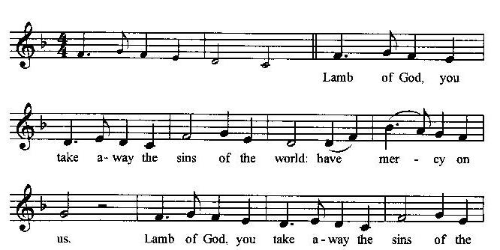
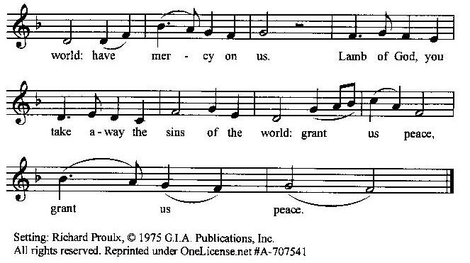

Prayer for Absolution (the people kneeling or sitting):
Minister: Almighty God, our heavenly Father, who of your great mercy has promised forgiveness of sins to all those who with hearty repentance and true faith turn unto You; Have mercy upon us; pardon and deliver us from all our sins, confirm and strengthen us in all goodness, and bring us to everlasting life, through Jesus Christ our Lord.
All: Amen.
The Comforting Words of Forgiveness (the people sitting):
Minister: Hear what comforting words our Savior Christ says to all who truly turn to him: Come to me, all you who are weary and carry heavy burdens, and I will give you rest. God so loved the world that he gave his only Son, so that everyone who believes in him will not perish but have eternal life. Hear also what St. Paul says: Christ Jesus came into the world to save sinners. Hear also what St. John says: If anyone sins, we have an Advocate with the Father, Jesus Christ the righteous: and he is the atonement for our sins.
The Passing of the Peace:
Minister: The peace of the Lord be always with you.
People: And also with you.
Minister: As the peace of Christ has been extended to you, extend the peace of the Lord to one another, and greet those who are near to you in the name of the Lord. (The people rise and remain standing.)
(The people greet those near to them, saying, “The peace of the Lord be with you,” or, “Peace be with you,” or simply, “Peace.” They respond to one another, “And also with you,” or simply, “Peace”.)

Hymn of Entry Into the Heavenly Worship (all standing):
O Thou, Who at Thy Eucharist Didst Pray (No. 395)
Preparation for the Table:
(Minister: I wash my hands in innocence, and go about your altar, O LORD, proclaiming aloud your praise and telling of all your wonderful deeds). [Psalm 26:6-7, NIV]
The Sursum Corda (all standing):
Minister: The Lord be with you.
People: And also with you.
Minister: Lift up your hearts.
People: We lift them up unto the Lord.
Minister: Let us give thanks unto our Lord God.
People: It is meet and right so to do.

The Salutation:
Minister: It is very meet, right, and our gladsome duty, that we should at all times, and in all places, give thanks unto You, O Lord, Holy Father, Almighty, Everlasting God,
The Preface:
Minister: Through Jesus Christ our Lord. In fulfillment of his true promise, the Holy Spirit came down from heaven, lighting upon the disciples, to teach them and to lead them into all truth; uniting peoples of many tongues in the confession of one faith, and giving to your Church the power to serve You as a royal priesthood, and to preach the Gospel to all nations.
Minister: Therefore, with Angels and Archangels and with all the company of heaven, we laud and magnify your glorious Name, evermore praising You, and saying,

The Sanctus (the people standing, singing):
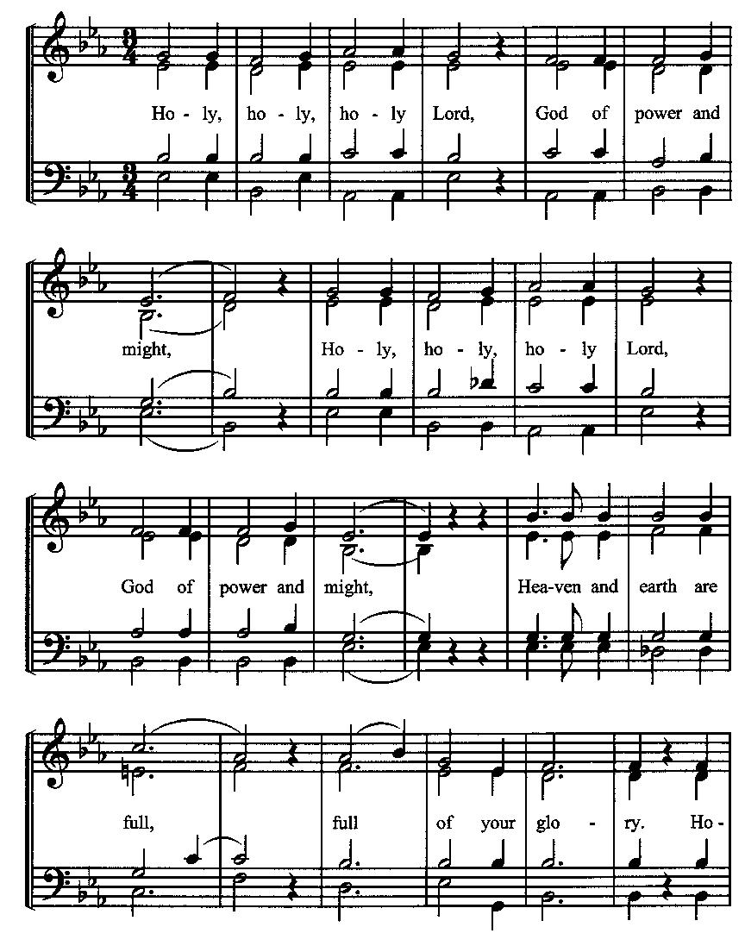
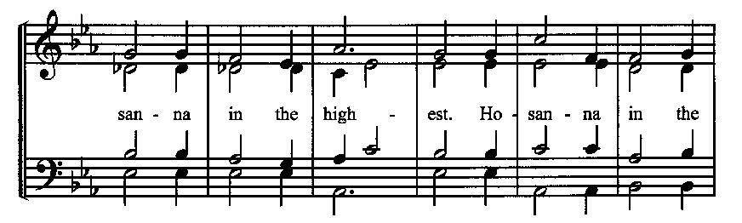
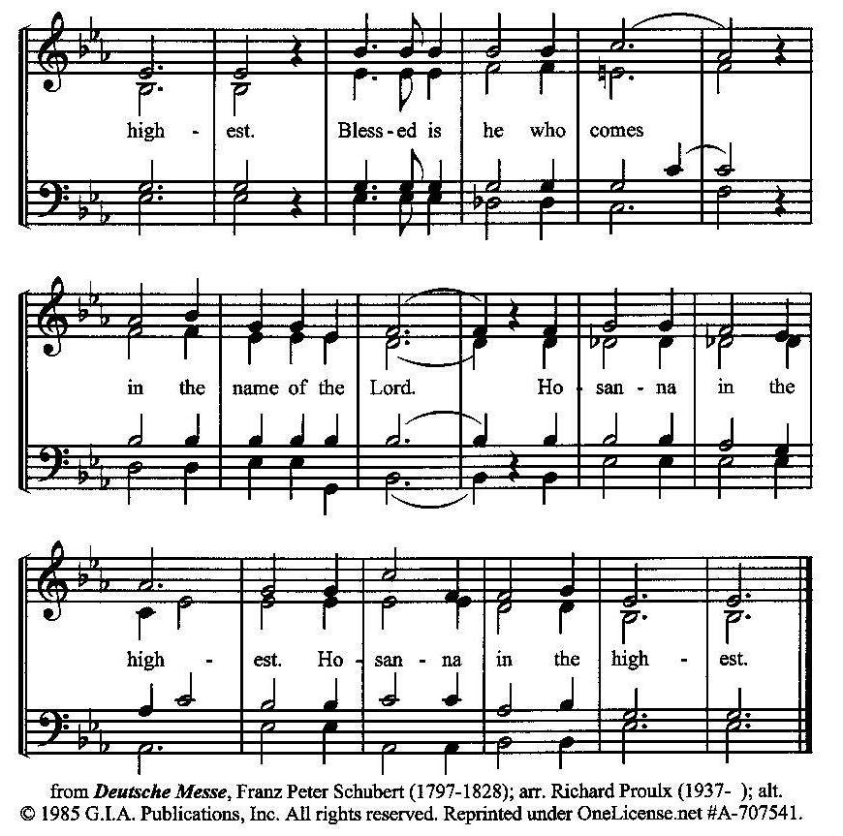
The Prayer of Humble Access and for Cleansing
(the people kneeling or sitting):
Minister: Let us pray together:
All: We do not presume to come to this your table, O merciful Lord, trusting in our own righteousness, but in your many and great mercies. We are not worthy so much as to gather up the crumbs under your table. But You are the same Lord, whose nature is always to have mercy: Grant us, therefore, gracious Lord, so to experience the spiritual presence of your dear Son Jesus Christ at this your table, that we may be made clean by his body and blood, and that we may evermore dwell in him, and he in us. Deliver us, gracious Lord, from the presumption of coming to this table for solace for ourselves only, and not for strength to serve You and others. Deliver us, gracious Lord, from the presumption of coming to this table for pardon of our sins only, and not for transformation of our lives in your holiness. Amen.
Epiclesis Prayer (the people kneeling or sitting):
Minister: Holy and gracious Father, in your infinite love You made us for yourself; and, when we had fallen into sin and become subject to evil and death, You sent Jesus Christ, your only and eternal Son, to share our human nature, to live and die as one of us, to reconcile us to You, the God and Father of all. He stretched out his arms upon the cross and offered himself, in obedience to your will, a perfect sacrifice for the sins of the whole world. Recalling now his death, resurrection, and ascension, we offer You these gifts. Sanctify them by your Holy Spirit to be for us the Body and Blood of your Son, the holy food and drink of new and unending life in him. Sanctify us also, that we may faithfully receive this holy Sacrament, and serve You in unity, constancy, and peace; and at the last day bring us with all your saints into the joy of your eternal kingdom. We ask this through Jesus Christ, your Son, our Lord; through him, and with him, and in him, in the unity of the Holy Spirit, all honor and glory are yours, O Father Almighty, now and forever.
All: Amen.
The Words of Institution (the people kneeling or sitting):
Minister: Our Lord Jesus Christ, on the night that he was betrayed took bread; and when he had given thanks, he broke it, and gave it to his disciples, saying, Take, eat; this is my Body which is given for you: Do this in remembrance of me.
Likewise, after supper, he took the cup; and when he had given thanks, he gave it to them, saying, Drink this, all of you; for this is my blood of the New Testament, which is shed for you, and for many, for the remission of sins: Do this, as often as you shall drink it, in remembrance of me.
All: Amen.
Minister: Therefore, we proclaim the mystery of faith:
People: Christ has died. Christ is risen. Christ will come again.
The Fraction:
Minister: Christ our passover is sacrificed for us.
People: Therefore let us keep the feast.

Fraction Anthem (the people kneeling or sitting, singing):
(The cantor sings the first line, and then all sing the other lines.)
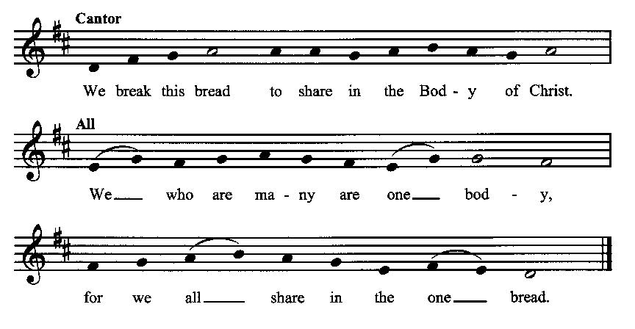

Minister: The gifts of God for the people of God. Take them in remembrance that Christ died for you and rose again, and feed on him in your hearts by faith with thanksgiving.
Communion Hymn (cantors only, the people kneeling or sitting):
“Christ for the world we sing! The world to Christ we bring with one accord: with us the work to share, with us reproach to dare, with us the cross to bear, for Christ our Lord.
Christ for the world we sing! The world to Christ we bring with joyful song: the newborn souls, whose days, reclaimed from error’s ways, inspired with hope and praise, to Christ belong.” (Christ for the World We Sing, vv. 3-4; Samuel Wolcott)
The Communion: (After the minister(s) and acolyte(s) are served, the people come forward to receive, as space is available. The people kneel if they are able, or stand. Communion by intincture: The people receive the Bread in their open hands, continue to hold it, then dip the Bread in the cup, and then consume.) They return to their seats via the side aisles.
Renewal of the Mutual Invocation of God’s Grace for the Eucharist:
Minister: The Lord be with you.
People: And also with you.

The Prayer of Thanksgiving and Living Sacrifice:
(The minister kneeling, the people kneeling or sitting):
Minister: Let us pray together:
All: O Lord and Heavenly Father, we heartily thank You because You feed us, in these holy mysteries, with the spiritual food of the most precious Body and Blood of your Son our Savior Jesus Christ; because by this You assure us of your favor and goodness toward us; because we are living members of the body of your Son and heirs of your eternal kingdom. We ask You to accept this our sacrifice of praise and thanksgiving, and to grant that by the merits and death of your Son Jesus Christ and through faith in him, we and all your whole Church may obtain all of the benefits of his passion. And here we offer and present unto You, O Lord, ourselves, our souls and bodies, to be a reasonable, holy, and living sacrifice unto You; humbly asking You that we may be filled with your grace and heavenly benediction; through Jesus Christ our Lord; by whom, and with whom, in the Unity of the Holy Spirit, all honor and glory be unto You, O Father Almighty, world without end. AMEN.

ACTS OF DISMISSAL
Recessional Hymn (all standing, singing):
Great Is Thy Faithfulness (No. 304)
The Prayer of Benediction:
Minister: Therefore, my beloved brethren, be steadfast, immovable, always abounding in the work of the Lord, knowing that your toil is not in vain in the Lord; and may the blessing of God Almighty, the Father, the Son, and the Holy Spirit, be among you and remain with you always.
All: Amen.
Minister: Let us go forth in the Name of Christ.
People: Thanks be to God.
(The people then be seated.)
Greetings and Announcements
Postlude:
(The people sit and remain quiet until the candles are extinguished and the organ raises its voice.)
_________________________________________________
Based on, and freely adapted from,
John Wesley’s Order for the Administration of the Lord’s Supper,
the 1662 and 1979 editions of The Book of Common Prayer, and
Common Worship: Services and Prayers for the Church of England
______________________________________
Scripture Lessons for July 21 (Ninth Sunday after Pentecost):
2 Samuel 7:1-17; Psalm 89:20-37; Ephesians 2:11-22; Mark 6:30-34, 53-56
Parish Prayer for This Week and Next Sunday
Those living on Pomona Road
_______________________________________

Parish Notices

Upcoming Class – Books Available Now
On July 21 we will be starting a new class during the Afterword, using the Brian Kluth book, Generous Life. This book is a very practical guide to increasing our generosity, with daily devotionals and tips, which include basic money management skills. Each family can get a book, whether or not you are able to stay for the class. That way, even if you miss a week, you don’t have to fall behind. The class will run from July 21 – 25 August. This would be a great class to invite people to if they have an interest in building the Kingdom with their financial resources.

Coming Events at Epworth
Today, 10:00 am Word & Table Service
Today, 11:30 am Fellowship
Today, 11:40 Afterword (moderated discussion)
Thursday, 7:00 pm Evening Prayers
Tuesday, 16 July Class Meeting (6:30)
Sunday, 21 July Afterword Class: Generous Life

July Birthdays & Anniversaries

04 – Adam & Andrea Graham

Sermon Notes

Epworth Church Office Email
epworthchapel.office@gmail.com
All correspondence for the office should be sent to this email address.

Pastor Crow Contact Information
Healing prayer is provided every week upon request
Rev. John Crow, Rector and Pastor
208-501-4037
jdowningcrow@hotmail.com

