Service of Word & Table

at

Epworth Chapel on the Green
6110 W. Northview Street, Boise, Idaho 83704
208-336-3951
www.epworthchapelonthegreen.org

The Rev. John Crow, Rector and Pastor
208-501-4037
July 7, 2024, 10:00 a.m.
Seventh Sunday after Pentecost

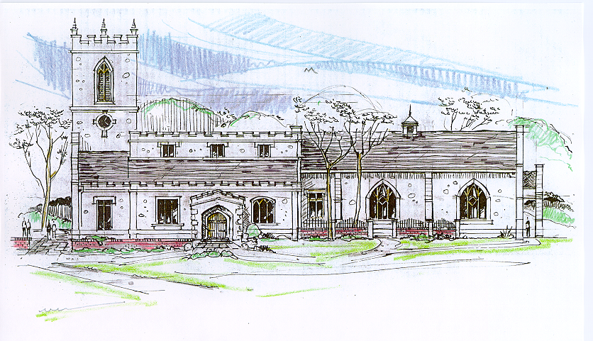

_______________________________________________
“Through the deep current of the historical church we will collaboratively serve and reach the lost in order to make disciples who love Jesus.”
____________________________________________________
This service will be live streamed, and in the course of that any or all persons who attend may be filmed. Remaining in the service will constitute your consent to appear in the live-streamed, recorded, and published service

Rector and Pastor: The Rev. John Crow
Cantors: Bryan Vanshur, Shannon Nichols
Readers:
Old Testament: Bryan Vanshur
Psalm: Bryan Vanshur
Epistle: Stan Crow
Acolytes: Stephen Crow, Josiah Crow, Corbin Crosswhite, Jessica Crosswhite
Jr. Acolytes: Asher Crow, & Lizzie Crosswhite
Usher: Kendra Millar
_______________________________
ACTS OF ENTRANCE
(The people enter and remain in prayer and meditation.)
Prelude:
Entrance canticle (cantors only):
“Thou art our holy Lord, the all-subduing Word, healer of strife; Thou didst thyself abase, that from sin’s deep disgrace thou mightiest save our race, and give us life.
Thou art the great High Priest; Thou hast prepared the feast of heavenly love; while in our mortal pain none calls on thee in vain; help thou didst not disdain, help from above.” (Thou Art Our Holy Lord, vv. 1-2; Clement of Alexandria)
Processional Hymn (all standing, singing):
Praise to the Lord, the Almighty (No. 477)
Minister: Blessed be God: Father, Son, and Holy Spirit.
People: And blessed be his kingdom, now and forever.
Lord’s Prayer:
Minister: Let us pray.
(All standing): Our Father, who art in heaven, hallowed be thy Name. Thy kingdom come. Thy will be done, on earth as it is in heaven. Give us this day our daily bread. And forgive us our trespasses, as we forgive those who trespass against us. And lead us not into temptation, but deliver us from evil, for thine is the kingdom, and the power, and the glory, for ever and ever. Amen.
The Collect for Purity:
Minister: Almighty God, unto whom all hearts are open, all desires known, and from whom no secrets are hid; cleanse the thoughts of our hearts by the inspiration of your Holy Spirit, that we may perfectly love You, and worthily magnify your holy Name, through Christ our Lord.
All: Amen.
The Gloria Hymn (all standing):
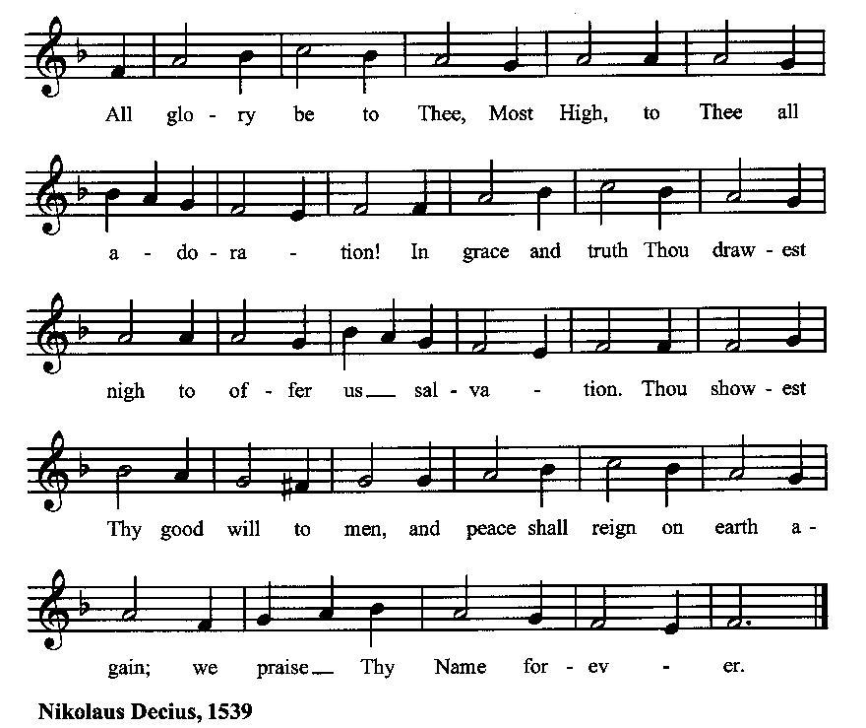

Minister: Holy God, Holy and Mighty, Holy Immortal One,
People: Have mercy upon us.
SERVICE OF THE WORD
Mutual Invocation of the Grace of God for the Service of the Word:
Minister: The Lord be with you.
People: And also with you.
(The people then be seated.)
The Ten Commandments (the people sitting):
Minister: God spoke these words, and said, I am the Lord your God:
You shall have no other gods but me.
You shall not make to yourself any graven image, to bow down to them, or worship them.
You shall not take the name of the Lord your God in vain.
Remember that you keep holy the Sabbath day.
Honor your father and your mother.
You shall not murder.
You shall not commit adultery.
You shall not steal.
You shall not bear false witness against your neighbor.
You shall not covet.
The Great Commandments (the people sitting):
Minister: Hear what our Lord Jesus Christ says. You shall love the Lord your God with all your heart, and with all your soul, and with all your mind. This is the first and great commandment. And the second is like unto it: You shall love your neighbor as yourself. On these two commandments hang all the Law and the Prophets.
The Kyrie (the people sitting, singing):
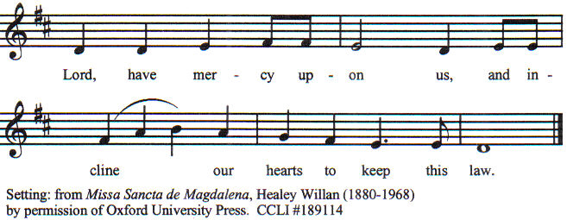

Old Testament Lesson (the people sitting):
Reader: The Old Testament lesson is written in the fifth chapter of the second book of the prophet Samuel, beginning at verse 1:
- Then all the tribes of Israel came to David at Hebron, and said, “Behold, we are your bone and flesh.
- In times past, when Saul was king over us, it was you that led out and brought in Israel; and the Lord said to you, ‘You shall be shepherd of my people Israel, and you shall be prince over Israel.’”
- So all the elders of Israel came to the king at Hebron; and King David made a covenant with them at Hebron before the Lord, and they anointed David king over Israel.
- David was thirty years old when he began to reign, and he reigned forty years.
- At Hebron he reigned over Judah seven years and six months; and at Jerusalem he reigned over all Israel and Judah thirty-three years.
- And the king and his men went to Jerusalem against the Jeb′usites, the inhabitants of the land, who said to David, “You will not come in here, but the blind and the lame will ward you off”—thinking, “David cannot come in here.”
- Nevertheless David took the stronghold of Zion, that is, the city of David.
- And David said on that day, “Whoever would smite the Jeb′usites, let him get up the water shaft to attack the lame and the blind, who are hated by David’s soul.” Therefore it is said, “The blind and the lame shall not come into the house.”
- And David dwelt in the stronghold, and called it the city of David. And David built the city round about from the Millo inward.
- And David became greater and greater, for the Lord, the God of hosts, was with him. (RSV)
Reader: The Word of the Lord.
People: Thanks be to God.

The Psalm: (The people sit for the responsive reading, by half-verse, of Psalm 48, a song of praise for God’s dwelling in Jerusalem.)
Reader: The Psalm is chapter 48.
Reader: 1 Great is the Lord, and highly to be praised
People: in the city of our God is his holy hill.
Reader: 2 Beautiful and lofty, the joy of all the earth, is the hill of Zion,
People: the very center of the world and the city of the great King,
Reader: 3 God is in her citadels;
People: he is known to be her sure refuge.
Reader: 4 Behold, the kings of the earth assembled
People: and marched forward together.
Reader: 5 They looked and were astounded;
People: they retreated and fled in terror.
Reader: 6 Trembling seized them there;
People: they writhed like a woman in childbirth, like ships of the sea when the east wind shatters them.
Reader: 7 As we have heard, so we have seen, in the city of the Lord of hosts, in the city of our God;
People: God has established her forever.
Reader: 8 We have waited in silence on your loving-kindness, O God,
People: in the midst of your temple.
Reader: 9 Your praise, like your name, O God, reaches to the world’s end;
People: your right hand is full of justice,
Reader: 10 Let Mount Zion be glad and the cities of Judah rejoice,
People: because of your judgments.
Reader: 11 Make the circuit of Zion; walk round about her;
People: count the number of her towers.
Reader: 12 Consider well her bulwarks; examine her strongholds;
People: that you may tell those who come after.
Reader: 13 This God is our God for ever and ever;
People: he shall be our guide for evermore. (BCP)

Gloria Patri (the people sitting)
Reader: Glory be to the Father, and to the Son, and to the Holy Spirit;
People: As it was in the beginning, is now and ever shall be, world without end. Amen.
Collect for the Seventh Sunday after Pentecost (the people sitting):
Minister: O God, you have taught us to keep all your commandments by loving you and our neighbor: Grant us the grace of your Holy Spirit, that we may be devoted to you with our whole heart, and united to one another with pure affection; through Jesus Christ our Lord, who lives and reigns with you and the Holy Spirit, one God, for ever and ever.
All: Amen.

The Epistle (the people sitting):
Reader: The epistle lesson is written in the twelfth chapter of Paul’s second letter to the Corinthians, beginning at verse 1:
- I must boast; there is nothing to be gained by it, but I will go on to visions and revelations of the Lord.
- I know a man in Christ who fourteen years ago was caught up to the third heaven—whether in the body or out of the body I do not know, God knows.
- And I know that this man was caught up into Paradise—whether in the body or out of the body I do not know, God knows—
- and he heard things that cannot be told, which man may not utter.
- On behalf of this man I will boast, but on my own behalf I will not boast, except of my weaknesses.
- Though if I wish to boast, I shall not be a fool, for I shall be speaking the truth. But I refrain from it, so that no one may think more of me than he sees in me or hears from me.
- And to keep me from being too elated by the abundance of revelations, a thorn was given me in the flesh, a messenger of Satan, to harass me, to keep me from being too elated.
- Three times I besought the Lord about this, that it should leave me;
- but he said to me, “My grace is sufficient for you, for my power is made perfect in weakness.” I will all the more gladly boast of my weaknesses, that the power of Christ may rest upon me.
- For the sake of Christ, then, I am content with weaknesses, insults, hardships, persecutions, and calamities; for when I am weak, then I am strong. (RSV)
Reader: Here ends the Epistle.
People: Thanks be to God.
Sequence Hymn (all standing):
Behold the Servant of the Lord!, vv. 1-2 (No. 373)

The Gospel (all standing, and turning toward the Gospel reading):
Minister: The holy Gospel is written in the sixth chapter of the Gospel according to Mark, beginning at verse 1:
Minister:
- 1 He went away from there and came to his own country; and his disciples followed him.
- And on the sabbath he began to teach in the synagogue; and many who heard him were astonished, saying, “Where did this man get all this? What is the wisdom given to him? What mighty works are wrought by his hands!
- Is not this the carpenter, the son of Mary and brother of James and Joses and Judas and Simon, and are not his sisters here with us?” And they took offense at him.
- And Jesus said to them, “A prophet is not without honor, except in his own country, and among his own kin, and in his own house.”
- And he could do no mighty work there, except that he laid his hands upon a few sick people and healed them.
- And he marveled because of their unbelief. And he went about among the villages teaching.
- And he called to him the twelve, and began to send them out two by two, and gave them authority over the unclean spirits.
- He charged them to take nothing for their journey except a staff; no bread, no bag, no money in their belts;
- but to wear sandals and not put on two tunics.
- And he said to them, “Where you enter a house, stay there until you leave the place.
- And if any place will not receive you and they refuse to hear you, when you leave, shake off the dust that is on your feet for a testimony against them.”
- So they went out and preached that men should repent.
- And they cast out many demons, and anointed with oil many that were sick and healed them. (RSV)
Minister: The Gospel of the Lord.
People: Praise to You, Lord Christ.
Sequence Hymn (all standing):
Behold the Servant of the Lord!, vv. 3-4 (No. 373)
[Elementary age children may exit for Children's Worship in the Parish Hall.
They will return to the service at the Passing of the Peace.]
Minister: Grace be unto you, and peace, from our Lord Jesus Christ.
All: Amen. (The people then be seated.)

The Sermon
Minister: In the name of the Father, the Son and the Holy Spirit.
All: Amen.
Silence, for review of the sermon, and for meditative prayer
SERVICE OF THE TABLE: THE GREAT THANKSGIVING
The Nicene Creed (all standing):
Minister: Let us confess our faith, saying:
All: We believe in one God,
the Father, the Almighty,
maker of heaven and earth,
of all that is, seen and unseen.
We believe in one Lord, Jesus Christ,
the only Son of God,
eternally begotten of the Father,
God from God, Light from Light,
true God from true God,
begotten, not made,
of one Being with the Father.
Through him all things were made.
For us and for our salvation
he came down from heaven:
by the power of the Holy Spirit
he became incarnate from the Virgin Mary,
and was made man.
For our sake he was crucified under Pontius Pilate;
he suffered death and was buried.
On the third day he rose again
in accordance with the Scriptures;
he ascended into heaven
and is seated at the right hand of the Father.
He will come again in glory to judge the living and the dead,
and his kingdom will have no end.
We believe in the Holy Spirit, the Lord, the giver of life,
who proceeds from the Father and the Son.
With the Father and the Son he is worshiped and glorified.
He has spoken through the Prophets.
We believe in one holy catholic and apostolic Church.
We acknowledge one baptism for the forgiveness of sins.
We look for the resurrection of the dead,
and the life of the world to come. Amen.
Minister: (The people sitting) Let us with gladness present the offerings and oblations of our life and labor to the Lord.
Offertory:
Offering Hymn (all standing):
On My Heart Imprint Your Image (No. 149)
Minister: All things come from You, O Lord,
People: And of your own have we given You.
The Prayers of the People (the people kneeling or sitting):
Minister: Let us pray for the Church and the world. Almighty God, we pray for your Church throughout the world; grant that our divisions may cease, that we may be one, and that we may be found without fault at the day of your coming, let us pray to the Lord:
People: Lord, hear our prayer.
Minister: For our President and all who govern and hold authority in our nation and in the world, let us pray to the Lord:
People: Lord, hear our prayer.
Minister: For all ministers of your Gospel, that they might faithfully preach your Word, administer your sacraments, and care for your people, let us pray to the Lord:
People: Lord, hear our prayer.
Minister: For the peace of the world, that a spirit of respect and forbearance may grow among all nations and peoples, let us pray to the Lord:
People: Lord, hear our prayer.
Minister: For our enemies and all who wish us harm, and for all whom we have injured or offended, let us pray to the Lord:
People: Lord, hear our prayer.
Minister: For this congregation, that we might show forth your glory in all that we do; and for those who have commended themselves to our prayers, including these: _____________:
[Nation: United Arab Emerites
Denomination: Evangelical Covenant Church
Congregation: Skyline Church in La Mesa, CA, and the Rev. Jeremy McGarity
Ministry: Jerusalem University College
Parishioners: Those living on Phillippi Street],

Grant that all of these may be delivered from anxiety, and live in joy, peace, and health.
(Please add your own intentions, either silently or aloud.)
Minister: Let us pray to the Lord:
People: Lord, hear our prayer.
Minister: We bless your holy Name for the thanksgivings of your people, including these: _________; for those in every generation in whom Christ has been honored; Give us grace to follow their good examples, that with them we may be partakers of your heavenly kingdom.
(Please add your intentions, either silently or aloud.)
Minister: Let us pray to the Lord:
People: Lord, hear our prayer

Collect (the people kneeling or sitting):
Minister: Ever living God, whose will it is that all should come to You through your Son Jesus Christ: Inspire our witness to him, that all may know the power of his forgiveness and the hope of his resurrection; who lives and reigns with You and the Holy Spirit, one God, now and for ever.
All: Amen.
Preparation for Holy Communion (the people sitting):
Minister: The Lord’s Supper was ordained by God to be a means of conveying grace according to the need of each person. Those for whom it was ordained are all those who know and feel that they want the grace of God, to restrain them from sin, or to forgive their sins, or to assure them of pardon, or to renew their souls in the image of God, or to enter into the holy presence of God in communion with him. No preparation is indispensably necessary, other than a desire to receive the grace God pleases to give. No fitness or church membership is required at the time of communicating, other than a sense of our state, of our utter sinfulness and helplessness apart from Christ. Therefore, if you want such grace as God pleases to give to you, draw near with faith, and as you prepare to receive this holy sacrament to your comfort and strength, make your sincere confession to Almighty God, kneeling if you wish and are able, or otherwise sitting.

The Prayer of Confession, Petition and Thanksgiving:
(The minister kneels, and the people kneel or sit.)
Minister: Let us pray together:
All: Most merciful God, we confess that we have sinned against thee in thought, word, and deed, by what we have done, and by what we have left undone. We have not loved thee with our whole heart; we have not loved our neighbors as ourselves. We are truly sorry and we humbly repent. For the sake of thy Son Jesus Christ, have mercy on us and forgive us; that we may delight in thy will, and walk in thy ways, to the glory of thy Name. Amen.

The Agnus Dei (the people kneeling or sitting, singing):
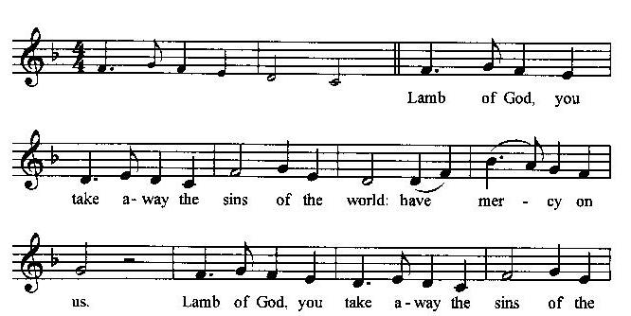
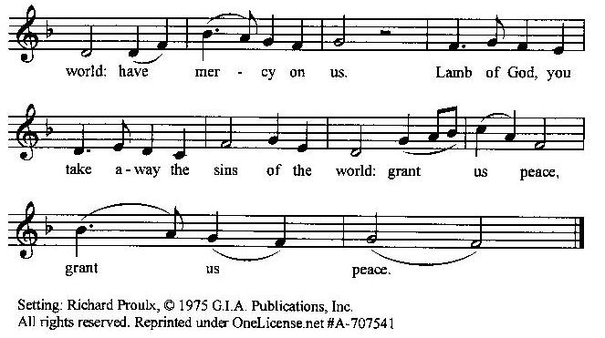

Prayer for Absolution (the people kneeling or sitting):
Minister: Almighty God, our heavenly Father, who of your great mercy has promised forgiveness of sins to all those who with hearty repentance and true faith turn unto You; Have mercy upon us; pardon and deliver us from all our sins, confirm and strengthen us in all goodness, and bring us to everlasting life, through Jesus Christ our Lord.
All: Amen.
The Comforting Words of Forgiveness (the people sitting):
Minister: Hear what comforting words our Savior Christ says to all who truly turn to him: Come to me, all you who are weary and carry heavy burdens, and I will give you rest. God so loved the world that he gave his only Son, so that everyone who believes in him will not perish but have eternal life. Hear also what St. Paul says: Christ Jesus came into the world to save sinners. Hear also what St. John says: If anyone sins, we have an Advocate with the Father, Jesus Christ the righteous: and he is the atonement for our sins.
The Passing of the Peace:
Minister: The peace of the Lord be always with you.
People: And also with you.
Minister: As the peace of Christ has been extended to you, extend the peace of the Lord to one another, and greet those who are near to you in the name of the Lord. (The people rise and remain standing.)
(The people greet those near to them, saying, “The peace of the Lord be with you,” or, “Peace be with you,” or simply, “Peace.” They respond to one another, “And also with you,” or simply, “Peace”.)

Hymn of Entry Into the Heavenly Worship (all standing):
With Christ We Share a Mystic Grave (No. 305)
Preparation for the Table:
(Minister: I wash my hands in innocence, and go about your altar, O LORD, proclaiming aloud your praise and telling of all your wonderful deeds). [Psalm 26:6-7, NIV]
The Sursum Corda (all standing):
Minister: The Lord be with you.
People: And also with you.
Minister: Lift up your hearts.
People: We lift them up unto the Lord.
Minister: Let us give thanks unto our Lord God.
People: It is meet and right so to do.

The Salutation:
Minister: It is very meet, right, and our gladsome duty, that we should at all times, and in all places, give thanks unto You, O Lord, Holy Father, Almighty, Everlasting God,

The Preface:
Minister: Through Jesus Christ our Lord. In fulfillment of his true promise, the Holy Spirit came down from heaven, lighting upon the disciples, to teach them and to lead them into all truth; uniting peoples of many tongues in the confession of one faith, and giving to your Church the power to serve You as a royal priesthood, and to preach the Gospel to all nations.

Minister: Therefore, with Angels and Archangels and with all the company of heaven, we laud and magnify your glorious Name, evermore praising You, and saying,

The Sanctus (the people standing, singing):
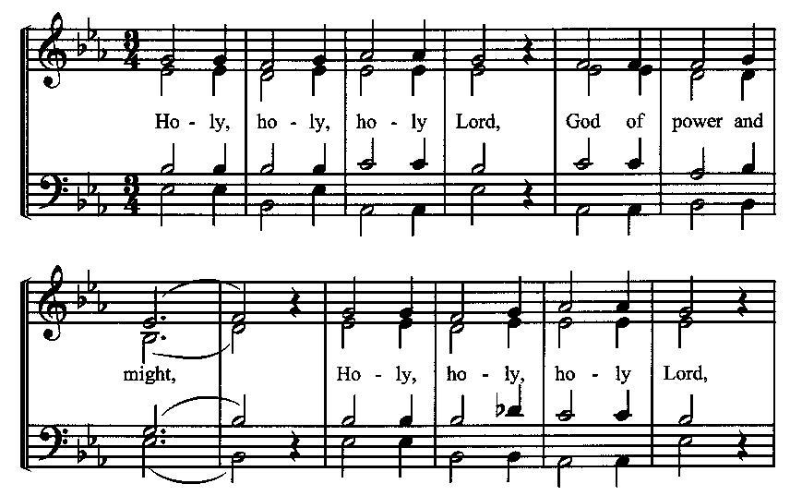
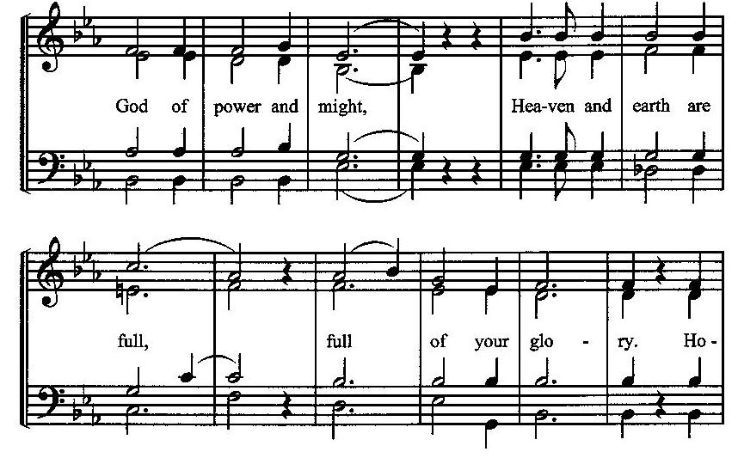
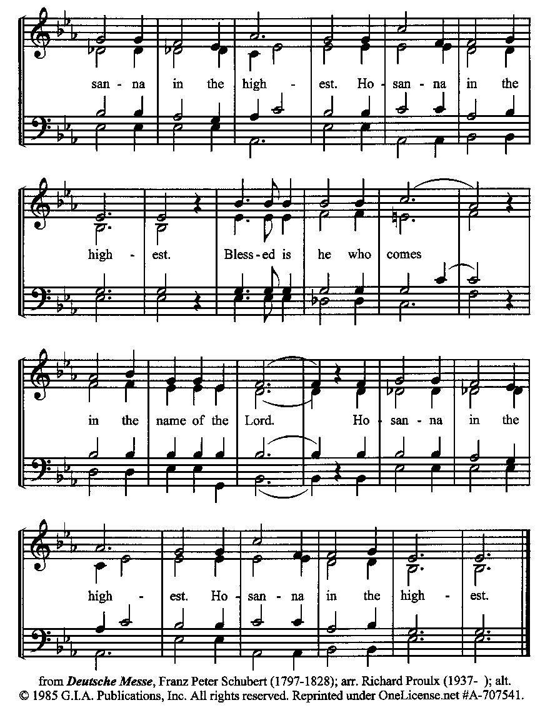
The Prayer of Humble Access and for Cleansing
(the people kneeling or sitting):
Minister: Let us pray together:
All: We do not presume to come to this your table, O merciful Lord, trusting in our own righteousness, but in your many and great mercies. We are not worthy so much as to gather up the crumbs under your table. But You are the same Lord, whose nature is always to have mercy: Grant us, therefore, gracious Lord, so to experience the spiritual presence of your dear Son Jesus Christ at this your table, that we may be made clean by his body and blood, and that we may evermore dwell in him, and he in us. Deliver us, gracious Lord, from the presumption of coming to this table for solace for ourselves only, and not for strength to serve You and others. Deliver us, gracious Lord, from the presumption of coming to this table for pardon of our sins only, and not for transformation of our lives in your holiness. Amen.
Epiclesis Prayer (the people kneeling or sitting):
Minister: Holy and gracious Father, in your infinite love You made us for yourself; and, when we had fallen into sin and become subject to evil and death, You sent Jesus Christ, your only and eternal Son, to share our human nature, to live and die as one of us, to reconcile us to You, the God and Father of all. He stretched out his arms upon the cross and offered himself, in obedience to your will, a perfect sacrifice for the sins of the whole world. Recalling now his death, resurrection, and ascension, we offer You these gifts. Sanctify them by your Holy Spirit to be for us the Body and Blood of your Son, the holy food and drink of new and unending life in him. Sanctify us also, that we may faithfully receive this holy Sacrament, and serve You in unity, constancy, and peace; and at the last day bring us with all your saints into the joy of your eternal kingdom. We ask this through Jesus Christ, your Son, our Lord; through him, and with him, and in him, in the unity of the Holy Spirit, all honor and glory are yours, O Father Almighty, now and forever.
All: Amen.
The Words of Institution (the people kneeling or sitting):
Minister: Our Lord Jesus Christ, on the night that he was betrayed took bread; and when he had given thanks, he broke it, and gave it to his disciples, saying, Take, eat; this is my Body which is given for you: Do this in remembrance of me.
Likewise, after supper, he took the cup; and when he had given thanks, he gave it to them, saying, Drink this, all of you; for this is my blood of the New Testament, which is shed for you, and for many, for the remission of sins: Do this, as often as you shall drink it, in remembrance of me.
All: Amen.
Minister: Therefore, we proclaim the mystery of faith:
People: Christ has died. Christ is risen. Christ will come again.
The Fraction:
Minister: Christ our passover is sacrificed for us.
People: Therefore let us keep the feast.

Fraction Anthem (the people kneeling or sitting, singing):
(The cantor sings the first line, and then all sing the other lines.)
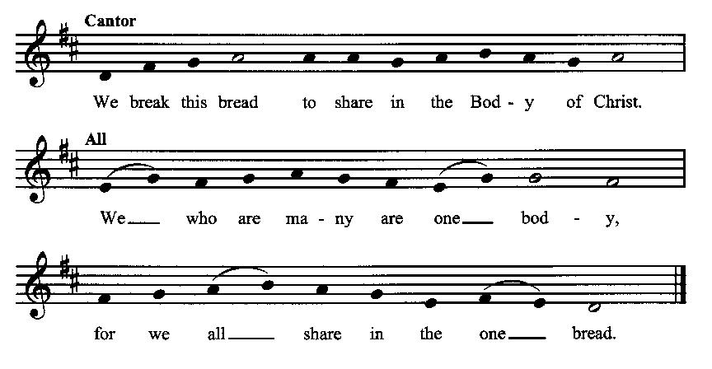
Minister: The gifts of God for the people of God. Take them in remembrance that Christ died for you and rose again, and feed on him in your hearts by faith with thanksgiving.
Communion Hymn (cantors only, the people kneeling or sitting):
“Ever be thou our Guide, our Shepherd, and our Pride, our Staff and Song; Jesus, thou Christ and God, by thy perennial Word, lead us where thou has trod, make our faith strong.
So now, and till we die, sound we thy praises high, and joyful sing; let all the holy throng who to the church belong unite and swell the song to Christ our King!” (Thou Art Our Holy Lord, vv. 3-4; Clement of Alexandria)
The Communion: (After the minister(s) and acolyte(s) are served, the people come forward to receive, as space is available. The people kneel if they are able, or stand. Communion by intincture: The people receive the Bread in their open hands, continue to hold it, then dip the Bread in the cup, and then consume.) They return to their seats via the side aisles.
Renewal of the Mutual Invocation of God’s Grace for the Eucharist:
Minister: The Lord be with you.
People: And also with you.

The Prayer of Thanksgiving and Living Sacrifice:
(The minister kneeling, the people kneeling or sitting):
Minister: Let us pray together:
All: O Lord and Heavenly Father, we heartily thank You because You feed us, in these holy mysteries, with the spiritual food of the most precious Body and Blood of your Son our Savior Jesus Christ; because by this You assure us of your favor and goodness toward us; because we are living members of the body of your Son and heirs of your eternal kingdom. We ask You to accept this our sacrifice of praise and thanksgiving, and to grant that by the merits and death of your Son Jesus Christ and through faith in him, we and all your whole Church may obtain all of the benefits of his passion. And here we offer and present unto You, O Lord, ourselves, our souls and bodies, to be a reasonable, holy, and living sacrifice unto You; humbly asking You that we may be filled with your grace and heavenly benediction; through Jesus Christ our Lord; by whom, and with whom, in the Unity of the Holy Spirit, all honor and glory be unto You, O Father Almighty, world without end. AMEN.

ACTS OF DISMISSAL
Recessional Hymn (all standing, singing):
Joy Is a Fruit That Will Not Grow (No. 347)
The Prayer of Benediction:
Minister: Therefore, my beloved brethren, be steadfast, immovable, always abounding in the work of the Lord, knowing that your toil is not in vain in the Lord; and may the blessing of God Almighty, the Father, the Son, and the Holy Spirit, be among you and remain with you always.
All: Amen.
Minister: Let us go forth in the Name of Christ.
People: Thanks be to God.
(The people then be seated.)
Greetings and Announcements
Postlude:
(The people sit and remain quiet until the candles are extinguished and the organ raises its voice.)
_________________________________________________
Based on, and freely adapted from,
John Wesley’s Order for the Administration of the Lord’s Supper,
the 1662 and 1979 editions of The Book of Common Prayer, and
Common Worship: Services and Prayers for the Church of England
______________________________________
Today’s Altar Flowers
Are given by Kelsey Williams

Scripture Lessons for July 14 (Eighth Sunday after Pentecost):
2 Samuel 6:1-5, 12-19; Psalm 24; Ephesians 1:3-14; Mark 6:14-29
Parish Prayer for This Week and Next Sunday
Those living on Plymouth Street
_______________________________________

Parish Notices
Upcoming Class – Books Available Now
On July 21 we will be starting a new class during the Afterword, using the Brian Kluth book, Generous Life. This book is a very practical guide to increasing our generosity, with daily devotionals and tips, which include basic money management skills. Each family can get a book, whether or not you are able to stay for the class. That way, even if you miss a week, you don’t have to fall behind. The class will run from July 21 – 25 August. This would be a great class to invite people to if they have an interest in building the Kingdom with their financial resources.

Coming Events at Epworth
Today, 10:00 am Word & Table Service
Today, 11:30 am Fellowship
Today, 11:40 Afterword (moderated discussion)
Thursday, 7:00 pm Evening Prayers
Tuesday, 16 July Class Meeting (6:30)
Sunday, 21 July Afterword Class: Generous Life

July Birthdays & Anniversaries

04 – Adam & Andrea Graham

Sermon Notes

Epworth Church Office Email
epworthchapel.office@gmail.com
All correspondence for the office should be sent to this email address.

Pastor Crow Contact Information
Healing prayer is provided every week upon request
Rev. John Crow, Rector and Pastor
208-501-4037
jdowningcrow@hotmail.com

