Service of Word & Table

at

Epworth Chapel on the Green
6110 W. Northview Street, Boise, Idaho 83704
208-336-3951
www.epworthchapelonthegreen.org

The Rev. John Crow, Rector and Pastor
208-501-4037
June 23, 2024, 10:00 a.m.
Fifth Sunday after Pentecost

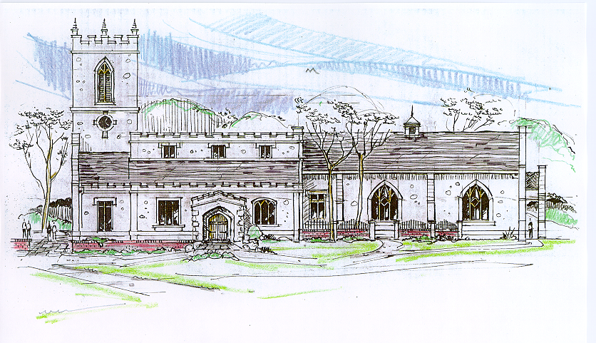

_______________________________________________
“Through the deep current of the historical church we will collaboratively serve and reach the lost in order to make disciples who love Jesus.”
____________________________________________________
This service will be live streamed, and in the course of that any or all persons who attend may be filmed. Remaining in the service will constitute your consent to appear in the live-streamed, recorded, and published service

Rector and Pastor: The Rev. John Crow
Cantors: Bryan Vanshur, Shannon Nichols
Readers:
Old Testament: Adam Graham
Psalm: Adam Graham
Epistle: Stephen Crow
Acolytes: Stephen Crow, Josiah Crow, Corbin Crosswhite, Jessica Crosswhite
Jr. Acolytes: Asher Crow, & Lizzie Crosswhite
Usher: Kendra Millar
_______________________________
ACTS OF ENTRANCE
(The people enter and remain in prayer and meditation.)
Prelude:
Entrance canticle (cantors only):
“Jesus, thy blood and righteousness my beauty are, my glorious dress; ‘midst flaming worlds, in these arrayed, with joy shall I lift up my head.
Bold shall I stand in thy great day, for who aught to my charge shall lay? Fully absolved through these I am, from sin and fear, from guilt and shame.” (Jesus, Thy Blood and Righteousness, vv. 1-2; Nicolaus Ludwig von Zinzendorf)
Processional Hymn (all standing, singing):
Amazing Grace (No. 240)
Minister: Blessed be God: Father, Son, and Holy Spirit.
People: And blessed be his kingdom, now and forever.
Lord’s Prayer: (found on page I in the pew hymnal)
Minister: Let us pray…

The Collect for Purity:
Minister: Almighty God, unto whom all hearts are open, all desires known, and from whom no secrets are hid; cleanse the thoughts of our hearts by the inspiration of your Holy Spirit, that we may perfectly love You, and worthily magnify your holy Name, through Christ our Lord.
All: Amen.

The Gloria Hymn (all standing):
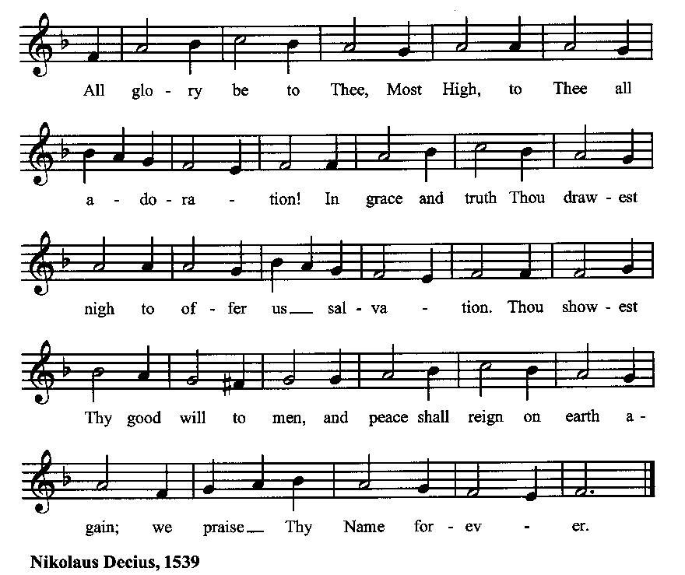

Minister: Holy God, Holy and Mighty, Holy Immortal One,
People: Have mercy upon us.
SERVICE OF THE WORD
Mutual Invocation of the Grace of God for the Service of the Word:
Minister: The Lord be with you.
People: And also with you.
(The people then be seated.)
The Ten Commandments (the people sitting):
Minister: God spoke these words, and said, I am the Lord your God:
You shall have no other gods but me.
You shall not make to yourself any graven image, to bow down to them, or worship them.
You shall not take the name of the Lord your God in vain.
Remember that you keep holy the Sabbath day.
Honor your father and your mother.
You shall not murder.
You shall not commit adultery.
You shall not steal.
You shall not bear false witness against your neighbor.
You shall not covet.

The Great Commandments (the people sitting):
Minister: Hear what our Lord Jesus Christ says. You shall love the Lord your God with all your heart, and with all your soul, and with all your mind. This is the first and great commandment. And the second is like unto it: You shall love your neighbor as yourself. On these two commandments hang all the Law and the Prophets.
The Kyrie (the people sitting, singing):
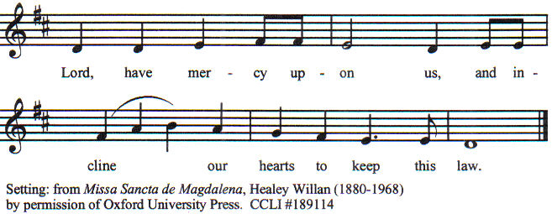

Old Testament Lesson (the people sitting):
Reader: The Old Testament lesson is written in the seventeenth chapter of the first book of the prophet Samuel, beginning at verse 32:
- And David said to Saul, “Let no man’s heart fail because of him; your servant will go and fight with this Philistine.”
- And Saul said to David, “You are not able to go against this Philistine to fight with him; for you are but a youth, and he has been a man of war from his youth.”
- But David said to Saul, “Your servant used to keep sheep for his father; and when there came a lion, or a bear, and took a lamb from the flock,
- I went after him and smote him and delivered it out of his mouth; and if he arose against me, I caught him by his beard, and smote him and killed him.
- Your servant has killed both lions and bears; and this uncircumcised Philistine shall be like one of them, seeing he has defied the armies of the living God.”
- And David said, “The Lord who delivered me from the paw of the lion and from the paw of the bear, will deliver me from the hand of this Philistine.” And Saul said to David, “Go, and the Lord be with you!”
- Then Saul clothed David with his armor; he put a helmet of bronze on his head, and clothed him with a coat of mail.
- And David girded his sword over his armor, and he tried in vain to go, for he was not used to them. Then David said to Saul, “I cannot go with these; for I am not used to them.” And David put them off.
- Then he took his staff in his hand, and chose five smooth stones from the brook, and put them in his shepherd’s bag or wallet; his sling was in his hand, and he drew near to the Philistine.
- And the Philistine came on and drew near to David, with his shield-bearer in front of him.
- And when the Philistine looked, and saw David, he disdained him; for he was but a youth, ruddy and comely in appearance.
- And the Philistine said to David, “Am I a dog, that you come to me with sticks?” And the Philistine cursed David by his gods.
- The Philistine said to David, “Come to me, and I will give your flesh to the birds of the air and to the beasts of the field.”
- Then David said to the Philistine, “You come to me with a sword and with a spear and with a javelin; but I come to you in the name of the Lord of hosts, the God of the armies of Israel, whom you have defied.
- This day the Lord will deliver you into my hand, and I will strike you down, and cut off your head; and I will give the dead bodies of the host of the Philistines this day to the birds of the air and to the wild beasts of the earth; that all the earth may know that there is a God in Israel,
- and that all this assembly may know that the Lord saves not with sword and spear; for the battle is the Lord’s and he will give you into our hand.”
- When the Philistine arose and came and drew near to meet David, David ran quickly toward the battle line to meet the Philistine.
- And David put his hand in his bag and took out a stone, and slung it, and struck the Philistine on his forehead; the stone sank into his forehead, and he fell on his face to the ground. (RSV)
Reader: The Word of the Lord.
People: Thanks be to God.

The Psalm: (The people sit for the responsive reading, by half-verse, of Psalm 9, a call for God to bring justice.)
Reader: The Psalm is chapter 9, beginning at verse 9:
Reader: 9 The LORD will be a refuge for the oppressed,
People: a refuge in time of trouble.
Reader: 10 Those who know your Name will put their trust in you,
People: for you never forsake those who seek you, O Lord.
Reader: 11 Sing praise to the Lord who dwells in Zion;
People: proclaim to the peoples the things he has done.
Reader: 12 The Avenger of blood will remember them;
People: he will not forget the cry of the afflicted.
Reader: 13 Have pity on me, O Lord;
People: see the misery I suffer from those who hate me, O you who lift me up from the gate of death;
Reader: 14 So that I may tell of all your praises and rejoice in your salvation
People: in the gates of the city of Zion.
Reader: 15 The ungodly have fallen into the pit they dug,
People: and in the snare they set is their own foot caught.
Reader: 16 The Lord is known by his acts of justice;
People: the wicked are trapped in the works of their own hands.
Reader: 17 The wicked shall be given over to the grave,
People: and also all the people that forget God.
Reader: 18 For the needy shall not always be forgotten,
People: and the hope of the poor shall not perish for ever.
Reader: 19 Rise up, O Lord, let not the ungodly have the upper hand;
People: let them be judged before you.
Reader: 20 Put fear upon them, O Lord;
People: let the ungodly know they are but mortal. (BCP)
Gloria Patri (the people sitting)
Reader: Glory be to the Father, and to the Son, and to the Holy Spirit;
People: As it was in the beginning, is now and ever shall be, world without end. Amen.

Collect for the Fifth Sunday after Pentecost (the people sitting):
Minister: O Lord, make us have perpetual love and reverence for your holy Name, for you never fail to help and govern those whom you have set upon the sure foundation of your loving-kindness; through Jesus Christ our Lord, who lives and reigns with you and the Holy Spirit, one God, for ever and ever.
All: Amen.

The Epistle (the people sitting):
Reader: The epistle lesson is written in the sixth chapter of Paul’s second letter to the Corinthians, beginning at verse 1:
- Working together with him, then, we entreat you not to accept the grace of God in vain.
- For he says, “At the acceptable time I have listened to you, and helped you on the day of salvation.” Behold, now is the acceptable time; behold, now is the day of salvation.
- We put no obstacle in any one’s way, so that no fault may be found with our ministry,
- but as servants of God we commend ourselves in every way: through great endurance, in afflictions, hardships, calamities,
- beatings, imprisonments, tumults, labors, watching, hunger;
- by purity, knowledge, forbearance, kindness, the Holy Spirit, genuine love,
- truthful speech, and the power of God; with the weapons of righteousness for the right hand and for the left;
- in honor and dishonor, in ill repute and good repute. We are treated as impostors, and yet are true;
- as unknown, and yet well known; as dying, and behold we live; as punished, and yet not killed;
- as sorrowful, yet always rejoicing; as poor, yet making many rich; as having nothing, and yet possessing everything.
- Our mouth is open to you, Corinthians; our heart is wide.
- You are not restricted by us, but you are restricted in your own affections.
- In return—I speak as to children—widen your hearts also. (RSV)
Reader: Here ends the Epistle.
People: Thanks be to God.
Sequence Hymn (all standing):
Christ Is Made the Sure Foundation, vv. 1-3 (No. 381)

The Gospel (all standing, and turning toward the Gospel reading):
Minister: The holy Gospel is written in the fourth chapter of the Gospel according to Mark, beginning at verse 35:
Minister:
- On that day, when evening had come, he said to them, “Let us go across to the other side.”
- And leaving the crowd, they took him with them in the boat, just as he was. And other boats were with him.
- And a great storm of wind arose, and the waves beat into the boat, so that the boat was already filling.
- But he was in the stern, asleep on the cushion; and they woke him and said to him, “Teacher, do you not care if we perish?”
- And he awoke and rebuked the wind, and said to the sea, “Peace! Be still!” And the wind ceased, and there was a great calm.
- He said to them, “Why are you afraid? Have you no faith?”
- And they were filled with awe, and said to one another, “Who then is this, that even wind and sea obey him?” (RSV)
Minister: The Gospel of the Lord.
People: Praise to You, Lord Christ.
Sequence Hymn (all standing):
Christ Is Made the Sure Foundation, vv. 4-5 (No. 381)
[Elementary age children may exit for Children's Worship in the Parish Hall.
They will return to the service at the Passing of the Peace.]
Minister: Grace be unto you, and peace, from our Lord Jesus Christ.
All: Amen. (The people then be seated.)
The Sermon
Minister: In the name of the Father, the Son and the Holy Spirit.
All: Amen.
Silence, for review of the sermon, and for meditative prayer
SERVICE OF THE TABLE: THE GREAT THANKSGIVING
The Nicene Creed (all standing): (found on page II in the pew hymnal)
Minister: Let us confess our faith, saying…

Minister: (The people sitting) Let us with gladness present the offerings and oblations of our life and labor to the Lord.
Offertory:
Offering Hymn (all standing):
For the Life That You Have Given (No. 485)
Minister: All things come from You, O Lord,
People: And of your own have we given You.
The Prayers of the People (the people kneeling or sitting):
Minister: Let us pray for the Church and the world. Almighty God, we pray for your Church throughout the world; grant that our divisions may cease, that we may be one, and that we may be found without fault at the day of your coming, let us pray to the Lord:
People: Lord, hear our prayer.
Minister: For our President and all who govern and hold authority in our nation and in the world, let us pray to the Lord:
People: Lord, hear our prayer.
Minister: For good will and fair treatment between people of all races and ethnicities, both individually, and under the law, let us pray to the Lord:
People: Lord, hear our prayer.
Minister: For the peace of the world, that a spirit of respect and forbearance may grow among all nations and peoples, let us pray to the Lord:
People: Lord, hear our prayer.
Minister: For the poor and the oppressed, prisoners and captives, the unemployed, and all who are in need or trouble, let us pray to the Lord:
People: Lord, hear our prayer.
Minister: For this congregation, that we might show forth your glory in all that we do; and for those who have commended themselves to our prayers, including these: _____________:
[Nation: Uganda
Denomination: The Episcopal Church
Congregation: Santa Ana FMC in Santa Ana, CA, and the Rev. Refugio Sanchez
Ministry: Gordon-Conwell Seminary
Parishioners: Those living on Northview Street],
Grant that all of these may be delivered from anxiety, and live in joy, peace, and health.
(Please add your own intentions, either silently or aloud.)
Minister: Let us pray to the Lord:
People: Lord, hear our prayer.
Minister: We bless your holy Name for the thanksgivings of your people, including these: _________; for those in every generation in whom Christ has been honored; Give us grace to follow their good examples, that with them we may be partakers of your heavenly kingdom.
(Please add your intentions, either silently or aloud.)
Minister: Let us pray to the Lord:
People: Lord, hear our prayer

Collect:
Minister: Almighty God, grant that the words which we have heard this day with our outward ears, may, through your grace, be so grafted inwardly in our hearts, that they may bring forth in us the fruit of good living, to the honor and praise of your Name; through Jesus Christ our Lord.
All: Amen.

Preparation for Holy Communion (the people sitting):
Minister: You who do truly and earnestly repent of your sins, and
are in love and charity with your neighbors, and intend to
lead a new life, following the commandments of God, and
walking from henceforth in his holy ways: Draw near with
faith, and make your humble confession to Almighty God,
kneeling if you wish and are able, or otherwise, sitting..

The Prayer of Confession, Petition and Thanksgiving:
(The minister kneels, and the people kneel or sit.)
Minister: Let us pray together:
All: Most merciful God, we confess that we have sinned against thee in thought, word, and deed, by what we have done, and by what we have left undone. We have not loved thee with our whole heart; we have not loved our neighbors as ourselves. We are truly sorry and we humbly repent. For the sake of thy Son Jesus Christ, have mercy on us and forgive us; that we may delight in thy will, and walk in thy ways, to the glory of thy Name. Amen.

The Agnus Dei (the people kneeling or sitting, singing):
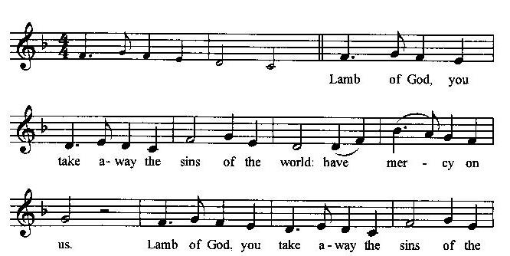
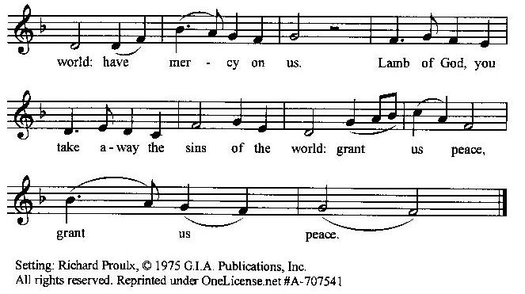

Prayer for Absolution (the people kneeling or sitting):
Minister: Almighty God, our heavenly Father, who of your great mercy has promised forgiveness of sins to all those who with hearty repentance and true faith turn unto You; Have mercy upon us; pardon and deliver us from all our sins, confirm and strengthen us in all goodness, and bring us to everlasting life, through Jesus Christ our Lord.
All: Amen.

The Comforting Words of Forgiveness (the people sitting):
Minister: Hear what comforting words our Savior Christ says to all who truly turn to him: Come to me, all you who are weary and carry heavy burdens, and I will give you rest. God so loved the world that he gave his only Son, so that everyone who believes in him will not perish but have eternal life. Hear also what St. Paul says: Christ Jesus came into the world to save sinners. Hear also what St. John says: If anyone sins, we have an Advocate with the Father, Jesus Christ the righteous: and he is the atonement for our sins.
The Passing of the Peace:
Minister: The peace of the Lord be always with you.
People: And also with you.
Minister: As the peace of Christ has been extended to you, extend the peace of the Lord to one another, and greet those who are near to you in the name of the Lord. (The people rise and remain standing.)
(The people greet those near to them, saying, “The peace of the Lord be with you,” or, “Peace be with you,” or simply, “Peace.” They respond to one another, “And also with you,” or simply, “Peace”.)
Hymn of Entry Into the Heavenly Worship (all standing):
Break Thou the Bread of Life (No. 387)
Preparation for the Table:
(Minister: I wash my hands in innocence, and go about your altar, O LORD, proclaiming aloud your praise and telling of all your wonderful deeds). [Psalm 26:6-7, NIV]
(Please see John Wesley’s statement on fitness for communion at the back cover of this folder)

The Sursum Corda (all standing):
Minister: The Lord be with you.
People: And also with you.
Minister: Lift up your hearts.
People: We lift them up unto the Lord.
Minister: Let us give thanks unto our Lord God.

People: It is meet and right so to do.

The Salutation:
Minister: It is very meet, right, and our gladsome duty, that we should at all times, and in all places, give thanks unto You, O Lord, Holy Father, Almighty, Everlasting God,
The Preface:
Minister: Through Jesus Christ our Lord. In fulfillment of his true promise, the Holy Spirit came down from heaven, lighting upon the disciples, to teach them and to lead them into all truth; uniting peoples of many tongues in the confession of one faith, and giving to your Church the power to serve You as a royal priesthood, and to preach the Gospel to all nations.
Minister: Therefore, with Angels and Archangels and with all the company of heaven, we laud and magnify your glorious Name, evermore praising You, and saying,

The Sanctus (the people standing, singing):

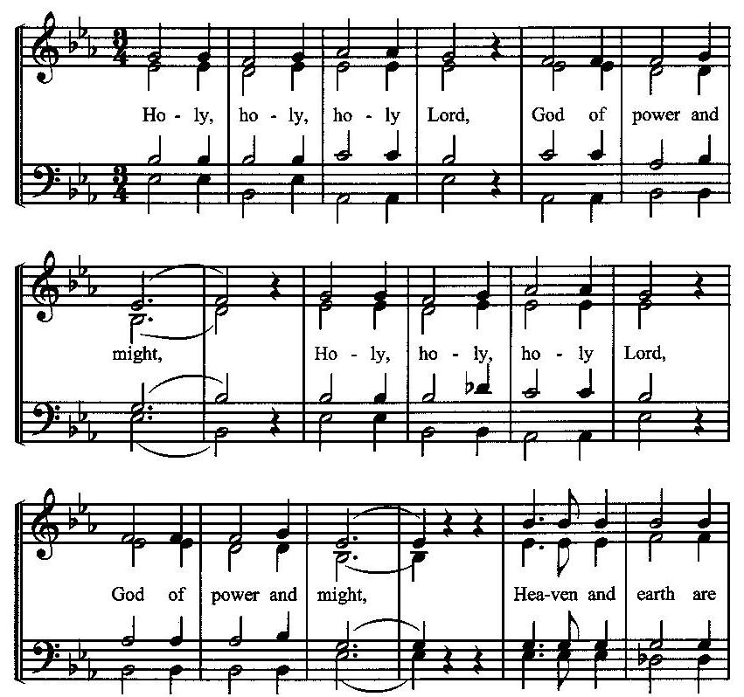
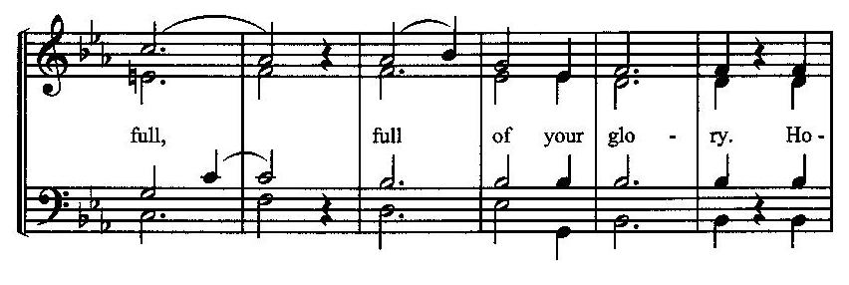
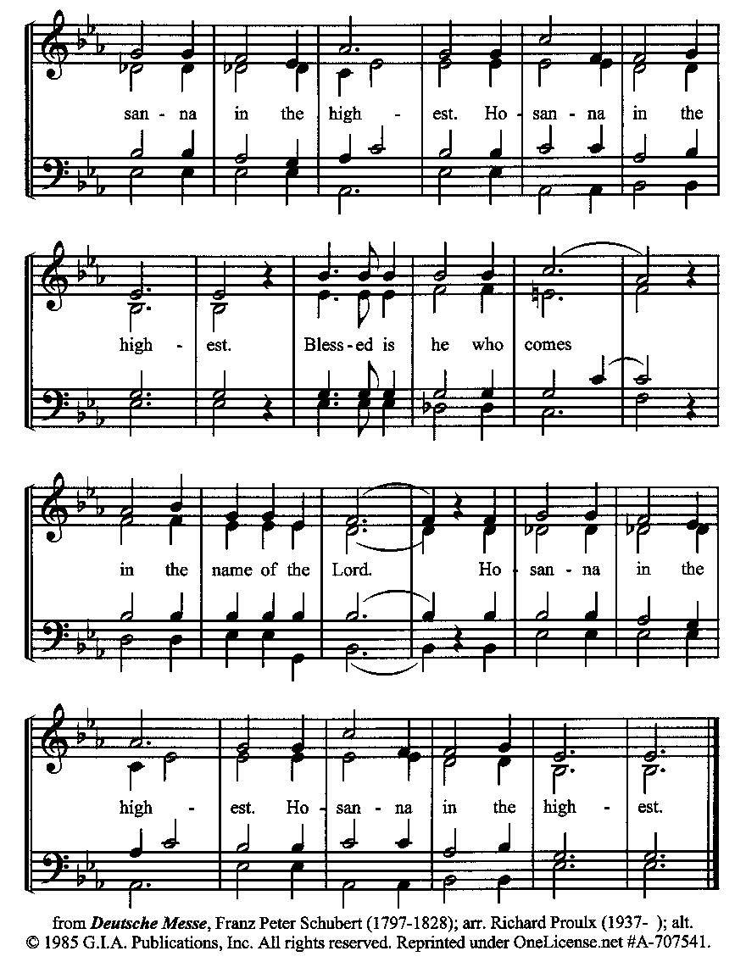
The Prayer of Humble Access and for Cleansing
(the people kneeling or sitting):
Minister: Let us pray together:
All: We do not presume to come to this your table, O merciful Lord, trusting in our own righteousness, but in your many and great mercies. We are not worthy so much as to gather up the crumbs under your table. But You are the same Lord, whose nature is always to have mercy: Grant us, therefore, gracious Lord, so to experience the spiritual presence of your dear Son Jesus Christ at this your table, that we may be made clean by his body and blood, and that we may evermore dwell in him, and he in us. Deliver us, gracious Lord, from the presumption of coming to this table for solace for ourselves only, and not for strength to serve You and others. Deliver us, gracious Lord, from the presumption of coming to this table for pardon of our sins only, and not for transformation of our lives in your holiness. Amen.
Epiclesis Prayer (the people kneeling or sitting):
Minister: Holy and gracious Father, in your infinite love You made us for yourself; and, when we had fallen into sin and become subject to evil and death, You sent Jesus Christ, your only and eternal Son, to share our human nature, to live and die as one of us, to reconcile us to You, the God and Father of all. He stretched out his arms upon the cross and offered himself, in obedience to your will, a perfect sacrifice for the sins of the whole world. Recalling now his death, resurrection, and ascension, we offer You these gifts. Sanctify them by your Holy Spirit to be for us the Body and Blood of your Son, the holy food and drink of new and unending life in him. Sanctify us also, that we may faithfully receive this holy Sacrament, and serve You in unity, constancy, and peace; and at the last day bring us with all your saints into the joy of your eternal kingdom. We ask this through Jesus Christ, your Son, our Lord; through him, and with him, and in him, in the unity of the Holy Spirit, all honor and glory are yours, O Father Almighty, now and forever.
All: Amen.
The Words of Institution (the people kneeling or sitting):
Minister: Our Lord Jesus Christ, on the night that he was betrayed took bread; and when he had given thanks, he broke it, and gave it to his disciples, saying, Take, eat; this is my Body which is given for you: Do this in remembrance of me.
Likewise, after supper, he took the cup; and when he had given thanks, he gave it to them, saying, Drink this, all of you; for this is my blood of the New Testament, which is shed for you, and for many, for the remission of sins: Do this, as often as you shall drink it, in remembrance of me.
All: Amen.
Minister: Therefore, we proclaim the mystery of faith:
People: Christ has died. Christ is risen. Christ will come again.
The Fraction:
Minister: Christ our passover is sacrificed for us.
People: Therefore let us keep the feast.

Fraction Anthem (the people kneeling or sitting, singing):
(The cantor sings the first line, and then all sing the other lines.)
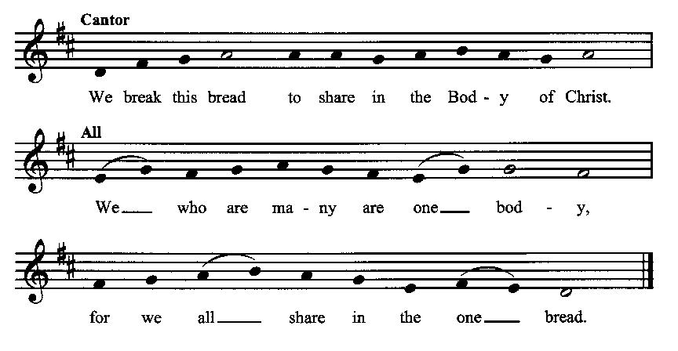

Minister: The gifts of God for the people of God. Take them in remembrance that Christ died for you and rose again, and feed on him in your hearts by faith with thanksgiving.
Communion Hymn (cantors only, the people kneeling or sitting):
“Lord, I believe thy precious blood, which, at the mercy seat of God, forever doth for sinners plead, for me, e’en for my soul, was shed.
Lord, I believe were sinners more than sands upon the ocean shore, thou hast for all a ransom paid, for all a full atonement made.” (Jesus, Thy Blood and Righteousness, vv. 3-4; Nicolaus Ludwig von Zinzendorf)
The Communion: (After the minister(s) and acolyte(s) are served, the people come forward to receive, as space is available. The people kneel if they are able, or stand. Communion by intincture: The people receive the Bread in their open hands, continue to hold it, then dip the Bread in the cup, and then consume.) They return to their seats via the side aisles.
Renewal of the Mutual Invocation of God’s Grace for the Eucharist:
Minister: The Lord be with you.
People: And also with you.

The Prayer of Thanksgiving and Living Sacrifice:
(The minister kneeling, the people kneeling or sitting):
Minister: Let us pray together:
All: O Lord and Heavenly Father, we heartily thank You because You feed us, in these holy mysteries, with the spiritual food of the most precious Body and Blood of your Son our Savior Jesus Christ; because by this You assure us of your favor and goodness toward us; because we are living members of the body of your Son and heirs of your eternal kingdom. We ask You to accept this our sacrifice of praise and thanksgiving, and to grant that by the merits and death of your Son Jesus Christ and through faith in him, we and all your whole Church may obtain all of the benefits of his passion. And here we offer and present unto You, O Lord, ourselves, our souls and bodies, to be a reasonable, holy, and living sacrifice unto You; humbly asking You that we may be filled with your grace and heavenly benediction; through Jesus Christ our Lord; by whom, and with whom, in the Unity of the Holy Spirit, all honor and glory be unto You, O Father Almighty, world without end. AMEN.

ACTS OF DISMISSAL
Recessional Hymn (all standing, singing):
Sing, My Soul, His Wondrous Love (No. 400)
The Prayer of Benediction:
Minister: May the peace of God, which passes all understanding, keep your hearts and minds in the knowledge and love of God, and of his Son Jesus Christ our Lord; and may the blessing of God Almighty, the Father, the Son, and the Holy Spirit, be among you and remain with you always.
All: Amen.
Minister: Let us go forth in the Name of Christ.
People: Thanks be to God.
(The people then be seated.)
Greetings and Announcements
Postlude:
(The people sit and remain quiet until the candles are extinguished and the organ raises its voice.)
_________________________________________________
Based on, and freely adapted from,
John Wesley’s Order for the Administration of the Lord’s Supper,
the 1662 and 1979 editions of The Book of Common Prayer, and
Common Worship: Services and Prayers for the Church of England
______________________________________
Today’s Altar Flowers
Are provided by Kelsey Williams

Scripture Lessons for June 30 (Sixth Sunday after Pentecost):
2 Samuel 1:1, 7-27; Psalm 130; 2 Corinthians 8:7-15; Mark 5:21-43
Parish Prayer for This Week and Next Sunday
Those living on Overlook Road
_______________________________________

Parish Notices

Today: Natalie Bridges Missionary Update
Natalie Bridges, a local missionary working in Bistria, Romania, will be speaking today during the Afterword. Come here the latest on how God has been working through her to reach the people of Romania.

Weekly Healing Service
In order to provide a regular opportunity for extended healing prayer, the time immediately following evening prayers is now designated for anointing and healing prayer. Those who attend evening prayers are not expected to stay for the healing prayer unless they want to.

Welcoming New Members!
Now that we are a Free Methodist society, it’s time for those who have sat through the membership classes in the You Are the Church booklet back in the Spring. We will be welcoming new members on July 7th. If you would like to become a member of this newly formed Free Methodist society, please let Pastor John know, and you will be recognized. If you did not sit through the classes, but would like to become a member, let Pastor John know that.
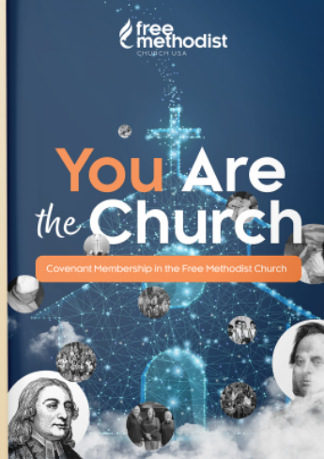

Coming Events at Epworth
Today, 10:00 am Word & Table Service
Today, 11:30 am Fellowship & presentation by
Natalie Bridges
Thursday, 7:00 pm Evening Prayers & Healing Service
Sunday, 7 July New Members Welcomed

June Birthdays & Anniversaries
08 – Tom & Lorrie Walker
10 – Carollen Ryan
11 – Mary Young (Robinson)
14 – Rich & Lynn Reid
15 – Keith & Robyn Millar
19 – Stan Crow
30 – Keith Millar

Sermon Notes

John Wesley’s statement on fitness for communion
The Lord’s Supper was ordained by God to be a means of conveying grace according to the need of each person. Those for whom it was ordained are all those who know and feel that they want the grace of God, to restrain them from sin, or to forgive their sins, or to assure them of pardon, or to renew their souls in the image of God, or to enter into the holy presence of God in communion with him. No preparation is indispensably necessary, other than a desire to receive the grace God pleases to give. No fitness or church membership is required at the time of communicating, other than a sense of our state, of our utter sinfulness and helplessness apart from Christ.

Epworth Church Office Email
epworthchapel.office@gmail.com
All correspondence for the office should be sent to this email address.

Pastor Crow Contact Information
Healing prayer is provided every week upon request
Rev. John Crow, Rector and Pastor
208-501-4037
jdowningcrow@hotmail.com

